
NORTH CAROLINA

REGISTER

VOLUME 33 ● ISSUE 04 ● Pages 315 – 455

August 15, 2018

I. IN ADDITION

Building Code Council – Notice of Rulemaking Proceedings 315 – 330

Board of Elections and Ethics Enforcement – Advisory Opinion 331 – 334

Environmental Management Commission – Public Notice 335

II. PROPOSED RULES

Insurance, Department of

Department 336 – 338

Industrial Commission 338 – 345

Public Safety, Department of

Governor's Crime Commission 345 – 348

Environmental Quality, Department of

Environmental Management Commission 348 – 422

Occupational Licensing Boards and Commissions

Cosmetic Art Examiners, Board of 422 – 424

State Human Resources, Office of

State Human Resources Commission 424 – 425

III. TEMPORARY RULES

Department of Environmental Quality

Wildlife Resources Commission 426 – 441

IV. RULES REVIEW COMMISSION 442 – 455

PUBLISHED BY
The Office of Administrative Hearings
Rules Division Julian Mann III, Director
6714 Mail Service Center Molly Masich, Codifier of Rules
Raleigh, NC 27699-6714 Dana McGhee, Publications Coordinator
Telephone (919) 431-3000 Lindsay Woy, Editorial Assistant
Fax (919) 431-3104 Cathy Matthews-Thayer, Editorial Assistant

Contact List for Rulemaking Questions or Concerns

For questions or concerns regarding the Administrative Procedure Act or any of its components, consult with the agencies below. The bolded headings are typical issues which the given agency can address, but are not inclusive.

Rule Notices, Filings, Register, Deadlines, Copies of Proposed Rules, etc.

Office of Administrative Hearings

Rules Division
1711 New Hope Church Road (919) 431-3000
Raleigh, North Carolina 27609 (919) 431-3104 FAX

contact: Molly Masich, Codifier of Rules molly.masich@oah.nc.gov (919) 431-3071
Dana McGhee, Publications Coordinator dana.mcghee@oah.nc.gov (919) 431-3075
Lindsay Woy, Editorial Assistant lindsay.woy@oah.nc.gov (919) 431-3078
Cathy Matthews-Thayer, Editorial Assistant cathy.thayer@oah.nc.gov (919) 431-3006

Rule Review and Legal Issues

Rules Review Commission
1711 New Hope Church Road (919) 431-3000
Raleigh, North Carolina 27609 (919) 431-3104 FAX

contact: Amber Cronk May, Commission Counsel amber.may@oah.nc.gov (919) 431-3074
Amanda Reeder, Commission Counsel amanda.reeder@oah.nc.gov (919) 431-3079
Jason Thomas, Commission Counsel jason.thomas@oah.nc.gov (919) 431-3081
Alexander Burgos, Paralegal alexander.burgos@oah.nc.gov (919) 431-3080
Julie Brincefield, Administrative Assistant julie.brincefield@oah.nc.gov (919) 431-3073

Fiscal Notes & Economic Analysis and Governor's Review

Office of State Budget and Management
116 West Jones Street (919) 807-4700
Raleigh, North Carolina 27603-8005 (919) 733-0640 FAX
Contact: Anca Grozav, Economic Analyst osbmruleanalysis@osbm.nc.gov (919) 807-4740
Carrie Hollis, Economic Analyst osbmruleanalysis@osbm.nc.gov (919) 807-4757

NC Association of County Commissioners
215 North Dawson Street (919) 715-2893
Raleigh, North Carolina 27603
contact: Amy Bason amy.bason@ncacc.org

NC League of Municipalities (919) 715-4000
150 Fayetteville Street, Suite 300
Raleigh, North Carolina 27601
contact: Sarah Collins scollins@nclm.org

Legislative Process Concerning Rule-making
545 Legislative Office Building
300 North Salisbury Street (919) 733-2578
Raleigh, North Carolina 27611 (919) 715-5460 FAX

Karen Cochrane-Brown, Director/Legislative Analysis Division karen.cochrane-brown@ncleg.net
Jeff Hudson, Staff Attorney Jeffrey.hudson@ncleg.net

NORTH CAROLINA REGISTER
Publication Schedule for January 2019 – December 2019

FILING DEADLINES |  |  | NOTICE OF TEXT |  | PERMANENT RULE |  |  | TEMPORARY RULES
Volume & issue number | Issue date | Last day for filing | Earliest date for public hearing | End of required comment  Period | Deadline to submit to RRC  for review at  next meeting | RRC Meeting Date | Earliest Eff.  Date of  Permanent Rule | 270th day from publication in the Register
33:13 | 01/02/19 | 12/06/18 | 01/17/19 | 03/04/19 | 03/20/19 | 04/18/19 | 05/01/19 | 09/29/19
33:14 | 01/15/19 | 12/19/18 | 01/30/19 | 03/18/19 | 03/20/19 | 04/18/19 | 05/01/19 | 10/12/19
33:15 | 02/01/19 | 01/10/19 | 02/16/19 | 04/02/19 | 04/22/19 | 05/16/19 | 06/01/19 | 10/29/19
33:16 | 02/15/19 | 01/25/19 | 03/02/19 | 04/16/19 | 04/22/19 | 05/16/19 | 06/01/19 | 11/12/19
33:17 | 03/01/19 | 02/08/19 | 03/16/19 | 04/30/19 | 05/20/19 | 06/20/19 | 07/01/19 | 11/26/19
33:18 | 03/15/19 | 02/22/19 | 03/30/19 | 05/14/19 | 05/20/19 | 06/20/19 | 07/01/19 | 12/10/19
33:19 | 04/01/19 | 03/11/19 | 04/16/19 | 05/31/19 | 06/20/19 | 07/18/19 | 08/01/19 | 12/27/19
33:20 | 04/15/19 | 03/25/19 | 04/30/19 | 06/14/19 | 06/20/19 | 07/18/19 | 08/01/19 | 01/10/20
33:21 | 05/01/19 | 04/09/19 | 05/16/19 | 07/01/19 | 07/22/19 | 08/15/19 | 09/01/19 | 01/26/20
33:22 | 05/15/19 | 04/24/19 | 05/30/19 | 07/15/19 | 07/22/19 | 08/15/19 | 09/01/19 | 02/09/20
33:23 | 06/03/19 | 05/10/19 | 06/18/19 | 08/02/19 | 08/20/19 | 09/19/19 | 10/01/19 | 02/28/20
33:24 | 06/17/19 | 05/24/19 | 07/02/19 | 08/16/19 | 08/20/19 | 09/19/19 | 10/01/19 | 03/13/20
34:01 | 07/01/19 | 06/10/19 | 07/16/19 | 08/30/19 | 09/20/19 | 10/17/19 | 11/01/19 | 03/27/20
34:02 | 07/15/19 | 06/21/19 | 07/30/19 | 09/13/19 | 09/20/19 | 10/17/19 | 11/01/19 | 04/10/20
34:03 | 08/01/19 | 07/11/19 | 08/16/19 | 09/30/19 | 10/21/19 | 11/21/19 | 12/01/19 | 04/27/20
34:04 | 08/15/19 | 07/25/19 | 08/30/19 | 10/14/19 | 10/21/19 | 11/21/19 | 12/01/19 | 05/11/20
34:05 | 09/03/19 | 08/12/19 | 09/18/19 | 11/04/19 | 11/20/19 | 12/19/19 | 01/01/20 | 05/30/20
34:06 | 09/16/19 | 08/23/19 | 10/01/19 | 11/15/19 | 11/20/19 | 12/19/19 | 01/01/20 | 06/12/20
34:07 | 10/01/19 | 09/10/19 | 10/16/19 | 12/02/19 | 12/20/19 | 01/16/20 | 02/01/20 | 06/27/20
34:08 | 10/15/19 | 09/24/19 | 10/30/19 | 12/16/19 | 12/20/19 | 01/16/20 | 02/01/20 | 07/11/20
34:09 | 11/01/19 | 10/11/19 | 11/16/19 | 12/31/19 | 01/21/20 | 02/20/20 | 03/01/20 | 07/28/20
34:10 | 11/15/19 | 10/24/19 | 11/30/19 | 01/14/20 | 01/21/20 | 02/20/20 | 03/01/20 | 08/11/20
34:11 | 12/02/19 | 11/06/19 | 12/17/19 | 01/31/20 | 02/20/20 | 03/19/20 | 04/01/20 | 08/28/20
34:12 | 12/16/19 | 11/21/19 | 12/31/19 | 02/14/20 | 02/20/20 | 03/19/20 | 04/01/20 | 09/11/20

This document is prepared by the Office of Administrative Hearings as a public service and is not to be deemed binding or controlling.
EXPLANATION OF THE PUBLICATION SCHEDULE

This Publication Schedule is prepared by the Office of Administrative Hearings as a public service and the computation of time periods are not to be deemed binding or controlling. Time is computed according to 26 NCAC 2C .0302 and the Rules of Civil Procedure, Rule 6.

GENERAL

The North Carolina Register shall be published twice a month and contains the following information submitted for publication by a state agency:
(1) temporary rules;
(2) text of proposed rules;
(3) text of permanent rules approved by the Rules Review Commission;
(4) emergency rules
(5) Executive Orders of the Governor;
(6) final decision letters from the U.S. Attorney General concerning changes in laws affecting voting in a jurisdiction subject of Section 5 of the Voting Rights Act of 1965, as required by G.S. 120-30.9H; and
(7) other information the Codifier of Rules determines to be helpful to the public.

COMPUTING TIME: In computing time in the schedule, the day of publication of the North Carolina Register is not included. The last day of the period so computed is included, unless it is a Saturday, Sunday, or State holiday, in which event the period runs until the preceding day which is not a Saturday, Sunday, or State holiday.

FILING DEADLINES

ISSUE DATE: The Register is published on the first and fifteen of each month if the first or fifteenth of the month is not a Saturday, Sunday, or State holiday for employees mandated by the State Personnel Commission. If the first or fifteenth of any month is a Saturday, Sunday, or a holiday for State employees, the North Carolina Register issue for that day will be published on the day of that month after the first or fifteenth that is not a Saturday, Sunday, or holiday for State employees.

LAST DAY FOR FILING: The last day for filing for any issue is 15 days before the issue date excluding Saturdays, Sundays, and holidays for State employees.

NOTICE OF TEXT

EARLIEST DATE FOR PUBLIC HEARING: The hearing date shall be at least 15 days after the date a notice of the hearing is published.

END OF REQUIRED COMMENT PERIOD
An agency shall accept comments on the text of a proposed rule for at least 60 days after the text is published or until the date of any public hearings held on the proposed rule, whichever is longer.

DEADLINE TO SUBMIT TO THE RULES REVIEW COMMISSION: The Commission shall review a rule submitted to it on or before the twentieth of a month by the last day of the next month.

.
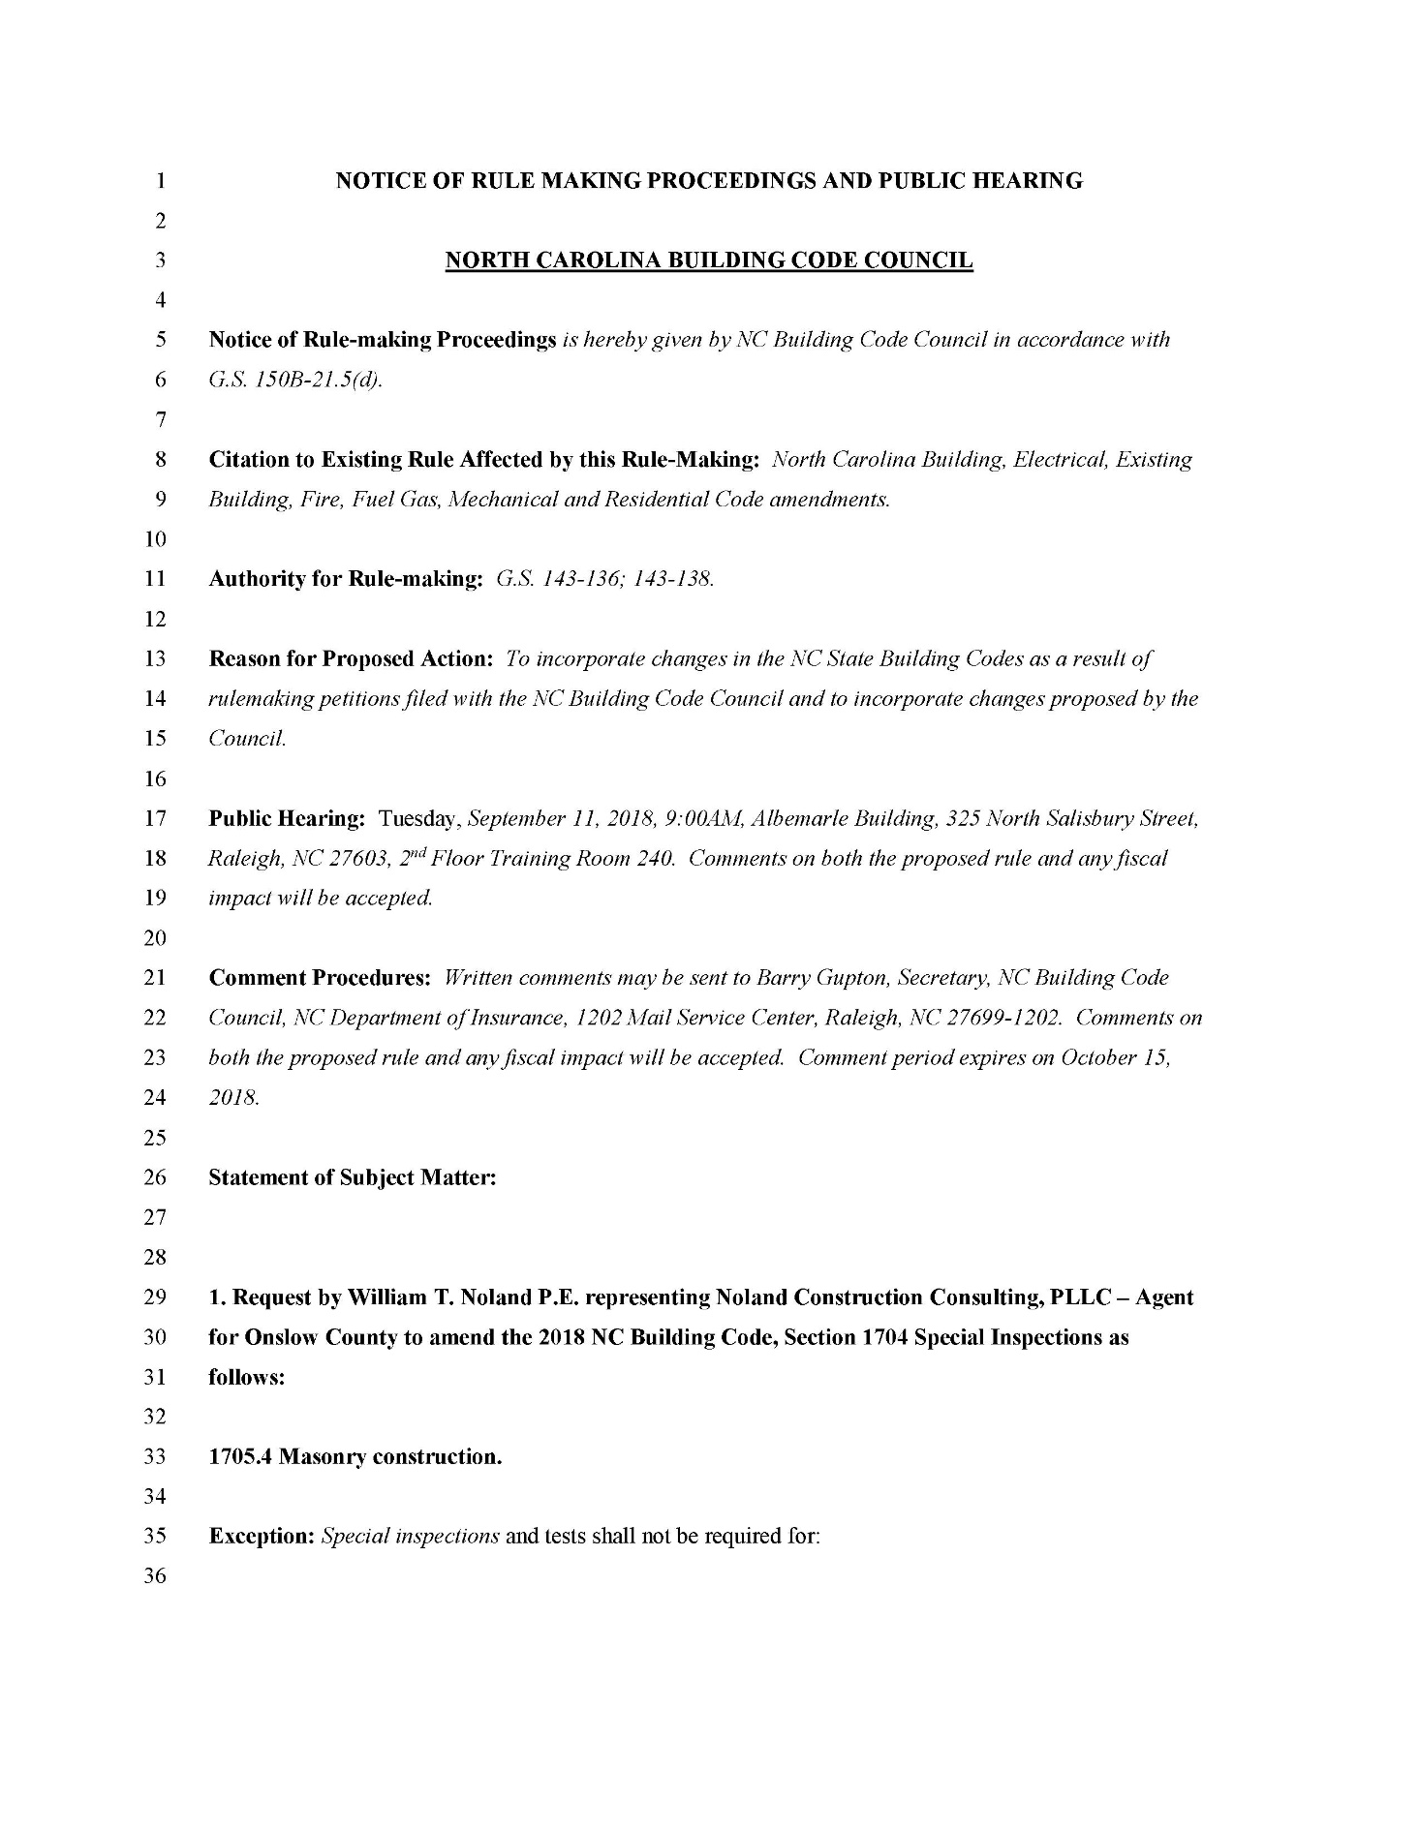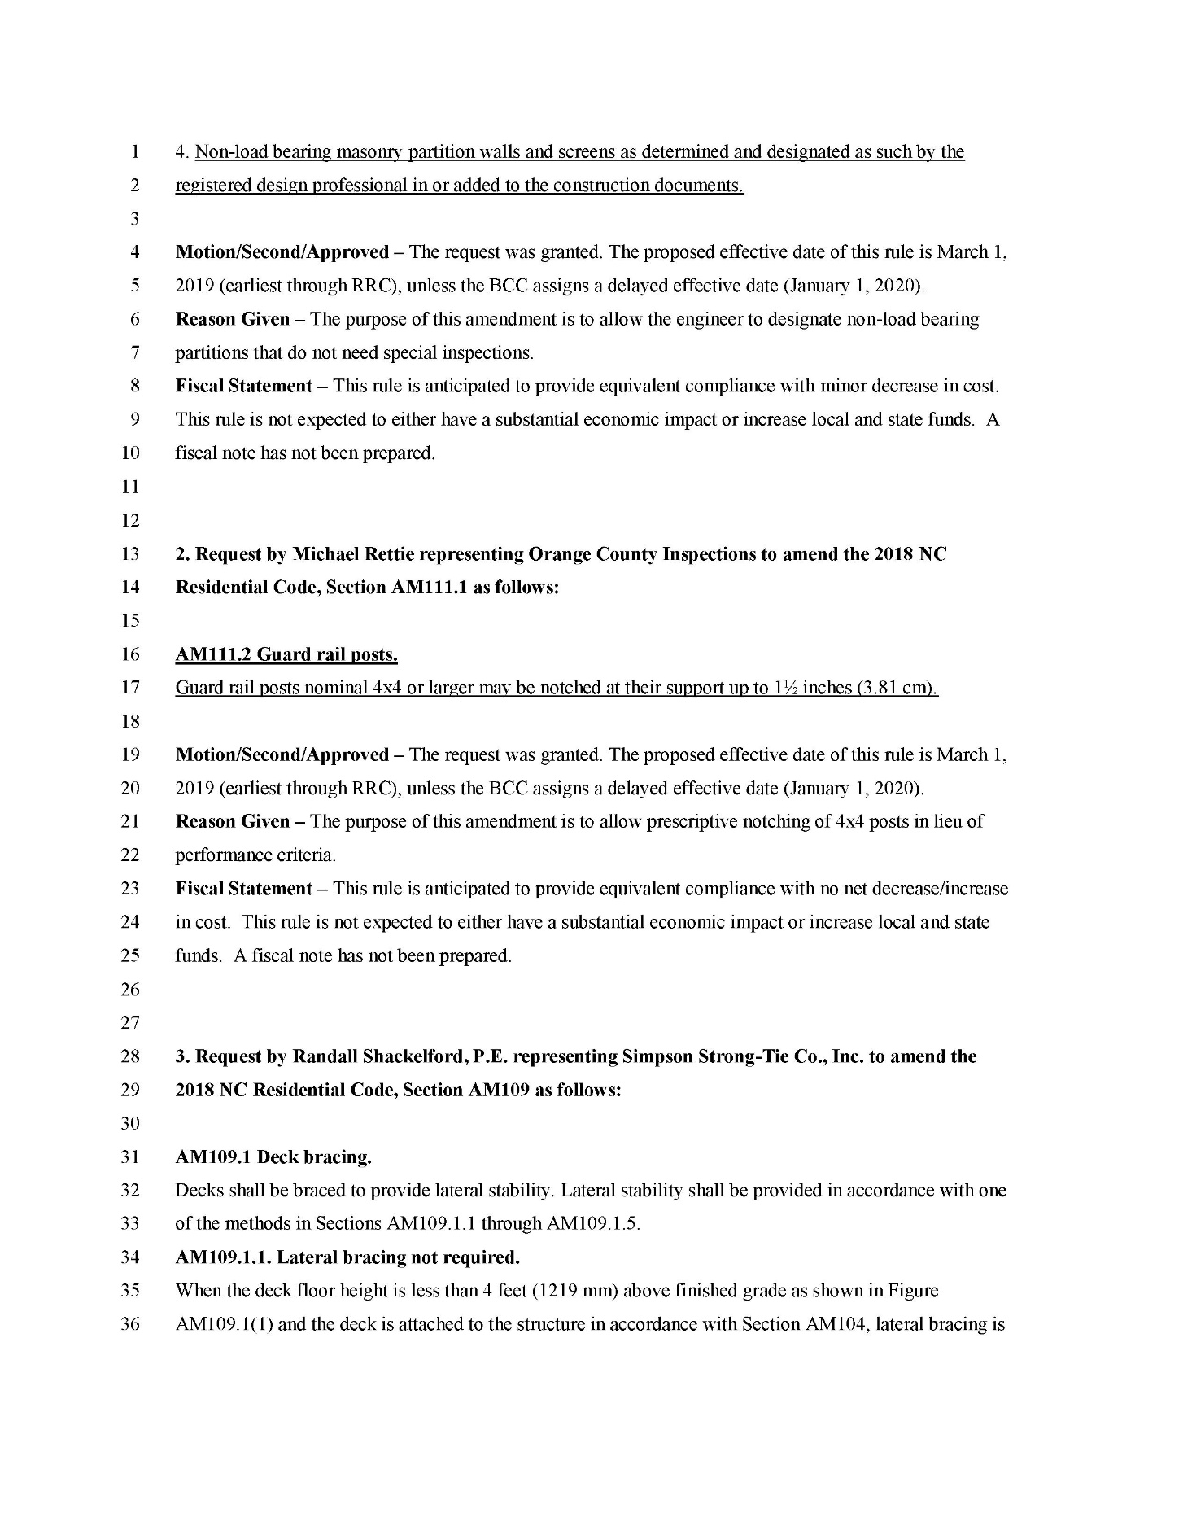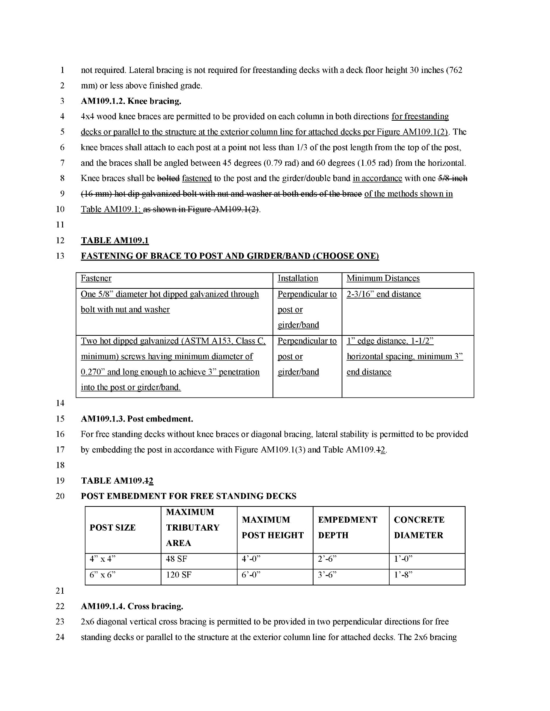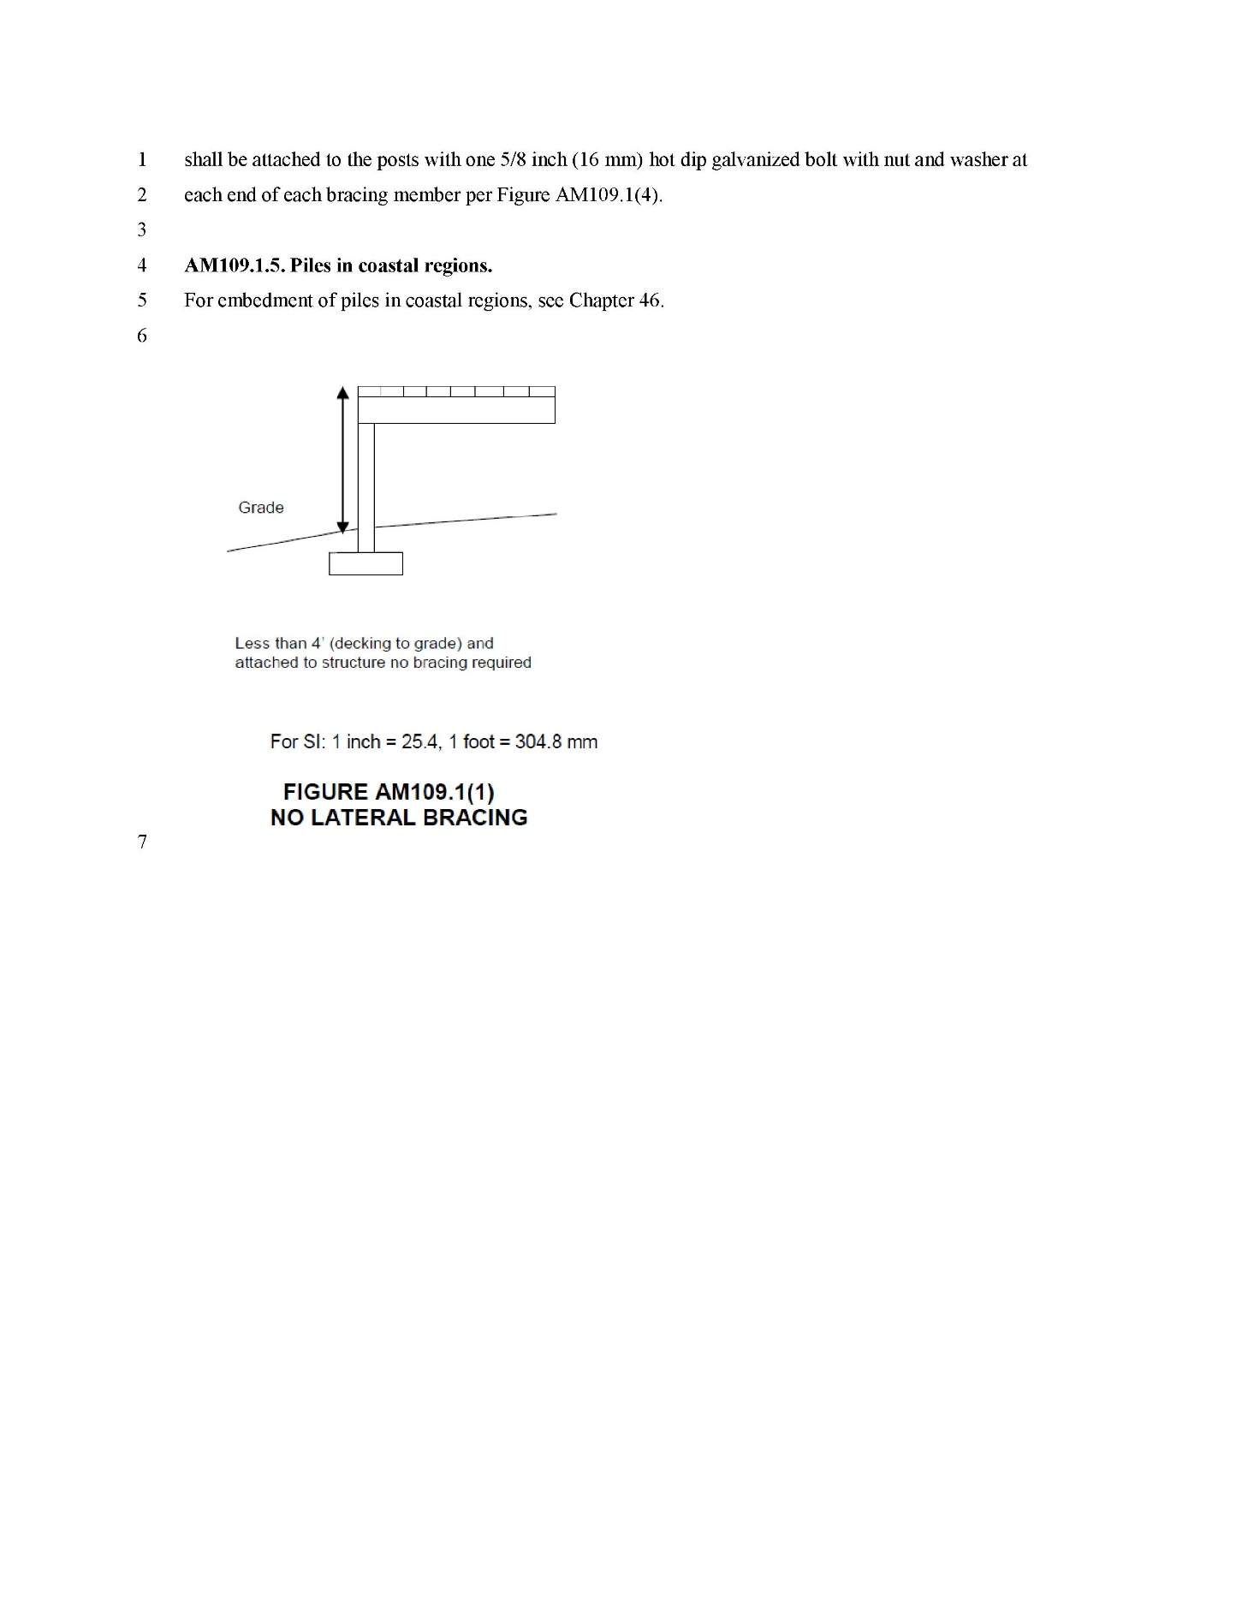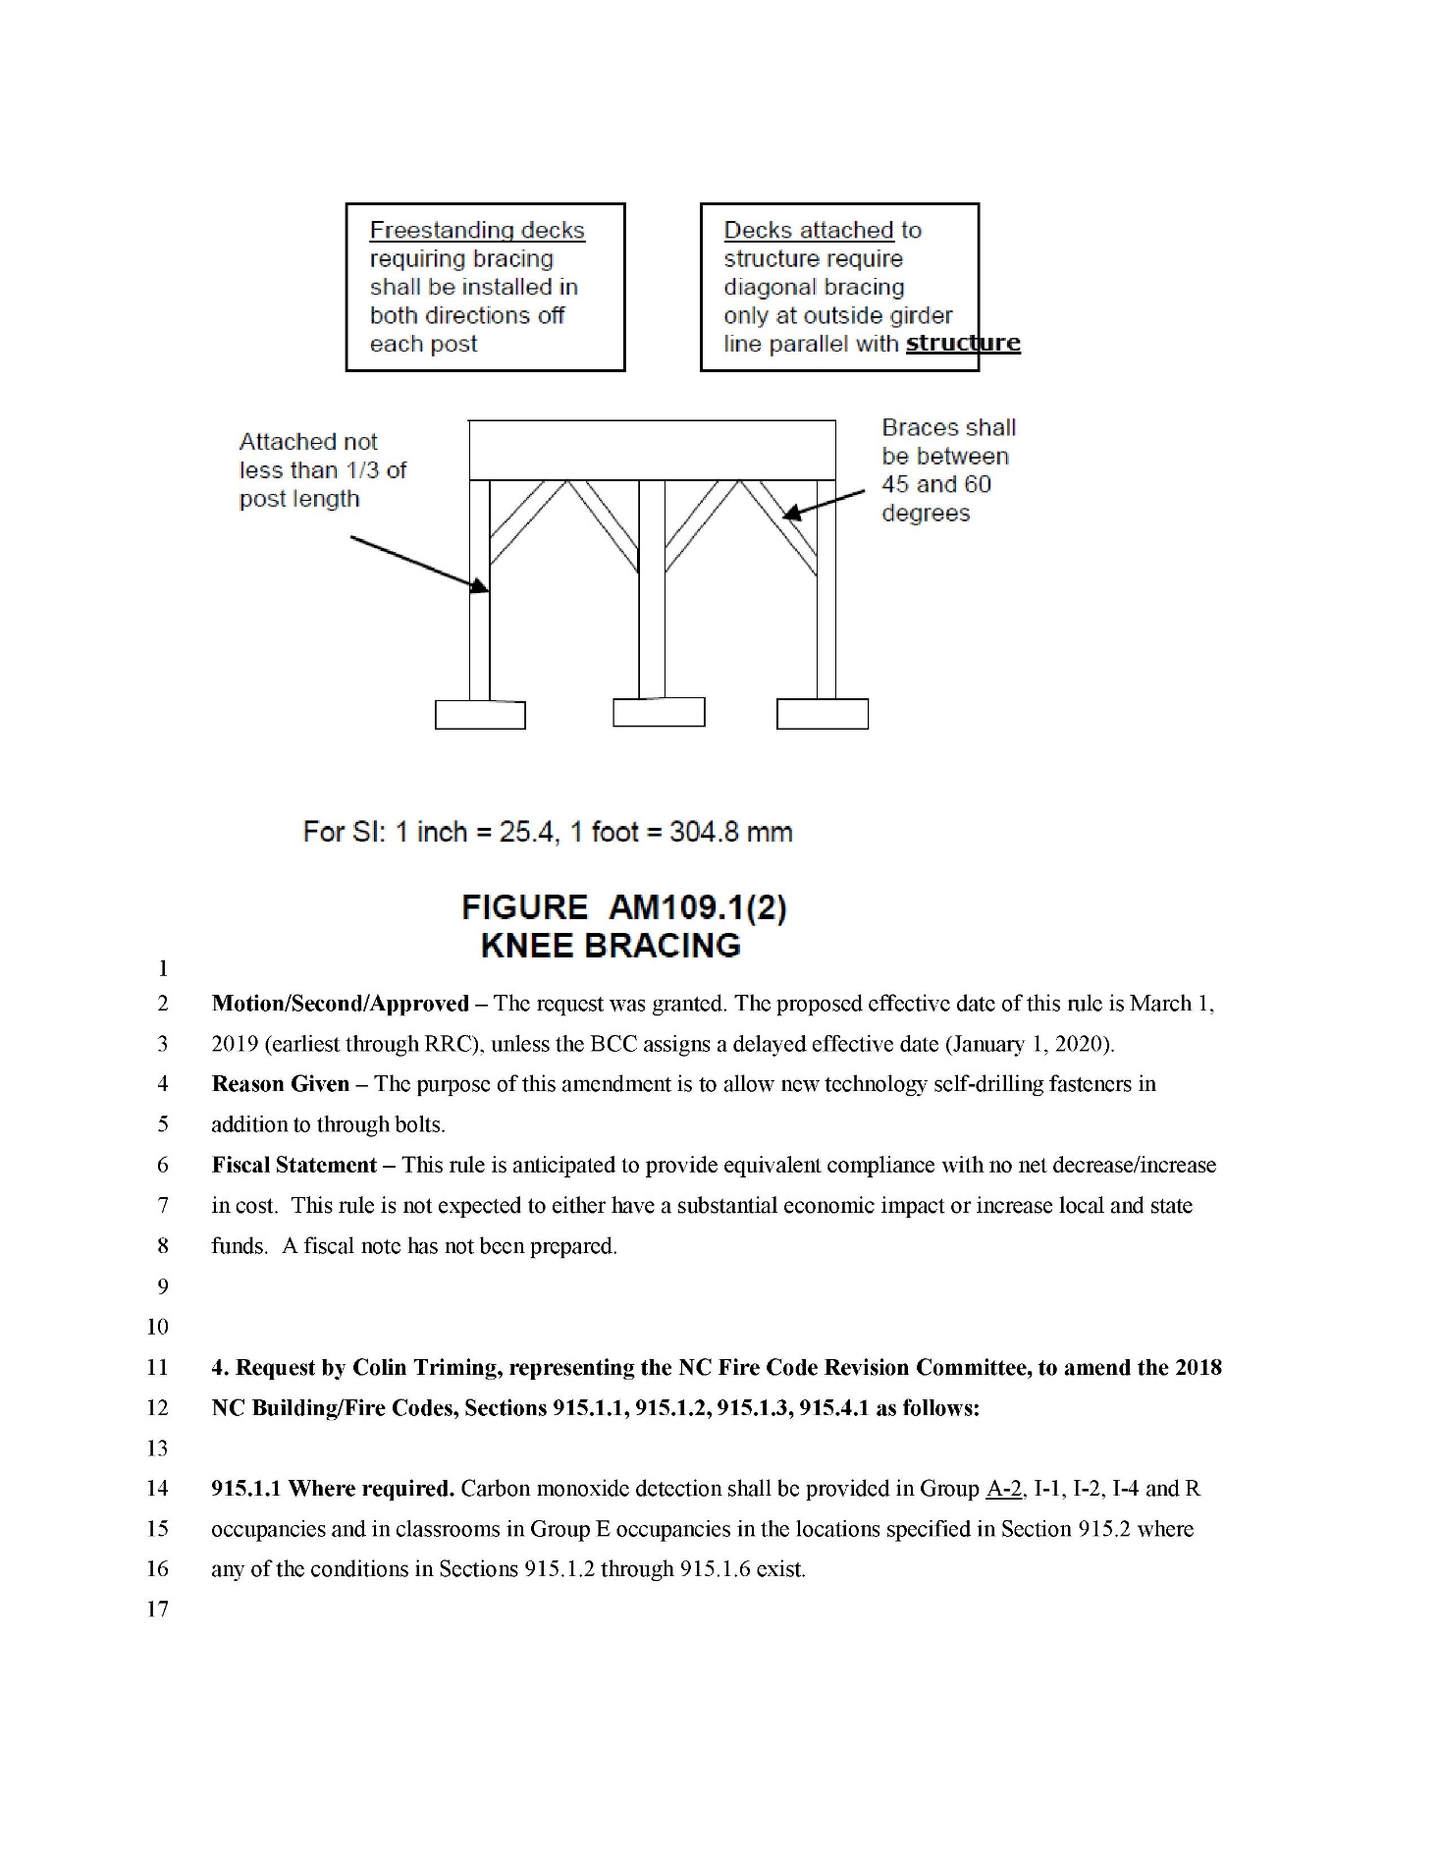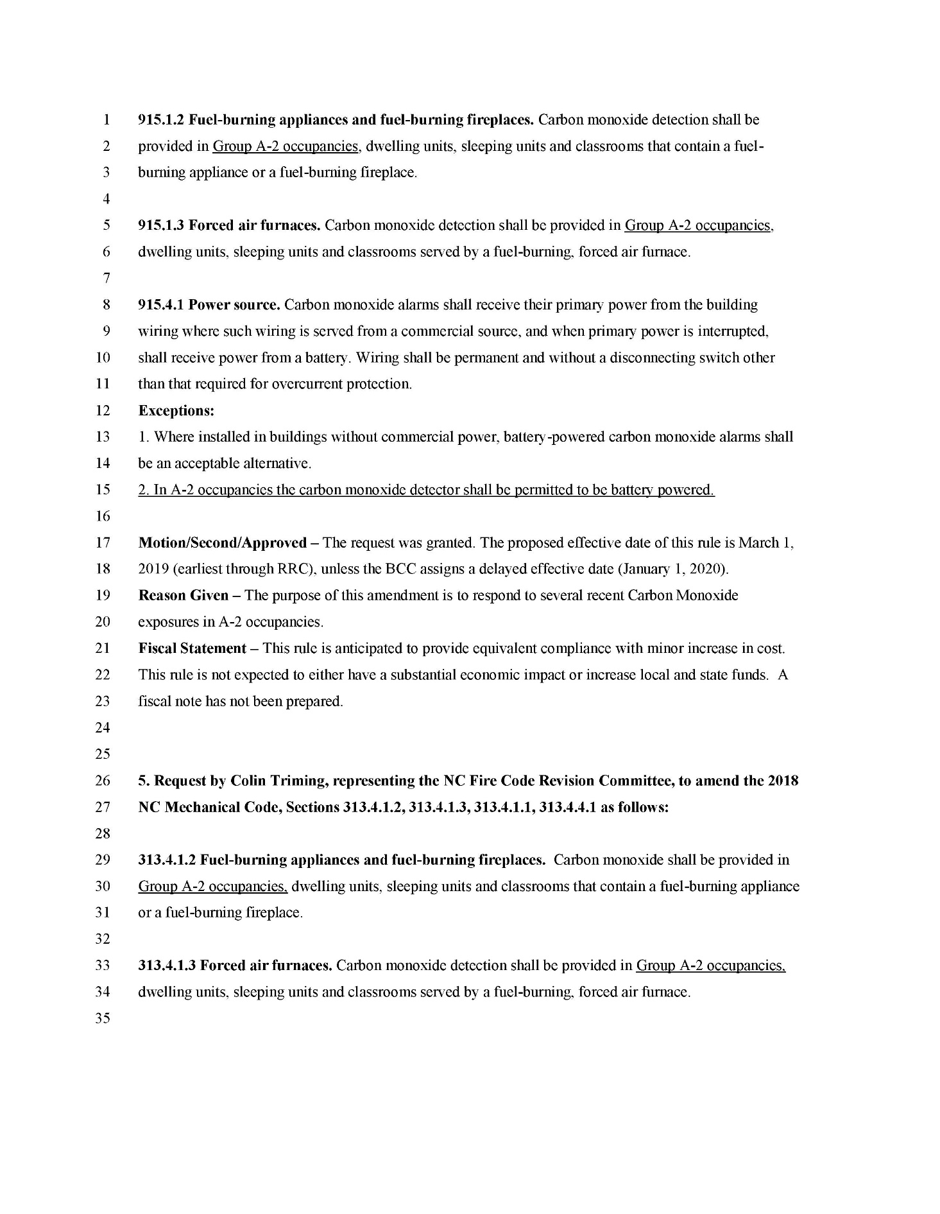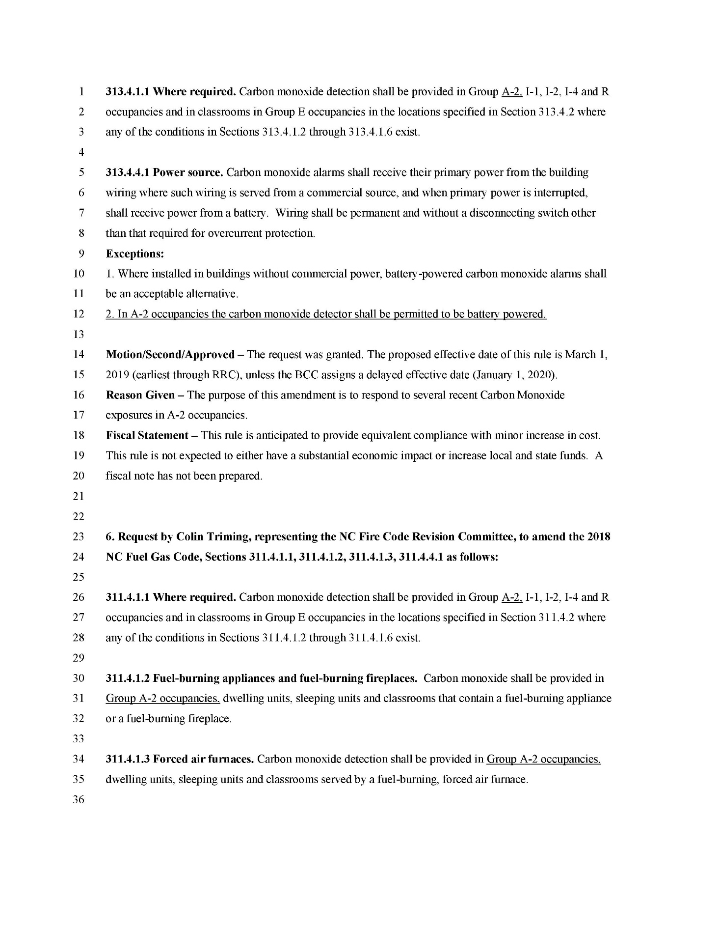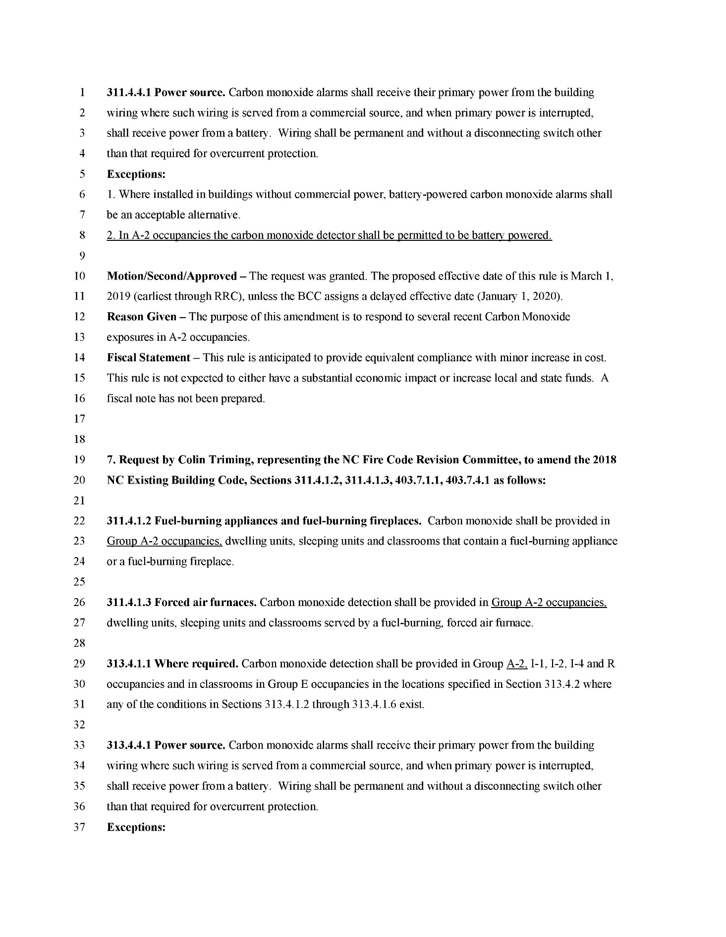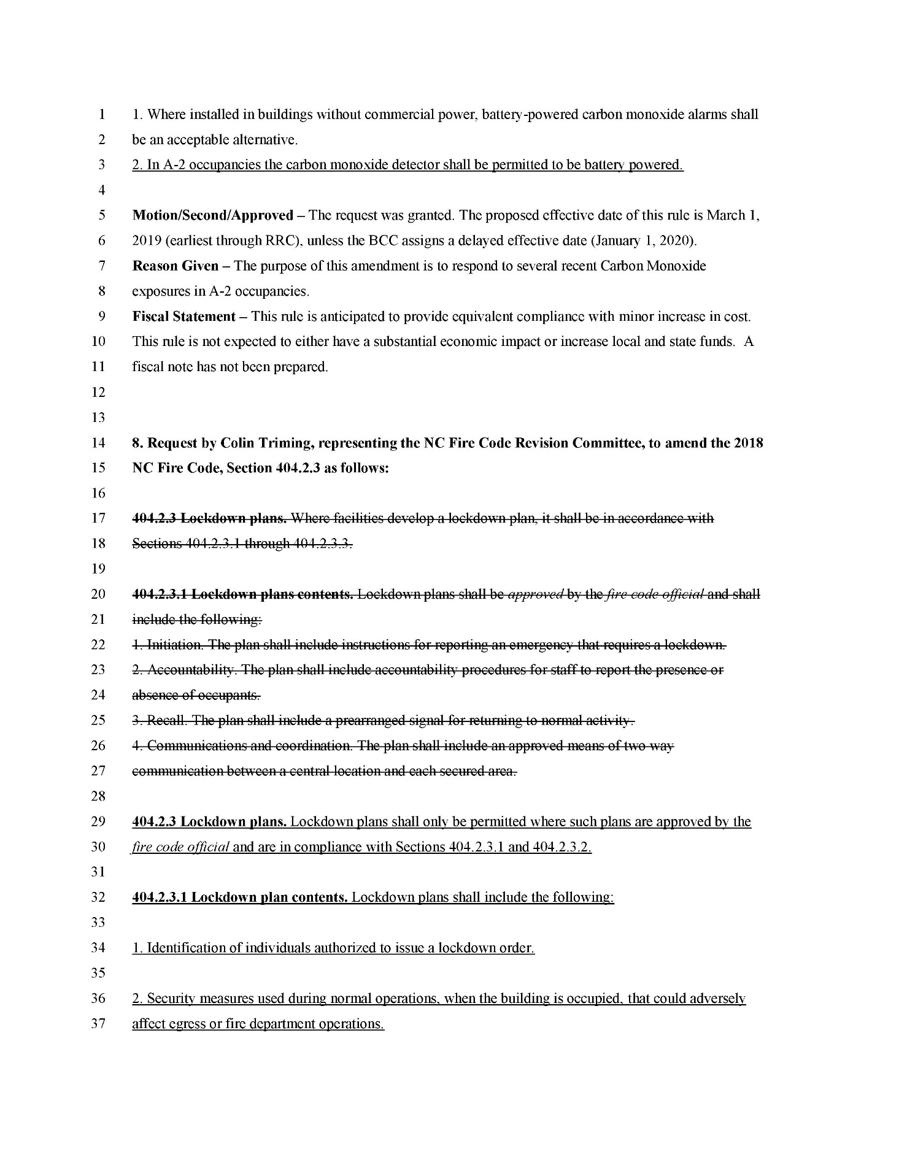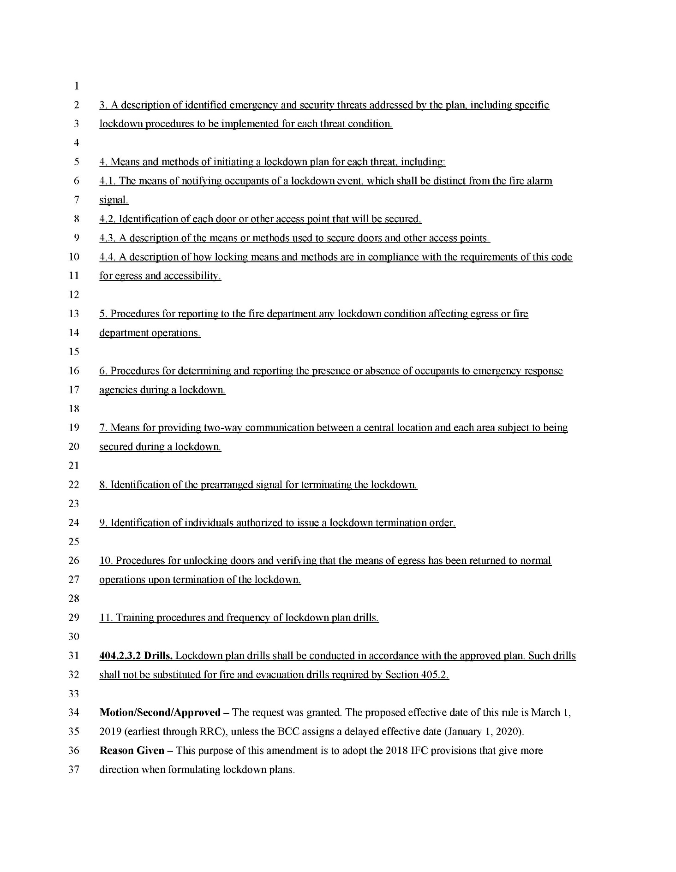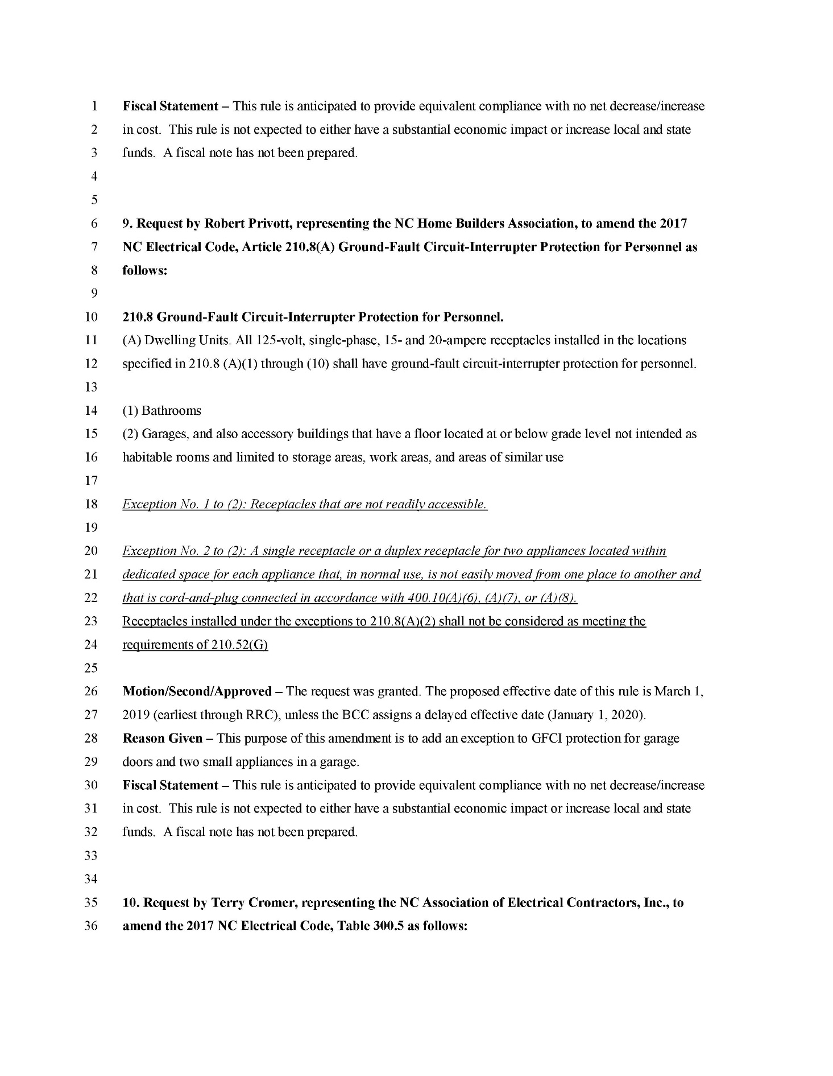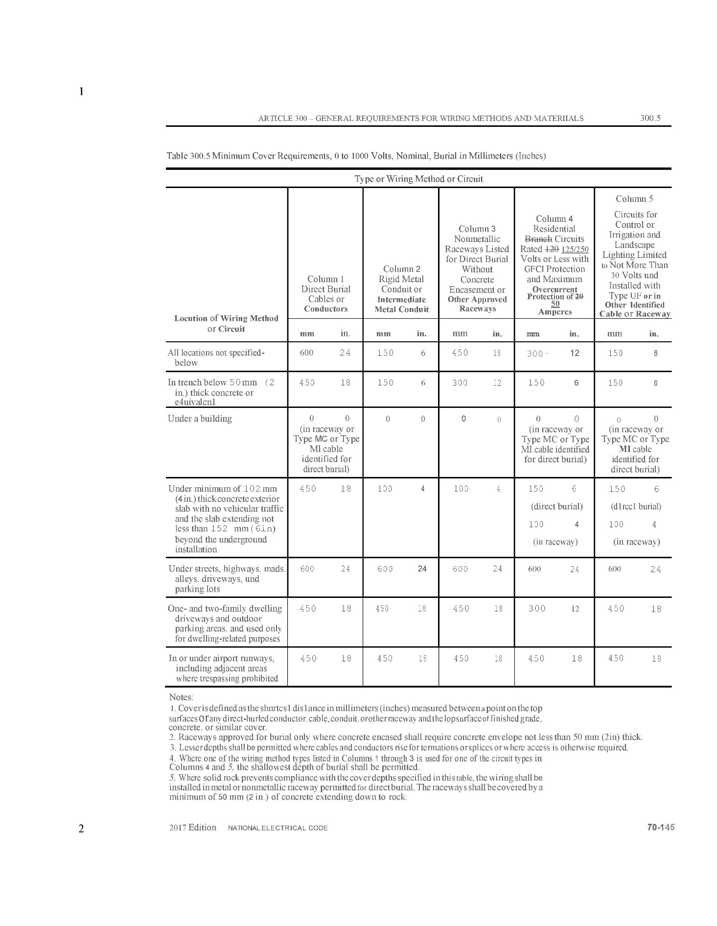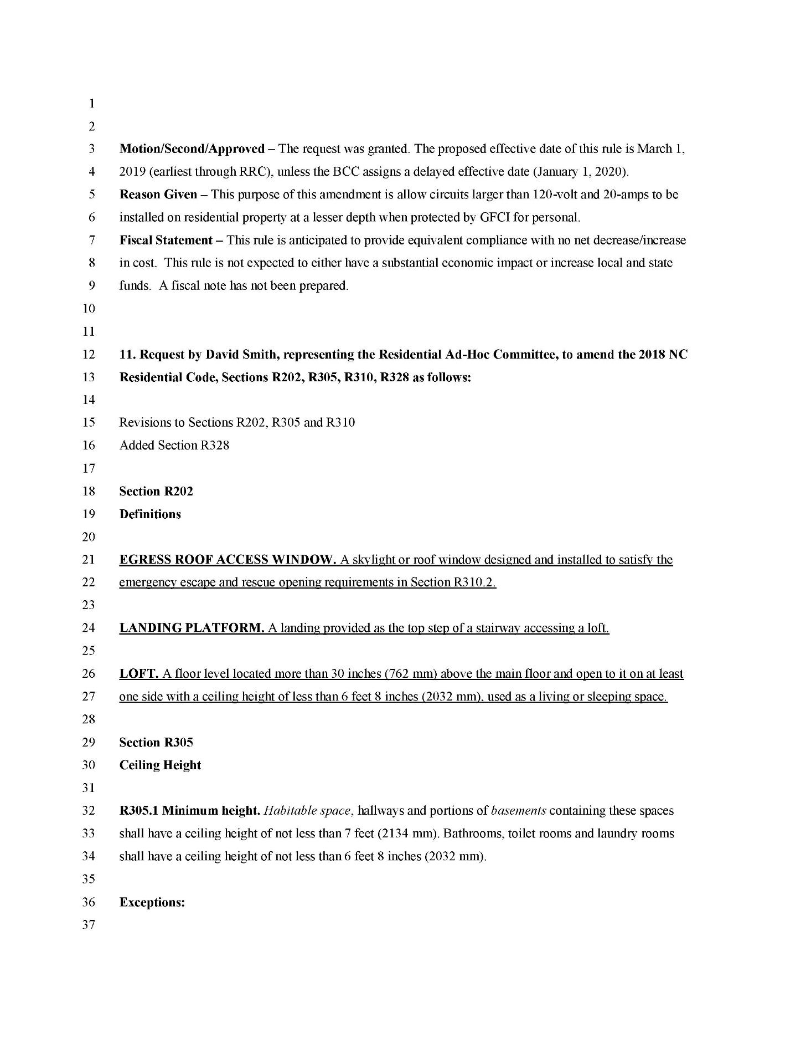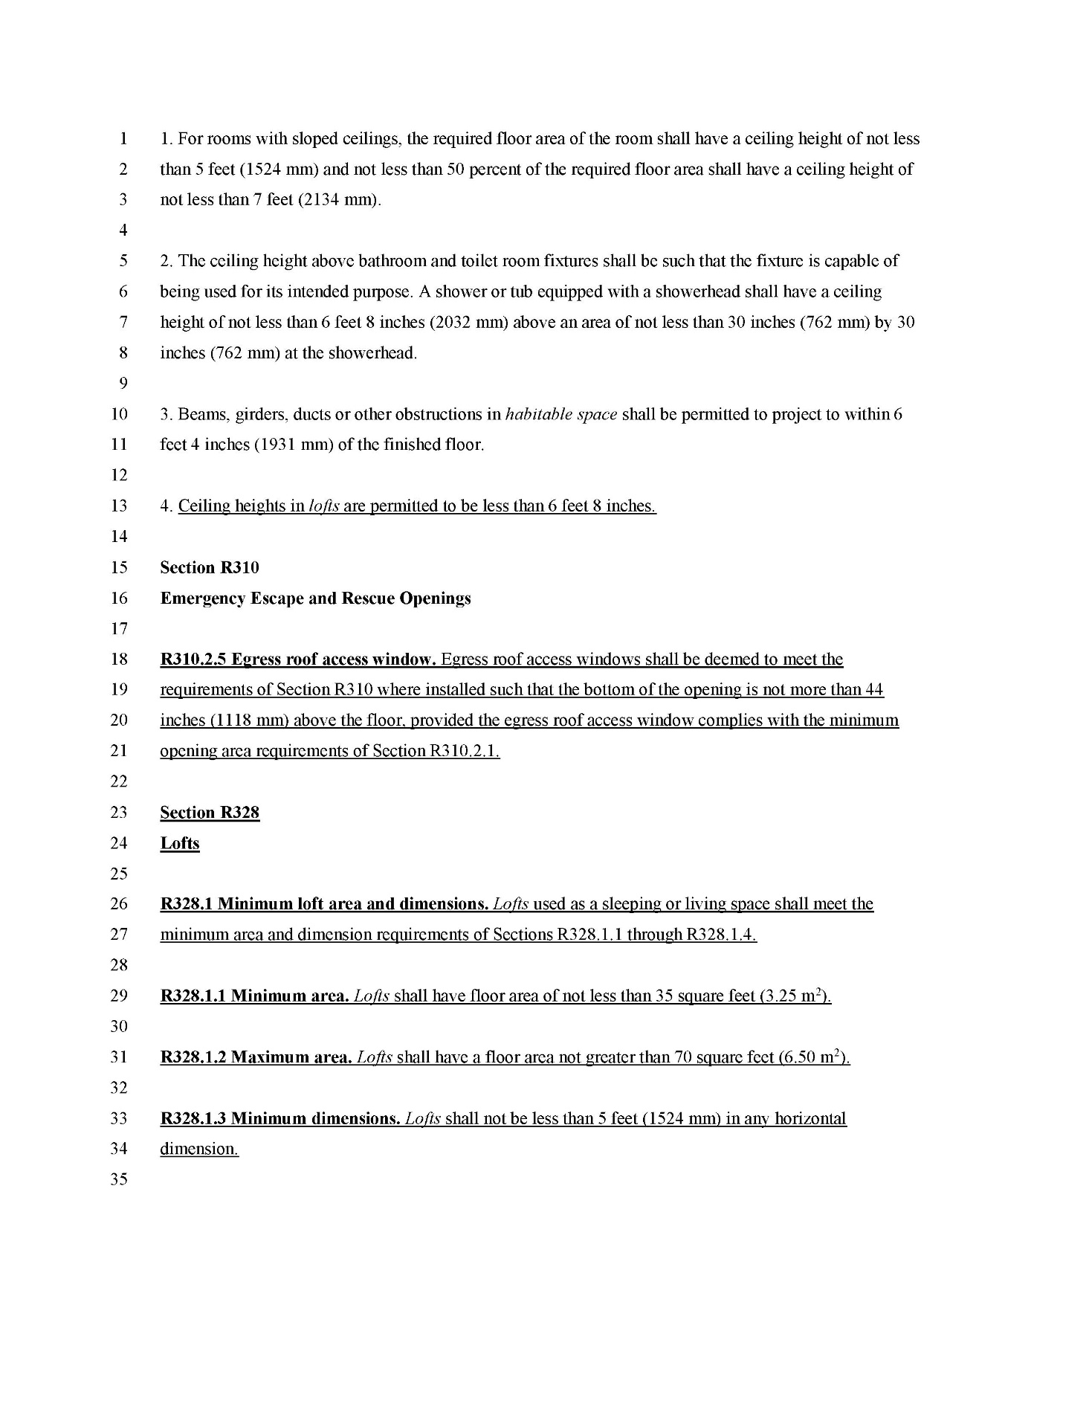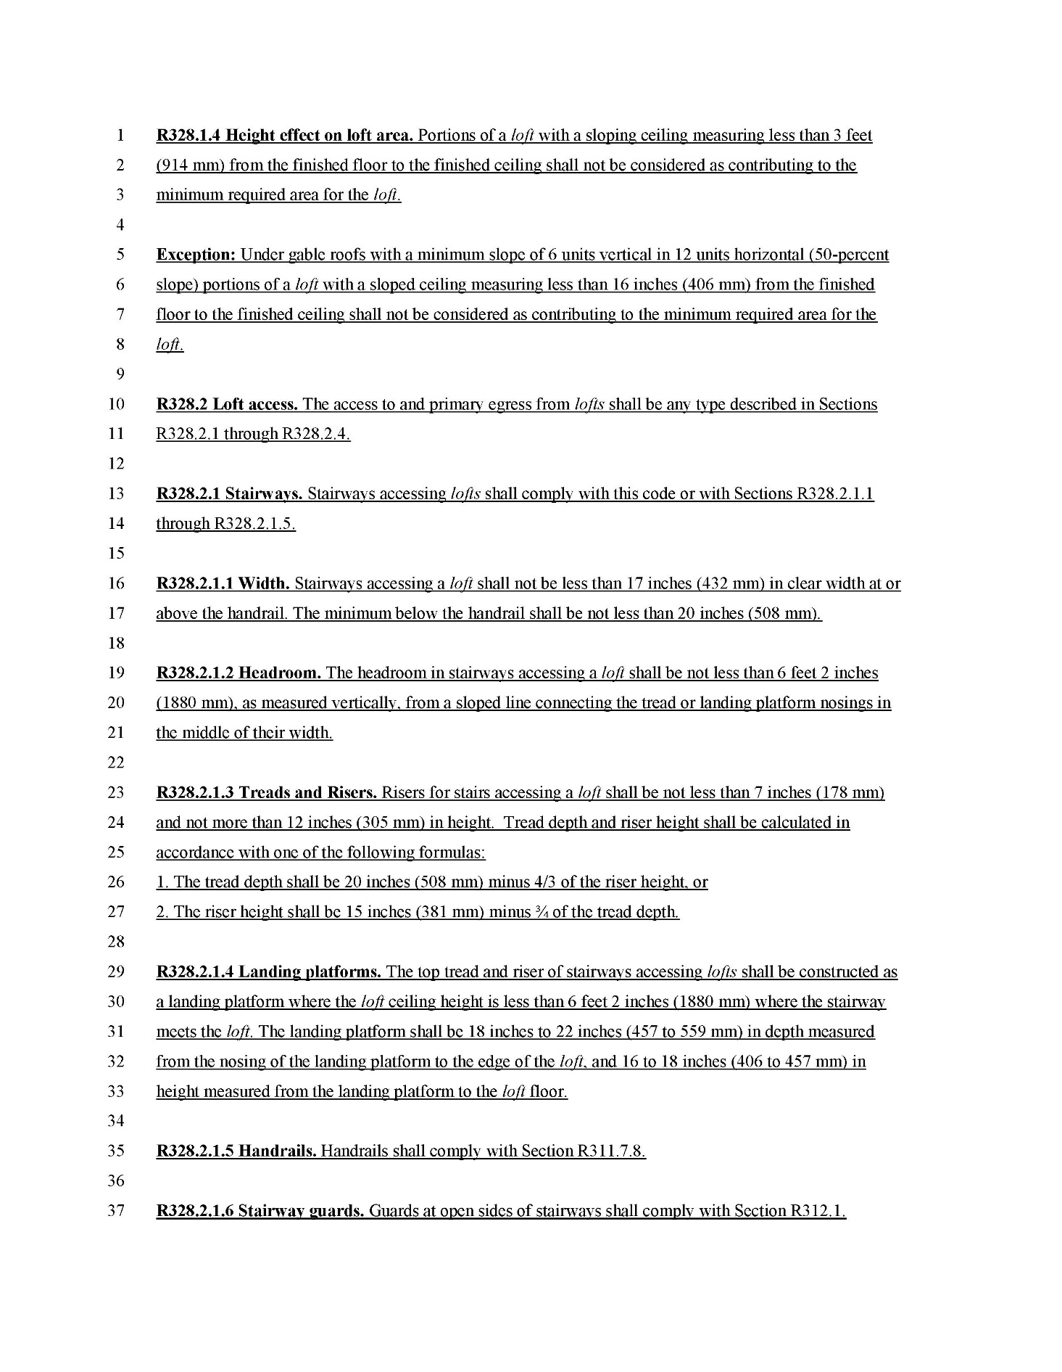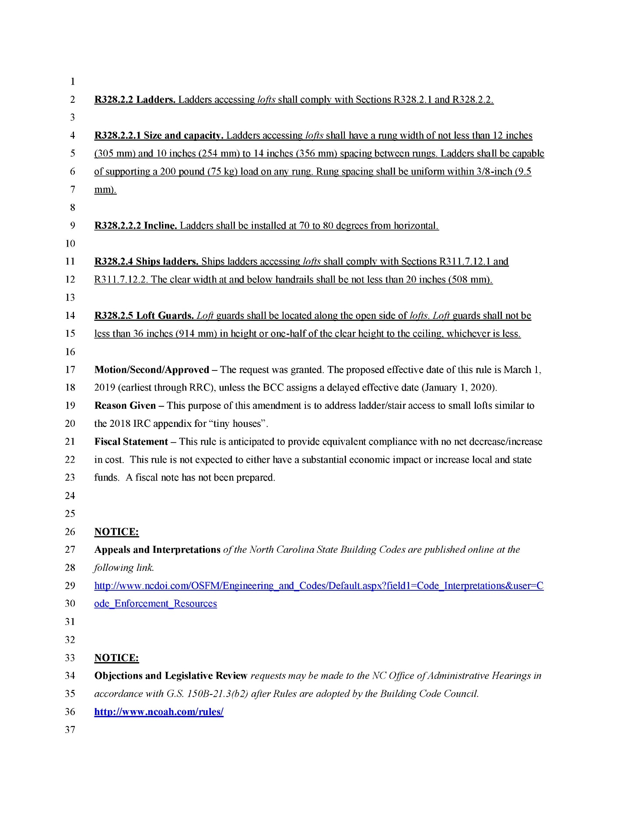
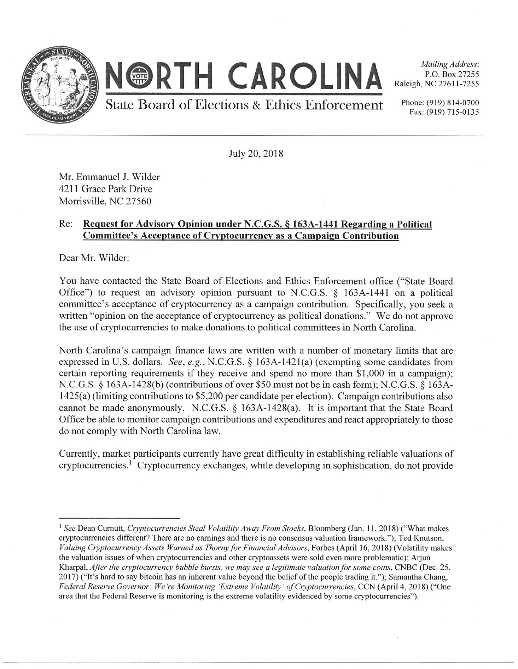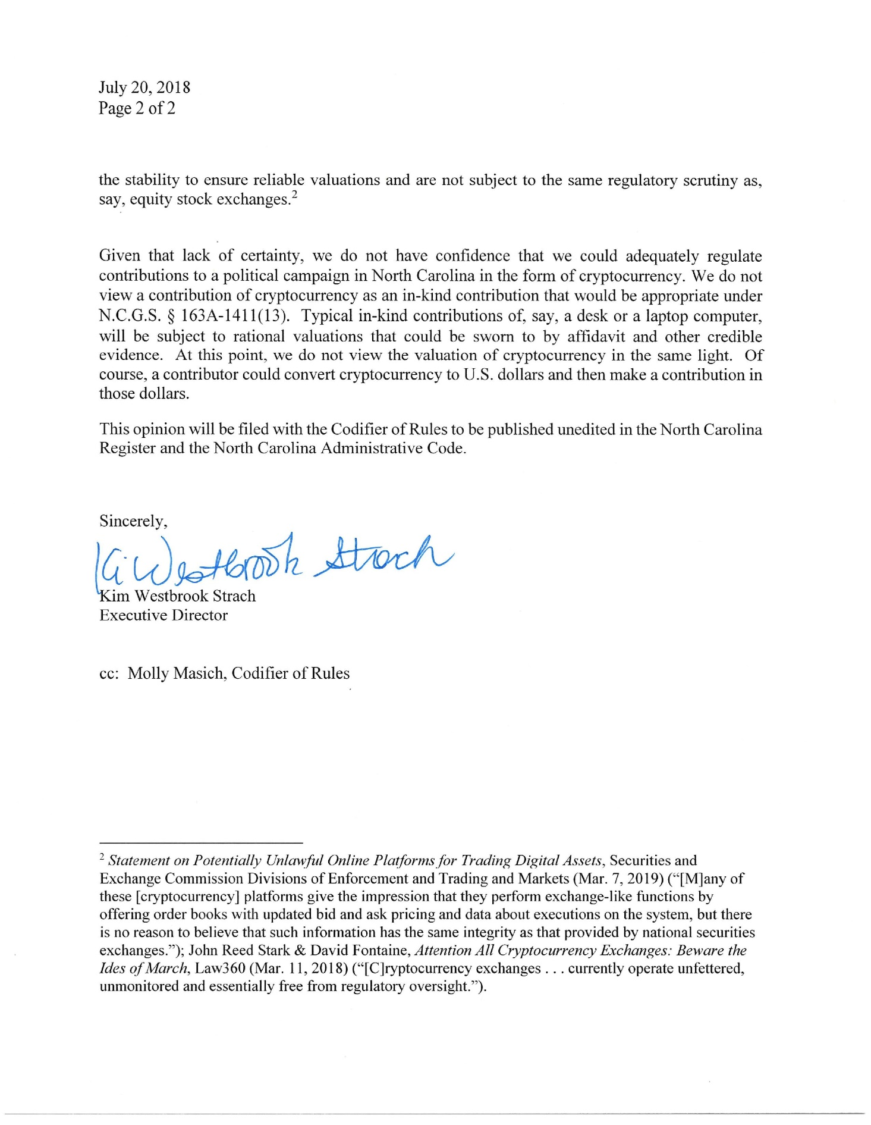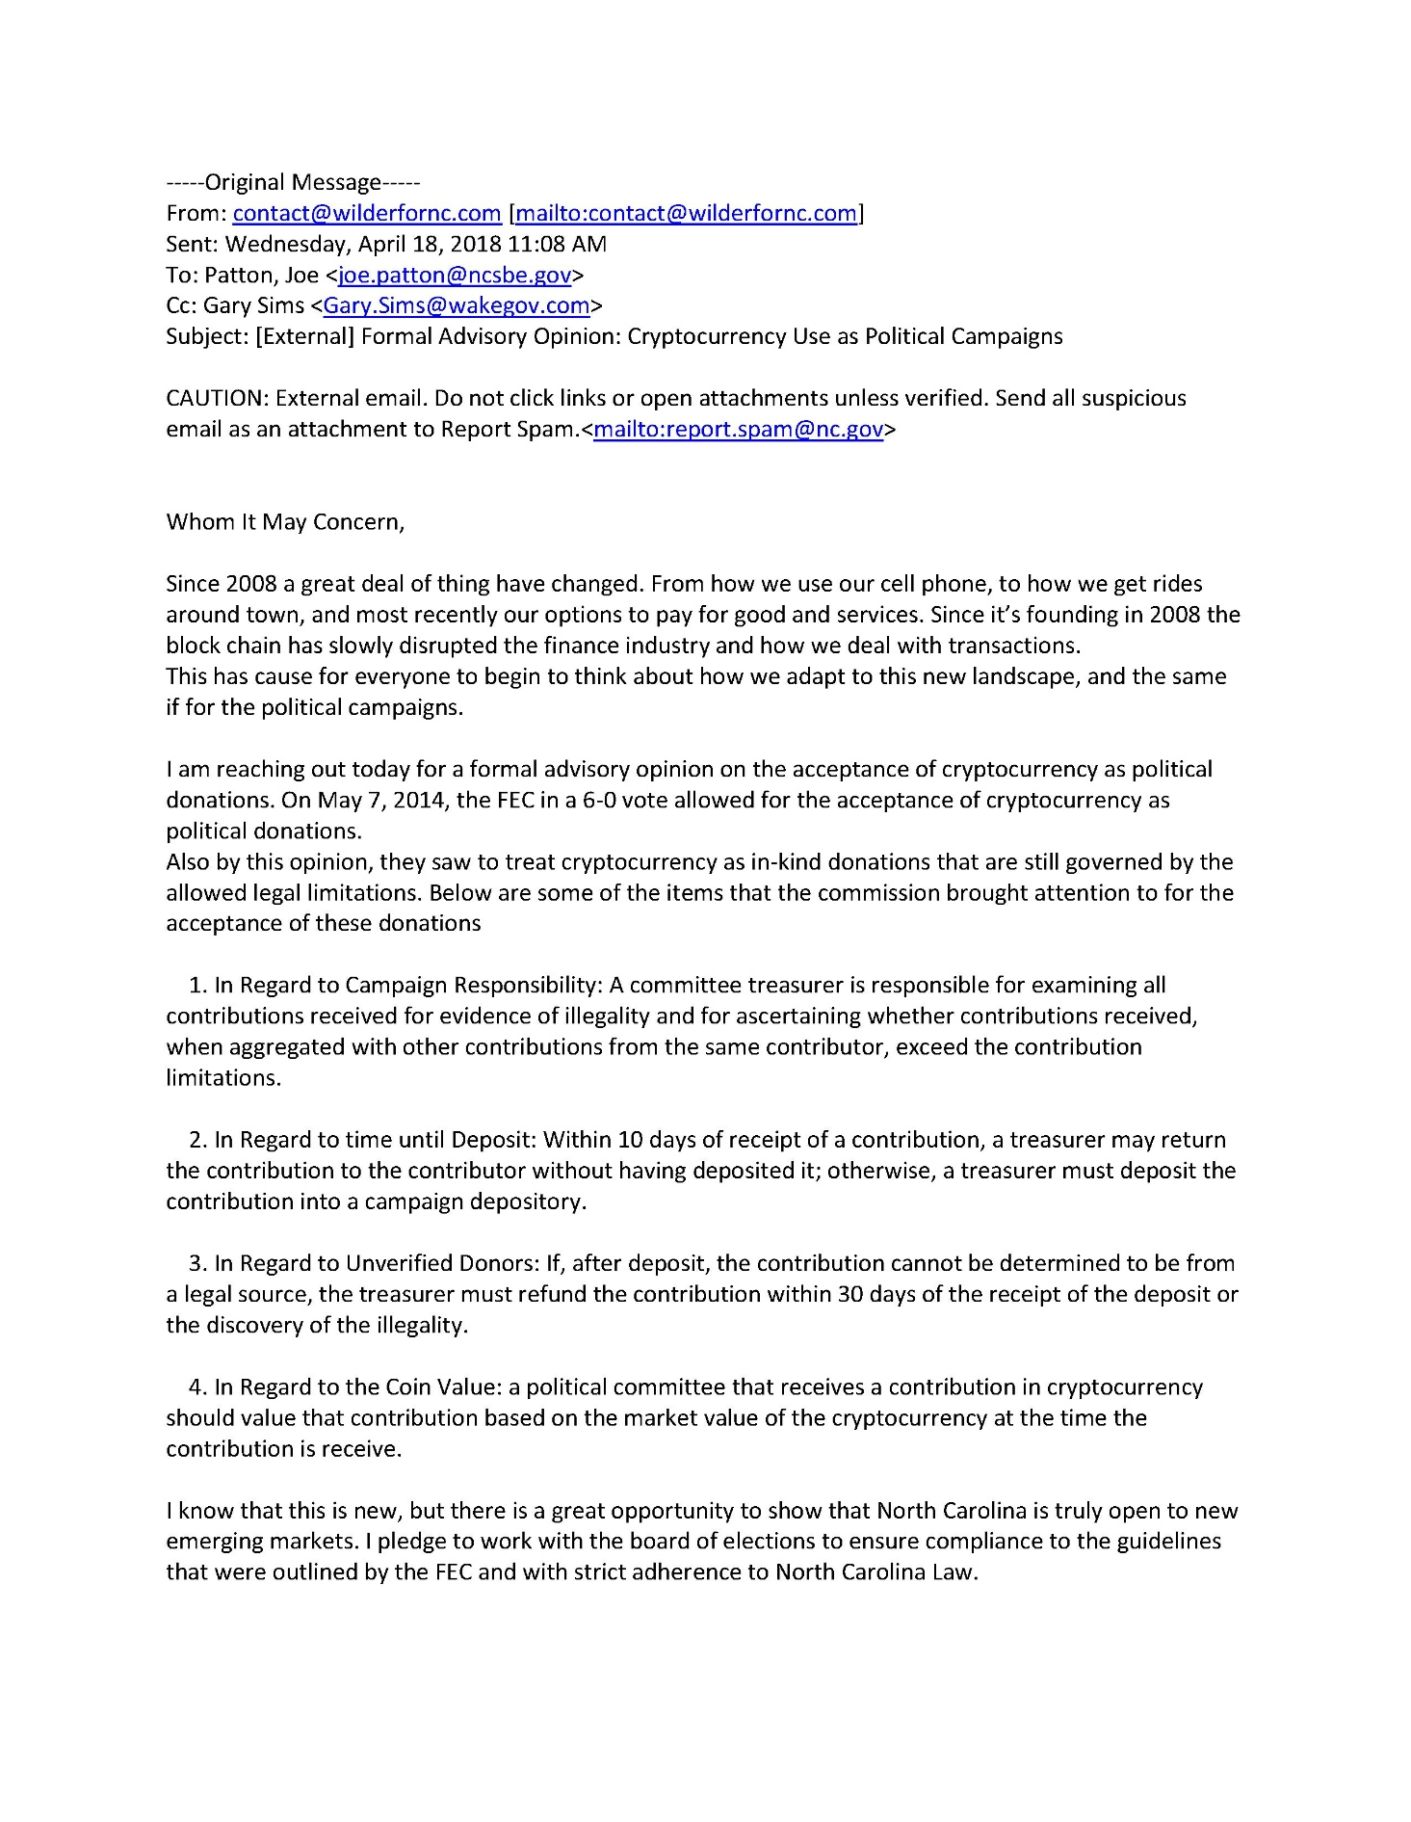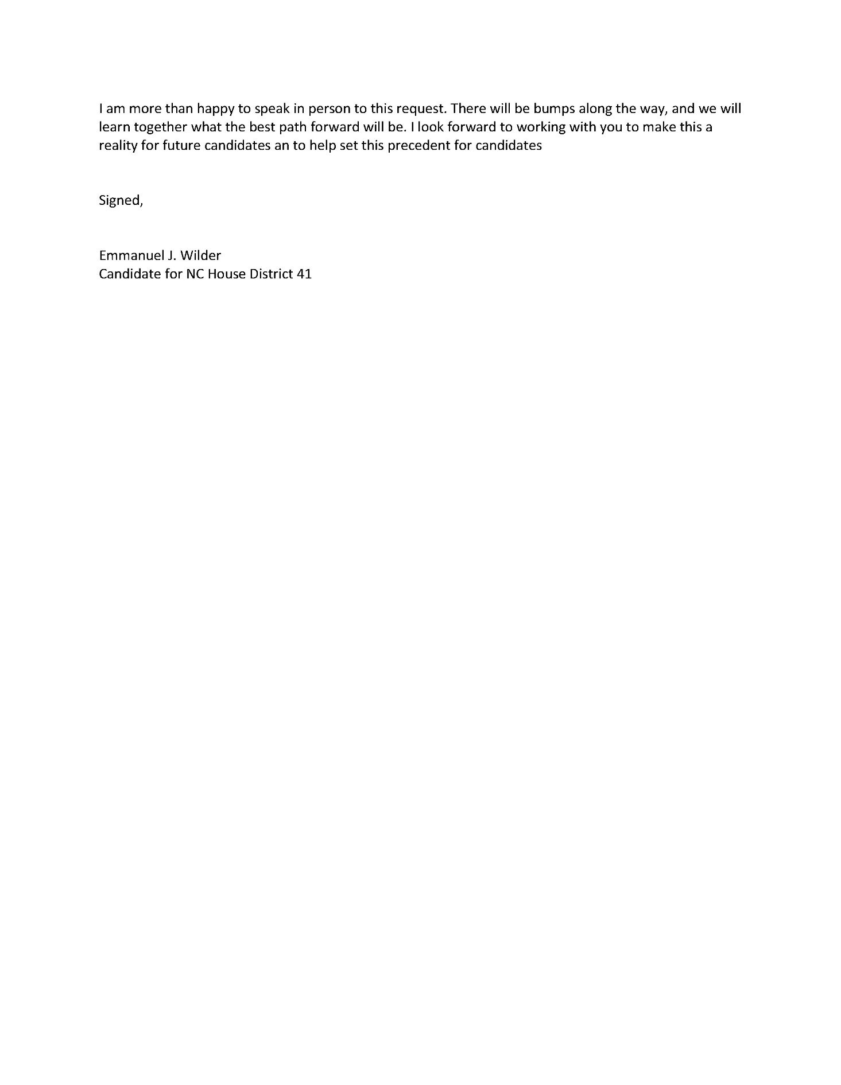

Public Notice
North Carolina Environmental Management Commission
Division of Water Resources/Water Quality Permitting Section
1617 Mail Service Center
Raleigh, NC 27699-1617
Notice of Intent to Reissue an NPDES General Wastewater Permit

The North Carolina Environmental Management Commission proposes to reissue the following NPDES wastewater general permit:

NPDES General Permit No. NCG550000 for the discharge of domestic wastewater from single family residences and other 100% domestic discharges with similar characteristics.

Written comments regarding the proposed general permit will be accepted until 30 days after the publish date of this notice. The Director of the NC Division of Water Resources (DWR) may hold a public hearing should there be a significant degree of public interest. Please mail comments and/or information requests to DWR at the above address. Interested persons may visit the DWR at 512 N. Salisbury Street, Raleigh, NC to review information on file. Additional information on this notice may be found on our website:
http://deq.nc.gov/about/divisions/water-resources/water-resources-permits/wastewater-branch/npdes-wastewater/public-notices

For questions or comments about NPDES General Permit No. NCG550000 for the discharge of domestic wastewater from single family residences and other 100% domestic discharges with similar characteristics, please contact Derek Denard at phone # (919) 807-6307 or via e-mail: derek.denard@ncdenr.gov

Note from the Codifier: The notices published in this Section of the NC Register include the text of proposed rules. The agency must accept comments on the proposed rule(s) for at least 60 days from the publication date, or until the public hearing, or a later date if specified in the notice by the agency. If the agency adopts a rule that differs substantially from a prior published notice, the agency must publish the text of the proposed different rule and accept comment on the proposed different rule for 60 days.
Statutory reference: G.S. 150B-21.2.

TITLE 11 – department of insurance

Notice is hereby given in accordance with G.S. 150B-21.2 that the Department of Insurance intends to adopt the rules cited as 11 NCAC 07 .0401 and .0402.

Link to agency website pursuant to G.S. 150B-19.1(c): http://www.ncdoi.com/LS/Rules.aspx

Proposed Effective Date: December 1, 2018

Public Hearing:

Date: September 13, 2018

Time: 10:00 a.m.

Location: 1st Floor Hearing Room, Room 131 (Albemarle Building) located a 325 N. Salisbury Street, Raleigh, NC 27603

Reason for Proposed Action: The rules are being proposed in accordance with Session Law 2017-118.

Comments may be submitted to: Loretta Peace-Bunch, NC Department of Insurance, 1201 Mail Service Center, Raleigh, NC 27699-1201; phone (919) 807-6004; email loretta.peace-bunch@ncdoi.gov

Comment period ends: October 15, 2018

Procedure for Subjecting a Proposed Rule to Legislative Review: If an objection is not resolved prior to the adoption of the rule, a person may also submit written objections to the Rules Review Commission after the adoption of the Rule. If the Rules Review Commission receives written and signed objections after the adoption of the Rule in accordance with G.S. 150B-21.3(b2) from 10 or more persons clearly requesting review by the legislature and the Rules Review Commission approves the rule, the rule will become effective as provided in G.S. 150B-21.3(b1). The Commission will receive written objections until 5:00 p.m. on the day following the day the Commission approves the rule. The Commission will receive those objections by mail, delivery service, hand delivery, or facsimile transmission. If you have any further questions concerning the submission of objections to the Commission, please call a Commission staff attorney at 919-431-3000.

Fiscal impact (check all that apply).

State funds affected

Environmental permitting of DOT affected

Analysis submitted to Board of Transportation

Local funds affected

Substantial economic impact (≥$1,000,000)

Approved by OSBM

No fiscal note required by G.S. 150B-21.4
SECTION .0400 - AERIAL ADVENTURE PARK FINANCIAL RESPONSIBILITY

11 NCAC 07 .0401 DEFINITIONS

The definitions contained in G.S. 66-455 are incorporated in this Section by reference. In addition to those definitions, the following definitions apply to this Section:
(1) "Proof of Insurance" shall mean a Certificate of Insurance (COI) from an acceptable insurer.
(2) "Acceptable Insurer" shall mean any insurance company licensed under G.S. 58-6-7.

Authority G.S. 66-458.

11 NCAC 07 .0402 PROOF OF INSURANCE COVERAGE

(a) A person operating a challenge course, zip line, or other similar device subject to the provisions of G.S. 66-455 through G.S. 66-458 shall file with the Commissioner, on an annual basis, proof that it has obtained liability insurance satisfying the requirements of G.S. 66-456 from an acceptable insurer.

(b) Proof of Insurance shall be filed with the Director of Risk Management, North Carolina Department of Insurance, 1201 Mail Service Center, Raleigh, NC 27699 or may be filed electronically by e-mailing challengcoursecoi@ncdoi.gov.

Authority G.S. 66-458.

* * * * * * * * * * * * * * * * * * * *

Notice is hereby given in accordance with G.S. 150B-21.2 that the Department of Insurance intends to amend the rules cited as 11 NCAC 10 .0602, .0603, .0605, and repeal the rule cited as 11 NCAC 10 .0606.

Link to agency website pursuant to G.S. 150B-19.1(c): http://www.ncdoi.com/LS/Rules.aspx

Proposed Effective Date: December 1, 2018

Public Hearing:

Date: September 14, 2018

Time: 10:00 a.m.

Location: 1st Floor Hearing Room, Room 131 (Albemarle Building) located as 325 N. Salisbury Street, Raleigh, NC 27603

Reason for Proposed Action: In accordance with Session Law 2018-120, the Department of Insurance is proposing the amendments of 11 NCAC 10 .0602, 11 NCAC 10 .0603, 11 NCAC 10 .0605 and the repeal of 11 NCAC 10 .0606.

Comments may be submitted to: Loretta Peace-Bunch, NC Department of Insurance, 1201 Mail Service Center, Raleigh, NC 27699-1201; phone (919) 807-6004; email loretta.peace-bunch@ncdoi.gov

Comment period ends: October 15, 2018

Procedure for Subjecting a Proposed Rule to Legislative Review: If an objection is not resolved prior to the adoption of the rule, a person may also submit written objections to the Rules Review Commission after the adoption of the Rule. If the Rules Review Commission receives written and signed objections after the adoption of the Rule in accordance with G.S. 150B-21.3(b2) from 10 or more persons clearly requesting review by the legislature and the Rules Review Commission approves the rule, the rule will become effective as provided in G.S. 150B-21.3(b1). The Commission will receive written objections until 5:00 p.m. on the day following the day the Commission approves the rule. The Commission will receive those objections by mail, delivery service, hand delivery, or facsimile transmission. If you have any further questions concerning the submission of objections to the Commission, please call a Commission staff attorney at 919-431-3000.

Fiscal impact (check all that apply).

State funds affected

Environmental permitting of DOT affected

Analysis submitted to Board of Transportation

Local funds affected

Substantial economic impact (≥$1,000,000)

Approved by OSBM

No fiscal note required by G.S. 150B-21.4

Chapter 10 - Property and Casualty Division

SECTION .0600 - CONSENT TO RATE

11 NCAC 10 .0602 CONSENT TO RATE PROCEDURES: RATE BUREAU COVERAGES

(a) An initial (first time) application to effect consent to rate on a specific risk of coverage subject to Article 36 of G.S. 58, in excess of the rate promulgated by the North Carolina Rate Bureau, shall contain the following: Insurers may charge a premium in excess of that promulgated by the North Carolina Rate Bureau by instituting a consent to rate procedure that meets the requirements of G.S. 58-36-30(b), (b1) and this Rule.

(1) a description of the insurance proposed, including primary and excess limits, the amount of coverage, the property insured, the deductible, and any other factor used for rating, where applicable;

(2) the rate and premium that would be charged without application of consent to rate;

(3) the proposed rate and premium;

(4) the percent increase. The rate to be charged shall be presumed reasonable if it does not exceed 250 percent of the rate that would be charged without application of consent to rate. Any proposed rate in excess of 250 percent must be explained fully and shall be subject to review and approval of the Commissioner pursuant to G.S. 58-36-30(b). (This is not required for and does not apply to nonfleet private passenger motor vehicle physical damage insurance);

(5) a statement that the rate charged does not exceed the rate that would be applicable if the applicant had been charged 550 percent of the rate with no Safe Driver Incentive Plan points. Any proposed rate in excess of 550 percent must be explained fully, submitted individually, and shall be subject to review and approval of the Commissioner pursuant to G.S. 58-36-30(b). (This is required for nonfleet private passenger motor vehicle physical damage insurance only);

(6) the names and addresses of the insurer, the writing agent, and the insured;

(7) the effective date of the proposed rate;

(8) the policy period;

(9) the policy number; and

(10) a letter signed by the insured acknowledging and consenting to the proposed rate. If coverage for the specific risk written on consent to rate is available through a residual market (FAIR Plan, Beach Plan, North Carolina Reinsurance Facility, North Carolina Workers Compensation Insurance Plan), a statement signed by the insured acknowledging that fact must also be executed.

(b) A letter signed by each insured acknowledging and consenting to the proposed rate shall be retained in the insurer's office and be made available to the Commissioner upon request. Residential Property With Not More than Four Housing Units:

(1) The premium to be charged against loss to residential property with not more than four housing units shall be presumed reasonable if it does not exceed 250 percent of the premium based upon the approved rates in North Carolina.

(2) Any proposed premium in excess of 250 percent of the premium based upon the approved rates in North Carolina shall be filed with the Commissioner for his review and approval in accordance with the procedures set forth in G.S. 58-36-30(a).

(c) All records generated under G.S. 58-36-30(b), (b1) and this Rule shall be maintained in accordance with the requirements of 11 NCAC 19 .0100.

Authority G.S. 58-2-40(1); 58-36-30(b).

11 NCAC 10 .0603 CONSENT TO RATE PROCEDURES: COMMERCIAL COVERAGES

(a) An initial (first time) application to effect consent to rate on a specific risk of coverage subject to Article 40 of G.S. 58, in excess of the rate promulgated by a licensed rating organization or filed by a company on its own behalf shall contain the following:

(1) a description of the insurance proposed, including primary and excess limits, the amount of coverage, the property insured, the deductible, and any other factor used for rating, where applicable;

(2) the rate and premium that would be charged without application of consent to rate;

(3) the proposed rate and premium;

(4) the percent increase. The rate to be charged shall be presumed reasonable if it does not exceed 250 percent of the rate that would be charged without application of consent to rate. Any proposed rate in excess of 250 percent must be explained fully and is subject to review and approval by the Commissioner pursuant to G.S. 58-40-30(c);

(5) the names and addresses of the insurer, the writing agent, and the insured;

(6) the effective date of the proposed rate;

(7) the policy period;

(8) the policy number; and

(9) a letter signed by the insured acknowledging and consenting to the proposed rate. If coverage for the specific risk written on consent to rate is available through a residual market (FAIR Plan, Beach Plan, North Carolina Reinsurance Facility, North Carolina Workers Compensation Insurance Plan), a statement signed by the insured acknowledging that fact must also be executed.

(b) If a policy for which the insured had consented to pay a higher premium rate is reinstated after a lapse, the insurer shall not have to obtain a signed statement from the insured under this Rule for the reinstatement.

(c) After a signed application is obtained by an insurer under this Rule for a policy, all subsequent changes in the policy shall be endorsements for the purposes of G.S. 58-40-30(c).

(d) If a particular kind of coverage is added to a policy by endorsement during the term of the policy and the added coverage is written at a higher rate under G.S. 58-40-30(c) and under this Rule, the insurer shall obtain the signature of the insured under this Rule no later than the next renewal of the policy.

(e) If an insured consents to pay a higher premium rate under G.S. 58-40-30(c) and this Rule and consent to rate coverage is subsequently terminated, if the insured and insurer enter into another agreement under G.S. 58-40-30(c) and this Rule, the insurer does not have to obtain the signature of the insured under this Rule unless three years have elapsed since the termination of the coverage.

(b)(f) A letter signed by each insured acknowledging and consenting to the proposed rate shall be retained in the insurer's office and be made available to the Commissioner upon request. All records generated under G.S. 58-40-30(c) and this Rule shall be maintained in accordance with the requirements of 11 NCAC 19 .0100.

Authority G.S. 58-2-40(1); 58-40-30(c).

11 NCAC 10 .0605 CONSENT TO RATE AUTO LIABILITY COVERAGE

When the consent to rate procedures under G.S. 58-36-30(b) are used to provide motor vehicle liability coverage limits at higher liability limits as required by an excess liability insurer, under G.S. 58-36-30(b), the application to effect required consent to rate notice shall also show the higher liability limits required by the excess liability insurer. read as follows:

NOTICE: THE PREMIUM THAT WE ARE CHARGING FOR HIGHER LIABILITY LIMITS ON AUTOMOBILE LIABILITY COVERAGE FOR YOUR COVERED VEHICLE(S) EXCEEDS THE PREMIUM BASED UPON THE APPROVED RATES IN NORTH CAROLINA, IN ACCORDANCE WITH G.S. 58-36-30(b).

Authority G.S. 58-2-40(1); 58-36-30(b).

11 NCAC 10 .0606 CONSENT TO RATE PROCEDURES

(a) If a policy for which the insured had consented to pay a higher premium rate is reinstated after a lapse, the insurer shall not have to obtain a signed statement from the insured under this Section for the reinstatement.

(b) All records generated under G.S. 58-36-30(b) or G.S. 58-40-30(c) and under this Section shall be maintained in accordance with 11 NCAC 19 .0002 and 11 NCAC 19 .0007.

(c) After a signed application is obtained by an insurer under this Section for a policy, all subsequent changes in the policy shall be endorsements for the purposes of G.S. 58-36-30(b) or G.S. 58-40-30(c).

(d) If a particular kind of coverage is added to a policy by endorsement during the term of the policy and the added coverage is written at a higher rate under G.S. 58-36-30(b) or G.S. 58-40-30(c) and under this Section, the insurer shall obtain the signature of the insured under Rules .0602 and .0603 of this Section no later than the next renewal of the policy.

(e) If an insured consents to pay a higher premium rate under G.S. 58-36-30(b) or G.S. 58-40-30(c) and under this Section and consent to rate coverage is subsequently terminated, if the insured and insurer enter into another agreement under G.S. 58-36-30(b) or G.S. 58-40-30(c) and under this Section, the insurer does not have to obtain the signature of the insured under Rules .0602 and .0603 of this Section unless three years have elapsed since the termination of the coverage.

Authority G.S. 58-2-40(1); 58-36-30(b); 58-40-30(c).

* * * * * * * * * * * * * * * * * * * *

Notice is hereby given in accordance with G.S. 150B-21.2 that the Industrial Commission intends to amend the rules cited as 11 NCAC 23A .0101-.0103, .0108, .0302, .0411, .0503, .0602, .0603, .0608, .0609A-.0611, and repeal the rule cited as 11 NCAC 23A .0618.

Pursuant to G.S. 150B-21.17, the Codifier has determined it impractical to publish the text of rules proposed for repeal unless the agency requests otherwise. The text of the rule(s) is available on the OAH website at http://reports.oah.state.nc.us/ncac.asp.

Link to agency website pursuant to G.S. 150B-19.1(c): http://www.ic.nc.gov/proposed11NCAC23AGroup1Rules.html

Proposed Effective Date: December 1, 2018

Public Hearing:

Date: September 26, 2018

Time: 2:00 p.m.

Location: Room 245, 2nd Floor, Department of Insurance, Albemarle Building, 325 North Salisbury Street, Raleigh, NC 27603

Reason for Proposed Action: On its own initiative, the Industrial Commission ("Commission") conducted an internal review of its rules and sought informal stakeholder feedback. The proposed amendments reflect changes the Commission felt were necessary to clarify the rules, provide for increased efficiency, or update the rules to reflect current practices.

The Industrial Commission proposes to repeal Rule 11 NCAC 23A .0618 because it is unnecessary. Pursuant to G.S. 97-78.1 the Code of Judicial Conduct applies to Commissioners and Deputy Commissioners. Since the Code of Judicial Conduct governs disqualifications and recusals, the rule is repetitive.

Comments may be submitted to: Ashley B. Snyder, 1233 Mail Service Center, Raleigh, NC 27699-1233; phone (919) 807-2524; email Ashley.snyder@ic.nc.gov

Comment period ends: October 15, 2018

Procedure for Subjecting a Proposed Rule to Legislative Review: If an objection is not resolved prior to the adoption of the rule, a person may also submit written objections to the Rules Review Commission after the adoption of the Rule. If the Rules Review Commission receives written and signed objections after the adoption of the Rule in accordance with G.S. 150B-21.3(b2) from 10 or more persons clearly requesting review by the legislature and the Rules Review Commission approves the rule, the rule will become effective as provided in G.S. 150B-21.3(b1). The Commission will receive written objections until 5:00 p.m. on the day following the day the Commission approves the rule. The Commission will receive those objections by mail, delivery service, hand delivery, or facsimile transmission. If you have any further questions concerning the submission of objections to the Commission, please call a Commission staff attorney at 919-431-3000.

Fiscal impact (check all that apply).

State funds affected 11 NCAC 23A .0108, .0302, .0609A

Environmental permitting of DOT affected

Analysis submitted to Board of Transportation

Local funds affected 11 NCAC 23A .0108, .0302, .0609A

Substantial economic impact (≥$1,000,000)

Approved by OSBM

No fiscal note required by G.S. 150B-21.4 11 NCAC 23A .0101-.0103, .0411, .0503, .0602, .0603, .0608, .0610, .0611, .0618

Chapter 23 - Industrial Commission

SUBCHAPTER 23A - WORKERS' COMPENSATION RULES

SECTION .0100 - ADMINISTRATION

11 NCAC 23A .0101 Location of MAIN OFFICE and Hours of Business

The main office of the North Carolina Industrial Commission is located in the Dobbs Building, 430 North Salisbury Street, Raleigh, North Carolina. Documents that are not being filed electronically may be filed via hand-delivery in accordance with Rule .0108 of this Section may be filed at the main office between the hours of 8:00 a.m. and 5:00 p.m. only. Documents permitted to be filed electronically may be filed until 11:59 p.m. on the required filing date.

Authority G.S. 97-80(a).

11 NCAC 23A .0102 OFFICIAL FORMS

(a) Copies of the Commission's rules and forms may be obtained by contacting the Commission in person at the address in Rule .0101 of this Subchapter, Section, by written request mailed to North Carolina Industrial Commission, 4340 1236 Mail Service Center, Raleigh, NC 27699-4340, 27699-1236, Attn.: Administrator, Office of the Clerk, or from the Commission's website at http://www.ic.nc.gov/abtrules.html and http://www.ic.nc.gov/forms.html.

(b) Insurance carriers, self-insured employers, attorneys attorneys, and other parties may reproduce current Commission forms for their own use, provided:

(1) no statement, question, or information blank contained on the Commission form is omitted from the substituted form; and

(2) the substituted form is identical in size and format with to the Commission form.

Authority G.S. 97-80(a); 97-81(a).

11 NCAC 23A .0103 Notice of Accident and Claim of Injury or Occupational Disease

To give notice of an accident or occupational disease and to make a workers workers' compensation claim, an employee may complete a Form 18 Notice of Accident to Employer and Claim of Employee, Representative, or Dependent and file it in accordance with Rule .0108 of this Section. electronically with Claims Administration, or by mail to North Carolina Industrial Commission, 4335 Mail Service Center, Raleigh, NC 26799-4335.

Authority G.S. 97-22; 97-24; 97-58; 97-80(a); 97-81.

11 NCAC 23A .0108 ELECTRONIC FILINGS WITH THE COMMISSION; HOW TO FILE

(a) All documents filed with the Commission in workers' compensation cases shall be submitted electronically in accordance with this Rule. Any document transmitted to the Commission in a manner not in accordance with this Rule shall not be accepted for filing. Any document filed with the Commission that requires contemporaneous payment of a processing fee pursuant to Rule 11 NCAC 23E .0203 shall not be deemed filed until the fee has been paid in full. The electronic filing requirements of this Rule shall not apply to claimants, employees, medical providers, or non-insured employers without legal representation. Claimants, Employees, medical providers, and non-insured employers without legal representation may file all documents with the Commission via the Commission's Electronic Document Filing Portal ("EDFP"), electronic mail, facsimile, U.S. Mail, private courier service, or hand delivery.

(b) Except as set forth in Paragraphs (d) and (e) of this Rule, all documents shall be transmitted to the Commission via EDFP. Information regarding how to register for and use EDFP is available at http://www.ic.nc.gov/training.html. In the event EDFP is inoperable, all documents required to be filed via EDFP shall be transmitted to the Commission via electronic mail to edfp@ic.nc.gov. Documents required to be filed via EDFP that are sent to the Commission via electronic mail when EDFP is operable shall not be accepted for filing.

(c) Transcripts of depositions shall be filed with the Commission pursuant to this Rule by the court reporting service. The transcripts Transcripts filed with the Commission shall have only one page of text per page and shall include all exhibits. The parties shall provide the Commission's court reporting service with the information necessary to effectuate filing of the deposition transcripts and attached exhibits via EDFP. If an exhibit to a deposition is in a form that makes submission of an electronic copy impracticable, counsel for the party offering the exhibit shall make arrangements with the Commission to facilitate the submission of the exhibit. Condensed transcripts and paper copies of deposition transcripts shall not be accepted for filing.

(d) A Form 19 shall be filed as the first report of injury (FROI) via electronic data interchange (EDI), except in claims involving non-insured employers or in claims for lung disease, in which case the Form 19 shall be filed electronically to forms@ic.nc.gov, by mail to 1235 Mail Service Center, Raleigh, North Carolina 27699-1235, or as otherwise permitted pursuant to Paragraph (a) of this Rule. in accordance with Paragraph (e) of this Rule. Information regarding how to register for and use EDI is available at www.ncicedi.info.

(e) The workers' compensation forms and documents listed in Table 1 shall not be required to be transmitted via EDFP provided all applicable qualifying conditions are met.

Table 1: Forms and documents exempt from EDFP filing requirements and how to file them:

DOCUMENT | QUALIFYING CONDITION(S) | HOW TO FILE
Form 18 | No IC file number has been assigned | Electronically to forms@ic.nc.gov, by mail to 4335 1235 Mail Service Center, Raleigh, North Carolina 27699-4335, 27699-1235, or as otherwise permitted pursuant to Paragraph (a) of this Rule
Form 18B | Always exempt from EDFP filing requirement | Electronically to forms@ic.nc.gov, by mail to 4335 1235 Mail Service Center, Raleigh, North Carolina 27699-4335, 27699-1235, or as otherwise permitted pursuant to Paragraph (a) of this Rule
Form 19 | 1. The claim involves a non-insured employer; or  2. The claim is for lung disease. | Electronically to forms@ic.nc.gov, by mail to 4335 Mail Service Center, Raleigh, North Carolina 27699-4335, or as otherwise permitted pursuant to Paragraph (a) of this Rule
Form 51 | Always exempt from EDFP filing requirement | Electronically to forms@ic.nc.gov
Plaintiff's Attorney Representation Letter | No IC file number has been assigned | Electronically to forms@ic.nc.gov
Medical motions, responses, and appeals of administrative orders on medical motions filed pursuant to Rule .0609A of this Subchapter | Always exempt from EDFP filing requirement | Electronically to medicalmotions@ic.nc.gov or as otherwise permitted pursuant to Paragraph (a) of this Rule
Documents to be filed with the Commission's Compliance & Fraud Investigative Division | Always exempt from EDFP filing requirement | Electronically to fraudcomplaints@ic.nc.gov or as otherwise permitted pursuant to Paragraph (a) of this Rule
Documents to be filed with the Commission's Medical Fees Section | Always exempt from EDFP filing requirement | Electronically to medicalfees@ic.nc.gov or as otherwise permitted pursuant to Paragraph (a) of this Rule
Documents to be filed with the Commission's Safety Education & Training Section | Always exempt from EDFP filing requirement | Electronically to safety@ic.nc.gov or as otherwise permitted pursuant to Paragraph (a) of this Rule
A Form 25N to be filed with the Commission's Medical Rehabilitation Nurses Section | No IC file number has been assigned | Electronically to 25N@ic.nc.gov
Rehabilitation referrals to be filed with the Commission's Medical Rehabilitation Nurses Section | No IC file number has been assigned | Electronically to rehab.referrals@ic.nc.gov

(f) A self-insured employer, carrier or guaranty association, third-party administrator, court reporting service, or law firm may apply to the Commission for an emergency temporary waiver of the electronic filing requirement set forth in Paragraph (a) of this Rule when it is unable to comply because of temporary technical problems or lack of electronic mail or internet access. The request for an emergency temporary waiver shall be included with any filing submitted via facsimile, U.S. Mail, or hand delivery due to such temporary technical or access issues.

(g) A Notice of Appeal to the North Carolina Court of Appeals shall be accepted for filing by the Commission via EDFP or U.S. Mail.

Authority G.S. 97-80; 97-81.

SECTION .0300 - INSURANCE

11 NCAC 23A .0302 Required Contact Information from Carriers

All insurance carriers, third party administrators administrators, and self-insured employers shall designate a primary contact person for workers' compensation issues in North Carolina and shall maintain and provide annually on July 1 to the Director of Claims Administration of the Commission, Commission via email at rule302@ic.nc.gov, the primary contact person's current contact information, including direct telephone and facsimile numbers, mailing addresses, and email addresses. Contact information shall be updated within 30 days of any change.

Authority G.S. 97-80(a); 97-94.

SECTION .0400 – DISABILITY, COMPENSATION, FEES

11 NCAC 23A .0411 safety rules

The process for the Commission to approve safety rules or regulations adopted by an employer as set forth in G.S. 97-12 is as follows:
(1) The rules shall comply with the general provisions of the safety rules outlined by the American National Standards Institute and the Occupational Safety and Health Act. These standards can be purchased at http://ansi.org/ and accessed free of charge at https://www.osha.gov/law-regs.html, respectively.
(2) The rules shall be filed by the employer in writing with the Commission Commission's Safety Education Director by mailing them to 4339 Mail Service Center, Raleigh, NC 27699-4339 or e-mailing them to safety@ic.nc.gov. in accordance with Rule .0108 of this Subchapter.
(3) The rules shall be reviewed by the Safety Education Director of the Commission or the Commission's designee and approved if they are found to be in compliance with Item (1) of this Rule. The Commission shall return to the employer a copy of the rules bearing a certificate of approval from the Commission indicating that the rules have been approved by the Commission pursuant to G.S. 97-12. An employer may revise and resubmit the rules if not approved by the Safety Education Director of the Commission.

Authority G.S. 97-12; 97-80(a).

SECTION .0500 – AGREEMENTS

11 NCAC 23A .0503 Notice of Last Payment Filing Requirement

The forms form(s) required to be provided by G.S. 97-18(h) include are (1) Form 28B Report of Employer or Carrier/Administrator of Compensation and Medical Compensation Paid and Notice of Right to Additional Medical Compensation, Compensation that requires a statement as to the last date of compensation, and (2) Form 28C Report of Employer or Carrier/Administrator of Compensation and Medical Compensation Paid Pursuant to a Compromise Settlement Agreement Agreement. that requires a statement as to the final payment of compensation.

Authority G.S. 97-18(h); 97-80(a).

SECTION .0600 – CLAIMS ADMINISTRATION AND PROCEDURES

11 NCAC 23A .0602 Request for Hearing

(a) Contested claims shall be set on the hearing docket only upon the written request of one of the parties for a hearing or rehearing of the case in dispute. Any request for hearing shall contain the following:

(1) the basis of the disagreement between the parties, including a statement of the issues raised by the requesting party;

(2) the date of injury;

(3) the part of the body injured;

(4) the city and county where the injury occurred;

(5) the names and addresses of all doctors and other expert witnesses whose testimony is needed by the requesting party;

(6) the names of all lay witnesses to be called to testify for the requesting party;

(7) an estimate of the time required for the hearing of the case; and

(8) the telephone number(s), email address(es), and mailing address(es) of the party(ies) requesting the hearing and their legal counsel.

(b) A Form 33 Request that Claim be Assigned for Hearing, completed in full, shall constitute compliance with this Rule. The request for a hearing shall be filed with the Docket Section of the Commission. Office of the Clerk in accordance with Rule .0108 of this Subchapter. A copy of the Request for Hearing Form 33 Request that Claim be Assigned for Hearing shall be forwarded to the attorneys for all opposing parties, or to the opposing parties themselves, if unrepresented.

Authority G.S. 97-80(a); 97-83.

11 NCAC 23A .0603 Responding to a Party's Request for Hearing

(a) No later than 45 days from receipt of a request for hearing from a party, the opposing party or parties shall file with the Commission a response to the request for hearing.

(b) The response shall contain the following:

(1) the basis of the disagreement between the parties, including a statement of the issues raised by the moving party that are conceded and the issues raised by the moving party that are denied;

(2) the date of the injury, if it is contended to be different than that alleged by the moving party;

(3) the part of the body injured, if it is contended to be different than that alleged by the moving party;

(4) the city and county where the injury occurred, if they are contended to be different than that alleged by the moving party;

(5) an estimate of the time required for the hearing of the case; and

(6) the telephone number(s), email address(es), and mailing address(es) of the party or parties responding to the request for hearing and their legal counsel.

(c) A Form 33R Response to Request that Claim be Assigned for Hearing, completed in full and filed with the Docket Section Office of the Clerk of the Commission, in accordance with Rule .0108 of this Subchapter, shall constitute compliance with this Rule. A copy of the Form 33R Response to Request that Claim be Assigned for Hearing shall be forwarded to the attorneys for all opposing parties or the opposing parties themselves, if unrepresented.

Authority G.S. 97-80(a); 97-83.

11 NCAC 23A .0608 Statement of Incident Leading to Claim

(a) Upon the request of the employer or his or her the employer's agent to take a written or a recorded statement, the employer or his the employer's agent shall advise the employee that the statement may be used to determine whether the claim will be paid or denied. Any plaintiff employee who gives his or her employer, it's the employer's carrier, or any agent of the employer either a written or recorded statement of the facts and circumstances surrounding his or her injury shall be furnished a copy of the statement within 45 days after a request by the employee. Further, any plaintiff employee who shall give a written or recorded statement of the facts and circumstances surrounding his or her injury shall, without request, be furnished a copy no less than of the statement within 45 days from after the filing of a Form 33 Request that Claim be Assigned for Hearing. The copy shall be furnished at the expense of the person, firm firm, or corporation at whose direction the statement was taken.

(b) If any person, firm firm, or corporation unreasonably fails to comply with this Rule, then an order may be entered by a Commissioner or Deputy Commissioner prohibiting that person, firm firm, or corporation, or its representative, from introducing the statement into evidence or using any part of the statement.
Authority G.S. 97-80(a).

11 NCAC 23A .0609A Medical Motions and Emergency Medical Motions

(a) Medical motions brought pursuant to G.S. 97-25 and responses thereto shall be brought before either the Office of the Chief Deputy Commissioner or the Executive Secretary and shall be submitted electronically to medicalmotions@ic.nc.gov. in accordance with Rule .0108 of this Subchapter. For parties to whom the electronic filing requirements of Rule .0108(b) of this Subchapter apply, Motions motions, responses, and notices of appeal and responses shall be submitted under the EDFP category "Medical Motions and Responses." The submitting party shall contemporaneously serve a copy of the filing to to the Commission and the opposing party or opposing party's counsel, if represented.

(b) Following receipt of a notice of hearing before a Deputy Commissioner on a medical motion or appeal, the parties shall submit all subsequent filings and communications electronically directly to the Deputy Commissioner assigned.

(c)(b) In addition to any notice of representation contained in a medical motion or response, an attorney who is retained by a party to prosecute or defend a medical motion or appeal before the Commission shall file a notice of representation in accordance with Rule .0108 of the this Subchapter and send a copy of the notice to all other counsel and all unrepresented parties involved in the proceeding.

(d)(c) Motions submitted pursuant to G.S. 97-25 and requesting medical relief other than emergency relief shall contain the following:

(1) a designation as a "Medical Motion" brought pursuant to G.S. 97-25 and a statement directly underneath the case caption clearly indicating the request is for either an administrative ruling by the Executive Secretary or an expedited full evidentiary hearing before a Deputy Commissioner;

(2) the employee's name. If the employee is unrepresented, the employee's telephone number and, if available, the employee's email address and fax number. If the employee is represented, the name, email address, telephone number, and fax number of employee's counsel;

(3) the employer's name and employer code;

(4) the carrier or third party administrator's name, carrier code, telephone number, fax number, and, to the extent available, email address;

(5) the adjuster's name, email address, telephone number, and fax number if counsel for the employer and carrier has not been retained;

(6) if an attorney has been retained for the employer or carrier, the attorney's name, email address, telephone number, and fax number;

(7)(2) a statement of the treatment or relief requested;

(8)(3) a statement of the medical diagnosis of the employee and the name of any health care provider having made a diagnosis or treatment recommendation that is the basis for the motion;

(9)(4) a statement as to whether the claim has been admitted on a Form 60, Employer's Admission of Employee's Right to Compensation, Form 63, Notice to Employee of Payment of Compensation without Prejudice (G.S. 97-18(d)) or Payment of Medical Benefits Only without Prejudice (G.S. 97-2(19) & 97-25), Form 21, Agreement for Compensation for Disability, or is subject to a prior Commission Opinion and Award or Order finding compensability, with supporting documentation attached;

(10)(5) a statement of the time-sensitive nature of the request, if any;

(11)(6) an explanation of opinions known and in the possession of the movant by any relevant experts, independent medical examiners, and second opinion examiners;

(12)(7) if the motion requests a second opinion examination pursuant to G.S. 97-25, the motion shall specify whether the employee has made a prior written request to the defendants for the examination, as well as the date of the request and the date of the denial, if any;

(13)(8) a representation that informal means of resolving the issue have been attempted in good faith, and a statement of the opposing party's position, if known; and position or that there has been a reasonable attempt to contact the opposing party and ascertain its position; and

(14)(9) a proposed Order in Microsoft Word format. format, in accordance with Rule .0609 of this Section.

(e)(d) Motions submitted pursuant to G.S. 97-25 and requesting emergency medical relief shall contain the following:

(1) a boldface or otherwise emphasized designation as "Emergency Medical Motion";

(2) the employee's name. If if the employee is unrepresented, the employee's telephone number and, if available, the employee's email address and fax number. If the employee is represented, the name, email address, telephone number, and fax number of the employee's counsel; number;

(3) the employer's name and employer code, if known;

(4) the carrier or third party administrator's name, carrier code, telephone number, fax number, and, if available, email address;

(5)(3) the adjuster's name, email address, telephone number, and fax number if counsel for the employer/carrier has not been retained;

(6) the counsel for employer/carrier's name, email address, telephone number, and fax number;

(7)(4) an explanation of the medical diagnosis and treatment recommendation of the health care provider that requires emergency attention;

(8)(5) a statement of the need for a shortened time period for review, including relevant dates and the potential for adverse consequences if the recommended relief is not provided emergently;

(9)(6) an explanation of opinions known and in the possession of the movant by any relevant experts, independent medical examiner, and second opinion examiners;

(10)(7) a representation that informal means of resolving the issue have been attempted in good faith, and a statement of the opposing party's position, if known; position or that there has been a reasonable attempt to contact the opposing party and ascertain its position;

(11)(8) documents known and in the possession of the movant relevant to the request, including relevant medical records; and

(12)(9) a proposed Order in Microsoft Word format. format, in accordance with Rule .0609 of this Section.

(f)(e) Upon receipt of an emergency medical motion, the non-moving party(ies) shall be advised by the Commission of any time allowed for response and whether informal telephonic oral argument is necessary.

(g)(f) A party may appeal an Order of the Executive Secretary on a motion brought pursuant to G.S. 97-25(f)(1) or receipt of a ruling on a motion to reconsider filed pursuant to Rule .0702(b) of this Subchapter by filing notice of appeal electronically to medicalmotions@ic.nc.gov in accordance with Rule .0108 of this Subchapter within 15 calendar days of receipt of the Order. Notices of appeal shall be submitted via EDFP under the category "Medical Motions and Responses." A letter or motion expressing an intent to appeal a decision of the Executive Secretary shall be considered a request for an expedited hearing pursuant to G.S. 97-25 and G.S. 97-84. The letter or motion shall specifically identify the Order from which the appeal is taken and shall indicate that the appeal is from an administrative Order by the Executive Secretary entered pursuant to G.S. 97-25(f)(1). After receipt of a notice of appeal, the appeal shall be assigned to a Deputy Commissioner and an Order under the name of the Deputy Commissioner to which the appeal is assigned shall be issued within five days of receipt of the notice of appeal.

(h)(g) Depositions, if requested by the parties or ordered by the Deputy Commissioner, shall be taken in accordance with Rule .0612 of this Section and on the Deputy Commissioner's order pursuant to G.S. 97-25. In full evidentiary hearings conducted by a Deputy Commissioner pursuant to G.S. 97-25(f)(1) and (f)(2), depositions shall be completed and all transcripts, briefs, and proposed Opinion and Awards filed with the Deputy Commissioner in accordance with Rule .0108 of this Subchapter within 60 days of the filing of the motion or appeal. The Deputy Commissioner may reduce or enlarge the timeframe contained in this Paragraph for good cause shown or upon agreement of the parties.

(i)(h) A party may appeal the decision of a Deputy Commissioner filed pursuant to G.S. 97-25(f)(2) by filing notice of appeal to the Full Commission within 15 calendar days of receipt of the decision in accordance with Rule .0108 of this Subchapter. A letter expressing an intent to appeal a Deputy Commissioner's decision filed pursuant to G.S. 97-25 shall be considered notice of appeal to the Full Commission, provided that the letter specifically identifies the decision from which appeal is taken and indicates that the appeal is taken from a decision by a Deputy Commissioner pursuant to G.S. 97-25(f)(2). After receipt of notice of appeal, the appeal shall be acknowledged by the Commission within three days by sending an Order under the name of the Chair of the Panel to which the appeal is assigned. The Order shall set the schedule for filing briefs. A Full Commission hearing on an appeal of a medical motion filed pursuant to G.S. 97-25 shall be held telephonically and shall not be recorded unless unusual circumstances arise and the Commission so orders. All correspondence, briefs, and motions related to the appeal shall be addressed to the Chair of the Panel with a copy to his or her law clerk. and shall be filed in accordance with Rule .0108 of this Subchapter.

(j)(i) A party may appeal the administrative decision of the Chief Deputy Commissioner or the Chief Deputy Commissioner's designee filed pursuant to G.S. 97-25(f)(3) by filing notice of appeal electronically to medicalmotions@ic.nc.gov in accordance with Rule .0108 of this Subchapter within 15 calendar days of receipt of the Order. A letter or motion expressing an intent to appeal the Chief Deputy Commissioner's or the Chief Deputy Commissioner's designee's Order filed pursuant to G.S. 97-25(f)(3) shall be considered a notice of appeal, provided that the letter specifically identifies the Order from which appeal is taken and indicates that the appeal is from an Order of a Deputy Commissioner entered pursuant to G.S. 97-25(f)(3). After receipt of notice of appeal, the appeal shall be acknowledged within five days by sending an Order under the name of the Deputy Commissioner to whom the appeal is assigned. The appeal of the administrative decision of the Chief Deputy Commissioner or the Chief Deputy Commissioner's designee shall be subject to G.S. 97-25(f)(2) and G.S 97-84.

(k) Claimants and employers without legal representation are not required to file documents via electronic transmission and may file documents with the Commission via EDFP, electronic mail, facsimile, U.S. Mail, private courier service, or hand delivery.

Authority G.S. 97-25; 97-78(f)(2); 97-78(g)(2); 97-80(a); S.L. 2014-77.

11 NCAC 23A .0610 Pre-Trial Agreement

(a) A Pre-Trial Agreement shall be signed by the attorneys and filed with the Commission in accordance with Rule .0108 of this Subchapter 10 days before the hearing, unless a shorter time period is ordered upon agreement of the parties.

(b) The Pre-Trial Agreement shall be prepared in a form that conforms to the Order on Final Pre-Trial Conference adopted in the North Carolina Rules of Practice for the Superior and District Courts. Should the parties fail to comply with a Pre-Trial Order, the Commissioner or Deputy Commissioner shall remove the case from the hearing docket if required in the interests of justice or to promote judicial economy. Should the parties thereafter comply with the Pre-Trial Order after the removal of the case, the Pre-Trial Agreement shall be directed to the Commissioner or Deputy Commissioner who removed the case from the docket and filed in accordance with Rule .0108 of this Subchapter. The Commissioner or Deputy Commissioner shall order the case returned to the hearing docket as if a Request for Hearing had been filed on the date of the Order to return the case to the hearing docket. No new Form 33 Request that Claim be Assigned for Hearing is required.

(c) If the parties need a conference, a Commissioner or Deputy Commissioner shall order the parties to participate in a pre-trial conference. This conference shall be conducted at such place and by such method as the Commissioner or Deputy Commissioner deems appropriate, including conference telephone calls.

(d) Any party may request a pre-trial conference to aid in settling the case or resolving contested issues prior to trial. Requests for such pre-trial conferences shall be directed to the Commissioner or Deputy Commissioner before whom the claim has been calendared.

Authority G.S. 97-80(a); 97-80(b); 97-83.

11 NCAC 23A .0611 Hearings Before the Commission

(a) The Commission may, on its own motion, order a hearing or rehearing of any case in dispute. The Commission shall set a contested case for hearing in a location deemed convenient to witnesses and the Commission.

(b) In setting contested cases for hearing, cases in which the payment of workers' compensation benefits is at issue take precedence.

(c) The Commission shall give notice of hearings in every case. Postponement or continuance of a duly scheduled hearing shall be allowed only in the discretion of a Commissioner or Deputy Commissioner before whom the case is set if required in the interests of justice or to promote judicial economy. Where When a party has not notified the Commission of the attorney representing the party prior to the mailing of calendars for hearing, notice to that party constitutes notice to the party's attorney.

(d) In a contested case, the record includes all prior Opinion and Awards, filed Commission forms, form agreements, awards, and orders of the Commission. Any other documents that the parties wish to have included in the record shall be introduced and received into evidence.

(e) Hearing costs shall be assessed in each case set for hearing, including those cases that are settled after being calendared and notices mailed, and shall be payable upon receipt of a statement from the Commission.

(f)(e) In the event of inclement weather or natural disaster, hearings set by the Commission shall be cancelled or delayed if the proceedings before the General Court of Justice in that county are cancelled or delayed.

Authority G.S. 97-79; 97-80(a); 97-84; 97-91.

11 NCAC 23A .0618 Disqualification of a Commissioner or Deputy Commissioner

Authority G.S. 97-79(b); 97-80(a).

TITLE 14b – department of public safety

Notice is hereby given in accordance with G.S. 150B-21.2 and G.S. 150B-21.3A(c)(2)g. that the Department of Public Safety/Governor's Crime Commission intends to readopt with substantive changes the rules cited as 14B NCAC 05 .0201-.0208, .0301-.0307, .0310, .0311, .0401, .0402, and .0501.

Link to agency website pursuant to G.S. 150B-19.1(c): https://www.ncdps.gov/administrative-rules

Proposed Effective Date: February 1, 2019

Instructions on How to Demand a Public Hearing: (must be requested in writing within 15 days of notice): Email Rulemaking Coordinator Margaret McDonald at Margaret.mcdonald@ncdps.gov to request a public hearing.

Reason for Proposed Action: The Agency designated the above referenced rules in Chapters 05 of Title 14B of the North Carolina Administrative Code as "Necessary with Substantive Public Interest" during the Periodic Rule Review. Upon further review of the Chapter, it has been determined that the rules should be repealed and replaced with new rules.

Comments may be submitted to: Margaret McDonald, Department of Public Safety, 4201 Mail Service Center, Raleigh, NC 27699-4201

Comment period ends: October 15, 2018

Procedure for Subjecting a Proposed Rule to Legislative Review: If an objection is not resolved prior to the adoption of the rule, a person may also submit written objections to the Rules Review Commission after the adoption of the Rule. If the Rules Review Commission receives written and signed objections after the adoption of the Rule in accordance with G.S. 150B-21.3(b2) from 10 or more persons clearly requesting review by the legislature and the Rules Review Commission approves the rule, the rule will become effective as provided in G.S. 150B-21.3(b1). The Commission will receive written objections until 5:00 p.m. on the day following the day the Commission approves the rule. The Commission will receive those objections by mail, delivery service, hand delivery, or facsimile transmission. If you have any further questions concerning the submission of objections to the Commission, please call a Commission staff attorney at 919-431-3000.

Fiscal impact (check all that apply).

State funds affected

Environmental permitting of DOT affected

Analysis submitted to Board of Transportation

Local funds affected

Substantial economic impact (≥$1,000,000)

Approved by OSBM

No fiscal note required by G.S. 150B-21.4

No fiscal note required by G.S. 150B-21.3A(d)(2)

Chapter 05 - Governor's Crime Commission

SECTION .0200 – GRANT REAPPLICATION PROCESS

14B NCAC 05 .0201 NOTICE OF AVAILABILITY OF FUNDS

Within 90 days of notice to the division of availability of grant funds, the executive director will contact eligible grantees announcing the availability of such funds, and outlining the preapplication process.

Authority G.S. 143B-477; 143B-479.

14B NCAC 05 .0202 CONSISTENCY WITH STATE OR FEDERAL GRANT PROGRAMS

To be considered for funding, a preapplication must be for a project whose objectives are consistent with the objectives and guidelines set forth in a state or federal grant program and relevant plan as may have been approved by the Governor's Crime Commission. Any such plans shall be available for public inspection at the offices of the Governor's Crime Commission Division, and will contain the types of programs anticipated with program and project goals and objectives.

Authority G.S. 143B-477; 143B-479.

14B NCAC 05 .0203 REQUEST FOR PREAPPLICATION FORMS

Interested applicants should request a "Preapplication Form" from the division.

Authority G.S. 143B-477; 143B-479.

14B NCAC 05 .0204 GRANT PREAPPLICATION FORM

The preapplication form contains the following elements which must be completely addressed in accordance with the appropriate state or federal grant program guidelines, and/or relevant plan, and preapplication instructions:
(1) general administrative information,
(2) problems addressed by proposed project,
(3) project operation,
(4) detailed budget narrative and budget summary,
(5) original signature of authorizing official,
(6) additional supporting material as may be requested.

Authority G.S. 143B-477; 143B-479.

14B NCAC 05 .0205 PREAPPLICATION SUBMISSION PROCEDURES

(a) All applicants must submit the original and two copies of the preapplication form.

(b) Preapplications must be submitted by hand-delivery, or by certified or registered mail, postage prepaid, return receipt requested.

(c) Preapplications must be hand-delivered or postmarked to the Governor's Crime Commission Division on or before February 15 of each year, or on such other date as may be announced in the Notice of Availability of Funds.

Authority G.S. 143B-477; 143B-479.

14B NCAC 05 .0206 INCOMPLETE PREAPPLICATIONS

If a preapplication is found to be incomplete, the Executive Director of the Division or his designee may:
(1) reject the preapplication; or
(2) contact the applicant to obtain additional information or corrections.

Authority G.S. 143B-477; 143B-479.

14B NCAC 05 .0207 REVIEW OF PREAPPLICATIONS

(a) Major factors in deciding which preapplicants shall be designated eligible grantees, as determined by the Executive Director of the Governor's Crime Commission Division, are:

(1) completion of all requirements set forth in these Rules;

(2) sufficiency of documentation of the problem and project operation;

(3) detailed budget narrative and budget summary; and

(4) other factors that may be contained in the relevant plan, if any.

(b) The Executive Director of the Governor's Crime Commission Division or his designee shall score each preapplication using an objective rating scale.

(c) The commission or the relevant committee shall then review the preapplications and a summary of the ratings, and shall recommend to the secretary which preapplicants should be determined to be eligible to submit complete applications for grant awards. The secretary shall then decide which preapplicants will be eligible to submit grant applications.

Authority G.S. 143B-477; 143B-479.

14B NCAC 05 .0208 NOTIFICATION TO PREAPPLICANTS

The executive director or his designee shall notify the preapplicants, in writing, within 60 days of the date on which preapplications are due, as to whether their preapplications have been approved and they have been designated as eligible grantees, or rejected. However, final approval and funding is contingent upon successful completion of the application process and receipt by the Governor's Crime Commission Division of state or federal grant program funds.

Authority G.S. 143B-477; 143B-479.

section .0300 – grant application and administration

14B NCAC 05 .0301 APPLICATION FORM AND REQUIREMENTS

Once preapplicants have been notified that their preapplications have been approved and they have been designated as eligible grantees, they must submit an application form. Applicants must use the application form entitled "Governor's Crime Commission Grant Application", which will be provided by the division.

Authority G.S. 143B-477; 143B-479.

14B NCAC 05 .0302 APPLICATION SUBMISSION PROCEDURES

(a) All applicants must submit the original application and one copy to the Governor's Crime Commission Division.

(b) Non-governmental agencies must provide for a unit of local or state government to serve as the project grantee and submit the proper number of copies as outlined in (a) of this Rule.

(c) Applications must be submitted by hand-delivery, or by certified or registered mail, postage prepaid, return receipt requested.

Authority G.S. 143B-477; 143B-479.

14B NCAC 05 .0303 APPLICATION DUE DATE

(a) Applications must be hand-delivered or postmarked to the Governor's Crime Commission Division on or before April 15 of each year, or on or before such other date as may be announced in the Notice of Availability of Funds.

(b) Upon written request of and approval by the executive director or his designee, the deadline for submitting an application may be extended for up to 60 days after the announced deadline date. If the application is not received within the approved extension period, the preapplicant forfeits eligible grantee status and loses funding for the program identified in the preapplication.

Authority G.S. 143B-477; 143B-479.

14B NCAC 05 .0304 GRANT APPLICATION PROCESS

(a) Grant applications requesting a total of less than two thousand dollars ($2,000) in federal funds will not be accepted, unless otherwise specified in the Notice of Availability of Funds.

(b) Applications are reviewed by the executive director or his designee. Applications must adhere to the guidelines for the appropriate state or federal grant program and include the following elements, as described in the application instructions:

(1) general administrative information;

(2) problems addressed by proposed project;

(3) a goal statement, measurable objectives of the project and project activities;

(4) project operation;

(5) monitoring and evaluation criteria for the project;

(6) detailed budget description including a budget narrative, budget summary, and matching funds information;

(7) a list of grant conditions which must be agreed to by an authorizing official of the applicant;

(8) a certification of non-supplanting;

(9) a plan for assumption of project costs on a continuing basis by the applicant;

(10) a statement of consent authorizing certain services or outlays made by other agencies to be charged against funds which could be used by local units of government if appropriate, (and if applicable);

(11) a certification of filing of an equal employment opportunity program;

(12) a certification that the grantee will comply with all drug-free workplace requirements set forth in the federal Anti-Drug Abuse Act of 1988;

(13) a certification that neither the grantee nor its officers or consultants are presently debarred, proposed for debarment, suspended, declared ineligible, or voluntarily excluded from receiving federal funds. (If this certification cannot be provided, the applicant will not necessarily be denied participation in this program. The applicant must submit an explanation of why it cannot provide the certification. The certification or explanation will be considered in connection with the determination by the Division and Crime Commission as to whether to approve the application. However, if neither the certification nor an explanation is provided, then the application will be rejected.)

(14) a certification of filing of an environmental evaluation (if applicable);

(15) a certification of submission of application to the state budget officer (state agencies only);

(16) memorandum of agreement or contract with local governmental unit (private, non-profit programs only);

(17) original signatures of authorizing official, implementing project director, and applicant's chief financial officer; and

(18) agreement to submit annual audit of program.

(c) Applications for first year funds of an approved two year project should be made according to the procedures set out in .0311(b) of these Rules for one year grants, except the measurable objectives and activities sections, the project operation section, and the monitoring and evaluation section must be written to cover the entire approved grant period. These objectives and activities and operations sections will then serve to guide the projects throughout the duration of their grant periods. Applicants must also submit two one-year budgets.

(d) If an application is found to be incomplete, the executive director or his designee will send written notice to the applicant specifically noting the deficiencies. Such notice will indicate the date the grant application was received and the date it was returned. When any applicant has been requested to correct a deficiency in any application, but has failed to do so within 30 days of such notification, that applicant's eligibility will be forfeited, and those funds will be reallocated. However, forfeiture will not occur if the applicant makes a written request for extension (of not more than 45 days), and the request is approved by the executive director.
Authority G.S. 143B-477; 143B-479.

14b NCAC 05 .0305 GRANT PERIOD

Projects will be assigned a grant period of up to two years, and, whenever possible, the grant's ending date shall coincide with the close of the grantee's fiscal year.

Authority G.S. 143B-477; 143B-479.

14B NCAC 05 .0306 TIME LIMITATION ON FEDERAL FUNDING

Grantees may receive up to two years of funding on a project, at such ratios of federal funds to matching state or local funds as may be specified by each particular federal grant program or relevant guidelines. Projects may be considered for one or more additional grant periods consistent with federal regulations and subject to availability of funds.

Authority G.S. 143B-477; 143B-479.

14B NCAC 05 .0307 GRANT AWARD CONTRACTS

Grant award contracts, bearing the original signatures of the grantee's authorizing official and the executive director, must be returned by the grantee to the Governor's Crime Commission Division within 30 days of mailing. No alterations of any kind may be made on this contract.

Authority G.S. 143B-477; 143B-479.

14B NCAC 05 .0310 CONTINUATION FUNDS

(a) In order to apply for second year continuation funds, grantees must submit a Cumulative Progress Report, and either a full Grant Application or a Subgrant Adjustment Request.

(b) The executive director or his designee will review the request for continuation funds based on the grantee's documentation of satisfactory grant performance. The applicant will be notified in writing of approval or rejection of the request for continuation funds.

Authority G.S. 143B-477; 143B-479.

14B NCAC 05 .0311 ADJUSTMENTS TO GRANTS

Requests for adjustments (regarding budget, program, and personnel, for example) to approved applications may be made at any time up to 90 days before the project's scheduled termination date by using the Subgrant Adjustment Form and providing sufficient explanation for the proposed amendments.

Authority G.S. 143B-477; 143B-479.

section .0400 - Penalties

14B NCAC 05 .0401 GRANT TERMINATION OR SUSPENSION

(a) A grant may be terminated or fund payments suspended by the executive director, where he or she finds a failure to comply with the terms and conditions of the:

(1) grant award contract;

(2) grant application;

(3) guidelines promulgated by the relevant federal criminal justice block grant program or approved plan; or

(4) a failure to submit the Notice of Implementation to the division.

(b) Upon such finding, the executive director shall notify the grantee in writing and provide the grantee opportunity to correct any noted deficiencies found within 20 days. If said deficiencies are not corrected within this period the executive director may suspend payments or cancel the grant after furnishing written notice to the grantee.

Authority G.S. 143B-477; 143B-479.

14B NCAC 05 .0402 LOSS OF GRANTEE ELIGIBILITY

Any grantee who refuses to honor or otherwise fails to meet in whole or in part any standard or special condition associated with an accepted grant award, whether written and appended to that grant by the executive director, or which is a part of any section or attachment to the grant application form completed and submitted by that agency, or which is contained in a federal criminal justice block grant program or guidelines or approved plan, will be declared ineligible to receive any grant award until the offending grantee has completely satisfied its obligations to the satisfaction of the secretary or his designee and the chairman of the appropriate committee.

Authority G.S. 143B-477; 143B-479.

Chapter 05 - Governor's Crime Commission

section .0500 - Appeal

14B NCAC 05 .0501 APPEAL

Any persons aggrieved by an adverse decision under Rules .0311, .0401 or .0402 of this Chapter may be entitled to appeal for a hearing in accordance with Chapter 150B of the General Statutes.

Authority G.S. 150B-2; 150B-23.

TITLE 15A – DEPARTMENT OF ENVIRONMENTAL QUALITY

Notice is hereby given in accordance with G.S. 150B-21.2 that the Environmental Management Commission intends to adopt the rule cited as 15A NCAC 02K .0224.

Link to agency website pursuant to G.S. 150B-19.1(c): https://deq.nc.gov/permits-regulations/rules-regulations/proposed-rules

Proposed Effective Date: January 1, 2019

There are two sets of Coal Combustion Residual-related (CCR) rules sharing these public hearing locations and hearing officers. The Division of Energy, Mineral, and Land Resources will be presenting a proposed rule, 15A NCAC 02K .0224 “Additional Requirements for Dams That Impound Coal Combustion Residuals,” that would update the State’s CCR, Dam Safety program to be “at least as protective as” the dam-safety-related federal requirements. The Division of Waste Management (DWM) will be presenting a set of proposed rules relating to the “Disposal and Recycling” of coal combustion residuals. The purpose of the DWM proposed rules are to streamline and clarify the State’s regulatory requirements for CCR landfills, impoundment, closure and dust control and transportation plans for recycling of residuals.

Four public hearings will be held to solicit comments on the proposed rules. The time and locations are as follows.

Public Hearing:

Date: September 4, 2018

Time: 6:00 p.m.

Location: Wayne Community College Richard Auditorium, 3000 Wayne Memorial Drive, Goldsboro, NC 27534

Public Hearing:

Date: September 20, 2018

Time: 6:00 p.m.

Location: Mitchell Community College Bldg B, MCB 117 Multipurpose Room, 219 N. Academy Street, Mooresville, NC 28115

Public Hearing:

Date: September 25, 2018

Time: 6:00 p.m.

Location: Asheville Buncombe Technical Community College – Ferguson Auditorium, 340 Victoria Road, Asheville, NC 28801

Public Hearing:

Date: September 27, 2018

Time: 6:00 p.m

Location: Rockingham Community College, Room 100, Auditorium in Advanced Technology, Building 215, Wrenn Memorial Drive Highway 65, Wentworth, NC 27375

The public is invited to attend the hearings and provide verbal or written comments on the proposed rules and the associated Regulatory Impact Analysis (RIA) for each Division’s proposals. The RIA and the proposed rule language for the Dam Safety rule can be found on the DEQ “Proposed Rules” webpage at: https://deq.nc.gov/permits-regulations/rules-regulations/proposed-rules. Comments on the proposed Dam Safety Rule should be directed to Division of Energy, Mineral, and Land Resources and comments on the Division of Waste Management’s “Disposal and Recycling” rules should be directed to the Division of Waste Management.

Reason for Proposed Action: In August of 2014, the NC General Assembly adopted legislation that provided a broad program to address existing and future coal combustion residual (CCR) management. The approved legislation is referred to as the Coal Ash Management Act, or CAMA. Similarly, in December of 2014, the USEPA Administrator signed the “Final Rule: Disposal of Coal Combustion Residuals (CCR) for Electric Utilities.” Relative to the dam safety elements of the EPA rule, the North Carolina CCR requirements are very similar to those of the federal program. The EMC asked the Division of Energy, Mineral, and Land Resources (DEMLR) staff to assess the equivalency of the State’s CCR Dam Safety elements to those of the federal requirements and to recommend needed changes in the State’s Dam Safety program. After the analysis, the staff prepared a proposed additional rule, 15A NCAC 02K .0224, that would update the State’s CCR, Dam Safety program to be “at least as protective as” the federal requirements.

Comments may be submitted to: Andrew Brooks, P.E., State Dam Safety Engineer, Division of Energy, Mineral, and Land Resources, 1612 Mail Service Center, Raleigh, NC 27699-1612; email Andrew.brooks@ncdenr.gov

Questions on the hearings or proposed rules can be directed to Mr. Brooks at 919-707-9219 or at the email address above or to Daniel Kang at 919-707-9239.

Comment period ends: October 15, 2018

Procedure for Subjecting a Proposed Rule to Legislative Review: If an objection is not resolved prior to the adoption of the rule, a person may also submit written objections to the Rules Review Commission after the adoption of the Rule. If the Rules Review Commission receives written and signed objections after the adoption of the Rule in accordance with G.S. 150B-21.3(b2) from 10 or more persons clearly requesting review by the legislature and the Rules Review Commission approves the rule, the rule will become effective as provided in G.S. 150B-21.3(b1). The Commission will receive written objections until 5:00 p.m. on the day following the day the Commission approves the rule. The Commission will receive those objections by mail, delivery service, hand delivery, or facsimile transmission. If you have any further questions concerning the submission of objections to the Commission, please call a Commission staff attorney at 919-431-3000.

Fiscal impact (check all that apply).

State funds affected

Environmental permitting of DOT affected

Analysis submitted to Board of Transportation

Local funds affected

Substantial economic impact (≥$1,000,000)

Approved by OSBM

No fiscal note required by G.S. 150B-21.4

Chapter 02 - Environmental Management

SUBCHAPTER 02K - DAM SAFETY

SECTION .0200 - OBTAINING APPROVAL FOR DAM CONSTRUCTION: REPAIR: OR REMOVAL

15A NCAC 02K .0224 ADDITIONAL REQUIREMENTS FOR DAMS that IMPOUND Coal Combustion Residuals

(a) For the purposes of this Rule:
(1) "CCR" means Coal Combustion Residuals.
(2) "CCR unit" means any CCR landfill, CCR surface impoundment, or lateral expansion of a CCR unit, or a combination of more than one of these units, based on the context of the paragraph(s) in which it is used. This term includes both new and existing units, unless otherwise specified. For the purpose of this Rule, the term only applies to CCR dams and surface impoundments.
(3) "Dam" means a structure and appurtenant works erected to impound or divert water.
(4) "Design flood" means the flood hydrograph that is used during an engineering assessment of the CCR unit.
(5) "Liquefaction" means a phenomenon whereby a saturated or partially saturated soil loses strength and stiffness in response to an applied stress, usually earthquake shaking or other sudden change in stress condition, causing it to behave like a liquid.
(6) "PMF" means Probable Maximum Flood.
(7) "Probable Maximum Flood" means the flood that may be expected from the most severe combination of critical meteorological and hydrological conditions that are reasonably possible in the drainage basin. Rainfall associated with the PMF can be found at the following locations: http://www.nws.noaa.gov/oh/hdsc/PMP_documents/HMR51.pdf and http://www.nws.noaa.gov/oh/hdsc/PMP_documents/HMR52.pdf.
(8) "Toe" means the point of intersection between the upstream or downstream face of a dam and the natural ground.
(9) "100-year flood" means a flood that has a 1-percent chance of recurring in any given year. Rainfall amounts for the 100-year flood can be found at: https://hdsc.nws.noaa.gov/hdsc/pfds/pfds_map_cont.html and https://hdsc.nws.noaa.gov/hdsc/pfds/pfds_map_cont.html.

(b) This Rule shall apply to a CCR unit that meets one or more of the following:
(1) has a dam height of 25 feet or more above the downstream toe of the structure and has a storage volume of 50 acre-feet or more, unless the unit is exempt by G.S. 143-215.25A; or
(2) contains residuals to an elevation of five feet or more above the downstream toe of the structure and that has a storage volume of 20 acre-feet or more; or
(3) contains residuals to an elevation of greater than or equal to 20 feet above the downstream toe of the structure; or
(4) has been classified as high hazard.

(c) Inspections and Structural Stability Assessments of CCR units shall be completed as follows:
(1) At intervals not exceeding seven days, a qualified engineer, or a person under his or her responsible charge, shall inspect the discharge of all outlets of hydraulic structures that pass underneath the base of the CCR unit for discoloration of discharge or changes in flow.
(2) A qualified engineer, or a person under his or her responsible charge, shall conduct monitoring of all instrumentation supporting the operation of the CCR unit no less than once per month according to the standards listed under 40 CFR 257.83(a), which is hereby incorporated by reference, including subsequent amendments and additions. A copy of this document may be obtained at no cost at https://www.ecfr.gov/cgi-bin/text-idx?tpl=/ecfrbrowse/Title40/40cfr257_main_02.tpl
(3) During the annual inspections of all CCR units, a qualified engineer, or a person under his or her responsible charge, shall conduct a visual inspection of hydraulic structures underlying the base of the CCR unit in order to maintain structural integrity by being kept free of deterioration, deformation, distortion, bedding deficiencies, sedimentation, and debris.
(4) A qualified engineer, or a person under his or her responsible charge, shall conduct structural stability assessments and shall document whether the design, construction, operation, and maintenance of the CCR unit is consistent with the provisions of 40 CFR 257.73(d) and 257.74(d), which is hereby incorporated by reference, including subsequent amendments and additions, the NC Dam Safety Law of 1967, and the rules of this Subchapter. The structural stability assessment shall be completed by a qualified engineer once every five years and submitted to the Department for review.

(d) All CCR dams described in Paragraph (b) of this Rule shall have a spillway system with capacity to pass a flow resulting from a design flood as specified in the Minimum Spillway Design Flood for CCR Units table provided in this Item. These requirements shall apply in place of the Minimum Spillway Design Flood table under Rule .0205(e) of this Section, unless the applicant provides calculations, designs, and plans to show, to the satisfaction of the Director, that the design flow can be stored, passed through, or passed over the CCR unit without failure occurring. The combined capacity of all spillways shall be designed, constructed, operated and maintained to adequately manage flow during and following the peak discharge as provided in the following table.

Minimum Spillway Design Flood for CCR Units
Hazard¹ | Size² | Spillway Design Flood³
Low (Class A) | Small | 100 YR
Low (Class A) | Medium | 100 YR
Low (Class A) | Large | 1/3 PMF (Probable Maximum Flood)
Low (Class A) | Very Large | ½ PMF
Intermediate  (Class B) | Small | 1000 YR
Intermediate  (Class B) | Medium | 1/3 PMF or 1000 YR whichever is larger
Intermediate  (Class B) | Large | ½ PMF
Intermediate  (Class B) | Very Large | ¾ PMF
High  (Class C) | Small | PMF (Probable Maximum Flood)
High  (Class C) | Medium | PMF
High  (Class C) | Large | PMF
High  (Class C) | Very Large | PMF
¹ The "Hazard" categories in this table for CCR units are based on 15A NCAC 02K .0105 Classification of Dams and are the same "Hazard" categories shown in the "Minimum Spillway Design Storms" table for non-CCR dams contained in Rule .0205(e) of this Section.
² The "Size" categories are the same as described in the "Criteria for Spillway Design Storm Size Classification" table found in Rule .0205(e) of this Section.
³ The "Spillway Design Flood" specifications were derived from the combination of the more-stringent criterion from the spillway design-flood elements of the federal CCR regulations and the existing spillway design elements of Rule .0205(e) of this Section.

(e) Structural stability assessments shall be evaluated as follows:
(1) For purposes of this Rule, the critical cross sections utilized for the required structural stability assessments, are the cross sections anticipated by the design engineer to be the most susceptible to structural failure.
(2) CCR surface impoundments shall be assessed under seismic loading conditions for a seismic loading event with a 2 percent probability of exceedance in 50 years, equivalent to a return period of approximately 2,500 years, based on the USGS Seismic Hazard Maps for seismic events with this return period for the region where the CCR unit is located. This document is hereby incorporated by reference, including subsequent amendments and editions. A copy may be obtained at no cost at https://earthquake.usgs.gov/hazards/hazmaps.
(3) CCR units constructed of soils that are susceptible to liquefaction, as identified by a liquefaction potential analysis, shall meet liquefaction factors of safety. The liquefaction potential analysis shall include:
(4) Stability assessments shall be required for CCR units with downstream slopes that may be inundated by the pool of an adjacent water body. These assessments shall include conditions for maximum pool loading, minimum pool loading, and rapid drawdown of the adjacent waterbody.
(5) The safety factor assessments shall be supported by the following engineering calculations:
(A) The calculated static factor of safety for the end-of-construction loading condition shall equal or exceed 1.30. The assessment of this loading condition is only required for the initial safety factor assessment and is not required for subsequent assessments;
(B) the calculated static factor of safety for the long-term, maximum storage pool loading condition shall equal or exceed 1.50;
(C) the calculated static factor of safety under the maximum surcharge pool loading condition shall equal or exceed 1.40;
(D) the calculated seismic factor of safety shall equal or exceed 1.00; and
(E) for dams constructed of soils that have susceptibility to liquefaction, the calculated liquefaction factor of safety shall equal or exceed 1.20. Post-liquefaction stability analyses shall include characterization of the site conditions, identification of the minimum liquefaction-inducing forces based on soil characterization, determination of seismic effect on liquefied layers of the embankment, and calculation of factors of safety against each liquefied layer of the embankment.

(f) CCR units and surrounding areas that are constructed of earthen material shall be designed, constructed, operated, and maintained so that the vegetation meets the conditions outlined in the FEMA 534 guidance document entitled, "Technical Manual for Dam Owners: Impacts of Plants on Earthen Dams" issued on September 2005. This document is hereby incorporated by reference, including subsequent amendments and editions. A copy may be obtained at no cost at https://www.fema.gov/media-library/assets/documents/1027. However, alternative forms of slope protection may be approved by the Director, upon request by a qualified engineer through a plan submittal, which is shown to provide equal or better protection from erosion as would be achieved with vegetation.

Authority G.S. 143-215.26; 143-215.27; 143-215.31; 143-215.32; 143-215.34; 143-215.25A(6).

* * * * * * * * * * * * * * * * * * * *

Notice is hereby given in accordance with G.S. 150B-21.2 that the Environmental Management Commission intends to adopt the rules cited as 15A NCAC 13B .2001-.2018.

Link to agency website pursuant to G.S. 150B-19.1(c): http://deq.nc.gov/permits-regulations/rules-regulations/proposed-main

Proposed Effective Date: January 1, 2019

There are two sets of Coal Combustion Residual-related (CCR) rules sharing these public hearing locations and hearing officers. The Division of Energy, Mineral, and Land Resources will be presenting a proposed rule, 15A NCAC 02K .0224 “Additional Requirements for Dams That Impound Coal Combustion Residuals,” that would update the State’s CCR, Dam Safety program to be “at least as protective as” the dam-safety-related federal requirements. The Division of Waste Management (DWM) will be presenting a set of proposed rules relating to the disposal and recycling of coal combustion residuals. The purpose of the DWM proposed rules are to streamline and clarify the State’s regulatory requirements for CCR landfills, impoundment, closure and dust control and transportation plans for recycling of residuals.

Public Hearing:

Date: September 4, 2018

Time: 6:00 p.m.

Location: Wayne Community College Richard Auditorium, 3000 Wayne Memorial Drive, Goldsboro, NC 27534

Public Hearing:

Date: September 20, 2018

Time: 6:00 p.m.

Location: Mitchell Community College Bldg B, MCB 117 Multipurpose Room, 219 N. Academy Street, Mooresville, NC 28115

Public Hearing:

Date: September 25, 2018

Time: 6:00 p.m.

Location: Asheville Buncombe Technical Community College – Ferguson Auditorium, 340 Victoria Road, Asheville NC 28801

Public Hearing:

Date: September 27, 2018

Time: 6:00 p.m.

Location: Rockingham Community College, Room 100 Auditorium in Advanced Technology Building, 215 Wrenn Memorial Drive Highway 65, Wentworth, NC 27375

Reason for Proposed Action: The Division of Waste Management proposes regulations 15A NCAC 13B .2001 through .2018 which are as stringent or more so than the EPA's rules for the management of coal combustion residuals, as well as existing North Carolina industrial landfill rules and the Coal Ash Management Act. The proposed rule’s purpose is to streamline and clarify the State of North Carolina’s regulatory requirements for coal combustion residual landfills, impoundments closure, and dust control and transportation plans for coal ash and flue gas desulfurization product recycling facilities. This clarity will provide benefit to the public, regulated community and regulators. It will make the rules easier to understand and encourage transparency during the regulatory process; it will provide guidance and clarity to owners and consultants on what are the permitting requirements; and it will allow the public to clearly identify the various requirements of the permitted facilities.

The establishment of regulations specific to the large volumes of coal combustion residuals, which are being produced in North Carolina, are one of the several facets of coal ash management that the Department of Environmental Quality is responsible to solicit public comment. Other important issues at hand are permits for air controls, discharge points and impoundment closures. Event calendars and information regarding these other aspects of coal ash management in North Carolina can be found at https://deq.nc.gov/news/hot-topics/coal-ash-nc.

Comments may be submitted to: Ellen Lorscheider, Deputy Director DWM, 1646 Mail Service Center, Raleigh, NC 27699-1646, email (PREFERRED) publiccomments@ncdenr.gov - please put "CCR Rule" in the subject line

Comment period ends: October 15, 2018

Procedure for Subjecting a Proposed Rule to Legislative Review: If an objection is not resolved prior to the adoption of the rule, a person may also submit written objections to the Rules Review Commission after the adoption of the Rule. If the Rules Review Commission receives written and signed objections after the adoption of the Rule in accordance with G.S. 150B-21.3(b2) from 10 or more persons clearly requesting review by the legislature and the Rules Review Commission approves the rule, the rule will become effective as provided in G.S. 150B-21.3(b1). The Commission will receive written objections until 5:00 p.m. on the day following the day the Commission approves the rule. The Commission will receive those objections by mail, delivery service, hand delivery, or facsimile transmission. If you have any further questions concerning the submission of objections to the Commission, please call a Commission staff attorney at 919-431-3000.

Fiscal impact (check all that apply).

State funds affected

Environmental permitting of DOT affected

Analysis submitted to Board of Transportation

Local funds affected

Substantial economic impact (≥$1,000,000)

Approved by OSBM

No fiscal note required by G.S. 150B-21.4

chapter 13 – solid waste management

subchapter 13b - SOLID WASTE MANAGEMENT

15A NCAC 13B .2001 PURPOSE, SCOPE, AND APPLICABILITY FOR CCR FACILITIES AND UNITS, AND CCR TO CCP TREATMENT AND PROCESSING FACILITIES

(a) Purpose. The purpose of Rules .2001 through .2017 of this Section is to regulate the permitting siting, design, construction, operation, closure and post-closure of all Coal Combustion Residual (CCR) disposal facilities and units. Rule .2018 of this Section describes the performance standards for Coal Combustion Products (CCP) reuse facilities.

(b) Scope. Rules .2001 through .2017 of this Section describe the performance standards, application requirements, and permitting procedures for new and existing CCR disposal facilities and unit(s). Rule .2018 of this Section describes the performance standards for CCR to CCP treatment and processing facilities. Rules of this Section are intended to:

(1) establish the State standards for CCR disposal facilities and units and CCR to CCP treatment and processing facilities to provide for effective practices to protect the public health and environment; and

(2) coordinate other State Rules applicable to disposal or reuse.

(c) Applicability. Owners and operators of CCR disposal facilities and units and CCR to CCP treatment and processing facilities shall conform to the requirements of Rules .2001 through .2018 of this Section.

(d) Owners and operators of CCR disposal facilities and unit(s) or CCR to CCP treatment and processing facilities shall comply with any other applicable Federal, State and Local laws, rules, regulations, or other requirements.

Authority G.S. 130-294; 130A-309.207.

15A NCAC 13B .2002 DEFINITIONS

This Rule contains definitions for terms that appear throughout the Rules pertaining to CCR units, Rules .2001 through .2018 of this Section; additional definitions appear in the specific Rules to which they apply.
(1) "100-year flood" or "One hundred-year flood" means a flood that has a one-percent or greater chance of recurring in any year or a flood of a magnitude equaled or exceeded once in 100 years on average over a significantly long period.
(2) "Active life" or "in operation" means the period of operation beginning with the initial placement of CCR in the CCR unit and ending at completion of closure activities in accordance with Rule .2013 of this Section.
(3) "Aquifer" means a geological formation, group of formations, or portion of a formation capable of yielding groundwater.
(4) "Areas susceptible to mass movement" means those areas of influence (i.e., areas characterized as having an active or substantial possibility of mass movement) where the movement of earth material at, beneath, or adjacent to the CCR unit(s), because of natural or man-induced events, results in the downslope transport of soil and rock material by means of gravitational influence. Areas of mass movement include, but are not limited to, landslides, avalanches, debris slides and flows, soil fluction, block sliding, and rock fall.
(5) "Base liner system" means the liner system installed on the CCR unit's foundation to control the flow of leachate.
(6) "Beneficial" and "benefit" means promoting public health and environmental protection, offering equivalent success relative to other alternatives, and preserving natural resources.
(7) "Boiler slag" means the molten bottom ash collected at the base of slag tap and cyclone type furnaces that is quenched with water. It is made up of hard, black, angular particles that have a smooth, glassy appearance.
(8) "Bottom ash" means the agglomerated, angular ash particles formed in pulverized coal furnaces that are too large to be carried in the flue gases and collect on the furnace walls or fall through open grates to an ash hopper at the bottom of the furnace.
(9) "Cap system" means a liner system installed over the CCR unit(s) to minimize infiltration of precipitation and contain the wastes.
(10) "CCR fugitive dust" means solid airborne particulate matter that contains or is derived from CCR, emitted from any source other than a stack or chimney.
(11) "CCR landfill" or "landfill" means an area of land or an excavation that receives CCR and which is not a surface impoundment, an underground injection well, a salt dome formation, a salt bed formation, an underground or surface coal mine, or a cave. For purposes of this subpart, a CCR landfill also includes sand and gravel pits and quarries that receive CCR, CCR piles, and any practice that does not meet the definition of a beneficial use of CCR.
(12) "CCR leachate" or "leachate" means any liquid, including any CCR suspended components in liquid, that has percolated through or drained from CCR.
(13) "CCR pile" or "pile" means any non‐containerized accumulation of solid, non‐flowing CCR that is placed on the land. CCR that is beneficially used offsite is not a CCR pile.
(14) "CCR unit" means any CCR landfill, CCR surface impoundment, or lateral expansion of a CCR landfill, or a combination of more than one of these units, based on the context of the paragraph(s) in which it is used. This term includes both new and existing units, unless otherwise specified.
(15) "Cell" means a subdivision of a phase, which describes modular or partial construction, for purposes of leachate and stormwater management a cell may be subdivided into subcells.
(16) "Closed" means placement of CCR in a CCR unit has ceased, and the owner or operator has completed closure of the CCR unit in accordance with Rule .2013 of this Section and has initiated post‐closure care in accordance with Rule .2013 of this Section.
(17) "Coal combustion products (CCP)" means fly ash, bottom ash, boiler slag, or flue gas desulfurization materials that are beneficially used, including use for structural fill, as defined in G.S. 130A-309.201(4).
(18) "Coal combustion residuals (CCR)" means residuals, including fly ash, bottom ash, boiler slag, mill rejects, and flue gas desulfurization residue produced by a coal-fired generating unit destined for disposal, as defined in G.S. 130A-290(2b).
(19) "Coal combustion residuals surface impoundment" means a topographic depression, excavation, or diked area that is: primarily formed from earthen materials; without a base liner approved for use by Article 9 of Chapter 130A of the General Statutes or rules adopted thereunder for a combustion products landfill or coal combustion residuals landfill, industrial landfill, or municipal solid waste landfill; and designed to hold accumulated coal combustion residuals in the form of liquid wastes, wastes containing free liquids, or sludges, and that is not backfilled or otherwise covered during periods of deposition. "Coal combustion residuals surface impoundment" shall only include impoundments owned by a public utility, as defined in G.S. 62-3. "Coal combustion residuals surface impoundment" includes all of the following: an impoundment that is dry due to the deposited liquid having evaporated, volatilized, or leached; an impoundment that is wet with exposed liquid; lagoons, ponds, aeration pits, settling ponds, tailings ponds, and sludge pits, when these structures are designed to hold accumulated coal combustion residuals; and a coal combustion residuals surface impoundment that has been covered with soil or other material after the final deposition of coal combustion residuals at the impoundment.
(20) "Compliance boundary" means a boundary around a disposal system at and beyond which groundwater quality standards may not be exceeded and only applies to facilities which have received a permit issued under the authority of G.S. 143-215.1 or G.S. 130A.
(21) "Contaminate" or "Contamination" means the introduction of foreign materials of such nature, quality, and quantity into the groundwaters as to exceed the groundwater quality standards specified in 15A NCAC 02L (Classifications and Water Quality Standards Applicable to the Groundwaters of North Carolina). [Note: 15A NCAC 02L .0202(b)(3) addresses where naturally occurring substances exceed the established standard.]
(22) "Dike" means an embankment, berm, or ridge of either natural or man‐made materials used to prevent the movement of liquids, sludges, solids, or other materials.
(23) "Displacement" means the relative movement of any two sides of a fault measured in any direction.
(24) "Disposal" means the discharge, deposit, injection, dumping, spilling, leaking, or placing of any solid waste as defined in Section 1004(27) of the Resource Conservation and Recovery Act (RCRA) into or on any land or water so that such solid waste, or constituent thereof, may enter the environment or be emitted into the air or discharged into any waters, including groundwaters. For purposes of this subpart, disposal does not include the storage or the beneficial use of CCR.
(25) "Encapsulated beneficial use" means a beneficial use of CCR that binds the CCR into a solid matrix that minimizes its mobilization into the surrounding environment.
(26) "Facility" means all contiguous land, and structures, other appurtenances, and improvements on the land, used for treating, storing, disposing, or otherwise conducting solid waste management of CCR. A facility may consist of several treatments, storage, or disposal operational units (e.g., one or more landfills, surface impoundments, or combinations of them).
(27) "Factor of safety" means the ratio of the forces or moments resisting mass movement to the forces or moments tending to produce mass movement.
(28) "Fault" means a fracture or fracture zone along which there has been displacement of the two sides relative to one another parallel to the fracture.
(29) "Floodplain" means the lowland and relatively flat areas adjoining inland and coastal waters, including flood-prone areas of offshore islands, that are inundated by the 100-year flood.
(30) "Flue gas desulfurization material (FGD)" means the material produced through a process used to reduce sulfur dioxide emissions from the exhaust gas system of a coal-fired boiler. The physical nature of these materials varies from a wet sludge to a dry powdered material, depending on the process, and their composition comprises either sulfites, sulfates, or a mixture thereof.
(31) "Fly ash" means the very fine, powdery material, composed mostly of silica with nearly all particles spherical in shape, which is a product of burning finely ground coal in a boiler to produce electricity and is removed from the plant exhaust gases by air emission control devices.
(32) "Free liquids" means liquids that readily separate from the solid portion of a waste under ambient temperature and pressure.
(33) "Groundwater" means those waters occurring in the subsurface under saturated conditions.
(34) "Holocene" means the most recent epoch of the Quaternary period, extending from the end of the Pleistocene Epoch to the present.
(35) "Hydraulic conductivity" means the rate at which water can move through a permeable medium (i.e., the coefficient of permeability).
(36) "In operation" means the same as active life.
(37) "Industrial solid waste" means solid waste generated by manufacturing or industrial processes that is not a hazardous waste regulated under Subtitle C of RCRA. Such waste may include, but is not limited to, waste resulting from the following manufacturing processes: electric power generation; fertilizer/agricultural chemicals; food and related products/by-products; inorganic chemicals; iron and steel manufacturing; leather and leather products; nonferrous metals manufacturing/foundries; organic chemicals; plastics and resins manufacturing; pulp and paper industry; rubber and miscellaneous plastic products; stone, glass, clay, and concrete products; textile manufacturing; transportation equipment; and water treatment. This term does not include mining waste.
(38) "Karst terranes" means areas where karst topography, with its characteristic surface and subterranean features, is developed as the result of dissolution of limestone, dolomite, or other soluble rock.
(39) "Landfill facility" means all contiguous land and structures, waste management unit(s), other appurtenances, and improvements on the land within the legal description of the site included in or proposed for the Solid Waste Permit.
(40) "Landfill unit" means a discrete area of land or an excavation that receives a particular type of waste such as industrial or municipal solid waste, and is not a land application unit, surface impoundment, injection well, or waste pile, as defined under 40 CFR Part 257.
(41) "Lateral expansion" means a horizontal expansion of the waste boundaries of an existing CCR unit(s).
(42) "Leachate" means any liquid, including any suspended components in liquid, that has percolated through or drained from solid waste.
(43) "Licensed Geologist" means an individual who is licensed to practice geology in accordance with G.S. 89E.
(44) "Liner system" means an engineered environmental control system which can incorporate filters, drainage layers, compacted soil liners, geomembrane liners, piping systems, and connected structures.
(45) "Liquefaction factor of safety" means the factor of safety (safety factor) determined using analysis under liquefaction conditions.
(46) "Liquid waste" means any waste material that is determined to contain "free liquids" as defined by Method 9095 (Paint Filter Liquids Test), S.W. 846.
(47) "Lithified earth material" means all rock, including all naturally occurring and naturally formed aggregates or masses of minerals or small particles of older rock that formed by crystallization of magma or by induration of loose sediments. This term does not include man-made materials, such as fill, concrete, and asphalt, or unconsolidated earth materials, soil, or regolith lying at or near the earth surface.
(48) "Maximum horizontal acceleration in lithified earth material" means the maximum expected horizontal acceleration at the ground surface as depicted on a seismic hazard map, with a 98% or greater probability that the acceleration will not be exceeded in 50 years, or the maximum expected horizontal acceleration based on a site specific seismic risk assessment.
(49) "Minerals" means soil, clay, coal, phosphate, metallic ore, and any other solid material or substance of commercial value found in natural deposits on or in the earth.
(50) "Monitoring well" means any well constructed for the primary purpose of obtaining samples of groundwater or other liquids for examination or testing, or for the observation or measurement of groundwater levels. This definition excludes lysimeters, tensiometers, and other devices used to investigate the characteristics of the unsaturated zone but includes piezometers, a type of monitoring well constructed solely for the purpose of determining groundwater levels.
(51) "New CCR landfill" means a CCR landfill or lateral expansion of a CCR landfill that first receives CCR or commences construction after October 19, 2015. A new CCR landfill has commenced construction if the owner or operator has obtained the federal, state, and local approvals or permits necessary to begin physical construction and a continuous on-site, physical construction program had begun after October 19, 2015. Overfills are also considered new CCR landfills .
(52) "Open pit mine" means an excavation made at the surface of the ground for the purpose of extracting minerals, inorganic and organic, from their natural deposits, which excavation is open to the surface.
(53) "Operator" means the person(s) responsible for the overall operation of a CCR unit.
(54) "Overfill" means a CCR landfill constructed over a closed CCR surface impoundment.
(55) "Owner" means the person(s) who owns a CCR unit or part of a CCR unit.
(56) "Phase" means an area constructed that provides five years of operating capacity.
(57) "Poor foundation conditions" mean those areas where features exist which indicate that a natural or human induced event may result in inadequate foundation support for the structural components of an existing or new CCR unit. For example, failure to maintain static and seismic factors of safety would cause a poor foundation condition.
(58) "Professional Engineer" means a person who has been duly registered and licensed as a professional engineer in accordance with the requirements of G.S. 89C.
(59) "Project engineer" means the official representative of the permittee who is licensed to practice engineering in the State of North Carolina, who is responsible for observing, documenting, and certifying that activities related to the quality assurance of the construction of the solid waste management unit conforms to the Division approved plan, the permit to construct and the rules specified in this Section. All certifications shall bear the seal and signature of the professional engineer and the date of certification.
(60) "Qualified person" means a person or persons trained to recognize specific appearances of structural weakness and other conditions which are disrupting or have the potential to disrupt the operation or safety of the CCR unit by visual observation and, if applicable, to monitor instrumentation.
(61) "Quality control" means that combination of testing, observation, and monitoring provided during construction to confirm that requirements stated or depicted in the plans and specifications are being achieved.
(62) "Receptor" means any human, plant, animal, or structure which is, or has the potential to be, affected by the release or migration of contaminants. Any well constructed for the purpose of monitoring groundwater and contaminant concentrations shall not be considered a receptor.
(63) "Review boundary" means a boundary around a permitted disposal facility, midway between a waste boundary and a compliance boundary at which groundwater monitoring is required.
(64) "Registered Land Surveyor" means an individual who is licensed to practice surveying in accordance with G.S. 89C.
(65) "Run‐off" or "Runoff" means the portion of precipitation that drains from an area as surface flow.
(66) "Sand and gravel pit" or "quarry" means an excavation for the extraction of aggregate, minerals or metals. The terms sand and gravel pit or quarry do not include subsurface or surface coal mines.
(67) "Seasonal High Groundwater Table" means the highest level of the saturated zone in the soil during a year with normal rainfall. Seasonal high groundwater table may be determined in the field through identification of redoximorphic features in the soil profile, monitoring of the water table elevation, or modeling of predicted groundwater elevations.
(68) "Seismic factor of safety" means the factor of safety (safety factor) determined using analysis under earthquake conditions using the peak ground acceleration for a seismic event with a two percent probability of exceedance in 50 years, equivalent to a return period of approximately 2,500 years, based on the U.S. Geological Survey (USGS) seismic hazard maps for seismic events with this return period for the region where the CCR surface impoundment is located.
(69) "Seismic impact zone" means an area having a two percent or greater probability that the maximum expected horizontal acceleration, expressed as a percentage of the earth's gravitational pull (g), will exceed 0.10 g in 50 years.
(70) "Solid waste management" or "management" means the systematic administration of the activities which provide for the collection, source separation, storage, transportation, processing, treatment, or disposal of solid waste.
(71) "Standards" means groundwater quality standards as specified in 15A NCAC 02L .0202.
(72) "Static factor of safety" means the factor of safety (safety factor) determined using analysis under the long‐term, maximum storage pool loading condition, the maximum surcharge pool loading condition, and under the end‐of construction loading condition.
(73) "Structural components" mean liners, leachate collection and removal systems, final covers, run‐on and run‐off systems, inflow design flood control systems, and any other component used in the construction and operation of the CCR unit that is necessary to ensure the integrity of the unit and that the contents of the unit are not released into the environment.
(74) "Structural fill" means an engineered fill with a projected beneficial end use constructed using coal combustion products that are properly placed and compacted. For purposes of this Section, the term includes fill used to reclaim open pit mines and for embankments, greenscapes, foundations, construction foundations, and for bases or sub-bases under a structure or a footprint of a paved road, parking lot, sidewalk, walkway, or similar structure.
(75) "Unstable area" means a location that is susceptible to natural or human induced events or forces capable of impairing the integrity, including structural components of some or all of the CCR unit that are responsible for preventing releases from such unit. Unstable areas can include poor foundation conditions, areas susceptible to mass movements, and karst terrains.
(76) "Use" or "reuse" of coal combustion products means the procedure whereby coal combustion products are directly used as either an ingredient in an industrial process to make a product, unless distinct components of the coal combustion products are recovered as separate end products or as an effective substitute for a commercial product or natural resource.
(77) "Water table" means the upper limit of the portion of the ground wholly saturated with water.
(78) "Washout" means the carrying away of solid waste by waters of the base flood.
(79) "Waste boundary" means the perimeter of the permitted waste disposal area.

Authority G.S. 130-294; 130A-309.207.

15A NCAC 13B .2003 GENERAL APPLICATION AND PROCESSING REQUIREMENTS FOR CCR FACILITIES AND UNITS

(a) Applicability. Owners or operators of a proposed or existing CCR facilities shall submit an application document as detailed in Rule .2005 of this Section in accordance with the criteria and scheduling requirements set forth as follows:

(1) New facility. Owners or operators proposing to establish a CCR facility or unit in accordance with the following criteria shall submit a Site Study and subsequently an application for a permit to construct as set forth in Rule .2005(a) of this Section. This Rule does not apply to new CCR surface impoundments which are prohibited by G.S. 130A-309.210(a). A new facility permit application is required when:
(A) The owner or operator proposes to establish a new CCR facility not previously permitted by the Division.
(B) The owner or operator proposes to expand a CCR facility in order to expand the CCR unit(s) boundary approved in accordance with Rule .2006(a)(1) of this Section.

(2) Amendment to the permit. For any subsequent phase of landfill development, the owner or operator shall prepare an application to amend the permit to construct in accordance with Rule .2005(b) of this Section.

(3) Substantial amendment to the permit. A permit issued in accordance with Paragraph (c) of this Rule approves a facility plan for the life of the CCR facility and a set of plans for the initial phase of landfill development. The owner or operator shall prepare an application in accordance with Rule .2005(c) of this Section and submit the application when there is:
(A) an increase in waste tonnage per year of greater than 10 percent occurs; or
(B) the facility waste boundaries expand from the property in the site suitability approval; or
(C) a proposed transfer of ownership of the CCR facility.

(4) Modifications to the permit. An owner or operator proposing changes to the plans approved in the permit shall request prior approval from the Division in accordance with Rule .2005(d) of this Section.

(5) Permit for Closure and Post-Closure of a CCR surface impoundment. An existing CCR surface impoundment that closes in accordance with G.S. 130A-309.214(a)(3)(c) shall prepare an application in accordance with Rule .2005(e) of this Section.

(b) Application format guidelines. All applications and plans required by Rules .2001 through .2018 of this Section shall be prepared in accordance with the following guidelines:

(1) The initial application shall:
(A) contain a cover sheet stating the project title and location, permit number, the applicant's name and address, and the engineer's name, address, signature, date of signature and seal; and
(B) contain a statement defining the purpose of the submittal signed and dated by the applicant.

(2) The text of the application shall:
(A) contain a table of contents or index outlining the body of the application and the appendices;
(B) be paginated consecutively; and
(C) identify revised text by noting the date of revision on the page.

(3) Drawings. The engineering drawings for all CCR facilities and units shall be submitted using the following format:
(A) The sheet size with title blocks shall be scalable such that if printed one inch equals 100 foot increments on a plan sized sheet (22 inches by 34 inches).
(B) The cover sheet shall include the project title, permit number, applicant's name, sheet index, legend of symbols, and the engineer's name, address, signature, date of signature, and seal.
(C) Where the requirements do not explicitly specify a minimum scale, maps and drawings shall be prepared at a scale that adequately illustrates the subject requirement(s).

(4) Number of copies. An applicant shall submit at a minimum a copy in pdf format or a format acceptable to the Division. The Division shall request additional copies as necessary. The Division shall require submittal of documents in electronic format.

(c) Permitting and Public Information Procedures.

(1) Purpose and Applicability.
(A) Purpose. During the permitting process, the Division shall provide for public review of and comment permit documents containing the applicable design and operating conditions. The Division shall provide for consideration of comments received and notification to the public of the permit design.
(B) Applicability. Applications for a Permit to Construct for a new facility, for a substantial amendment to the permit for an existing facility, or for a modification to the permit involving corrective remedy selection required by Rule .2015(e) through (i) of this Section shall be subject to the requirements of Subparagraphs (c)(2) through (c)(9) of this Rule. Applications submitted in accordance with Subparagraphs (a)(2) and (a)(4) of this Rule are not subject to the requirements of this Paragraph.

(2) Draft Permits.
(A) Once an application is complete, the Division shall decide whether the permit should be issued or denied.
(B) If the Division decides to deny the permit, the Division shall send a notice to deny to the applicant. Reasons for permit denial shall be in accordance with 15A NCAC 13B .0203(e).
(C) If the Division decides the permit should be issued, the Division shall prepare a draft permit.
(D) A draft permit shall contain (either expressly or by reference) all applicable terms and conditions for the permit.
(E) All draft permits shall be subject to the procedures of Subparagraphs (3) through (9) of this Paragraph, unless otherwise specified in those Subparagraphs.

(3) Fact Sheet.
(A) The Division shall prepare a fact sheet for every draft permit.
(B) The fact sheet shall include a brief description of the type of facility, unit or activity which is the subject of the draft permit. It shall also include a description of the area to be served and of the volume and characteristics of the waste stream, and a projection of the useful life of the unit(s). The fact sheet shall contain a brief summary of the basis for the draft permit conditions, including references to applicable statutory or regulatory provisions and appropriate supporting references to the permit application. The fact sheet shall describe the procedures for reaching a decision on the draft permit. It shall include the beginning and ending dates of the comment period under Subparagraph (4) of this Paragraph, the address where comments will be received, the procedures for requesting a public hearing and any other procedures by which the public may participate in the decision. The fact sheet shall contain the name and telephone number of a person to contact for additional information.
(C) The Division make it available to the public for review or copying on the Division website.

(4) Public Notice of Permit Actions and Public Hearings.
(A) The Division shall give public notice of each of the following: a draft or substantial amendment permit has been prepared; a public hearing has been scheduled under Subparagraph (6) of this Paragraph; or a notice of intent to deny a permit has been prepared under Part (2)(B) of this Paragraph.
(B) The Division shall give written notice of denial to the applicant.
(C) Public notices may describe more than one permit or permit action.
(D) Public notice of the preparation of a draft permit or a notice of intent to deny a permit shall allow at least 45 days for public comment.
(E) The Division shall give public notice of a public hearing at least 15 days before the hearing. Public notice of the hearing may be given at the same time as public notice of the draft permit and the two notices may be combined.
(F) Public notice of activities described in Part (A) of this Subparagraph shall be given by publication on the Division website, and by any other method deemed necessary or appropriate by the Division to give actual notice of the activities to persons potentially affected.
(G) General Public Notices. All public notices issued under this Part shall at minimum contain the following: name, address and phone number of the office processing the permit action for which notice is being given; name and address of the owner and operator applying for the permit; a brief description of the business conducted at the facility or activity described in the permit application including the size and location of the facility and type of waste accepted; a brief description of the comment procedures required by Subparagraphs (5) and (6) of this Paragraph, including a statement of procedures to request a public hearing, unless a hearing has already been scheduled, and other procedures by which the public may participate in the permit decision; name, address, and telephone number of a Division staff from whom interested persons may obtain further information; a description of the time frame and procedure for making an approval or disapproval decision of the application; and any additional information considered necessary or proper as required by the Division.
(H) Public Notices for Public Hearing. In addition to the general public notice described in Part (4)(A) of this Paragraph, the public notice of a public hearing shall contain the date, time, and place of the public hearing; a brief description of the nature and purpose of the public hearing, including the applicable rules and procedures; and a concise statement of the issues raised by the persons requesting the hearing.

(5) Public Comments and Requests for Public Hearings. During the public comment period any interested person may submit written comments on the draft permit and may request a public hearing if no hearing has already been scheduled. A request for a public hearing shall be in writing and shall state the nature of the issues proposed to be raised in the hearing. The Division shall consider all comments in making a final permit decision. The Division shall respond to all comments as provided in Subparagraph (9) of this Paragraph.

(6) Public Hearings.
(A) The Division shall hold a public hearing on a draft permit(s) when a hearing is requested. The Division may also hold a public hearing at its discretion whenever such a hearing might clarify one or more issues involved in the permit decision. Public hearings held pursuant to this Rule shall be at a location convenient to the nearest population center to the subject facility. Public notice of the hearing shall be given as specified in Subparagraph (4) of this Paragraph.
(B) Any person may submit oral or written statements and data concerning the draft permit. The public comment period under Subparagraph (4) of this Paragraph is extended to the close of any public hearing conducted under this Subparagraph. The hearing officer may also extend the public comment period by so stating at the hearing, when information is presented at the hearing which indicates the importance of extending the period to receive additional comments, to allow potential commenters to gather more information, to allow time for submission of written versions of oral comments made at the hearing, or to allow time for rebuttals of comments made during the hearing.
(C) The Division shall make available to the public a recording or written transcript of the hearing for review or copying at the Division of Waste Management - Solid Waste Section website.

(7) Reopening of the Public Comment Period.
(A) If any data, information, or arguments submitted during the public comment period appear to raise substantial new questions concerning a permit action, the Division may prepare a new draft permit, appropriately modified, under Subparagraph (2) of this Paragraph; prepare a fact sheet or revised fact sheet under Subparagraph (3) of this Paragraph and reopen the comment period under Subparagraph (4) of this Paragraph; or reopen or extend the comment period under Subparagraph (4) of this Paragraph to give interested persons an opportunity to comment on the information or arguments submitted.
(B) Comments filed during the reopened comment period shall be limited to the substantial new questions that caused its reopening. The public notice under Subparagraph (4) of this Paragraph shall define the scope of the reopening.
(C) Public notice of any of the actions of this Subparagraph shall be issued in accordance with Subparagraph (4) of this Paragraph.

(8) Permit Decision.
(A) After the close of the public comment period under Subparagraph (4) of this Paragraph on a draft permit or a notice of intent to deny a permit, the Division shall issue a permit decision. The Division shall notify the applicant and each person who has submitted a written request for notice of the permit decision. For the purposes of this Subparagraph, a permit decision means a decision to issue, deny or modify a permit.
(B) A permit decision shall become effective upon the date of the notification of the decision unless a later date is specified in the decision.

(9) Response to Comments.
(A) At the time that a permit decision is issued under Subparagraph (8) of this Paragraph, the Division shall issue a written response to comments. This response shall specify which provisions, if any, of the draft permit have been changed in the permit decision, and the reasons for the change. The response shall also describe and respond to comments on the draft permit raised during the public comment period, or during any public hearing.
(B) The Division shall make the response to comments available to the public for review or copying at the Division of Waste Management – Solid Waste Section webpage.

(d) Permit approval or denial. The Division shall review all permit applications in accordance with 15A NCAC 13B .0203.

Authority G.S. 130-294; 130A-309.207.

15A NCAC 13B .2004 GENERAL REQUIREMENTS FOR CCR FACILITIES AND UNITS

(a) Applicability. Permits issued by the Division for CCR facilities and units shall be subject to the general requirements set forth in this Rule.

(b) Terms of the Permit. The Solid Waste Management Permit shall incorporate requirements necessary to comply with this Subchapter and the North Carolina Solid Waste Management Act including the provisions of this Paragraph.

(1) Division Approved Plan. Permits shall incorporate a Division approved plan.

(2) Permit provisions. All CCR facilities and units shall conform to the specific conditions set forth in the permit and the following general provisions:
(A) Duty to Comply. The permittee shall comply with all conditions of the permit, unless otherwise authorized by the Division. Any permit noncompliance, except as otherwise authorized by the Division, constitutes a violation of the Act and is grounds for enforcement action or for permit revocation, modification, or suspension.
(B) Duty to Mitigate. In the event of noncompliance with the permit, the permittee shall take all reasonable steps to minimize releases to the environment, and shall carry out such measures as are reasonable to prevent adverse impacts on human health or the environment.
(C) Duty to Provide Information. The permittee shall furnish to the Division any information that the Division may request to determine whether cause exists for modifying, revoking or suspending the permit, or to determine compliance with the permit. The permittee shall also furnish to the Division, upon request, copies of records required to be kept under the conditions of the permit.
(D) Recordation Procedures. The permittee shall comply with the requirements of 15A NCAC 13B .0204 "Recordation of Land Disposal Permits" for a new permit to be effective.
(E) Need to Halt or Reduce Activity. It shall not be a defense for a permittee in an enforcement action to claim that it would have been necessary to halt or reduce the permitted activity in order to maintain compliance with the conditions of the permit.
(F) Permit Actions. The permit may be modified, reissued, revoked, suspended or terminated in accordance with G.S. 130A-23. The filing of a request by the permittee for a permit modification, or a notification of planned changes or anticipated noncompliance, does not stay any existing permit condition.
(G) Not Transferable. The permit shall not be transferable.
(H) Construction. If construction is not commenced within 18 months from the issuance date of the permit to construct, or an amendment or substantial amendment to the permit, then the permit shall expire. The applicant may re-apply for the permit, which shall be subject to statutes and rules in effect on the date of the re-application.
(I) Proper Operation and Maintenance. The permittee shall at all times properly operate and maintain all facilities and systems of treatment and control (and related appurtenances) which are installed or used by the permittee to achieve compliance with the conditions of the permit. Proper operation and maintenance includes effective performance, adequate funding, adequate operator staffing and training, and adequate laboratory and process controls, including appropriate quality assurance procedures. This provision requires the operation of back-up or auxiliary facilities or similar systems only when necessary to achieve compliance with the conditions of the permit.
(J) Inspection and Entry. The permittee shall allow the Division or an authorized representative to enter the permittee's premises where a regulated unit(s) or activity is located or conducted, or where records are kept under the conditions of the permit. The Division or its authorized representative shall have access in order to copy any records required to be kept under the conditions of the permit. The permittee shall allow the Division or its authorized representative to inspect any facilities, equipment (including monitoring and control equipment), practices or operations regulated by the Division. For the purposes of assuring permit compliance or as otherwise authorized by the Act, the permittee shall allow the Division or its authorized representative to sample or monitor, at any location under the operation or control of the permittee, the following: any materials, substances, parameters, soil, groundwater, surface water, gases or ambient air. The permittee shall allow the Division or its authorized representative to take photographs for the purpose of documenting items of compliance or noncompliance at permitted facilities, or where appropriate to protect legitimate proprietary interests, require the permittee to take such photographs for the Division.
(K) Waste Exclusions. Waste to be excluded from disposal in a CCR landfill is listed in Rule .2012 of this Section. Permit conditions may include additional exclusions as they become necessary in order to protect the public health and the environment or to ensure proper landfill operation.
(L) Additional Solid Waste Management Activities. Construction and operation of additional solid waste management activities at the facility shall not impede operation or monitoring of the CCR unit(s). Any proposed additional activities shall be submitted to the Division for review, approval, and permitting, as applicable, before construction and operation.

Authority G.S. 130-294; 130A-309.207.

15A NCAC 13B .2005 APPLICATION REQUIREMENTS FOR CCR FACILITIES AND UNITS

(a) Permit for a new CCR facility or unit. The owner and operator of a new CCR facility or unit shall meet the requirements of Rule .2006 of this Section prior to submitting an application for a permit to construct.

(1) Permit to Construct. The owner and operator of a new facility or unit shall provide a complete application for a permit to construct which shall contain the following:
(A) a facility plan that describes the comprehensive development of the CCR facility for the life of the site prepared in accordance with Rule .2007 of this Section;
(B) an engineering plan for the initial phase of landfill development prepared in accordance with Rule .2009 of this Section;
(C) a construction quality assurance plan prepared in accordance with Rule .2011 of this Section;
(D) an operation plan prepared in accordance with Rule .2012 of this Section;
(E) a closure and post-closure plan prepared in accordance with Rule .2013 of this Section; and
(F) monitoring plans prepared in accordance with Rule .2014(a) of this Section.

(2) Permit to Operate. The owner and operator shall meet the pre-operative requirements of the permit to construct in order to qualify the constructed CCR unit for a permit to operate. Construction quality assurance documentation shall be submitted in a timely and organized manner in order to facilitate the Division's review.

(b) Amendment to the permit. A complete application for an amendment to the permit shall contain:

(1) an updated engineering plan prepared in accordance with Rule .2009 of this Section;

(2) an updated construction quality assurance plan prepared in accordance with Rule .2011 of this Section;

(3) an updated operation plan prepared in accordance with Rule .2012 of this Section;

(4) an updated closure and post-closure plan prepared in accordance with Rule .2013 of this Section; and

(5) an updated monitoring plan prepared in accordance with Rule .2014 of this Section.

(c) Substantial amendment to the permit. A complete application for a substantial amendment to the permit shall contain:

(1) a facility plan that describes the comprehensive development of the CCR facility prepared in accordance with Rule .2007 of this Section; and

(2) local government approval in accordance with Rule .2006(d) of this Section.

(d) Modifications to the permit. The owner or operator may propose to modify plans that were prepared and approved in accordance with the requirements set forth in this Section. A complete application shall identify the requirement(s) proposed for modification and provide sufficient information in order to demonstrate compliance with the applicable requirements of this Section.

(e) A permit for closure and post-closure of a CCR surface impoundment. A complete application for a permit for closure and post-closure of a CCR surface impoundment shall contain:

(1) an engineering plan prepared in accordance with Rule .2009 of this Section;

(2) a construction quality assurance plan prepared in accordance with Rule .2011 of this Section;

(3) an operation plan prepared in accordance with Rule .2012 of this Section and;

(4) a closure and post-closure care plan prepared in accordance with Rule .2013 of this Section.

Authority G.S. 130-294; 130A-309.207.

15A NCAC 13B .2006 SITE STUDY REQUIREMENTS FOR CCR FACILITIES AND UNITS

(a) Purpose. As required under Rule .2005 of this Section, the owner or operator shall prepare a site study which meets the requirements of this Rule. The Division shall review the site study for a proposed new facility prior to consideration of an application for a permit to construct. Following review of the site study, the Division shall notify the applicant that either:

(1) the site is deemed suitable and the applicant is authorized to prepare an application for a permit to construct in accordance with Rule .2005 of this Section; or

(2) the site is deemed unsuitable for establishing a CCR unit(s) and shall specify the reasons that would prevent the CCR unit(s) from being operated in accordance with G.S. 130A Article 9, or 15A NCAC 13B, and any applicable federal laws and regulations.

(b) Scope. The site is the land which is proposed for the landfill facility. The site study presents a characterization of the land, incorporating various investigations and requirements pertinent to suitability of a CCR facility. The scope of the site study includes criteria associated with the public health and welfare, and the environment. The economic feasibility of a proposed site is not within the scope of this study. The information in the site study shall accurately represent site characteristics and shall be prepared by qualified person as defined in Rule .2002 of this Section. New CCR unit(s) and lateral expansions shall comply with the siting criteria set forth in Subparagraphs (c)(4) through (c)(10) of this Rule. In order to demonstrate compliance with specific criteria for each of the respective location restrictions, documentation or approval by agencies other than the Division of Waste Management, Solid Waste Section may be required. The scope of demonstrations including design and construction performance shall be addressed in the site study.

(c) The site study prepared for a CCR facility shall include the information required by this Paragraph.

(1) Characterization study. The site characterization study area includes the CCR facility and a 2000-foot perimeter measured from the proposed boundary of the CCR facility. The study shall include an aerial photograph taken within one year of the original submittal date, a report, and a local map. The map and photograph shall be at a scale of at least one inch equals 400 feet. The study shall identify the following:
(A) the entire property proposed for the disposal site and any on-site easements;
(B) existing land use and zoning;
(C) the location of residential structures and schools;
(D) the location of commercial and industrial buildings, and other potential sources of contamination;
(E) the location of potable wells and public water supplies;
(F) historic sites;
(G) state nature and historic preserves;
(H) the existing topography and features of the disposal site including: general surface water drainage patterns and watersheds, 100-year floodplains, perennial and intermittent streams, rivers, and lakes; and
(I) the classification of the surface water drainage from landfill site in accordance with 15A NCAC 02B .0300.

(2) Proposed Facility Plan. A conceptual plan for the development of the facility including drawings and a report shall be prepared which includes the drawings and reports described in Rule .2007(d)(1) and (e)(1) through (e)(3) of this Section.

(3) Site Hydrogeologic Report. The study shall be prepared in accordance with the requirements set forth in Rule .2008(a) of this Section.

(4) Floodplain Location Restrictions. CCR unit(s) or constructed embankments used to construct a CCR unit shall not be located in floodplains unless the owners or operators demonstrate that the unit will not restrict the flow of the flood, reduce the temporary water storage capacity of the floodplain, or result in washout of solid waste so as to pose a hazard to human health and the environment.

(5) Wetlands Location Restriction. New CCR unit(s) and lateral expansions shall not be located in wetlands, unless the owner or operator can make the following demonstrations to the Division:
(A) Where applicable under Sections 401 and 404 of the Clean Water Act, the presumption that a practicable alternative to the proposed landfill facility is available which does not involve wetlands is clearly rebutted.
(B) The construction and operation of the CCR unit(s) will not cause or contribute to violations of any applicable State water quality standards and will not violate any applicable toxic effluent standard or prohibition under Section 307 of the Clean Water Act.
(C) The construction and operation of the CCR unit(s) will not jeopardize the continued existence of endangered or threatened species or result in the destruction or adverse modification of a critical habitat, protected under the Federal Endangered Species Act of 1973. The construction and operation of the CCR unit(s) will not violate any requirement under the Marine Protection, Research, and Sanctuaries Act of 1972 for the protection of a marine sanctuary.
(D) The construction and operation of the CCR unit(s) will not cause or contribute to significant degradation of wetlands.
(E) The owner or operator shall demonstrate the integrity of the CCR unit(s) and its ability to protect ecological resources by addressing the following factors: erosion, stability, and migration potential of native wetland soils, muds and deposits used to support the CCR unit; erosion, stability, and migration potential of dredged and fill materials used to support the CCR unit; the volume and chemical nature of the waste managed in the CCR unit; impacts on fish, wildlife, and other aquatic resources and their habitat from release of the solid waste; the potential effects of catastrophic release of waste to the wetland and the resulting impacts on the environment; and any additional factors, as necessary, to demonstrate that ecological resources in the wetland are sufficiently protected to the extent required under Sections 401 and 404 of the Clean Water Act.
(F) The owner or operator shall demonstrate that steps have been taken to attempt to achieve no net loss of wetlands (as defined by acreage and function) by first avoiding impacts to wetlands to the maximum extent practicable in accordance with Parts (c)(5)(A) through (D) of this Rule, then minimizing unavoidable impacts to the maximum extent practicable, and finally offsetting remaining unavoidable wetland impacts through all appropriate and practicable compensatory mitigation actions (e.g., restoration of existing degraded wetlands or creation of man-made wetlands).
(G) The owner or operator shall also demonstrate that sufficient information is available to make a reasonable determination with respect to each of the demonstrations required by this Rule.
(H) For purposes of this Rule, wetlands means those areas that are defined in 40 CFR 232.2(r).

(6) Fault Areas. New CCR unit(s) and lateral expansions shall not be located within 200 feet (60 meters) of a fault that has had displacement in Holocene time unless the owner or operator demonstrates to the Division that an alternative setback distance of less than 200 feet (60 meters) will prevent damage to the structural integrity of the CCR unit and will be protective of human health and the environment.

(7) Seismic Impact Zones. New CCR unit(s) and lateral expansions shall not be located in seismic impact zones, unless the owner or operator demonstrates to the Division that all containment structures, including liners, leachate collection systems, and surface water control systems, are designed to resist the maximum horizontal acceleration in lithified earth material for the site.

(8) Unstable Area Location Restrictions. New CCR unit(s) and lateral expansions shall not be located in an unstable area unless the owners and operators of new CCR unit(s) and lateral expansions proposed for location in an unstable area demonstrate that engineering measures have been incorporated in the CCR unit's design to ensure that the integrity of any structural components of the CCR unit will not be disrupted. The owner and operator shall consider the following factors, at a minimum, when determining whether an area is unstable:
(A) On-site or local soil conditions that may result in significant differential settling;
(B) On-site or local geologic or geomorphologic features; and
(C) On-site or local human-made features or events (both surface and subsurface).

(9) Cultural Resources Location Restrictions. New CCR unit(s) and lateral expansions shall not damage or destroy a property of archaeological or historical significance which has been listed or determined eligible for a listing in the National Register of Historic Places. To aid in making a determination as to whether the property is of archeological or historical significance, the State's Historic Preservation Office in the Department of Natural and Cultural Resources may request the owner and operator to perform a site-specific survey which shall be included in the Site Study.

(10) State Nature and Historic Preserve Location Restrictions. New CCR unit(s) and lateral expansions shall not have an adverse impact, considering the purposes for designation of the Preserve lands and the location, access, size and operation of the landfill, on any lands included in the State Nature and Historic Preserve.

(11) Water Supply Watersheds Location Restrictions;
(A) New CCR unit(s) and lateral expansions shall not be located in the critical area of a water supply watershed, or in the watershed for a stream segment classified as WS-I, or in watersheds of other water bodies which indicate that no new landfills are allowed in accordance with the rules codified at 15A NCAC 02B .0200 entitled "Classifications and Water Quality Standards Applicable to Surface Waters of North Carolina."
(B) New CCR unit(s) and lateral expansions which proposes to discharge leachate to surface waters and shall obtain a National Pollution Discharge Elimination System (NPDES) Permit from the Department of Environmental Quality Division of Water Resources pursuant to Section 402 of the United States Clean Water Act, shall not be located within watersheds classified as WS-II or WS-III, or in watersheds of other water bodies which indicate that no new discharging landfills are allowed, in accordance with the rules codified at 15A NCAC 02B .0200.

(12) Endangered and Threatened Species Location Restrictions. New CCR unit(s) and lateral expansions shall not jeopardize the continued existence of endangered or threatened species or result in the destruction or adverse modification of a critical habitat, protected under the Federal Endangered Species Act of 1973.

(13) Local government approvals and zoning letter for CCR unit(s).

(14) Title VI Impacts. The cumulative impact of the proposed facility, when considered in relation to other similar impacts of facilities located or proposed in the community, would have a disproportionate adverse impact on a minority or low-income community protected by Title VI of the federal Civil Rights Act of 1964.

(d) Notwithstanding Subparagraphs (1) through (5) of this Paragraph, no local government approval or franchise shall be required for a CCR unit used only to dispose of waste generated by a coal-fired generating unit, or generated at its facility or generated at a facility located in North Carolina that is owned by the investor-owned utility, that is owned or operated by an investor-owned utility subject to the requirements of G.S. 143-215.107D.

(1) If the permit applicant is a unit of local government in which jurisdiction the proposed CCR facility is located, the approval of the governing board shall be required. Approval may be in the form of either a resolution or a vote on a motion. A copy of the resolution or the minutes of the meeting where the vote was taken shall be submitted to the Division as part of the site study.

(2) A permit applicant other than the unit of local government with jurisdiction over the proposed landfill site shall obtain a franchise in accordance with G.S. 130A-294(b1)(3) from each unit of local government in whose jurisdiction the site is located. A copy of the franchise shall be submitted to the Division as part of the site study.

(3) Prior to issuance of approval or a franchise, the jurisdictional local government(s) where the landfill is to be located shall hold at least one public meeting to inform the community of the proposed waste management activities as described in the proposed facility plan prepared in accordance with Subparagraph (2) of this Paragraph. The local government where the landfill is to be located shall provide a public notice of the meeting at least 30 days prior to the meeting. For purposes of this Subparagraph, public notice shall include a legal advertisement placed in a newspaper or newspapers serving the county and provision of a news release to at least one newspaper serving the county. Public notice shall include time, place, and purpose of the meetings required by this Subparagraph. The application for a franchise or other documentation as required by the appropriate local government(s), shall be placed at a location that is accessible by the public. This location shall be noted in the public notice. The permit applicant shall notify the property owners of all property that shares a common border with the proposed facility by means of a U.S. Postal Service registered letter, return receipt requested. The notice shall give the date, time and place of the public meeting, and shall describe the facility plan for the landfill, including the areal location and final elevation of all waste disposal units, the type and amount of waste to be disposed at the landfill, any other waste management activities to be conducted at the facility, and the proposed location of the entrance to the facility. Mailings shall be postmarked a minimum of 30 days prior to the public meeting which is being noticed. The applicant shall provide documentation of the content and mailing of the notices in the site study.

(4) Public notice of the meeting shall be documented in the site study. A tape recording or a written transcript of the meeting, all written material submitted representing community concerns, and all other written material distributed or used at the meeting shall be submitted as part of the site study.

(5) A letter from the unit of local government(s) having zoning jurisdiction over the site which states that the proposal meets all the requirements of the local zoning ordinance, or that the site is not zoned, shall be submitted to the Division as part of the site study.

(e) The owner or operator of the CCR unit shall comply with the recordkeeping, notification and the Internet requirements specified in Rule .2017(d) of this Section.

Authority G.S. 130-294; 130A-309.207.

15A NCAC 13B .2007 FACILITY REQUIREMENTS FOR CCR Landfills AND UNITS

(a) Purpose. As required under Rule .2005 of this Section, a permit applicant shall prepare a facility plan which meets the requirements of this Rule.

(b) Scope.

(1) The facility plan shall define the comprehensive development of the property proposed for a permit or described in the permit of an existing facility. The plan shall include a set of drawings and a report which present the long-term, general design concepts related to construction, operation, and closure of the CCR unit(s). The scope of the plan shall span the active life of the unit(s). Additional solid waste management activities located at the CCR facility shall be identified in the plan and shall meet the requirements of 15A NCAC 13B. The facility plan shall define the waste stream proposed for management at the CCR facility. If different types of landfill units or non-disposal activities are included in the facility design, the plan shall describe general waste acceptance procedures.

(2) The areal limits of the CCR unit(s), total capacity of the CCR unit(s), and the proposed waste stream shall be consistent with the Division's approval set forth in accordance with Rule .2006(a)(1) of this Section for a new facility.

(c) Use of Terms. The terminology used in describing areas of the CCR unit(s) shall be defined as follows and shall be used consistently throughout a permit application.

(1) A "phase" is an area constructed that provides approximately five years of operating capacity.

(2) A "cell" is a subdivision of a phase, which describes modular or partial construction.

(3) A "subcell" is a subdivision of a cell, which describes leachate and stormwater management, if required, for active or inactive areas of the constructed CCR unit(s).

(d) Facility Drawings. The facility plan shall include the following drawings:

(1) Site Development. The drawings which plot site development shall be prepared on topographic maps representative of existing site conditions; the maps shall locate or delineate the following:
(A) Delineate the areal limits of all landfill units, and incorporate the buffer requirements set forth in Rule .2010(b)(3) of this Section;
(B) Locate all solid waste management facilities and facility infrastructure, including landfill units;
(C) Delineate the areal limits of grading, including borrow and stockpile areas;
(D) Define phases of development for the life of the site. The minimum design time for a phase shall be approximately five-years of capacity.
(E) Delineate proposed final contours for the CCR unit(s) and facility features for closure; and
(F) Delineate physical features including floodplains, wetlands, unstable areas, and cultural resource areas as defined in Rule .2006 of this Section.

(2) Landfill Operation. The following information related to the long-term operation of the CCR unit(s)shall be included in facility drawings:
(A) proposed transitional contours for each phase of development including operational grades for existing phase(s) and construction grading for the new phase; and
(B) stormwater segregation features and details for inactive landfill subcells, if included in the design or required.

(3) Survey. A survey locating all property boundaries for the proposed landfill facility certified by an individual licensed to practice land surveying in the State of North Carolina.

(e) Facility Report. The facility plan shall include the following information:

(1) Waste stream. A discussion of the characteristics of the wastes received at the facility and facility specific management plans shall incorporate:
(A) the types of waste specified for disposal;
(B) average yearly disposal rates in tons and a representative daily rate that is consistent with the local government approval, if required, in accordance with Rule .2006 of this Section;
(C) the area served by the facility;
(D) procedures for segregated management at different on-site facilities; and
(E) equipment requirements for operation of the CCR unit(s).

(2) CCR unit(s) Capacity. An analysis of landfill capacity and soil resources shall be performed.
(A) The data and assumptions used in the analysis shall be included with the facility drawings and disposal rates specified in the facility plan and representative of operational requirements and conditions.
(B) The conclusions shall provide estimates of gross capacity of the CCR unit; gross capacity for each phase of development of the CCR unit; the estimated operating life of all CCR unit(s) in years; and required quantities of soil for landfill construction, operation, and closure; and available soil resources from on-site. Gross capacity is defined as the volume of the landfill calculated from the elevation of the initial waste placement through the top of the final cover, including any periodic cover.

(3) Special engineering features.
(A) Leachate management systems. The performance of and design concepts for the leachate collection system within active areas of the CCR unit(s), chimney drains, and any storm water segregation included in the engineering design shall be described. Normal operating conditions shall be defined. A contingency plan shall be prepared for storm surges or other considerations exceeding design parameters for the storage or treatment facilities.
(B) Containment and environmental control systems. A general description of the systems designed for proper landfill operation, system components, and corresponding functions shall be provided.
(C) Other device, components, and structures, if proposed by the applicant, shall be described.

Authority G.S. 130-294; 130A-309.207.

15A NCAC 13B .2008 GEOLOGIC AND HYDROGEOLOGIC INVESTIGATION REQUIREMENTS FOR CCR FACILITIES AND UNITS

(a) Site Hydrogeologic Report. A permit applicant shall conduct a hydrogeologic investigation and prepare a report. An investigation is required to assess the geologic and hydrogeologic characteristics of the proposed site to determine the suitability of the site for solid waste management activities, which areas of the site are most suitable for CCR unit(s), and the general groundwater flow paths and rates for the seasonal high groundwater table. The report shall provide an understanding of the relationship of the site groundwater flow regime to local and regional hydrogeologic features with special emphasis on the relationship of CCR unit(s) to groundwater receptors (especially drinking water wells) and to groundwater discharge features. Additionally, the scope of the investigation shall include the general geologic information necessary to address compliance with the pertinent location restrictions described in Rule .2006 of this Section. The Site Hydrogeologic Report shall provide, at a minimum, the following information:

(1) A report on local and regional geology and hydrogeology based on research of available literature for the area. This information is to be used in planning the field investigation. For sites located in piedmont or mountain regions, this report shall include an evaluation of structurally controlled features identified on a topographic map of the area.

(2) A report on field observations of the site that includes information on the following:
(A) topographic setting, springs, streams, drainage features, existing or abandoned wells, rock outcrops, (including trends in strike and dip), and other features that may affect site suitability or the ability to effectively monitor the site; and groundwater discharge features;
(B) for a proposed site where the owner or operator does not control the property from any landfill unit boundary to the controlling, downgradient, groundwater discharge feature(s), additional borings, geophysics or other hydrogeological investigations may be required to characterize the nature and extent of groundwater flow; and
(C) the hydrogeological properties of the bedrock, if the uppermost groundwater flow is predominantly in the bedrock. Bedrock for the purpose of this rule is defined as material below auger refusal.

(3) Borings for which the numbers, locations, and depths are sufficient to provide an adequate understanding of the subsurface conditions and groundwater flow regime of the uppermost aquifer at the site. The number and depths of borings required will depend on the hydrogeologic characteristics of the site. At a minimum, there shall be an average of one boring for each 10 acres of the proposed landfill area unless otherwise authorized by the Division. All borings intersecting the water table shall be converted to piezometers or monitoring wells in accordance with 15A NCAC 02C .0108.

(4) A testing program for the borings which describes the frequency, distribution, and type of samples taken and the methods of analysis (ASTM Standards or test methods approved by the Division) used to obtain, at a minimum, the following information:
(A) standard penetration - resistance (ASTM D 1586);
(B) particle size analysis (ASTM D 422);
(C) soil classification: Unified Soil Classification System (USCS)(ASTM D 2487);
(D) formation descriptions; and
(E) saturated hydraulic conductivity, porosity, effective porosity, and dispersive characteristics for each lithologic unit of the uppermost aquifer including the vadose zone.

(5) In addition to borings, other techniques may be used to investigate the subsurface conditions at the site, including but not limited to: geophysical well logs, surface geophysical surveys, and tracer studies.

(6) Stratigraphic cross-sections identifying hydrogeologic and lithologic units, and stabilized water table elevations.

(7) Water table information, including:
(A) tabulations of water table elevations measured at the time of boring, 24 hours, and stabilized readings for all borings (measured within a period of time short enough to avoid temporal variations in groundwater flow which could preclude accurate determination of groundwater flow direction and rate);
(B) tabulations of stabilized water table elevations over time in order to develop an understanding of seasonal fluctuations in the water table;
(C) an estimation of the long-term seasonal high groundwater table based on stabilized water table readings, hydrographs of wells in the area, precipitation and other meteorological data, and streamflow measurements from the site frequent enough to demonstrate infiltration and runoff characteristics, and any other information available; and
(D) a discussion of any natural or man-made activities that have the potential for causing water table fluctuations, including but not limited to, tidal variations, river stage changes, flood pool changes of reservoirs, high volume production wells, and injection wells.

(8) The horizontal and vertical dimensions of groundwater flow including flow directions, rates, and gradients.

(9) Groundwater contour map(s) to show the occurrence and direction of groundwater flow in the uppermost aquifer and any other aquifers identified in the hydrogeologic investigation. The groundwater contours shall be superimposed on a topographic map. The location of all borings and rock cores and the water table elevations or potentiometric data at each location used to generate the groundwater contours shall be shown on the groundwater contour map(s).

(10) A topographic map of the site locating soil borings with accurate horizontal and vertical control, which are tied to a permanent onsite benchmark.

(11) Information for wells and water intakes within the site characterization study area, in accordance with Rule .2006(c) of this Section including:
(A) boring logs, construction records, field logs and notes, for all onsite borings, piezometers and wells;
(B) construction records, number and location served by wells, and production rates, for public water wells; and
(C) available information for all surface water intakes, including use and production rate.

(12) Identification of other geologic and hydrologic considerations including but not limited to: slopes, streams, springs, gullies, trenches, solution features, karst terranes, sinkholes, dikes, sills, faults, mines, groundwater discharge features, and groundwater recharge/discharge areas.

(13) A report summarizing the geological and hydrogeological evaluation of the site that includes the following:
(A) a description of the relationship between the uppermost aquifer of the site to local and regional geologic and hydrogeologic features,
(B) a discussion of the groundwater flow regime of the site focusing on the relationship of CCR unit(s) to groundwater receptors and to groundwater discharge features,
(C) a discussion of the overall suitability of the proposed site for solid waste management activities and which areas of the site are most suitable for CCR unit(s), and
(D) a discussion of the groundwater flow regime of the uppermost aquifer at the site and the ability to effectively monitor the CCR unit(s) in order to ensure early detection of any release of constituents to the uppermost aquifer.

(b) Design Hydrogeologic Report

(1) A geological and hydrogeological report shall be submitted in the application for the Permit to Construct. This report shall contain the information required by Subparagraph (2) of this Paragraph. The number and depths of borings required shall be based on the geologic and hydrogeologic characteristics of the landfill facility. At a minimum, there shall be an average of one boring per acre of the investigative area. The area of investigation shall, at a minimum, be the area within the landfill footprint and landfill compliance boundary, unless otherwise authorized by the Division. The scope and purpose of the investigation is as follows:
(A) The investigation shall provide adequate information to demonstrate compliance with the vertical separation and foundation standards set forth in Rule .2010(b)(4) of this Section.
(B) The report shall include an investigation of the hydrogeologic characteristics of the uppermost aquifer for the proposed phase of CCR development and any leachate management unit(s). The purpose of this investigation is to provide more detailed and localized data on the hydrogeologic regime for this area in order to design an effective water quality monitoring system.

(2) The Design Hydrogeologic Report shall provide, at a minimum, the following information:
(A) the information required in Subparagraphs (a)(4) through (12) of this Rule;
(B) the technical information necessary to determine the design of the monitoring system as required by Rule .2014(c) of this Section;
(C) the technical information necessary to determine the relevant point of compliance as required by Rule .2014(c)(1)(B) of this Section;
(D) rock cores (for sites located in the piedmont or mountain regions) for which the numbers, locations, and depths are adequate to provide an understanding of the fractured bedrock conditions and groundwater flow characteristics of at least the upper 10 feet of the bedrock. Testing of the corings shall provide, at a minimum, rock types, recovery values, rock quality designation (RQD) values, saturated hydraulic conductivity and secondary porosity values, and rock descriptions, including fracturing and jointing patterns, etc.;
(E) a groundwater contour map based on the estimated long-term seasonal high water table that is superimposed on a topographic map and includes the location of all borings and rock cores and the water table elevations or potentiometric data at each location used to generate the groundwater contours;
(F) a bedrock contour map (for sites located in piedmont or mountain regions) illustrating the contours of the upper surface of the bedrock that is superimposed on a topographic map and includes the location of all borings and rock cores and the top of rock elevations used to generate the upper surface of bedrock contours;
(G) a three-dimensional groundwater flow net or several hydrogeologic cross-sections that characterize the vertical groundwater flow regime for this area;
(H) a report on the groundwater flow regime for the area including groundwater flow paths for both horizontal and vertical components of groundwater flow, horizontal and vertical gradients, flow rates, groundwater recharge areas and discharge areas;
(I) a report on the soils in the four feet immediately underlying the waste with relationship to properties of the soil. Soil testing cited in Subparagraph (a)(4) of this Rule shall be used as a basis for this discussion; and
(J) a certification by a Licensed Geologist that all borings which intersect the water table at the site have been constructed and maintained as permanent monitoring wells in accordance with 15A NCAC 02C .0108, or that the borings will be properly abandoned in accordance with the procedures for permanent abandonment of wells as delineated in 15A NCAC 02C .0113. All piezometers within the footprint area shall be overdrilled to the full depth of the boring, prior to cement or bentonite grout placement, and the level of the grout within the boring shall not exceed in height the elevation of the proposed basegrade.

(3) This Rule shall not apply to a permit for closure/post-closure prepared in accordance with Rule .2005(e).

Authority G.S. 130-294; 130A-309.207.

15A NCAC 13B .2009 ENGINEERING REQUIREMENTS FOR CCR FACILITIES AND UNITS

(a) Purpose. The engineering plan shall incorporate the detailed plans and specifications relative to the design and performance of the CCR unit(s) containment and environmental control systems. This plan shall set forth the design parameters and construction requirements for the components of the CCR unit(s)and shall establish the responsibilities of the design engineer. The engineered components shall be described in Rule .2010 of this Section. As required under Rule .2005 of this Section, the owner or operator shall submit an engineering plan, which meets the requirements of this Rule.

(b) Responsibilities of the design engineer. The engineering plan shall be prepared by a Professional Engineer licensed to practice engineering in accordance with G.S. 89C and shall meet the requirements of this Rule. The design engineer shall incorporate a statement certifying this fact and bearing his or her seal of registration.

(c) Scope. An engineering plan shall be prepared for a minimum phase of development that is approximately five years of operating capacity up to a maximum of the life-of-the site consistent with the development phases and design criteria defined in the facility plan. The engineering plan shall contain a report and a set of drawings which consistently represent the engineering design.

(d) An engineering report shall contain:

(1) A summary of the facility design that includes:
(A) a discussion of the analytical methods used to evaluate the design;
(B) definition of the critical conditions evaluated and assumptions made;
(C) a list of technical references used in the evaluation; and
(D) completion of any applicable location restriction demonstrations in accordance with Rule .2006 of this Section.

(2) A description of the materials and construction practices that conforms to the requirements set forth in Rule .2010 of this Section.

(3) A copy of the Design Hydrogeologic Report prepared in accordance with Rule .2008(b) of this Section.

(e) Engineering drawings shall illustrate:

(1) existing conditions: site topography, features, existing disposal areas, roads, and buildings;

(2) grading plans: proposed limits of excavation, subgrade elevations, intermediate grading for partial construction;

(3) stormwater segregation system, if required: location and detail of features;

(4) cap system: base and top elevations, landfill gas devices, infiltration barrier, surface water removal, protective and vegetative cover, and details;

(5) temporary and permanent sedimentation and erosion control plans;

(6) vertical separation requirement estimates including:
(A) Cross-sections, showing borings, which indicate existing ground surface elevations, base grades, seasonal high groundwater level, estimated long-term seasonal high groundwater level in accordance with Rule .2008(b)(2)(E) of this Section, and bedrock level in accordance with Rule .2008(b)(2)(F) of this Section; and
(B) A map showing the existing ground surface elevation and base grades. The map shall include labeled boring locations which indicate seasonal high groundwater level, estimated long term high groundwater level in accordance with Rule .2008(b)(2)(E) of this Section, and bedrock level in accordance with Rule .2008(b)(2)(F) of this Section.

(f) The engineering plan shall also describe and illustrate additional engineering features and details, if proposed by the applicant.

Authority G.S. 130-294; 130A-309.207.

15A NCAC 13B .2010 CONSTRUCTION REQUIREMENTS FOR CCR FACILITIES AND UNITS

(a) This Rule establishes the performance standards and minimum criteria for designing and constructing CCR unit(s). Additional standards for the cap system are described in Rule .2013 of this Section.

(b) New CCR unit(s) and lateral expansions shall comply with the following design and construction criteria.

(1) Base liner system description. The base liner system is constructed on the landfill subgrade and shall be designed to efficiently contain, collect and remove leachate generated by the CCR unit. At a minimum, the components of the liner system shall consist of one of the following designs:
(A) A composite liner utilizing a compacted clay liner (CCL). The composite liner is one liner that consists of two components; a geomembrane liner installed above and in direct and uniform contact with a compacted clay liner with a minimum thickness of 24 inches (0.61 m) and a permeability of no more than 1.0 X 10⁻⁷ cm/sec. The composite liner shall be designed and constructed in accordance with Subparagraphs (b)(8) and (b)(10) of this Rule.
(B) A composite liner utilizing a geosynthetic clay liner (GCL). The composite liner is one liner that consists of three components: a geomembrane liner installed above and in uniform contact with a GCL overlying a compacted clay liner with a minimum thickness of 18 inches (0.46 m) and a permeability of no more than 1.0 X 10⁻⁵ cm/sec. The composite liner shall be designed and constructed in accordance with Subparagraphs (b)(8) through (10) of this Rule.
(C) A composite liner utilizing two geomembrane liners. The composite liner consists of three components; two geomembrane liners each with an overlying leachate drainage system designed to reduce the maximum predicted head acting on the lower membrane liner to less than one inch. The lower membrane liner shall overlie a compacted clay liner with a minimum thickness of 12 inches (0.31 m) and a permeability of no more than 1.0 X 10⁻⁵ cm/sec. The composite liner system shall be designed and constructed in accordance with Subparagraphs (b)(8) and (b)(10) of this Rule.
(D) A composite liner for a combustion products landfill to be constructed partially or entirely within areas that have been formerly used for the storage or disposal of combustion products will be constructed in accordance with G.S. 130A-295.4(b).
(E) A composite liner for a converted CCR impoundment to a CCR landfill will be constructed in accordance with G.S. 130A-309.214(a)(1)(a).

(2) Leachate collection system (LCS) design and operation.
(A) The LCS, including all contributing appurtenances such as chimney drains or side slope drains if specified, shall be hydraulically designed to remove leachate from the CCR unit(s) and ensure that the leachate head on the composite liner does not exceed one foot under normal operating conditions. A means of quantitatively assessing the performance of the leachate collection system shall be provided in the engineering plan. The performance analysis shall evaluate the flow capacities of the drainage network necessary to convey leachate to the storage facility or off-site transport location. The engineering evaluation shall incorporate the following criteria:
(i) At a minimum, the geometry of the CCR unit(s) and the LCS shall be designed to control and contain the volume of leachate generated by the 24-hour, 25-year storm.
(ii) The performance analysis shall evaluate the leachate collection system for the flow capacities during conditions when the maximum impingement rate occurs on the LCS. The LCS flow capacity shall be designed to reduce the head on the liner system generated by the 24-hour, 25-year storm falling on an empty cell to less than one foot within 72 hours after the storm event.
(B) The LCS shall be designed to provide a zone of protection at least 24 inches separating the composite liner from activities performed on it, or shall be subject to approval from the division upon a demonstration of equivalent protection for the liner system.
(C) The LCS shall be designed to resist clogging and promote leachate collection and removal from the CCR unit(s).
(D) The LCS shall be operated to remove leachate from the CCR unit(s) in such a way as to ensure that the leachate head on the composite liner does not exceed one foot under normal operating conditions.
(E) Leachate management plan. The owner or operator of a CCR unit(s) designed with a LCS shall establish and maintain a leachate management plan which includes the following: periodic maintenance of the LCS; maintaining records for the amounts of leachate generated; semi-annual leachate quality sampling; approval for final leachate disposal; and a contingency plan for extreme operational conditions.
(F) All leachate collection lines shall be designed and constructed to permanently allow cleaning and remote camera inspection. Remote camera inspections of the leachate collection lines shall occur upon completion of the construction and at least once every five years. Cleaning of leachate collection lines found necessary for proper functioning and to address buildup of leachate over the liner shall occur in accordance with G.S. 130A-295.6(h)(3).
(G) Any pipes used to transmit leachate shall provide dual containment at road and stream crossings.
(H) The bottom liner of a sanitary landfill shall be constructed without pipe penetrations in accordance with G.S. 130A-295.6(h)(4).
(I) Leachate storage shall be designed and constructed in accordance with the requirements of 15A NCAC 13B .1680.
(J) The following criteria shall be met for all leachate pumping stations:
(i) Pump stations shall be designed with multiple pumps such that peak flow can be pumped with the largest pump out of service.
(ii) A standby power source or pump is required at pump stations. Controls shall be provided to automatically activate the standby source and signal an alarm condition.
(iii) As an alternative to Subpart (J)(ii) of this Subparagraph for pump stations with an average daily design flow of less than 15,000 gallons per day, a portable power source or pumping capability may be utilized. It shall be demonstrated to the Division that the portable source is owned or contracted by the permittee and is compatible with the station. If the portable power source or pump is dedicated to multiple pump stations, an evaluation of all the pump stations storage capacities and the rotation schedule of the portable power source or pump, including travel timeframes, shall be provided in the case of a multiple station power outage.
(iv) Pump stations shall have a telemetry system to provide remote notification of a problem condition to include power failure and high water alarm. and visual alarm.
(3) Horizontal separation requirements.
(A) Property line buffer. New CCR unit(s) at a new facility or lateral expansions of an existing unit shall establish a minimum 300-foot buffer between the CCR unit and all property lines for monitoring purposes.
(B) Offsite residential structures and wells. All CCR unit(s) at a new facility shall establish a minimum 500-foot buffer between the CCR unit and existing residential structures and wells.
(C) Surface waters. All CCR unit(s) at new facilities and lateral expansions shall establish a minimum 100-foot buffer between the CCR unit(s) and any stream, river, lake, pond or other waters of the state as defined in G.S. 143-212.
(D) Existing landfill units. A monitoring zone shall be established between a new CCR unit and any existing landfill units such as municipal solid waste (MSW), Industrial, CCR, or Land Clearing and Inert Debris (LCID), in order to establish a groundwater monitoring system as set forth in Rule .2014 of this Section.
(4) Vertical separation requirements. CCR unit(s) shall be constructed so that the post-settlement bottom elevation of waste is a minimum of five feet above the seasonal high groundwater table and the bedrock datum plane contours established in the Design Hydrogeological Report prepared in accordance with Rule .2008(b) of this Section.
(5) Survey control. One permanent benchmark of known elevation measured from a U.S. Geological Survey benchmark shall be established and maintained for each 50 acres of developed landfill, or part thereof, at the landfill facility. This benchmark shall be the reference point for establishing vertical elevation control. Any survey performed pursuant to this Subparagraph shall be performed by a Registered Land Surveyor. Latitude and longitude, expressed in decimal degrees, shall be indicated at the approximate center of the facility.
(6) Location coordinates. The North Carolina State Plane (NCSP) coordinates shall be established and one of its points shall be the benchmark of known NCSP coordinates.
(7) CCR unit(s) subgrade. The subgrade is the in-situ or modified soil layer(s), constructed embankments, and select fill providing the foundation for construction of the unit. The subgrade shall be graded in accordance to the plans and specifications prepared in accordance to Rule .2009 of this Section, which are incorporated into the permit to construct in accordance with Rule .2004(b) of this Section as follows:
(A) The owner or operator of the CCR unit(s) shall have the subgrade inspected by a qualified geologist or engineer when excavation is completed.
(B) The owner or operator of the CCR unit(s) shall notify the Division's hydrogeologist at least 24 hours before subgrade inspection.
(C) Compliance with the requirements of Subparagraph (b)(4) of this Rule and shall be in accordance with Rule .2008(b) of this Section or by placement of soil in accordance with this Subparagraph and verified in accordance with Rule .2011 of this Section.
(8) Compacted clay liners. Compacted clay liners are low permeability barriers designed to control fluid migration in a cap liner system or base liner system.
(A) Materials required. The soil materials used in constructing a compacted clay liner may consist of on-site or off-site sources, or a combination of sources; sources may possess adequate native properties or may require bentonite conditioning to meet the permeability requirement. The soil material shall be free of particles greater than three inches in any dimension.
(B) Construction requirements. Construction methods for the compacted clay liner shall be based upon the type and quality of the borrow source and shall be verified in the field by constructing test pad(s). The project engineer shall ensure that the compacted clay liner installation conforms with the Division approved plans including the following minimum requirements:
(i) A test pad shall be constructed prior to beginning installation of the compacted clay liner and whenever there is a significant change in soil material properties. The area and equipment, liner thickness, and subgrade slope and conditions shall be representative of full scale construction. Acceptance and rejection criteria shall be verified for each lift, a minimum of three test locations shall be established for testing moisture content, density, and a composite sample for recompacted lab permeability. At least one shelby tube sample for lab permeability testing, or another in-situ test that is approved by the Division as equivalent for permeability determination shall be obtained per lift.
(ii) Soil conditioning, placement, and compaction shall be maintained within the range identified in the moisture-density-permeability relation developed in accordance with Part (A) of this Subparagraph.
(iii) The final compacted thickness of each lift shall be a maximum of six inches.
(iv) Prior to placement of successive lifts, the surface of the lift in place shall be scarified or otherwise conditioned to eliminate lift interfaces.
(v) The final lift shall be protected from environmental degradation.
(C) Certification requirements. The project engineer shall include in the construction quality assurance report a discussion of all quality assurance and quality control testing required in this Subparagraph. The testing procedures and protocols shall be submitted in accordance with Rule .2011 of this Section and approved by the Division. The results of all testing shall be included in the construction quality assurance report including documentation of any failed test results, descriptions of the procedures used to correct the improperly installed material, and statements of all retesting performed in accordance with the Division approved plans including the following requirements:
(i) At a minimum, the quality control testing for accepting materials prior to and during construction of a compacted clay liner shall include: particle size distribution analysis, Atterberg limits, triaxial cell laboratory permeability, moisture content, percent bentonite admixed with soil, and the moisture-density-permeability relation. The project engineer shall certify that the materials used in construction were tested according to the Division approved plans.
(ii) At a minimum, the quality assurance testing for evaluating each lift of the compacted clay liner shall include: moisture content and density, and permeability testing. For each location, the moisture content and density shall be compared to the appropriate moisture-density-permeability relation. The project engineer shall certify that the liner was constructed using the methods and acceptance criteria consistent with test pad construction and tested in accordance with the plans incorporated into the permit to construct in accordance with Rule .2004(b) of this Section.
(iii) Any tests resulting in the penetration of the compacted clay liner shall be repaired using bentonite or as approved by the Division.
(9) Geosynthetic Clay liners. Geosynthetic clay liners are geosynthetic hydraulic barriers manufactured in sheets and installed by field seaming techniques.
(A) Materials required. Geosynthetic clay liners shall consist of natural sodium bentonite clay or equivalent, encapsulated between two geotextiles or adhered to a geomembrane. The liner material and any seaming materials shall have chemical and physical resistance not adversely affected by environmental exposure, waste placement, leachate generation and subgrade moisture composition. Accessory bentonite, used for seaming, repairs and penetration seaming shall be made from the same sodium bentonite as used in the geosynthetic clay liner or as recommended by the manufacturer. The type of geosynthetic clay liner shall be approved by the Division according to the criteria set forth in this Part.
(i) Reinforced geosynthetic clay liners shall be used on all slopes greater than 10H:1V.
(ii) The geosynthetic clay liner material shall have a demonstrated hydraulic conductivity of not more than 5 x 10⁻⁹ cm/sec under the anticipated confining pressure.
(B) Design and construction requirements. The design engineer shall ensure that the design of the geosynthetic clay liner installation conforms to the requirements of the manufacturer's recommendations and the Division approved plans. The Division approved plans shall provide for and include the following provisions:
(i) The surface of the supporting soil upon which the geosynthetic clay liner will be installed shall be reasonably free of stones, organic matter, protrusions, loose soil, and any abrupt changes in grade that could damage the geosynthetic clay liner;
(ii) Materials placed on top of the GCL shall be placed in accordance with the plans incorporated into the permit to construct in accordance with Rule .2004(b) of this Section. Equipment used to install additional geosynthetics shall be specified by the design engineer and as recommended by the manufacturer. A minimum of 12 inches of separation between the application equipment and the geosynthetic clay liner shall be provided when applying soil materials;
(iii) Materials that become prematurely hydrated shall be removed, repaired, or replaced, as specified by the project engineer and in accordance with the plans incorporated into the permit to construct prepared in accordance with Rule .2004(b) of this Section;
(iv) Field seaming preparation and methods, general orientation criteria, and restrictive weather conditions;
(v) Anchor trench design;
(vi) Critical tensile forces and slope stability, including seismic design;
(vii) Protection from environmental damage; and
(viii) Physical protection from the materials installed directly above the geosynthetic clay liner.
(C) Certification requirements.
(i) Before beginning installation of the geosynthetic clay liner, the project engineer shall visually inspect the exposed surface to evaluate the suitability of the subgrade and document that the surface is properly prepared and that the elevations are consistent with the approved engineering plans incorporated into the permit to construct in accordance with Rule .2004(b) of this Section.
(ii) The project engineer shall ensure that the geosynthetic clay installation conforms to the requirements of the manufacturer's recommendations and the plans incorporated into the permit to construct in accordance with Rule .2004(b) of this Section.
(iii) The project engineer shall include in the construction quality assurance report, a discussion of quality assurance, and quality control testing to document that material is placed in accordance with plans incorporated into the permit to construct in accordance with Rule .2004(b) of this Section.
(iv) The project engineer shall include in the construction quality assurance report a discussion of the approved data resulting from the quality assurance and quality control testing required in this Subparagraph.
(v) The testing procedures and protocols for field installation shall be submitted in accordance with Rule .2011 of this Section and approved by the Division.
(vi) The results of all testing shall be included in the construction quality assurance report, including documentation of any failed test results, descriptions of the procedures used to correct the improperly installed material, and performance documentation of all retesting, in accordance with the plans incorporated into the permit to construct in accordance with Rule .2004(b) of this Section, including the following: quality control testing of the raw materials and manufactured product; field and independent laboratory destructive testing of geosynthetic clay liner samples; and documentation prepared by the project engineer in accordance with Subpart (b)(9)(C)(i) of this Rule.
(10) Geomembrane liners. Geomembrane liners are geosynthetic hydraulic barriers manufactured in sheets and installed by field seaming techniques.
(A) Materials required. The liner material and any seaming materials shall have chemical and physical resistance not adversely affected by environmental exposure, waste placement and leachate generation. The type of geomembrane shall be approved by the Division according to the criteria set forth in this Part.
(i) High density polyethylene geomembrane liners shall have a minimum thickness of 60 mils.
(ii) The minimum thickness of any geomembrane approved by the Division shall be greater than 30 mils.
(B) Construction requirements. The project engineer shall ensure that the geomembrane installation conforms to the requirements of the manufacturer's recommendations and the Division approved plans including the following:
(i) The surface of the supporting soil upon which the geomembrane will be installed shall be reasonably free of stones, organic matter, protrusions, loose soil, and any abrupt changes in grade that could damage the geomembrane;
(ii) Field seaming preparation and methods, general orientation criteria, and restrictive weather conditions;
(iii) Anchor trench design;
(iv) Critical tensile forces and slope stability;
(v) Protection from environmental damage; and
(vi) Physical protection from the materials installed directly above the geomembrane.
(C) Certification requirements. The project engineer shall include in the construction quality assurance report a discussion of the approved data resulting from the quality assurance and quality control testing required in this Subparagraph. The testing procedures and protocols for field installation shall be submitted in accordance with Rule .2011 of this Section and approved by the Division. The results of all testing shall be included in the construction quality assurance report including documentation of any failed test results, descriptions of the procedures used to correct the improperly installed material, and statements of all retesting performed in accordance with the plans incorporated into the permit to construct in accordance with Rule .2004(b) of this Section, including the following:
(i) Quality control testing of the raw materials and manufactured product;
(ii) At a minimum, test seams shall be made upon each start of work for each seaming crew, upon every four hours of continuous seaming, every time seaming equipment is changed or if significant changes in geomembrane temperature and weather conditions are observed;
(iii) Nondestructive testing of all seams; and
(iv) Field and independent laboratory destructive testing of seam samples.
(11) Leachate collection pipes. A leachate collection pipe network shall be a component of the leachate collection system and shall be hydraulically designed to convey leachate from the CCR unit(s) to an appropriately sized leachate storage or treatment facility or a point of off-site transport. Leachate collection piping shall comply with the following:
(A) Materials required.
(i) The leachate collection piping shall have a minimum nominal diameter of six inches. All leachate collection lines shall be designed and constructed to permanently allow cleaning and remote camera inspection.
(ii) The chemical properties of the pipe and any materials used in installation shall not be adversely affected by waste placement or leachate generated by the landfill.
(iii) The physical properties of the pipe shall provide adequate structural strength to support the maximum static and dynamic loads and stresses imposed by the overlying materials and any equipment used in construction and operation of the landfill. Specifications for the pipe shall be submitted in the engineering report.
(B) Construction requirements.
(i) Leachate collection piping shall be installed according to the plans incorporated into the permit to construct in accordance with Rule .2004(b) of this Section.
(ii) The location and grade of the piping network shall provide access for periodic cleaning.
(iii) The bedding material for the leachate collection pipe shall consist of a coarse aggregate installed in direct contact with the pipe. The aggregate shall be chemically compatible with the leachate generated and shall be placed to provide adequate support to the pipe. The bedding material for main collector lines shall be extended to and in direct contact with the waste layer or a graded soil or granular filter.
(C) Certification requirements. The project engineer shall include in the construction quality assurance report a discussion of the quality assurance and quality control testing to ensure that the material is placed according to the approved plans. The testing procedures and protocols for field installation shall be submitted in accordance with Rule .2011 of this Section and approved by the Division. The results of all testing shall be included in the construction quality assurance report including documentation of any failed test results, descriptions of the procedures used to correct the improperly installed material, and statements of all retesting performed in accordance with plans incorporated into the permit to construct in accordance with Rule .2004(b) of this Section, including;
(i) all leachate piping installed to transmit leachate shall provide dual containment outside of the disposal unit; and
(ii) bottom liner of a CCR landfill shall be constructed without pipe penetrations.

(12) Drainage layers. Any soil, granular, or geosynthetic drainage nets used in the leachate collection system shall conform to the following requirements:
(A) Materials Required.
(i) The chemical properties of the drainage layer materials shall not be adversely affected by waste placement or leachate generated by the CCR unit.
(ii) The physical and hydraulic properties of the drainage layer materials shall promote lateral drainage of leachate through a zone of relatively high permeability or transmissivity under the predicted loads imposed by overlying materials.
(B) Construction Requirements.
(i) The drainage layer materials shall be placed in accordance with the approved plans prepared in accordance with Rule .2004(b) of this Section and in a manner that prevents equipment from working directly on the geomembrane.
(ii) The drainage layer materials shall be stable on the slopes specified on the engineering drawings.
(C) Certification requirements. The project engineer shall include in the construction quality assurance report a discussion of the quality assurance and quality control testing to ensure that the drainage layer material is placed according to the approved plans. The testing procedures and protocols for field installation shall be submitted in accordance with of Rule .2011 of this Section and approved by the Division. The results of all testing shall be included in the construction quality assurance report including documentation of any failed test results, descriptions of the procedures used to correct the improperly installed material, and statements of all retesting performed in accordance with the approved plans prepared in accordance with Rule .2004(b) of this Section.
(13) Filter layer criteria. All filter collection layers used in the leachate collection system shall be designed to prevent the migration of fine soil particles into a courser grained material, and permit water or gases to freely enter a drainage medium (pipe or drainage layer) without clogging.
(A) Materials required.
(i) Graded cohesionless soil filters. The granular soil material used as a filter shall have no more than five percent by weight passing the No. 200 sieve and no soil particles larger than three inches in any dimension.
(ii) Geosynthetic filters. Geosynthetic filter materials shall demonstrate adequate permeability and soil particle retention, and chemical and physical resistance which is not adversely affected by waste placement, any overlying material or leachate generated by the landfill.
(B) Construction requirements. All filter layers shall be installed in accordance with the engineering plan and specifications incorporated into the permit to construct prepared in accordance with Rule .2004(b) of this Section. Geosynthetic filter materials shall not be wrapped directly around leachate collection piping.
(C) Certification requirements. The project engineer shall include in the construction quality assurance report a discussion of the quality assurance and quality control testing to ensure that the filter layer material is placed according to the approved plans. The testing procedures and protocols for field installation shall be submitted in accordance with Rule .2011 of this Section and approved by the Division. The results of all testing shall be included in the construction quality assurance report including documentation of any failed test results, descriptions of the procedures used to correct the improperly installed material, and statements of all retesting performed in accordance with the approved plans prepared in accordance with Rule .2004(b) of this Section.

(14) Special engineering structures. Engineering structures, including cap systems or chimney drains, incorporated in the design and necessary to comply with the requirements of this Section shall be specified in the engineering plan. Material, construction, and certification requirements necessary to ensure that the structure is constructed in accordance with the design and acceptable engineering practices shall be included in the plans prepared in accordance with Rule .2009 of this Section.

(15) Sedimentation and erosion control. Adequate structures and measures shall be designed and maintained to manage the run-on and run-off generated by the 24-hour, 25-year storm event, and conform to the requirements of the Sedimentation Pollution Control Law 15A NCAC 04 and any required NPDES permits.

(16) Construction quality assurance (CQA) report. A CQA report shall be submitted in accordance with Rule .2011 of this Section.

Authority G.S. 130-294; 130A-309.207.

15A NCAC 13B .2011 CONSTRUCTION QUALITY ASSURANCE REQUIREMENTS FOR CCR FACILITIES AND UNITS

(a) Purpose of the construction quality control and quality assurance (CQA) plan. The CQA plan shall describe the observations and tests that will be used before, during, and upon completion of construction to ensure that the construction and materials meet the design specifications and the construction and certification requirements set forth in Rule .2010 of this Section. The CQA plan shall also describe the procedures to ensure that the integrity of the landfill systems will be maintained prior to waste placement.

(b) For construction of each cell, the CQA plan shall include at a minimum:

(1) Responsibilities and authorities. The plan shall establish responsibilities and authorities for the construction management organization. A pre-construction meeting shall be conducted prior to beginning construction of the initial cell, or as required by the permit. The meeting shall include a discussion of the construction management organization, respective duties during construction, and periodic reporting requirements for test results and construction activities;

(2) Inspection activities. A description of all field observations, tests and equipment that will be used to ensure that the construction meets or exceeds all design criteria established in accordance with Rules .2009, .2010, and .2013(d) of this Section;

(3) Sampling strategies. A description of all sampling protocols, sample size and frequency of sampling shall be presented in the CQA plan;

(4) Documentation. A description of reporting requirements for CQA activities; and

(5) Progress and troubleshooting meetings. A plan for holding daily and monthly troubleshooting meetings. The proceedings of the meetings shall be documented.

(c) Purpose of the CQA report. The CQA report shall contain the results of all the construction quality assurance and construction quality control testing including documentation of any failed test results, descriptions of procedures used to correct the improperly installed material, and results of all retesting performed. The CQA report shall contain as-built drawings noting any deviation from the approved engineering plans and shall also contain a comprehensive narrative including, but not limited to, daily reports from the project engineer, a series of color photographs of major project features, and documentation of proceedings of all progress and troubleshooting meetings.

(d) For construction of each cell, the CQA report shall be submitted:

(1) after completion of construction in order to qualify the constructed CCR unit(s) for a permit to operate;

(2) after completion of construction of the cap system in accordance with the requirements of Rule .2013 of this Section; and

(3) in accordance with the reporting schedule developed in accordance with Paragraph (b) of this Rule.

(4) The CQA report shall bear the seal of the project engineer and a certification that construction was completed in accordance with:
(A) the CQA plan,
(B) the conditions of the permit to construct,
(C) the requirements of this Rule, and
(D) acceptable engineering practices.

(e) The Division shall review the CQA report within 30 days of a complete submittal to ensure that the report meets the requirements of this Rule.

Authority G.S. 130-294; 130A-309.207.

15A NCAC 13B .2012 OPERATING REQUIREMENTS FOR CCR FACILITIES AND UNITS

(a) The owner or operator of a CCR unit(s) shall maintain and operate the facility in accordance with the operation plan prepared in accordance with this Rule. The operation plan shall be submitted in accordance with Rule .2005 of this Section. Each phase of operation shall be defined by an area which contains approximately five years of disposal capacity.

(b) Operation Plan. The owner or operator of a CCR unit(s) shall prepare an operation plan for each phase of landfill development. The plan shall include drawings and a report defining the information as identified in this Rule.

(1) Operation drawings. Drawings shall be prepared for each phase of landfill development. The drawings shall be consistent with the engineering plan and prepared in a format which is useable for the landfill operator. The operation drawings shall illustrate the following:
(A) existing conditions including the known limits of existing disposal areas;
(B) progression of construction cells for incremental or modular construction;
(C) progression of operation including initial waste placement, daily operations, yearly contour transitions, and final contours;
(D) Leachate and stormwater controls for active and inactive subcells, if required;
(E) special waste handling areas, such as asbestos disposal area, within the CCR unit(s);
(F) buffer zones, noting restricted use;
(G) stockpile and borrow operations; and
(H) other solid waste activities, such as tire disposal or storage, yard waste storage, white goods storage, recycling pads, etc.

(2) Operation Plan Description. The owner and operator of any CCR unit(s) shall maintain and operate the unit in accordance with the operation plan as described in Paragraphs (c) through (j) of this Rule.

(3) The operation plan shall include:
(A) The requirements of Rules .2012(c) through .2012(i), and .2018(e) of this Section;
(B) A Sedimentation and Erosion Control plan which incorporates adequate measures to control surface water run-off and run-on generated from the 24-hour, 25-year storm event;
(C) Operation drawings that illustrate annual phases of development which are consistent with the minimum and maximum slope requirements set forth in Rule .2012(b) of this Section.

(c) Waste Acceptance and Disposal Requirements.

(1) CCR unit(s) shall accept only those solid wastes it is permitted to receive. The unit shall not accept any CCR that has not been properly dewatered. The landfill owner or operator shall notify the Division within 24 hours of attempted disposal of any waste the CCR landfill is not permitted to receive, including waste from outside the area the landfill is permitted to serve.

(2) Asbestos waste shall be managed in accordance with 40 CFR 61, which is hereby incorporated by reference including any subsequent amendments and additions. The regulated asbestos waste shall be covered immediately with soil in a manner that will not cause airborne conditions and shall be disposed of separate and apart from other solid wastes, as shown on Operation drawings:
(A) in a defined isolated area within the footprint of the landfill, or
(B) in an area not contiguous with other disposal areas. Separate areas shall be designated so that asbestos is not exposed by future land-disturbing activities.

(d) Cover material requirements.

(1) Except as provided in Subparagraph (3) of this Paragraph, the owners and operators of all CCR unit(s) shall cover the solid waste with six inches of earthen material at a frequency needed to prevent dusting or migration of CCR. Cover shall be placed at more frequent intervals if necessary to control disease vectors, fires, odors, blowing litter, and scavenging. A notation of the date and time of the cover placement shall be recorded in the operating record as specified in Paragraph (n) of this Rule.

(2) Except as provided in Subparagraph (3) of this Paragraph, areas which will not have additional wastes placed on them for three months or more, but where final termination of disposal operations has not occurred, shall be covered and stabilized with vegetative ground cover or other stabilizing material.

(3) Alternative materials or an alternative thickness of cover may be approved by the Division if the owner or operator demonstrates that the alternative material or thickness controls disease vectors, fires, odors, blowing litter, scavenging, and dusting or migration of CCR without presenting a threat to human health and the environment. A CCR unit(s) owner or operator may apply for approval of an alternative cover material. If approval is given by the Division, approval would extend to all CCR unit(s) at one specific facility.

(e) Spreading and Compacting requirements.

(1) CCR unit(s) shall restrict solid waste into the smallest area feasible.

(2) CCR shall be compacted as densely as practical into cells or as specified by the design engineer.

(3) Appropriate methods such as fencing and diking shall be provided within the area to confine solid waste which is subject to be blown by the wind. At the conclusion of each operating day, all windblown material resulting from the operation shall be collected and disposed of by the owner and operator.

(f) Disease vector control. Owners and operators of all CCR unit(s) shall prevent or control on-site populations of disease vectors using techniques appropriate for the protection of human health and the environment. For purposes of this item, "disease vectors" means any rodents, flies, mosquitoes, or other animals or insects, capable of transmitting disease to humans.

(g) Air Criteria.

(1) The owner or operator of a CCR unit(s) shall adopt measures that will effectively minimize CCR from becoming airborne at the facility, including CCR fugitive dust originating from CCR unit(s), roads, and other CCR management and material handling activities.

(2) CCR fugitive dust control plan. The owner or operator of the CCR unit(s) shall prepare and operate in accordance with a CCR fugitive dust control plan as specified in Parts (2)(A) through (D) of this Section. This requirement applies in addition to, not in place of, any applicable standards under the Occupational Safety and Health Act.
(A) The CCR fugitive dust control plan shall identify and describe the CCR fugitive dust control measures the owner or operator will use to minimize CCR from becoming airborne at the facility. The owner or operator shall select, and include in the CCR fugitive dust control plan, the CCR fugitive dust control measures that are most appropriate for site conditions, along with an explanation of how the measures selected are applicable and appropriate for site conditions. Examples of control measures that may be appropriate include: Locating CCR inside an enclosure or partial enclosure; operating a water spray or fogging system; reducing fall distances at material drop points; using wind barriers, compaction, or vegetative covers; establishing and enforcing reduced vehicle speed limits; paving and sweeping roads; covering trucks transporting CCR; reducing or halting operations during high wind events; or applying a daily cover.
(B) If the owner or operator operates a CCR landfill or any lateral expansion of a CCR landfill, the CCR fugitive dust control plan shall include procedures to emplace CCR as conditioned CCR. Conditioned CCR means wetting CCR with water to a moisture content that will prevent wind dispersal, but will not result in free liquids. In lieu of water, CCR conditioning may be accomplished with an appropriate chemical dust suppression agent.
(C) The CCR fugitive dust control plan shall include procedures to log citizen complaints received by the owner or operator involving CCR fugitive dust events at the facility.
(D) The CCR fugitive dust control plan shall include a description of the procedures the owner or operator will follow to periodically assess the effectiveness of the control plan.

(3) Annual CCR fugitive dust control report. The owner or operator of a CCR unit(s) shall prepare an annual CCR fugitive dust control report that includes a description of the actions taken by the owner or operator to control CCR fugitive dust, a record of all citizen complaints, and a summary of any corrective measures taken. The fugitive dust control plan will be for the state fiscal year, which is July 1 through June 30, and shall be placed in the facility's operating record by August 1 of each year.

(4) The owner or operator of the CCR unit(s) shall comply with the recordkeeping, notification and the Internet requirements specified in Rule .2017(f) of this Section.

(5) The CCR landfill shall be adequately secured by means of gates, chains, berms, fences and other security measures approved by the Division to prevent unauthorized entry.

(6) In accordance with G.S. 130A-309.25, an individual trained in landfill operations shall be on duty at the site while the facility is open for public use and at all times during active waste management operations to ensure compliance with operational requirements.

(7) The access road to the site and access roads to monitoring locations shall be of all-weather construction and maintained in good condition.

(8) Signs providing information on disposal procedures the permit number and other pertinent information specified in the permit conditions shall be posted at the site entrance.

(9) Traffic signs or markers shall be provided as necessary to promote an orderly traffic pattern to and from the discharge area and to maintain efficient operating conditions.

(h) Erosion and sedimentation control requirements. All sedimentation and erosion control activities shall be conducted in accordance with the Sedimentation Control Act G.S. 113A-50, et seq., and rules promulgated under 15A NCAC 04. All required sedimentation and erosion control measures shall be installed and operable to mitigate excessive on-site erosion and to prevent silt from leaving the area of the landfill unit during the service life of the facility.

(i) Drainage control and water protection requirements.

(1) Surface water shall be diverted from the operational area.

(2) Surface water shall not be impounded over or in waste.

(3) Solid waste shall not be disposed of in water.

(4) Leachate management plan. The owner or operator of a CCR unit(s) designed with a leachate collection system shall establish and maintain a leachate management plan in accordance with Rule .2010(b)(2)(E) of this Section.

(5) CCR unit(s) shall not:
(A) Cause a discharge of pollutants into waters of the United States, including wetlands, that violates any requirements of the Clean Water Act, including the National Pollutant Discharge Elimination System (NPDES) requirements, pursuant to Section 402.
(B) Cause the discharge of a nonpoint source of pollution to waters of the United States, including wetlands, that violates any requirement of an area-wide or State-wide water quality management plan that has been approved under Section 208 or 319 of the Clean Water Act, as amended.

(j) Stormwater Discharges. All owners or operators of stormwater point source discharges associated with activities categorized as landfills which are permitted by the North Carolina Division of Waste Management under the provisions and requirements of G.S. 130A‐294, shall conduct all stormwater discharges in compliance with the provisions of G.S. 143‐215.1, other lawful standards and regulations promulgated and adopted by the North Carolina Environmental Management Commission and the Federal Water Pollution Control Act.

(k) Survey for Compliance. Within 60 days of the permittee's receipt of the Division's written request, the permittee shall cause to be conducted a survey of active or closed portions of unit(s) at the facility in order to determine whether operations are being conducted in accordance with the approved design and operational plans. The permittee shall report the results of such survey, including a map produced by the survey, to the Division within 90 days of receipt of the Division's request.

(1) A survey shall be required by the Division:
(A) If there is reason to believe that operations are being conducted in a manner that deviates from the plan listed in the effective permit, or
(B) As a verification that operations are being conducted in accordance with the plan listed in the effective permit.

(2) Any survey performed pursuant to this Paragraph shall be performed by a registered land surveyor duly authorized under North Carolina law to conduct such activities.

(l) All CCR unit(s) shall be examined by a qualified person as follows at intervals not exceeding seven days, inspect for any appearances of actual or potential structural weakness and other conditions which are disrupting or have the potential to disrupt the operation or safety of the CCR unit; and

(m) Existing and new CCR unit(s) shall be inspected on an annual basis by a qualified professional engineer to ensure that the design, construction, operation, and maintenance of the CCR unit(s) is consistent with recognized and generally accepted good engineering standards. The owner or operator of the CCR unit(s) shall complete the initial inspection for existing CCR unit(s) no later than 90 days after the effective date of this rule and for a new unit no later than 12 months following the date of initial receipt of CCR in the CCR unit(s). The inspection shall, at a minimum, include:

(1) A review of available information regarding the status and condition of the CCR unit, including, but not limited to, files available in the operating record (e.g., the results of inspections by a qualified person, and results of previous annual inspections); and

(2) A visual inspection of the CCR unit(s) to identify signs of distress or malfunction of the CCR unit(s).

(3) The qualified professional engineer shall prepare a report following each inspection that addresses changes in geometry of the structure since the previous annual inspection; the approximate volume of CCR contained in the unit at the time of the inspection; any appearances of an actual or potential structural weakness of the CCR unit(s), in addition to any existing conditions that are disrupting or have the potential to disrupt the operation and safety of the CCR unit(s); and other change(s) which may have affected the stability or operation of the CCR unit(s) since the previous annual inspection.

(n) If a deficiency or release is identified during an inspection, the owner or operator shall remedy the deficiency or release as soon as feasible and prepare documentation detailing the corrective measures taken.

(o) The owner or operator of the CCR unit(s) shall comply with the recordkeeping, notification and the Internet requirements specified in Rule .2017(f) of this Section.

Authority G.S. 130-294; 130A-309.207.

15A NCAC 13B .2013 CLOSURE AND POST-CLOSURE REQUIREMENTS FOR CCR FACILITIES AND UNITS

(a) Purpose. This Rule establishes criteria for the closure of all CCR unit(s) and subsequent requirements for post-closure compliance. The owner and operator shall develop specific plans for the closure and post-closure of the CCR unit(s) that comply with these rules, and submit them to the Division for review and approval.

(b) Scope.

(1) Closure. Standards shall be established for the scheduling and documenting of closure of all CCR unit(s) and design of the cap system. Construction requirements for the cap system shall incorporate requirements of Rules .2010 and .2011 of this Section.

(2) Post-closure. Standards shall be established for the monitoring and maintenance of the CCR unit(s) following closure.

(c) Criteria for conducting the closure of CCR unit(s).

(1) Written closure plan
(A) General content of the plan. The owner or operator of a CCR unit(s) shall prepare a written closure plan that describes the steps necessary to close the CCR unit(s) at any point during the active life of the CCR unit(s), consistent with recognized and generally accepted good engineering practices. The written closure plan shall include, at a minimum, the following information:
(i) A narrative description of how the CCR unit(s) will be closed in accordance with this Section.
(ii) If closure of the CCR unit(s) will be accomplished through removal of CCR from the CCR unit(s), a description of the procedures to remove the CCR and decontaminate the CCR unit(s) in accordance with Subparagraph (2) of this Paragraph.
(iii) If closure of the CCR unit(s) will be accomplished by leaving CCR in place, a description of the final cover system, designed in accordance with Subparagraph (3) of this Paragraph, and the methods and procedures to be used to install the final cover. The closure plan shall also discuss how the final cover system will achieve the performance standards specified in Subparagraph (3) of this Paragraph.
(iv) An estimate of the maximum inventory of CCR ever on‐site over the active life of the CCR unit(s).
(v) An estimate of the largest area of the CCR unit(s) ever requiring a final cover as required by Subparagraph (3) of this Paragraph at any time during the CCR unit's active life.
(vi) A schedule for completing all activities necessary to satisfy the closure criteria in this Section, including an estimate of the year in which all closure activities for the CCR unit(s) will be completed. The schedule should provide sufficient information to describe the sequential steps that will be taken to close the CCR unit(s), including identification of major milestones such as coordinating with and obtaining necessary approvals and permits from other agencies, the dewatering and stabilization phases of CCR surface impoundment closure, or installation of the final cover system, and the estimated timeframes to complete each step or phase of CCR unit(s) closure. When preparing the written closure plan, if the owner of a CCR unit(s) estimates that the time required to complete closure will exceed the timeframes specified in Part (6)(A) of this Paragraph, the written closure plan shall include the site‐specific information, factors and considerations that would support any time extension sought under Part (6)(B) of this Paragraph.
(B) Timeframes for preparing the initial written closure plan
(i) New CCR landfills, existing surface impoundments and any lateral expansion of a CCR unit(s). No later than the date of the initial receipt of CCR in the CCR unit(s), the owner shall prepare an initial written closure plan consistent with the requirements specified in Part (A) of this Subparagraph.
(ii) The owner has completed the written closure plan when the plan, including the certification required by Part (D) of this Subparagraph, has been placed in the facility's operating record as required by Rule .2017(h)(4) of this Section.
(C) Amendment of a written closure plan.
(i) The owner may amend the initial or any subsequent written closure plan developed pursuant to Part (A) of this Subparagraph at any time.
(ii) The owner shall amend the written closure plan whenever there is a change in the operation of the CCR unit(s) that would substantially affect the written closure plan in effect; or before or after closure activities have commenced, unanticipated events necessitate a revision of the written closure plan.
(iii) The owner shall amend the closure plan at least 60 days prior to a planned change in the operation of the facility or CCR unit(s), or no later than 60 days after an unanticipated event requires the need to revise an existing written closure plan. If a written closure plan is revised after closure activities have commenced for a CCR unit(s), the owner shall amend the current closure plan no later than 30 days following the triggering event.
(D) The owner of the CCR unit(s) shall obtain a written certification from a qualified professional engineer that the initial and any amendment of the written closure plan meets the requirements of this Section.

(2) Closure by removal of CCR. An owner may elect to close a CCR unit(s) by removing and decontaminating all areas affected by releases from the CCR unit(s). CCR removal and decontamination of the CCR unit(s) are complete when constituent concentrations throughout the CCR unit(s) and any areas affected by releases from the CCR unit(s) have been removed and groundwater monitoring concentrations do not exceed the groundwater protection standard established pursuant to Rule .2015(b) of this Section assessment monitoring for constituents listed in Rule .2014(c)(1)(D) of this Section and Rule .2015(c)(2) of this section and any site-specific groundwater analytes as required by the permit.

(3) Closure performance standard when leaving CCR in place
(A) The owner of a CCR unit(s) shall ensure that, at a minimum, the CCR unit(s) is closed in a manner that will:
(i) Control, minimize or eliminate, to the maximum extent feasible, post‐closure infiltration of liquids into the waste and releases of CCR, leachate, or contaminated runoff to the ground or surface waters or to the atmosphere;
(ii) Preclude the probability of future impoundment of water, sediment, or slurry;
(iii) Include measures that provide for major slope stability to prevent the sloughing or movement of the final cover system during the closure and post‐closure care period;
(iv) Minimize the need for further maintenance of the CCR unit(s); and
(v) Be completed in the shortest amount of time consistent with recognized and generally accepted good engineering practices.
(B) Drainage and stabilization of CCR surface impoundments. The owner of a CCR surface impoundment shall meet the following requirements prior to installing the final cover system required under Part (C) of this Subparagraph.
(i) Free liquids shall be eliminated by removing liquid wastes or solidifying the remaining wastes and waste residues.
(ii) Remaining wastes shall be stabilized sufficient to support the final cover system.
(C) Final cover system. If a CCR unit(s) is closed by leaving CCR in place, the owner shall install a final cover system that is designed to minimize infiltration and erosion, and shall meets the requirements of Subpart (C)(i) of this Subparagraph. The owner may select an alternative final cover system design, provided the alternative final cover system is designed and constructed to meet the criteria specified in Subpart (C)(ii) of this Subparagraph. The design of the final cover system shall be included in the written closure plan required by Subparagraph (1) of this Paragraph.
(i) Final cover system design and construction. The permeability of the final cover system shall be less than or equal to the permeability of any bottom liner system or natural subsoils present, or a permeability no greater than 1 × 10⁻⁵ cm/sec, whichever is less. The infiltration of liquids through the closed CCR unit(s) shall be minimized by the use of an infiltration layer that contains a minimum of 18 inches of earthen material. The erosion of the final cover system shall be minimized by the use of an erosion layer that contains a minimum of six inches of earthen material that is capable of sustaining native plant growth. The disruption of the integrity of the final cover system shall be minimized through a design that accommodates settling and subsidence.
(ii) Alternative final cover system. The design of the alternative final cover system shall include an infiltration layer that achieves an equivalent reduction in infiltration as the infiltration layer specified in Subpart (C)(i) of this Subparagraph. The design of the alternative final cover system shall include an erosion layer that provides equivalent protection from wind or water erosion as the erosion layer specified in Subpart (C)(i) of this Subparagraph. The disruption of the integrity of the alternative final cover system shall be minimized through a design that accommodates settling and subsidence.
(iii) The owner of the CCR unit(s) shall obtain a written certification from a qualified professional engineer that the design of the final cover system meets the requirements of this Section.

(4) Initiation of closure activities. The owner of a CCR unit(s) shall commence closure of the CCR unit(s) no later than the applicable timeframes specified in either Part (A) of this Subparagraph or Part (5)(A) of this Paragraph.
(A) The owner shall commence closure of the CCR unit(s) no later than 30 days after the date on which the CCR unit(s) either:
(i) Receives the known final receipt of waste, either CCR or any non‐CCR waste stream; or
(ii) Removes the known final volume of CCR from the CCR unit(s) for the purpose of beneficial use of CCR.
(B) For purposes of this Subparagraph, closure of the CCR unit(s) has commenced if the owner has ceased placing waste and completes any of the following actions or activities:
(i) Taken any steps necessary to implement the written closure plan required by Paragraph (c) of this Rule;
(ii) Submitted a completed application for any required state or agency permit or permit modification; or
(iii) Taken any steps necessary to comply with any state or other agency standards that are a prerequisite, or are otherwise applicable, to initiating or completing the closure of a CCR unit(s).

(5) Exceptions for Closure. The owner of a CCR unit(s) shall commence closure of the CCR unit(s) no later than the applicable timeframes specified in either Part (4)(A) of this Paragraph or Part (A) of this Subparagraph.
(A) Except as provided by Part (B) of this Subparagraph, the owner shall commence closure of a CCR unit(s) that has not received CCR or any non‐CCR waste stream or is no longer removing CCR for the purpose of beneficial use within two years of the last receipt of waste or within two years of the last removal of CCR material for the purpose of beneficial use.
(B) Notwithstanding Part (A) of this Subparagraph, the owner of the CCR unit(s) may secure an additional two years to initiate closure of the idle unit(s) provided the owner provides written documentation that the CCR unit(s) will continue to accept wastes or will start removing CCR for the purpose of beneficial use. The owner may obtain two‐year extensions provided the owner continues to be able to demonstrate that there is reasonable likelihood that the CCR unit(s) will accept wastes in the foreseeable future or will remove CCR from the unit(s) for the purpose of beneficial use. The owner shall place each completed demonstration, if more than one‐time extension is sought, in the facility's operating record in accordance with Rule .2017(h)(1) of this Section prior to the end of any two‐year period. The written documentation shall include information documenting that the CCR unit(s) has remaining storage or disposal capacity or that the CCR unit(s) can have CCR removed for the purpose of beneficial use; and that there is a reasonable likelihood that the CCR unit(s) will resume receiving CCR or non‐CCR waste streams in the foreseeable future or that CCR can be removed for the purpose of beneficial use. The narrative shall include a best estimate as to when the CCR unit(s) will resume receiving CCR or non‐CCR waste streams. The following are examples of situations that would support a determination that the CCR unit(s) will resume receiving CCR or non‐CCR waste streams in the foreseeable future:
(i) Normal plant operations include periods during which the CCR unit(s) does not receive CCR or non‐CCR waste streams, such as the alternating use of two or more CCR unit(s)s whereby at any point in time one CCR unit(s) is receiving CCR while CCR is being removed from a second CCR unit(s) after its dewatering.
(ii) The CCR unit(s) is dedicated to a coal‐fired boiler unit(s) that is temporarily idled (e.g., CCR is not being generated) and there is a reasonable likelihood that the coal‐fired boiler will resume operations in the future.
(iii) The CCR unit(s) is dedicated to an operating coal‐fired boiler (i.e., CCR is being generated); however, no CCR are being placed in the CCR unit(s) because the CCR are being entirely diverted to beneficial uses, but there is a reasonable likelihood that the CCR unit(s) will again be used in the foreseeable future.
(iv) The CCR unit(s) currently receives only non‐CCR waste streams and those non‐CCR waste streams are not generated for an extended period of time, but there is a reasonable likelihood that the CCR unit(s) will again receive non‐CCR waste streams in the future.
(C) In order to obtain additional time extension(s) to initiate closure of a CCR unit(s) beyond the two years provided by Part (A) of this Subparagraph, the owner of the CCR unit(s) shall include with the demonstration required by Part (B) of this Subparagraph the following statement signed by the owner or an authorized representative: "I certify under penalty of law that I have personally examined and am familiar with the information submitted in this demonstration and all attached documents, and that, based on my inquiry of those individuals immediately responsible for obtaining the information, I believe that the submitted information is true, accurate, and complete. I am aware that there are significant penalties for submitting false information, including the possibility of fine and imprisonment."
(D) For purposes of this Subparagraph, closure of the CCR unit(s) has commenced if the owner has ceased placing waste and completes any of the following actions or activities:
(i) Taken any steps necessary to implement the written closure plan required by Paragraph (c) of this Rule;
(ii) Submitted a completed application for any required state or agency permit or permit modification; or
(iii) Taken any steps necessary to comply with any state or other agency standards that are a prerequisite, or are otherwise applicable, to initiating or completing the closure of a CCR unit(s).

(6) Completion of closure activities.
(A) The owner shall complete closure of the CCR unit(s):
(i) For all CCR unit(s), within six months of commencing closure activities.
(ii) For existing CCR surface impoundments.
(iii) The owner or operator shall substantiate the factual circumstances demonstrating the need for extension.
(B) Extensions of closure timeframes. In order to obtain additional time extension(s) to complete closure of a CCR unit(s) beyond the times provided by Part (A) of this Subparagraph, the owner of the CCR unit(s) shall include with the demonstration required by Subpart (A)(iii) of this Subparagraph the following statement signed by the owner or an authorized representative: "I certify under penalty of law that I have personally examined and am familiar with the information submitted in this demonstration and all attached documents, and that, based on my inquiry of those individuals immediately responsible for obtaining the information, I believe that the submitted information is true, accurate, and complete. I am aware that there are significant penalties for submitting false information, including the possibility of fine and imprisonment."
(C) Upon completion, the owner of the CCR unit(s) shall obtain a certification from a qualified professional engineer verifying that closure has been completed in accordance with the closure plan specified in Subparagraph (c)(1) of this Rule and the requirements of this Section.

(7) No later than the date the owner initiates closure of a CCR unit(s), the owner shall prepare a notification of intent to close a CCR unit(s). The notification shall include the certification by a qualified professional engineer for the design of the final cover system in accordance with Subpart (3)(C)(iii) of this Paragraph, if applicable. The owner has completed the notification when it has been placed in the facility's operating record in accordance with Rule .2017(h)(1) of this Section.

(8) Within 30 days of completion of closure of the CCR unit(s), the owner shall prepare a notification of closure of a CCR unit(s). The notification shall include the certification by a qualified professional engineer in accordance with Part (6)(C) of this Paragraph. The owner has completed the notification when it has been placed in the facility's operating record as required by Rule .2017(h)(3) of this Section.

(9) Deed notations.
(A) Except as provided by Part (D) of this Subparagraph, following closure of a CCR unit(s), the owner shall record a notation on the deed to the property, or some other instrument that is normally examined during title search.
(B) The notation on the deed shall in perpetuity notify any potential purchaser of the property that:
(i) The land has been used as a CCR unit(s); and
(ii) Its use is restricted under the post-closure care requirements as provided by Subpart (d)(4)(A)(iii) of this Rule.
(C) Within 30 days of recording a notation on the deed to the property, the owner shall prepare a notification stating that the notation has been recorded. The owner has completed the notification when it has been placed in the facility's operating record in accordance with Rule .2017(h)(5) of this Section.
(D) An owner that closes a CCR unit(s) in accordance with Subparagraph (2) of this Paragraph is not subject to the requirements of Parts (A) through (C) of this Subparagraph.

(10) The owner of the CCR unit(s) shall comply with the closure recordkeeping, notification and the Internet requirements specified in Rule .2017(h) of this Section.

(11) The annual progress reports of closure implementation where the owner or operator shall prepare periodic progress reports summarizing the progress of closure implementation, including a description of the actions completed to date, any problems encountered and a description of the actions taken to resolve the problems, and projected closure activities for the upcoming year.

(d) Post-closure care requirements.

(1) Applicability.
(A) Except as provided by either Part (c)(1)(B) or Part (c)(1)(C) of this Rule, this Paragraph applies to the owners or operators of CCR landfills, CCR surface impoundments, and lateral expansions of CCR landfills that are subject to the closure criteria under Paragraph (c) of this Rule.
(B) An owner or operator of a CCR unit(s) that elects to close a CCR unit(s) by removing CCR as provided by Subparagraph (c)(2) of this Rule is not subject to the post-closure care criteria under this Section.

(2) Post-closure care maintenance requirements. Following closure of the CCR unit(s), the owner or operator shall conduct post-closure care for the CCR unit(s), which shall consist of at least the following:
(A) Maintaining the integrity and effectiveness of the final cover system, including making repairs to the final cover as necessary to correct the effects of settlement, subsidence, erosion, or other events, and preventing run-on and run-off from eroding or otherwise damaging the final cover;
(B) If the CCR unit(s) is subject to the design criteria under Rule .2010 of this Section, maintaining the integrity and effectiveness of the leachate collection and removal system and operating the leachate collection and removal system in accordance with the requirements of Rule .2010 of this Section; and
(C) Maintaining the groundwater monitoring system and monitoring the groundwater in accordance with the requirements of Rule .2014 of this Section.

(3) Post-closure care period.
(A) Except as provided by Part (B) of this Subparagraph, the owner or operator of the CCR unit(s) shall conduct post-closure care for 30 years.
(B) If at the end of the post-closure care period the owner or operator of the CCR unit(s) is operating under assessment monitoring in accordance with Rule .2015 of this Section, the owner or operator shall continue to conduct post-closure care until the owner or operator returns to detection monitoring in accordance with Rule .2014 of this Section.
(C) Every five years of the post-closure period the CCR unit(s) the owner or operator of a closed CCR unit(s) shall submit to the Division a review of all post closure plan requirements for that period, prepared by a qualified professional engineer. The Division shall review the information provided for compliance with the approved written plan, closure permit conditions, applicable statues and rules.

(4) Written post-closure plan.
(A) Content of the plan. The owner or operator of a CCR unit(s) shall prepare a written post-closure plan that includes, at a minimum, the following information:
(i) A description of the monitoring and maintenance activities required in Subparagraph (2) of this Paragraph for the CCR unit(s), and the frequency at which these activities will be performed;
(ii) The name, address, telephone number, and email address of the person or office to contact about the facility during the post‐closure care period; and
(iii) A description of the planned uses of the property during the post‐closure period. Post-closure use of the property shall not disturb the integrity of the final cover, liner(s), or any other component of the containment system, or the function of the monitoring systems unless necessary to comply with the requirements in this subpart. The Division may approve disturbance if the owner or operator of the CCR unit(s) demonstrates that disturbance of the final cover, liner, or other component of the containment system, including any removal of CCR, will not increase the potential threat to human health or the environment. The demonstration shall be certified by a qualified professional engineer, and shall be submitted to the Division for approval. The demonstration and Division approval shall be placed in the facility operating record and on the owners or operator's publicly accessible Internet site.
(B) Deadline to prepare the initial written post-closure plan.
(i) New CCR landfills and any lateral expansion of a CCR landfills. No later than the date of the initial receipt of CCR in the CCR unit(s), the owner or operator shall prepare an initial written post-closure plan consistent with the requirements specified in Part (A) of this Subparagraph.
(ii) The owner or operator has completed the written post-closure plan when the plan, including the certification required by Part (D) of this Subparagraph, has been placed in the facility's operating record in accordance with Rule .2017(h)(6) of this Section.
(C) Amendment of a written post-closure plan.
(i) The owner or operator may amend the initial or any subsequent written post-closure plan developed pursuant to Part (A) of this Subparagraph at any time.
(ii) The owner or operator shall amend the written closure plan whenever there is a change in the operation of the CCR unit(s) that would substantially affect the written post-closure plan in effect; or after post-closure activities have commenced, unanticipated events necessitate a revision of the written post-closure plan.
(iii) The owner or operator shall amend the written post-closure plan at least 60 days prior to a planned change in the operation of the facility or CCR unit(s), or no later than 60 days after an unanticipated event requires the need to revise an existing written post-closure plan. If a written post-closure plan is revised after post-closure activities have commenced for a CCR unit(s), the owner or operator shall amend the written post‐closure plan no later than 30 days following the triggering event.
(D) The owner or operator of the CCR unit(s) shall obtain a written certification from a qualified professional engineer that the initial and any amendment of the written post‐closure plan meets the requirements of this Section.

(5) Notification of completion of post-closure care period. No later than 60 days following the completion of the post-closure care period, the owner or operator of the CCR unit(s) shall prepare a notification verifying that post‐closure care has been completed. The notification shall include the certification by a qualified professional engineer verifying that post-closure care has been completed in accordance with the closure plan specified in Paragraph (d) of this Rule and the requirements of this Section. The owner or operator has completed the notification when it has been placed in the facility's operating record in accordance with Rule .2017(h)(7) of this Section.

(6) The owner or operator of the CCR unit(s) shall comply with the recordkeeping, notification and the Internet requirements specified in Rule .2017(h) of this Section.

Authority G.S. 130-294; 130A-309.207.

15A NCAC 13B .2014 DETECTioN MONITORING REQUIREMENTS FOR CCR facilities and units

(a) Applicability - All CCR unit(s) are subject to the detection monitoring requirements under Rule .2014 of this Section, except that Rule .2014 of this Section does not apply to CCR surface impoundments.

(1) New CCR landfills and lateral expansions of CCR unit(s). Prior to initial receipt of CCR by the CCR unit(s), the owner or operator shall be in compliance with the groundwater monitoring requirements specified in this Rule. In addition, the owner or operator of the CCR unit(s) shall initiate the detection monitoring program to include obtaining a minimum of eight independent samples for each well, (background and downgradient) during the first year of operation with at least the first sample taken prior to waste placement and subsequent samples taken every 30-45 days.

(2) Once a groundwater monitoring system and groundwater monitoring program has been established at the CCR unit(s) as required by this Rule, the owner or operator shall conduct groundwater monitoring and, if necessary, corrective action throughout the active life and post-closure care period of the CCR unit(s).

(3) In the event of a release from a CCR unit(s), the owner or operator shall immediately take all necessary measures to control the source(s) of releases so as to reduce or eliminate, to the maximum extent feasible, further releases of contaminants into the environment. The owner or operator of the CCR unit(s) shall comply with all applicable requirements in Rule .2015 of this Section if the release impacts groundwater quality.

(4) Annual groundwater monitoring and corrective action report. For CCR unit(s), the owner or operator shall prepare an annual groundwater monitoring and corrective action report. For new CCR landfills and lateral expansions of CCR unit(s), the owner or operator shall prepare the initial annual groundwater monitoring and corrective action report no later than January 31 of the year following the calendar year a groundwater monitoring system has been established for such CCR unit(s) as required by this Rule, and annually thereafter. For the preceding calendar year, the annual report shall document the status of the groundwater monitoring and corrective action program for the CCR unit(s), summarize key actions completed, describe any problems encountered, discuss actions to resolve the problems, and project key activities for the upcoming year. For purposes of this Section, the owner or operator has prepared the annual report when the report is placed in the facility's operating record in accordance with Rule .2017(g)(1) of this Section. At a minimum, the annual groundwater monitoring and corrective action report shall contain the following information, to the extent available:
(A) A map, aerial image, or diagram showing the CCR unit(s) and all background (or up-gradient), downgradient monitoring wells, and surface water monitoring locations to include the well and surface water location identification numbers, that are part of the groundwater monitoring program for the CCR unit(s);
(B) A USGS topographic map;
(C) A potentiometric surface map from the most recent sampling;
(D) Identification of any monitoring wells that were installed or decommissioned during the preceding year, along with a narrative description of why those actions were taken;
(E) In addition to all the monitoring data obtained under Rules .2014 and .2015 of this Section, a summary including the number of groundwater samples that were collected for analysis for each background and downgradient well, the dates the samples were collected, and whether the sample was required by the detection monitoring or assessment monitoring programs;
(F) A narrative discussion of any transition between monitoring programs (e.g., the date and circumstances for transitioning from detection monitoring to assessment monitoring in addition to identifying the constituent(s) detected above the current groundwater quality standards in accordance with 15A NCAC 02L .0202 or Interim Maximum Allowable Concentration (IMAC), and
(G) Other information required to be included in the annual report as specified in Rules .2014 and .2015 of this Section.

(b) A Monitoring Plan shall be submitted that contains the following information and shall apply to all CCR unit(s). The Monitoring Plan shall be prepared in accordance with this Rule.

(c) Groundwater monitoring plan. A groundwater monitoring plan, including information on the proposed groundwater monitoring system(s), sampling and analysis requirements, and detection monitoring requirements that fulfills the requirements of Subparagraph (1) of this Paragraph, shall be submitted.
(1) A groundwater monitoring system that consists of a sufficient number of wells of at least one background and three downgradient wells, installed at appropriate locations and depths, shall be installed to yield groundwater samples from the aquifer that:
(A) Represent the quality of the background ground water that has not been affected by leakage from the unit(s). Normally, determination of background water quality will be based on sampling of a well or wells that are hydraulically upgradient of the waste management area. However, the determination of background water quality may include sampling of wells that are not hydraulically upgradient of the waste management area where hydrogeologic conditions do not allow the owner and operator to determine which wells are hydraulically upgradient, or hydrogeologic conditions do not allow the owner and operator to place a well in a hydraulically upgradient location, or sampling at other wells will provide an indication of background groundwater quality that is as representative as that provided by the upgradient well(s); and
(B) Represent the quality of ground water passing the review boundary and the relevant point of compliance as approved by the Division. A review boundary is established around any disposal system midway between the compliance boundary and the waste boundary as to ensure detection of groundwater contamination in the uppermost aquifer. The relevant point of compliance shall be established no more than 250 feet from a waste boundary, or shall be at least 50 feet within the facility property boundary, whichever point is closer to the waste boundary. In determining the review boundary and the relevant point of compliance, the Division shall consider recommendations made by the owner and operator based upon consideration of at least the hydrogeologic characteristics of the facility and surrounding land; the quantity, quality, and direction of flow of the ground water; the proximity and withdrawal rate of the groundwater users; the existing quality of the ground water, including other sources of contamination and their cumulative impacts on the ground water, and whether the ground water is currently used or reasonably expected to be used for drinking water; public health, safety, and welfare effects; and practicable capability of the owner and operator.
(C) The groundwater monitoring plan shall include consistent sampling and analysis procedures that are designed to ensure monitoring results that provide an accurate representation of groundwater quality at the background and downgradient wells. The plan shall include procedures and techniques for sample collection; sample preservation and shipment; chain-of-custody control; and quality assurance and quality control.
(D) Detection groundwater monitoring. The monitoring shall include sampling and analytical methods that are appropriate for groundwater sampling and that accurately measure target constituents and other monitoring parameters in groundwater samples. Detection monitoring is required at CCR unit(s) for all groundwater monitoring wells that are part of the detection monitoring system as established in the approved monitoring plan. At a minimum, detection monitoring shall include monitoring for the constituents listed in the approved site-specific Water Quality Monitoring Plan including, but not limited to the following constituents and field parameters: alkalinity, antimony, arsenic, barium, beryllium, boron, cadmium, calcium, chloride, chromium, cobalt, copper, fluoride, iron, lead, manganese, mercury, nickel, nitrate, pH (field), selenium, silver, specific conductance (field), sulfate, temperature (field), thallium, turbidity (field), total dissolved solids (TDS), vanadium, and zinc. The monitoring frequency for all detection monitoring constituents shall be at least semiannual during the active life of the facility, and during the closure and post-closure periods. A minimum of one sample from each well (background and downgradient) shall be collected and analyzed for the constituents before waste placement in each cell or phase. At least one sample from each well (background and downgradient) shall be collected and analyzed during subsequent semiannual sampling events. The Classifications and Water Quality Standards Applicable to the Groundwaters of North Carolina 15A NCAC 02L are incorporated by reference, including subsequent amendments and editions. Copies of this material may be inspected or obtained at the Department of Environmental Quality or on the Department website.
(E) The sampling procedures and frequency shall be protective of human health and the environment.

(2) Each time groundwater is sampled elevations shall be measured in each well immediately prior to purging. Groundwater elevations in wells which monitor the same waste management area shall be measured within a 24-hour period to avoid temporal variations in groundwater flow which could preclude accurate determination of groundwater flow rate and direction. To accurately determine groundwater elevations for each monitoring well, the wells shall have been accurately surveyed by a North Carolina Registered Land Surveyor. The survey of the wells shall conform to at least the following levels of accuracy: horizontal location to the nearest 0.1 foot, vertical control for the ground surface elevation to the nearest 0.01 foot, and vertical control for the measuring reference point on the top of the inner well casing to the nearest 0.01 foot. To determine the rate of groundwater flow, the owner or operator shall provide data for hydraulic conductivity and porosity for the formation materials at each of the well locations.

(3) The owner or operator shall establish existing conditions of groundwater quality in hydraulically upgradient or background well(s) for each of the monitoring parameters or constituents required in the specific groundwater monitoring program that applies to the CCR unit(s).

(4) Should the owner or operator choose to perform statistical analysis of groundwater quality data whether for establishing background concentrations or determining if there is an exceedance of the groundwater protection standard, the owner or operator shall select one of the following statistical methods to be used in evaluating groundwater monitoring data for each constituent of concern. The statistical test chosen shall be conducted separately for each constituent of concern in each well. The statistical analysis shall be prepared and include a narrative description of the statistical method selected under the responsible charge of and bear the seal of a Licensed Geologist or Professional Engineer in accordance with G.S. 89E or 89C, respectively.
(A) A parametric analysis of variance (ANOVA) followed by multiple comparisons procedures to identify statistically significant evidence of contamination. The method shall include estimation and testing of the contrasts between each compliance well's mean and the background mean levels for each constituent.
(B) A parametric analysis of variance (ANOVA) based on ranks followed by multiple comparisons procedures to identify statistically significant evidence of contamination. The method shall include estimation and testing of the contrasts between each compliance well's median and the background median levels for each constituent.
(C) A tolerance or prediction interval procedure in which an interval for each constituent is established from the distribution of the background data, and the level of each constituent in each compliance well is compared to the upper tolerance or prediction limit.
(D) A control chart approach that gives control limits for each constituent.
(E) Another statistical test method that meets the performance standards of this Rule. The owner or operator shall submit a justification for an alternative test method to the Division for approval. The justification shall demonstrate that the alternative statistical test method meets the performance standards of this Rule. If approved, the owner or operator shall place a copy of the justification for an alternative test method in the operating record.

(5) Any statistical method chosen to evaluate groundwater monitoring data shall comply with the following performance standards, as appropriate:
(A) The statistical method used to evaluate groundwater monitoring data shall be appropriate for the distribution of chemical parameters or constituents of concern. If the distribution of the chemical parameters or constituents of concern is shown by the owner or operator (or the Division) to be inappropriate for a normal theory test, then the data shall be transformed or a distribution-free theory test shall be used. If the distributions for the constituents differ, more than one statistical method shall be considered.
(B) If an individual well comparison procedure is used to compare an individual compliance well constituent concentration with background constituent concentrations or a groundwater protection standard, the test shall be done at a Type I error level no less than 0.01 for each testing period. If a multiple comparisons procedure is used, the Type I experiment wise error rate for each testing period shall be no less than 0.05; however, the Type I error of no less than 0.01 for individual well comparisons shall be maintained. This performance standard does not apply to tolerance intervals, prediction intervals, or control charts.
(C) If a control chart approach is used to evaluate groundwater monitoring data, the specific type of control chart and its associated parameter values shall be protective of human health and the environment. The parameters shall be determined after considering the number of samples in the background data base, the data distribution, and the range of the concentration values for each constituent of concern.
(D) If a tolerance interval or a prediction interval is used to evaluate groundwater monitoring data, the levels of confidence and, for tolerance intervals, the percentage of the population that the interval shall contain, shall be protective of human health and the environment. These parameters shall be determined after considering the number of samples in the background data base, the data distribution, and the range of the concentration values for each constituent of concern.
(E) The statistical method shall account for data below the limit of detection with one or more statistical procedures that are protective of human health and the environment. Any practical quantitation limit (PQL) that is used in the statistical method shall be the lowest concentration level that can be reliably achieved within specified limits of precision and accuracy during routine laboratory operating conditions that are available to the facility.
(F) If necessary, as provided for in 40 CFR 258, the statistical method shall include procedures to control or correct for seasonal and spatial variability as well as temporal correlation in the data.

(6) Within 120 days of completing a groundwater sampling event, the owner or operator shall submit to the Division a report in electronic format that includes information from the sampling event; including, but not limited to: field observations relating to the condition of the monitoring wells; field data; summary of the laboratory data; field sampling quality assurance and quality control data; information on groundwater flow direction; groundwater flow rate for each well with constituents that exceed groundwater standards over background levels; and any other pertinent information related to the sampling event.

(7) The owner or operator may demonstrate that a source other than the CCR unit(s) or a natural variation in groundwater quality has caused contamination, or an error in sampling or analysis of data has resulted in false reporting of contamination. A report documenting this demonstration shall be certified by a Licensed Geologist or Professional Engineer and shall be submitted to the Division for review. The Division shall date and stamp the demonstration "approved" if the conditions of this Paragraph are met. A copy of the approved report shall also be placed in the operating record. If after 90 days, a successful demonstration is not made, the owner or operator shall initiate an assessment monitoring program as required in Rule .2015 of this Section.

(8) Monitoring wells shall be designed and constructed in accordance with the applicable North Carolina Well Construction Standards as codified in 15A NCAC 02C.
(A) Owners and operators shall obtain approval from the Division for the design, installation, development, and decommission of any monitoring well or piezometer. Documentation shall be placed in the operating record and provided to the Division.
(B) The monitoring wells and piezometers shall be operated, maintained, and accessible so that they perform to design specifications throughout the life of the monitoring program.

(9) The number, spacing, and depths of monitoring points shall be determined based upon site-specific technical information that shall include investigation of:
(A) Aquifer thickness, groundwater flow rate, and groundwater flow direction, including seasonal and temporal fluctuations in groundwater flow; and
(B) Unsaturated and saturated geologic units (including fill materials) overlying and comprising the uppermost aquifer, including thickness, stratigraphy, lithology, hydraulic conductivities, porosities and effective porosities.

(10) The Division may require or allow the use of alternative monitoring systems in addition to groundwater monitoring wells:
(A) at sites where the owner and operator does not control the property from any landfill unit(s) to the groundwater discharge feature(s); or
(B) at sites with hydrogeologic conditions favorable to detection monitoring by alternative methods.

(11) Owners and operators of CCR unit(s) shall comply with the groundwater monitoring, assessment and corrective action requirements under Rules .2014 and .2015 of this Section according to the following schedule:
(A) new CCR unit(s) shall be in compliance with the requirements before waste can be placed in the unit(s); and
(B) lateral expansions to existing CCR unit(s) shall be in compliance with the requirements before waste can be placed in the expansion area.
(12) Groundwater standards established under 15A NCAC 2L shall not be exceeded in the uppermost aquifer at the compliance boundary. A compliance boundary shall be established 250 feet from the waste boundary or 50 feet within the property boundary, whichever point is closer to the source.

(d) Surface water monitoring. The surface water monitoring system shall be as follows:
(1) The Division shall require a CCR facility to provide such surface water monitoring capability as the Division determines to be necessary to detect the effects of the facility on surface water in the area. In making such a determination, the Division shall consider the following factors:
(A) the design of the facility, the nature of the process it will use, and the type of waste it will handle;
(B) liner underdrain systems, commonly known as French drains, discharges;
(C) drainage patterns and other hydrological conditions in the area;
(D) proximity of surface water to the facility;
(E) uses that are being or may be made of any surface water that may be affected by the facility; and
(F) any other factors that reasonably relate to the potential for surface water effects from the facility.

(2) Detection surface water monitoring. The monitoring shall include sampling and analytical methods that are appropriate for surface water sampling and that accurately measure target constituents and other monitoring parameters in surface water samples. The surface water monitoring plan shall include at least one upstream and one downstream sampling location where the water quality is analyzed for constituents listed in Part (c)(1)(D) of this Rule. The monitoring frequency shall be at least semiannual during the active life of the facility, and during the closure and post-closure periods.

(3) Responsibility for sample collection and analysis shall be defined as a part of the monitoring plan.

(4) Any other information that the Division deems pertinent to the development of a surface water monitoring system will be required.

(5) Surface water standards established under 15A NCAC 2B .0200 shall not be exceeded. If a standard is not established under 15A NCAC 2B .0200, the owner or operator shall obtain a determination from the Division on establishing a surface water standard for each constituent detected in the surface water.

(6) A site shall not cause a discharge of pollutants into waters of the state that is in violation of the requirements of the National Pollutant Discharge Elimination System (NPDES), under Section 402 of the Clean Water Act, as amended, or that is in violation of standards promulgated under G.S. 143-214.1 and G.S. 143-215.

(7) A site shall not cause a discharge of dredged material or fill material into waters of the state that is in violation of the requirements under Section 404 of the Clean Water Act, as amended, or that is in violation of any state requirements regulating the discharge of dredged or fill material into waters of the state, including wetlands.

(8) A site shall not cause non-point source pollution of waters of the state that violates classification of the water, the appropriate standards, and antidegradation policies to support that classification.

(e) Gas Monitoring. Gas Monitoring shall be required unless otherwise approved by the Division.

(1) Owners and operators of all CCR unit(s) shall ensure that:
(A) the concentration of methane gas or other explosive gases generated by the facility does not exceed 25 percent of the lower explosive limit in on-site facility structures (excluding gas control or recovery system components);
(B) the concentration of methane gas or other explosive gases does not exceed the lower explosive limit for methane or other explosive gases at the facility property boundary; and
(C) the facility does not release methane gas or other explosive gases in any concentration that can be detected in offsite structures.
(2) Owners and operators of all CCR unit(s) shall implement a routine methane monitoring program to ensure that the standards of this Paragraph are met.
(A) The type of monitoring shall be determined based on soil conditions, the hydrogeologic conditions under and surrounding the facility, hydraulic conditions on and surrounding the facility, the location of facility structures and property boundaries, and the location of all off-site structures adjacent to property boundaries.
(B) The frequency of monitoring shall be quarterly or as approved by the Division.

(3) If methane or explosive gas levels exceeding the limits specified in Subparagraph (e)(1) of this Rule are detected, the owner and operator shall:
(A) immediately take all steps necessary to ensure protection of human health and notify the Division;
(B) within seven days of detection, place in the operating record the methane or explosive gas levels detected and a description of the steps taken to protect human health; and
(C) within 60 days of detection, implement a remediation plan for the methane or explosive gas releases, place a copy of the plan in the operating record, and notify the Division that the plan has been implemented. The plan shall describe the nature and extent of the problem and the proposed remedy.

(4) Owners or operators shall ensure that
(A) The concentration of hydrogen sulfide gas generated by the facility does not exceed 20 parts per million in facility structures (excluding gas control or recovery system components); and
(B) The concentration of hydrogen sulfide gas does not exceed 50 parts per million at the facility property boundary.

(5) Owners or operators shall ensure that the concentration of oxygen generated by the facility does not exceed assigned threshold of 19.5 percent - 23.5 percent in facility structures (excluding gas control or recovery system components);

(6) Based on the need for an extension demonstrated by the operator, the Division may establish alternative schedules for demonstrating compliance with Parts (3)(B) and (C) of this Paragraph.

(7) For purposes of this Item, "lower explosive limit" means the lowest percent by volume of a mixture of explosive gases in air that will propagate a flame at 25° C and atmospheric pressure.

(f) Leachate Monitoring. The owner or operator of a CCR landfill designed with a leachate collection system shall:

(1) conduct semi-annual leachate quality sampling from a Division approved sampling point, and

(2) detection monitoring shall include monitoring for the constituents listed in the approved site-specific Water Quality Monitoring Plan.

(g) A waste acceptability program. Owners and operators of all CCR unit(s) shall implement a program at the facility for detecting and preventing the disposal of industrial, hazardous, liquid, municipal solid waste and excluded wastes in accordance with the Operating Plan or the effective permit. This program shall include, at a minimum:
(1) random inspections of incoming loads or other comparable procedures;
(2) records of any inspections;
(3) training of facility personnel to recognize industrial, hazardous, liquid, municipal and excluded waste; and
(4) development of a contingency plan to properly manage any identified industrial, hazardous, liquid, municipal or excluded waste. The plan shall address identification, removal, storage and final disposition of the waste.

(h) The Monitoring Plan shall include any other monitoring plan or program which is necessary according to the Operating Plan or the effective permit.

(i) Monitoring plans shall be prepared under the responsible charge of and bear the seal of a Licensed Geologist or Professional Engineer in accordance with G.S. 89E or 89C, respectively.

(j) Monitoring plans shall be certified by a Licensed Geologist or Professional Engineer to be effective in providing early detection of any release of hazardous constituents from any point in a disposal cell or leachate surface impoundment to the uppermost aquifer, air, surface waters, or proximal area, so as to be protective of public health and the environment.

(k) Monitoring plans shall be submitted to the Division for review. The Division shall date and stamp the monitoring plans "approved" if they meet the conditions of this Rule. A copy of the approved monitoring plan shall be placed in the operating record.

(l) Once established at a CCR facility, all monitoring shall be conducted throughout the active life and post-closure care period for all CCR unit(s).

(m) The owner or operator of multiple CCR unit(s) may install a multiunit groundwater monitoring system instead of separate groundwater monitoring systems for each CCR unit(s). The multiunit groundwater monitoring system shall be equally as capable of detecting monitored constituents at the relative point of compliance of the CCR unit(s) as the individual groundwater monitoring system specified in Paragraph (b) of this Rule for each CCR unit(s) based on the following factors:

(1) Number, spacing, and orientation of each CCR unit(s);

(2) Hydrogeologic setting;

(3) Site history; and

(4) Engineering design of the CCR unit(s).

(n) The owner or operator of the CCR unit(s) shall comply with the recordkeeping, notification and the internet requirements specified in Rule .2017(g) of this Section.

Authority G.S. 130-294; 130A-309.207.

15A NCAC 13B .2015 ASSESSMENT AND CORRECTIVE ACTION REQUIREMENTS FOR CCR Landfills

(a) Applicability - All CCR unit(s) are subject to the assessment and corrective action requirements under this Rule except that this Rule does not apply to CCR surface impoundments.

(b) Assessment Program. Assessment is required if one or more constituents, as listed in Rule .2014(c)(1)(D) of this Section are detected above the current groundwater quality standards in accordance with 15A NCAC 02L .0202 or Interim Maximum Allowable Concentration (IMAC), in any sampling event. The owner and operator shall notify all persons within 14 days who own land or reside on land that directly overlies any part of the plume of contamination if contaminants have migrated off-site or are thought to have migrated off site;
(1) Within 30 days prepare a notification stating that an assessment monitoring program is to be established.
(2) Within 90 days of triggering an assessment monitoring program, the owner and operator shall submit an assessment monitoring work plan for Division review. The Division shall date and stamp the assessment monitoring program "approved" if the conditions of this Paragraph are met. The owner and operator shall place the approved program in the operating record, and notify all appropriate local government officials.

(c) Assessment Monitoring Work Plan. The assessment monitoring work plan shall be in accordance with the following:

(1) Install at least one additional groundwater monitoring well or methane gas monitoring well at the facility boundary or the compliance boundary, as defined in 15A NCAC 02L .0107, in the direction of contaminant migration. The new sampling point shall be installed at the facility boundary or compliance boundary at the location most likely to show impact based on the known geology and hydrogeology. The additional monitoring wells shall characterize the nature and extent of the release by determining the following factors:
(A) Lithology of the aquifer and unsaturated zone;
(B) Hydraulic conductivity of the aquifer and unsaturated zone;
(C) Groundwater flow rates;
(D) Minimum distance of travel;
(E) Resource value of the aquifer; and
(F) Nature, fate, and transport of any detected constituents.

(2) A minimum of one sample from each monitoring well shall be collected and analyzed for the following constituents during the initial sampling event: antimony, arsenic, barium, beryllium, boron, cadmium, total chromium, cobalt, fluoride, lead, lithium, mercury, molybdenum, radium 226 and 228, selenium, thallium, and vanadium. After the initial sampling event, for any constituent detected in the downgradient wells as the result of the analysis of constituents listed in this Subparagraph, a minimum of three additional independent samples from each well (background and downgradient) shall be collected and analyzed to establish a baseline for the new detected constituents. After the initial sampling event, the Division may specify, as provided for in 40 CFR 257, an appropriate subset of wells to be sampled and analyzed for constituents listed in this Subparagraph during assessment monitoring. After the initial sampling event, the Division may delete, as provided for in 40 CFR 257, any of the monitoring parameters listed in this Subparagraph for a CCR unit(s) if it can be shown that the removed constituents are not reasonably expected to be in or derived from the waste contained in the unit(s).

(3) If the new constituents do not have an established 15A NCAC 02L .0202 groundwater quality standard or Interim Maximum Allowable Concentration (IMAC), the owner or operator shall obtain a determination from the Division on establishing a groundwater protection standard for each constituent detected in groundwater. The groundwater protection standard shall be the most protective of the following:
(A) For constituents for which a maximum contamination level (MCL) has been promulgated under the Section 1412 of the Safe Drinking Water Act codified under 40 CFR Part 141, the MCL for that constituent;
(B) For constituents for which a water quality standard has been established under the North Carolina Rules Governing Public Water Systems, 15A NCAC 18C, the water quality standard for that constituent;
(C) For constituents for which a water quality standard has not been established under the North Carolina Groundwater Classifications and Standards, 15A NCAC 02L .0202, an Interim Maximum Allowable Concentration (IMAC) is established;
(D) For constituents for which MCLs or water quality standards have not been promulgated, the background concentration for the constituent established from wells in accordance with Rule .2014(c)(1)(A) of this Section; or
(E) For constituents for which the background level is higher than the MCL or water quality standard or health based levels identified under Subparagraph (4) of this Paragraph, the background concentration.

(4) The Division may establish a stricter than background alternative groundwater protection standard for constituents for which neither an MCL or water quality standard has not been established. These groundwater protection standards shall be appropriate health based levels that satisfy the following criteria:
(A) The level is derived in a manner consistent with EPA guidelines for assessing the health risks of environmental pollutants;
(B) The level is based on scientifically valid studies conducted in accordance with the Toxic Substances Control Act Good Laboratory Practice Standards (40 CFR Part 792) or equivalent;
(C) For carcinogens, the level represents a concentration associated with an excess lifetime cancer risk level (due to continuous lifetime exposure) of 1 x 10⁻⁶;
(D) For systemic toxicants, the level represents a concentration to which the human population (including sensitive subgroups) could be exposed on a daily basis that is likely to be without appreciable risk of deleterious effects during a lifetime. For the purposes of this Rule, systemic toxicants include toxic chemicals that cause effects other than cancer or mutation.

(5) In establishing groundwater protection standards under Paragraph (c) of this Rule the Division may consider the following:
(A) Multiple contaminants in the ground water;
(B) Exposure threats to sensitive environmental receptors; and
(C) Other site-specific exposure or potential exposure to ground water.

(d) Assessment Monitoring Report

(1) After obtaining the results from the initial and subsequent sampling events, the owner or operator shall submit an assessment monitoring report to the Division which shall be certified by a Licensed Geologist or Professional Engineer.

(2) Within 14 days, submit a report to the Division and place a notice in the operating record identifying the constituents listed in Subparagraph (c)(2) of this Rule that have been detected;

(3) The Division may approve an appropriate alternate frequency and/or subset of wells for repeated sampling and analysis for constituents listed in Subparagraph (c)(2) of this Rule required during the active life and post-closure care of the unit(s) considering all the following factors:
(A) Lithology of the aquifer and unsaturated zone;
(B) Hydraulic conductivity of the aquifer and unsaturated zone;
(C) Groundwater flow rates;
(D) Minimum distance of travel;
(E) Resource value of the aquifer; and
(F) Nature, fate, and transport of any detected constituents.

(4) The owner or operator may demonstrate that a source other than a CCR unit(s) caused the contamination. An alternate source demonstration report shall be prepared by a certified Licensed Geologist and submitted for approval by the Division. A copy of the approved report shall also be placed in the operating record. If a successful demonstration is made, the owner or operator may discontinue assessment monitoring, and may return to detection monitoring if the constituents are at or below background values and 15A NCAC 02L .0202 or approval is given by the Division according to Subparagraph (5) of this Paragraph. Until a successful demonstration is made, the owner or operator shall comply with Paragraph (b) of this Rule.

(5) The Division may give approval to the owner or operator to return to detection monitoring if all the following are met:
(A) The concentrations of the constituents are shown to be at or below background values and 15A NCAC 02L .0202 for two consecutive sampling events;
(B) The plume is not migrating horizontally or vertically; and
(C) The plume has not exceeded the compliance boundary.

(6) Within 90 days of finding any constituent detected above background or 15A NCAC 02L .0202, or the approved groundwater protection standards, the owner or operator shall initiate Assessment of Corrective Measures.

(e) Assessment of Corrective Measures. Assessment of corrective measures shall be completed within 90. The 90-day deadline to complete the assessment of corrective measures may be extended for no longer than 60 days. The assessment of corrective measures shall include an analysis of the effectiveness of potential corrective actions in meeting all of the requirements and objectives of the remedy as described under this Rule.

(1) The assessment of corrective measures document shall address all the following at a minimum:
(A) the performance, reliability, ease of implementation, and potential impacts of appropriate potential remedies, including safety impacts, cross-media impacts, and control of exposure to any residual contamination;
(B) the time required to begin and to complete the remedy;
(C) the costs of remedy implementation; and
(D) the institutional requirements such as State and Local permit requirements or other environmental or public health requirements that may substantially affect implementation of the remedy(s).

(2) The owner and operator shall discuss the results of the assessment of corrective measures, prior to the selection of the remedy, in a public meeting with interested and affected parties. The owner and operator shall provide a public notice of the meeting at least 30 days prior to the meeting. The notice shall include the time, place, date, and purpose of the meeting required by this Paragraph of this Rule. A copy of the public notice shall be forwarded to the Division at least five days prior to publication. The owner and operator shall mail a copy of the public notice to those persons requesting notification. Public notice shall be in accordance with Rule .2003(c)(4) of this Section.

(f) Selection of Remedy. Based on the results of the Assessment of Corrective Measures, the owner and operator shall select a remedy that, at a minimum, meets the standards listed in Subparagraph (2) of this Paragraph as follows:

(1) Within 30 days of selecting a remedy, the permittee shall submit an application to modify the permit describing the selected remedy to the Division for evaluation and approval. The application shall be subject to the processing requirements set forth in Rule .2003(c) and (d) of this Section. The application shall include the demonstrations necessary to comply with the financial assurance requirements set forth in accordance with Rule .2016 of this Section.

(2) Remedies shall:
(A) be protective of human health and the environment;
(B) attain the approved groundwater protection standards;
(C) control the source(s) of releases so as to reduce or eliminate, to the maximum extent practicable, further releases of constituents into the environment that may pose a threat to human health or the environment; and
(D) comply with standards for management of wastes as specified in Paragraph (l) of this Rule.

(3) In selecting a remedy that meets the standards of Subparagraph (f)(2) of this Rule, the owner and operator shall consider the following evaluation factors:
(A) The long-term and short-term effectiveness and protectiveness of the potential remedy(s), along with the degree of certainty that the remedy will prove successful based on consideration of the magnitude of reduction of existing risks; magnitude of residual risks in terms of likelihood of further releases due to wastes remaining following implementation of a remedy; the type and degree of long-term management required, including monitoring, operation, and maintenance; short-term risks that might be posed to the community, to workers, or to the environment during implementation of such a remedy, including potential threats to human health and the environment associated with excavation, transportation, and re-disposal or containment; time until full protection is achieved; potential for exposure of humans and environmental receptors to remaining wastes, considering the potential threat to human health and the environment associated with excavation, transportation, re-disposal, or containment; long-term reliability of the engineering and institutional controls; and potential need for replacement of the remedy.
(B) The effectiveness of the remedy in controlling the source to reduce further releases, based on consideration of the extent to which containment practices will reduce further releases, and the extent to which treatment technologies may be used.
(C) The ease or difficulty of implementing a potential remedy, based on consideration of the degree of difficulty associated with constructing the technology; the expected operational reliability of the technologies; the need to coordinate with and obtain necessary approvals and permits from other agencies; the availability of necessary equipment and specialists; and available capacity and location of needed treatment, storage, and disposal services.
(D) The practicable capability of the owner and operator, including a consideration of the technical and economic capability.

(4) The owner and operator shall specify as part of the selected remedy a schedule for initiating and completing remedial activities included in a corrective action plan. This schedule shall be submitted to the Division for review and approval. Such a schedule shall require the initiation of remedial activities within a reasonable period of time, taking into consideration the factors set forth in this Rule. The owner and operator shall consider the following factors in determining the schedule of remedial activities:
(A) nature and extent of contamination;
(B) practical capabilities of remedial technologies in achieving compliance with the approved groundwater protection standards and other objectives of the remedy;
(C) availability of treatment or disposal capacity for wastes managed during implementation of the remedy;
(D) desirability of utilizing technologies that are not currently available, but which may offer advantages over already available technologies in terms of effectiveness, reliability, safety, or ability to achieve remedial objectives;
(E) potential risks to human health and the environment from exposure to contamination prior to completion of the remedy;
(F) resource value of the aquifer, including current and future uses; proximity and withdrawal rate of users; groundwater quantity and quality; the potential damage to wildlife, crops, vegetation, and physical structures caused by exposure to contaminants; the hydrogeologic characteristics of the facility and surrounding land; groundwater removal and treatment costs; the costs and availability of alternative water supplies;
(G) practical capability of the owner and operator; and
(H) other relevant factors.

(g) A determination by the Division pursuant to this Paragraph shall not affect the authority of the State to require the owner and operator to undertake source control measures or other measures that may be necessary to eliminate or minimize further releases to the ground water, to prevent exposure to the ground water, or to remediate ground water to concentrations that are technically practicable and reduce threats to human health or the environment.

(h) Implementation of the Corrective Action Program. Based on the approved schedule for initiation, and completion of remedial activities, in 90 days after approval of the selected remedy or as approved by the Division, the owner and operator shall:

(1) Establish and implement a corrective action groundwater monitoring program that:
(A) at a minimum, meets the requirements of an assessment monitoring program under Paragraphs (b), (c), and (d) of this Rule;
(B) demonstrates the effectiveness of the corrective action remedy; and
(C) demonstrates compliance with groundwater protection standards or Interim Maximum Allowable Concentration (IMAC), pursuant to Paragraph (k) of this Rule.

(2) Implement the approved corrective action remedy; and

(3) Take any interim measures necessary to ensure the protection of human health and the environment. Interim measures shall be consistent with the objectives of and contribute to the performance of any remedy that may be required. The following factors shall be considered by an owner and operator in determining whether interim measures are necessary:
(A) time required to develop and implement a final remedy;
(B) actual or potential exposure of nearby populations or environmental receptors to hazardous constituents;
(C) actual or potential contamination of drinking water supplies or sensitive ecosystems;
(D) further degradation of the ground water that may occur if remedial action is not initiated expeditiously;
(E) weather conditions that may cause constituents to migrate or be released;
(F) risks of fire or explosion, or potential for exposure to hazardous constituents as a result of an accident or failure of a container or handling system; and
(G) other situations that may pose threats to human health or the environment.
(i) A Corrective Action Evaluation Report (CAER) shall be submitted at least once every five calendar years.

(j) The owner or operator or the Division may determine, based on information developed after implementation of the remedy has begun or other information, that compliance with requirements of Subparagraph (f)(2) of this Rule are not being achieved through the remedy selected. In such cases, the owner and operator shall implement other methods or techniques, as approved by the Division that could practicably achieve compliance with the requirements, unless the owner or operator makes the determination under Paragraph (g) of this Rule.

(k) If the owner or operator determines that compliance with requirements of Subparagraph (f)(2) of this Rule cannot be practically achieved with any currently available methods, the owner and operator shall:

(1) obtain certification of a Licensed Geologist or Professional Engineer and approval from the Division that compliance with the requirements under Subparagraph (f)(2) of this Rule cannot be practically achieved with any currently available methods;

(2) implement alternate measures to control exposure of humans or the environment to residual contamination, as necessary to protect human health and the environment;

(3) implement alternate measures for control of the sources of contamination, or for removal or decontamination of equipment, units, devices, or structures that are:
(A) technically practicable and
(B) consistent with the overall objective of the remedy; and

(4) submit a report justifying the alternative measures to the Division for review. The Division shall date and stamp the report "approved" if the conditions of this Paragraph are satisfied. The approved report shall be placed in the operating record prior to implementing the alternative measures.

(l) All solid wastes that are managed pursuant to a remedy required under Paragraph (f) of this Rule, or an interim measure required under Paragraph (f) of this Rule, shall be managed in a manner:

(1) that is protective of human health and the environment, and

(2) that complies with applicable state and federal requirements.

(m) Remedies selected pursuant to Paragraph (f) of this Rule shall be considered complete when:

(1) the owner and operator complies with the groundwater protection standards at all points within the plume of contamination that lie beyond the relevant point of compliance;

(2) compliance with the groundwater protection standards has been achieved by demonstrating that concentrations of constituents have not exceeded these standards for a period of three consecutive years, consistent with performance standards in Subparagraph (f)(2) of this Rule; and

(3) all actions required to complete the remedy have been satisfied.

(n) Upon completion of the remedy, the owner and operator shall submit a report to the Division documenting that the remedy has been completed in compliance with Paragraph (n) of this Rule. As required by G.S. 89C or G.S. 89E, a professional engineer or licensed geologist shall prepare and sign these documents. Upon approval by the Division, this report shall be placed in the operating record.

(o) When, upon completion of the certification, the Division determines that the corrective action remedy has been completed in accordance with Paragraph (n) of this Rule, the owner and operator shall be released from the requirements for financial assurance for corrective action under Rule .2016 of this Section.

Authority G.S. 130-294; 130A-309.207.

15A NCAC 13B .2016 FINANCIAL assurance REQUIREMENTS FOR CCR FACILITIES and UNITS

(a) Owners and operators of CCR facilities and units shall provide proof of financial assurance in accordance with the financial responsibility for landfills adopted pursuant to G.S. 130A-294(b) and G.S. 130A-309.27.

(b) Owners and operators of CCR facilities and units permitted under these Rules shall provide proof of financial assurance to ensure closure of the site in accordance with these Rules and to cover closure, post-closure, and corrective action of the CCR unit(s). Financial assurance may be demonstrated through financial instruments including but not limited to surety bonds, insurance, letters of credit, a funded trust, local government financial test, or corporate financial test. Documentation of financial assurance shall be kept current, and updated annually as required by changes in these Rules, changes in operation of the site, and inflation.

(c) Owners and operators of CCR facilities and unit(s) shall demonstrate the following minimum amounts of financial assurance for closure and post-closure care:

(1) Closure Cost Estimate. The owner and operator shall have a written estimate, in current dollars, of the cost of hiring a third party to close the entire area of all CCR unit(s), which have received permits to operate, at any time during the active life in accordance with the closure plan required under Rule .2013 of this Section. A copy of the closure cost estimate shall be placed in the operating record.
(A) The cost estimate shall equal the cost of closing the entire area of all CCR unit(s), which have received permits to operate, at any time during the active life when the extent and manner of its operation would make closure the most expensive, as indicated by its closure plan as set forth in Rule .2013 of this Section.
(B) During the active life of the CCR unit(s), the owner and operator shall annually adjust the closure cost estimate for inflation within 60 days prior to the anniversary date of the establishment of the financial instrument(s). For owners and operators using the local government financial test, the closure cost estimate shall be updated for inflation within 30 days after the close of the local government's fiscal year and before submission of updated information to the Division.
(C) The owner and operator shall increase the closure cost estimate and the amount of financial assurance provided under Subparagraph (2) of this Paragraph if changes to the closure plan or CCR unit(s) conditions increase the maximum cost of closure at any time during the remaining active life.
(D) The owner or operator may reduce the closure cost estimate and the amount of financial assurance provided under Subparagraph (2) of this Paragraph if the cost estimate exceeds the maximum cost of closure at any time during the remaining life of the CCR unit(s). Prior to any reduction of the closure cost estimate or the amount of financial assurance by the owner or operator, a written justification for the reduction shall be submitted to the Division for review. The Division shall date and stamp the justification "approved" if the conditions of this Paragraph are met. The reduction justification and the Division approval shall be placed in the CCR's operating record. No reduction of the closure cost estimate or the amount of financial assurance shall be allowed without Division approval.

(2) Financial Assurance for Closure. The owner and operator of each CCR unit(s) shall establish financial assurance for closure of the CCR unit(s) in compliance with Paragraph (a) of this Rule. The owner and operator shall provide continuous coverage for closure until released from financial assurance requirements by demonstrating compliance with Rule .2013 of this Section for final closure certification.

(3) Post-Closure Cost Estimate. The owner and operator shall have a written estimate, in current dollars, of the cost of hiring a third party to conduct post-closure care for the CCR unit(s) in compliance with the post-closure plan developed under Rule .2013 of this Section. The post-closure cost estimate used to demonstrate financial assurance in Subparagraph (2) of this Paragraph shall account for the total costs of conducting post-closure care, including annual and periodic costs as described in the post-closure plan over the entire post-closure care period. The post-closure cost estimate shall be placed in the operating record.
(A) The cost estimate for post-closure care shall be based on the most expensive costs of post-closure care during the post-closure care period.
(B) During the active life of the CCR unit(s) and during the post-closure care period, the owner and operator shall annually adjust the post-closure cost estimate for inflation within 60 days prior to the anniversary date of the establishment of the financial instrument(s). For owners and operators using the local government financial test, the post-closure cost estimate shall be updated for inflation within 30 days after the close of the local government's fiscal year and before submission of updated information to the Division.
(C) The owner and operator shall increase the post-closure care cost estimate and the amount of financial assurance provided under Subparagraph (2) of this Paragraph if changes in the post-closure plan or CCR unit(s) conditions increase the maximum costs of post-closure care.
(D) The owner or operator may reduce the post-closure cost estimate and the amount of financial assurance provided under Subparagraph (2) of this Paragraph if the cost estimate exceeds the maximum costs of post-closure care remaining over the post-closure care period. Prior to any reduction of the post-closure cost estimate by the owner or operator, a written justification for the reduction shall be submitted to the Division for review. The Division shall date and stamp the justification "approved" if the conditions of this paragraph are met. The written justification and the Division approval shall be placed in the CCR operating record. No reduction of the post-closure cost estimate shall be allowed without Division approval.

(4) Financial Assurance for Post-Closure. The owner and operator of each CCR unit(s) shall establish, in a manner in accordance with Paragraph (a) of this Rule, financial assurance for the costs of post-closure care as required under Rule .2013 of this Section. The owner and operator shall provide continuous coverage for post-closure care until released from financial assurance requirements for post-closure care by demonstrating compliance with Rule .2013 of this Section. Maintenance of financial assurance in the required amounts in Subparagraphs (c)(1) and (c)(2) of this Rule does not in any way limit the responsibility of owners and operators for the full costs of site closure and clean-up, the expenses of any on-site or off-site environmental restoration necessitated by activities at the site, and liability for all damages to third parties or private or public properties caused by the establishment and operation of the site.

(5) Corrective Action Cost Estimate. An owner and operator of a CCR unit(s) required to undertake a corrective action program under Rule .2015 of this Section shall have a written estimate, in current dollars, of the cost of hiring a third party to perform the corrective action. The corrective action cost estimate shall account for the total costs of corrective action activities as described in the corrective action program for the entire corrective action period. The corrective action cost estimate shall be placed in the operating record.
(A) The owner and operator shall annually adjust the estimate for inflation within 60 days prior to the anniversary date of the establishment of the financial instrument(s) until the corrective action program is completed in accordance with Rule .2015(l) of this Section. For owners and operators using the local government financial test, the corrective action cost estimate shall be updated for inflation within 30 days after the close of the local government's fiscal year and before submission of updated information to the Division.
(B) The owner and operator shall increase the corrective action cost estimate and the amount of financial assurance provided under Subparagraph (2) of this Paragraph if changes in the corrective action program or CCR unit(s) conditions increase the maximum costs of corrective action.
(C) The owner or operator may reduce the corrective action cost estimate and the amount of financial assurance provided under Subparagraph (2) of this Paragraph if the cost estimate exceeds the maximum remaining costs of corrective action. Prior to any reduction of the corrective action cost estimate by the owner or operator, a written justification for the reduction shall be submitted to the Division for review. The Division shall date and stamp the justification "approved" if the conditions of this Paragraph are met. The reduction justification and the Division approval shall be placed in the CCR's operating record. No reduction of the corrective action cost estimate shall be allowed without Division approval.

(6) Financial Assurance for Corrective Action. The owner and operator of each CCR unit(s) required to undertake a corrective action program under Rule .2015 of this Section shall establish, in a manner in accordance with Paragraph (a) of this Rule, financial assurance for the most recent corrective action program. The owner or operator shall provide continuous coverage for corrective action until released from financial assurance requirements for corrective action by demonstrating compliance with Rule .2015(l) of this Section.

Authority G.S. 130-294; 130A-309.207.

15A NCAC 13B .2017 RECORDKEEPING, NOTIFICATION, AND PUBLICLY ACCESSIBLE INTERNET SITE REQUIREMENTS

(a) Record Keeping.

(1) Each owner or operator of a CCR unit(s) shall maintain files of all information required by this Section in a written operating record at their facility.

(2) Unless specified otherwise, each file shall be retained for at least five years following the date of each occurrence, measurement, maintenance, corrective action, report, record, or study.

(3) An owner or operator of more than one CCR unit(s) may comply with the requirements of this Section in one recordkeeping system provided the system identifies each file by the name of each CCR unit(s). The files may be maintained on microfilm, on a computer, on computer disks, on a storage system accessible by a computer, on magnetic tape disks, or on microfiche.

(4) The owner or operator of a CCR unit(s) shall submit to the Division any demonstration or documentation required by this Section, if requested, when such information is not otherwise available on the owner or operator's publicly accessible Internet site.

(b) Notifications

(1) The notifications required under Paragraphs (d) through (i) of this Rule shall be sent to the Division before the close of business on the day the notification is required to be completed. For purposes of this Section, before the close of business means the notification shall be postmarked or sent by electronic mail (email). If a notification deadline falls on a weekend or federal holiday, the notification deadline is automatically extended to the next business day.

(2) Notifications may be combined as long as the deadline requirement for each notification is met.

(3) Unless otherwise required in this Section, the notifications specified in this Section shall be sent to the Division within 30 days of placing in the operating record the information required by this Rule.

(c) Public Accessible Internet Site

(1) Each owner or operator of a CCR unit(s) shall maintain a publicly accessible Internet site (CCR website) containing the information specified in this Section. The owner or operator's website shall be titled ''CCR Rule Compliance Data and Information.''

(2) An owner or operator of more than one CCR unit(s) may comply with the requirements of this Rule by using the same Internet site for multiple CCR unit(s) provided the CCR website clearly delineates information by the name or identification number of each unit(s).

(3) Unless otherwise required in this Rule, the information required to be posted to the CCR website shall be made available to the public for at least five years following the date on which the information was first posted to the CCR website.

(4) Unless otherwise required by this Rule, the information shall be posted to the CCR website within 30 days of placing the pertinent information required by this Rule in the operating record.

(d) Location restrictions. The owner or operator of a CCR unit(s) shall place the demonstrations documenting whether the CCR unit(s) is in compliance with the requirements in Rule .2006 of this Section as it becomes available, in the facility's operating record, on the publicly accessible internet site and submit proper notification.

(e) Design criteria. The owner or operator of a CCR unit(s) shall place the following information, as it becomes available, in the facility's operating record, on the publicly accessible internet site and submit proper notification. The design and construction certifications by a professional engineer in accordance with Rule .2013 of this Section. Within 60 days of commencing construction of a new CCR unit(s) or lateral expansion of an existing unit(s), provide notification of the design certification and place the design certification on the CCR website. If the owner or operator of the CCR unit(s) elects to install an alternative composite liner, the owner or operator shall also submit to the Division a copy of the alternative composite liner design.

(f) Operating criteria. The owner or operator of a CCR unit(s) shall place the following information, as it becomes available, in the facility's operating record, on the publicly accessible internet site and submit proper notification:

(1) The CCR fugitive dust control plan, and any subsequent amendment of the plan in accordance with Rule .2012(g)(2) of this Section except that only the most recent control plan shall be maintained in the facility's operating record.

(2) The annual CCR fugitive dust control report in accordance with Rule .2012(g)(3) of this Section.

(3) The initial and periodic control system plans in accordance with Rule .2012(h) through (j) of this Section.

(4) Documentation recording the results of the weekly inspection in accordance with Rule .2012(l) of this Section.

(5) Documentation recording the results of the annual inspection in accordance with Rule .2012(m) of this Section.

(g) Groundwater monitoring and corrective action. The owner or operator of a CCR unit(s) shall place the following information, as it becomes available, in the facility's operating record, on the publicly accessible internet site and submit proper notification:

(1) The annual groundwater monitoring and corrective action report in accordance with Rule .2014(a)(4) of this Section.

(2) Documentation of the design, installation, development, and decommissioning of any monitoring wells, piezometers and other measurement, sampling, and analytical devices in accordance with Rule .2014(c)(8) of this Section.

(3) The groundwater monitoring system certification in accordance with Rule .2014(j) of this Section.

(4) The selection of a statistical method certification in accordance with Rule .2014(c)(4) of this Section.

(5) Within 30 days of establishing an assessment monitoring program, the owner or operator of a CCR unit(s) shall prepare a notification stating that an assessment monitoring program has been established in accordance with Rule .2015(b)(2) of this Section.

(6) The analytical results of initial sampling and subsequent semi-annual sampling events in accordance with Rule .2014(c)(1)(D) of this Section.

(7) Within 30 days of returning to a detection monitoring program, the notification as required in Rule .2015(d)(5) of this Section.

(8) Within 30 days of detecting one or more constituents, as listed in Rule .2014(c)(1)(D) of this Section above the current groundwater quality standards in accordance with 15A NCAC 02L .0202, the notifications in accordance with Rule .2015(b) of this Section.

(9) Within 30 days of initiating the assessment of corrective measures requirements, the notification as required in Rule .2015(e) of this Section.

(10) The completed assessment of corrective measures in accordance with Rule .2015(e) of this Section.

(11) Documentation prepared by the owner or operator recording the public meeting for the corrective measures assessment in accordance with Rule .2015(e)(2) of this Section.

(12) The semiannual report describing the progress in selecting and designing the remedy and the selection of remedy report in accordance with Rule .2015(f) of this Section, except that the selection of remedy report shall be maintained until the remedy has been completed.

(13) Within 30 days of completing the remedy, notification shall be made in accordance with Rule .2015(n) of this Section.

(h) Closure and post-closure care. The owner or operator of a CCR unit(s) shall place the following information, as it becomes available, in the facility's operating record, on the publicly accessible internet site and submit proper notification:

(1) The notification and certification of intent to initiate closure of the CCR unit(s) in accordance with Rule .2013(c)(7) of this Section.

(2) The annual progress reports of closure implementation of the CCR unit(s) in accordance with Rule .2013(c)(11) of this Section.

(3) The notification and certification of closure completion in accordance with Rule .2013(c)(8) of this Section.

(4) The written closure plan, and any amendment of the plan, in accordance with Rule .2013(c)(1) of this Section, except that only the most recent closure plan shall be maintained in the facility's operating record irrespective of the time requirement specified in Subparagraph (a)(2) of this Rule.

(5) The notification recording a notation on the deed in accordance with Rule .2013(c)(9) of this Section.

(6) The written post-closure plan, and any amendment of the plan, in accordance with Rule .2013(d)(4) of this Section, except that only the most recent closure plan shall be maintained in the facility's operating record irrespective of the time requirement specified in Subparagraph (a)(2) of this Rule.

(7) The notification of completion of post-closure care period in accordance with Rule .2013(d)(5) of this Section.

Authority G.S. 130-294; 130A-309.207.

15A NCAC 13B .2018 CCR TO CCP Treatment and processing facilities and transportation Requirements

(a) Applicability. CCR removed from a CCR facility or unit(s) for use as CCP and the transportation of CCR is subject to this Rule.

(b) A CCR to CCP treatment and processing facility is defined as any facility that by either treatment or processing changes a CCR removed from a CCR facility or unit(s) to a CCP. Each CCR to CCP treatment and processing facility shall be permitted as a treatment and processing facility in accordance with the requirements of 15A NCAC 13B .0200 - Permits for Solid Waste Management Facilities and 15A NCAC 13B .0300 - Treatment and Processing Facilities.

(c) By definition, CCR does not have a beneficial use. In order for a CCR to be considered a CCP, the CCR shall meet the following criteria:

(1) The CCR shall provide a functional benefit;

(2) The CCR shall substitute for the use of a virgin material, conserving natural resources that would otherwise need to be obtained through practices, such as extraction; the use of the CCR shall meet relevant product specifications, regulatory standards or design standards when available, and when such standards are not available, the CCR is not used in excess quantities; and

(3) The user shall demonstrate and keep records, and provide such documentation upon request, that environmental releases to groundwater, surface water, soil and air are comparable to or lower than those from analogous products made without CCR, or that environmental releases to groundwater, surface water, soil and air will be at or below relevant regulatory and health‐based benchmarks for human and ecological receptors during use.

(d) Each CCR to CCP treatment and processing facility shall implement a dust control plan in accordance with Rule .2012(g).

(e) Each CCR to CCP treatment and processing facility shall provide a written plan for management of CCR treatment and processing to CCP. The plan shall provide measures and procedures to prevent uncontrolled exposure from the extended, repeated, or indefinite placement of large amounts of CCR directly on land outside of designated CCR storage sites. The plan shall address designated CCR storage sites, the use of impervious surfaces, leachate collection, and walls or wind barriers.

(f) Transportation of CCR.

(1) Transportation Plan. The owner or operator of a CCR unit from which CCR is to be excavated or CCR removed from a designated CCR storage site, shall provide a written plan ensuring the safe transport of the CCR outside of the CCR unit being excavated or the designated CCR storage site. The plan shall include the transport of CCR outside of the excavated CCR unit or designated CCR site, whether on or off the CCR facility. The plan shall provide a location and description of the CCR unit being excavated or the designated CCR storage site, the excavation process for the CCR unit or designated CCR storage site, the route(s) to be utilized in the transportation of the CCR, transport destination of the CCR, the types of equipment to be utilized in the transportation of the CCR, measures to be implemented in order to prevent loss of the CCR in transit, actions that will be taken should the CCR be lost in transit, a list of emergency contacts, incident reporting requirements, and contingency plan.

(2) Incident Reporting Requirement. The loss of CCR during transport outside of the CCR unit being excavated or other designated CCR storage site shall be reported to the Division within 24 hours of the incident and a written report shall be submitted to the Division within 15 working days of the incident. The report shall include the incident location, incident date and time, actions that led to the incident, and the measures taken to remove the CCR from the site of the incident.

(3) Annual Reporting. CCR transported to another state, shall be reported to the Division annually. The report shall include the origin of the CCR, quantity of CCR, in either cubic yards or tons, and the name and location of the CCR destination.

Authority G.S. 130-294; 130A-309.226.

* * * * * * * * * * * * * * * * * * * *

Notice is hereby given in accordance with G.S. 150B-21.2 and G.S. 150B-21.3A(c)(2)g. that the Environmental Management Commission intends to amend the rule cited as 15A NCAC 13B .0830, readopt with substantive changes the rules cited as 15A NCAC 13B .0831-.0833, .0835-.0839, .0841-.0845, and readopt without substantive changes the rules cited as 15A NCAC 13B .0834, .0840, and .0846.

Pursuant to G.S. 150B-21.2(c)(1), the text of the rule(s) proposed for readoption without substantive changes are not required to be published. The text of the rules are available on the OAH website: http://reports.oah.state.nc.us/ncac.asp.
Pursuant to G.S. 150B-21.17, the Codifier has determined it impractical to publish the text of rules proposed for repeal unless the agency requests otherwise. The text of the rule(s) are available on the OAH website at http://reports.oah.state.nc.us/ncac.asp

Link to agency website pursuant to G.S. 150B-19.1(c): http://deq.nc.gov/permits-regulations/rules-regulations/proposed-main

Proposed Effective Date: January 1, 2019

Public Hearing:

Date: September 6, 2018

Time: 6:00 p.m.

Location: NCDEQ Green Square Building, 217 West Jones Street, Raleigh, NC 27603, Room 1210

Reason for Proposed Action: Rule 15A NCAC 13B .0830 is proposed for amendment to make technical or clarifying changes and updates. Rules 15A NCAC 13B .0831-.0844 and .0846 are proposed for readoption to comply with the Rule Review requirements pursuant to G.S. 150B-21.3A. Rule .0845 is proposed for readoption as a repeal as it is unnecessary because the conditions for permit revocation are provided in statute. Proposed amendments to the rules include technical corrections and clarifications, updates to names and addresses, removal of redundant language, and assignment of rules to new rule citations so that the rules are grouped together by permit type, adding a requirement that septage land application sites have an all-weather access road, and allowing nutrient management plans to be prepared by an environmental professional instead of a technical specialist.

In addition to the published readoption and amendments, a portion of the rules in 15A NCAC 13B Section .0800 Septage Management are proposed to be reorganized during rule making as follows, with new citation numbers for the purpose of grouping together rules regarding the same facility types for ease of reference:

 | Current Citation |  |  |  | New Citation
Agency | Title | Sub  Chpt | Rule Citation | Rule Title | Title | Sub Chpt | Rule Citation
EMC | 15A | 13B | .0833 | SEPTAGE MANAGEMENT FIRM PERMITS | 15A | 13B | .0834
EMC | 15A | 13B | .0834 | PERMIT FEES | 15A | 13B | .0833
EMC | 15A | 13B | .0835 | SEPTAGE LAND APPLICATION SITE PERMITS | 15A | 13B | .0840
EMC | 15A | 13B | .0836 | SEPTAGE DETENTION AND TREATMENT FACILITY PERMITS | 15A | 13B | .0837
EMC | 15A | 13B | .0837 | LOCATION OF SEPTAGE LAND APPLICATION SITES | 15A | 13B | .0841
EMC | 15A | 13B | .0838 | MANAGEMENT OF SEPTAGE LAND APPLICATION SITES | 15A | 13B | .0842
EMC | 15A | 13B | .0839 | RECORD KEEPING FOR SEPTAGE MANAGEMENT FIRMS | 15A | 13B | .0836
EMC | 15A | 13B | .0840 | SAMPLING AND ANALYSIS | 15A | 13B | .0843
EMC | 15A | 13B | .0841 | STANDARDS FOR SEPTAGE DETENTION AND TREATMENT FACILITIES | 15A | 13B | .0838
EMC | 15A | 13B | .0842 | INNOVATIVE OR ALTERNATIVE TREATMENT OR STORAGE METHODS | 15A | 13B | .0839
EMC | 15A | 13B | .0843 | LAND USE AND SITE CLOSURE | 15A | 13B | .0844
EMC | 15A | 13B | .0844 | TRANSPORTATION OF SEPTAGE | 15A | 13B | .0835

Comments may be submitted to: Jessica Montie, 1646 Mail Service Center, Raleigh, NC 27699-1646; phone (919) 707-8247; fax (919) 707-8247; email Jessica.montie@ncdenr.gov

Comment period ends: October 15, 2018

Procedure for Subjecting a Proposed Rule to Legislative Review: If an objection is not resolved prior to the adoption of the rule, a person may also submit written objections to the Rules Review Commission after the adoption of the Rule. If the Rules Review Commission receives written and signed objections after the adoption of the Rule in accordance with G.S. 150B-21.3(b2) from 10 or more persons clearly requesting review by the legislature and the Rules Review Commission approves the rule, the rule will become effective as provided in G.S. 150B-21.3(b1). The Commission will receive written objections until 5:00 p.m. on the day following the day the Commission approves the rule. The Commission will receive those objections by mail, delivery service, hand delivery, or facsimile transmission. If you have any further questions concerning the submission of objections to the Commission, please call a Commission staff attorney at 919-431-3000.

Fiscal impact (check all that apply).

State funds affected

Environmental permitting of DOT affected

Analysis submitted to Board of Transportation

Local funds affected

Substantial economic impact (≥$1,000,000)

Approved by OSBM

No fiscal note required by G.S. 150B-21.4 15A NCAC 13B .0830

No fiscal note required by G.S. 150B-21.3A(d)(2) 15A NCAC 13B .0831-.0844 and .0846

Chapter 13 - Solid Waste Management

SUBCHAPTER 13B - SOLID WASTE MANAGEMENT

SECTION .0800 - SEPTAGE MANAGEMENT

15A NCAC 13B .0830 INCORPORATION BY REFERENCE

(a) All Sections of the Code of Federal Regulations (CFR) cited in this Section are hereby incorporated by reference, including subsequent amendments or additions. additions, and may be obtained free of charge at https://www.gpo.gov/fdsys/.

(b) Copies of Federal statutes, US Environmental Protection Agency (EPA) and American Society for Testing Materials (ASTM) test methods and procedures, and other published standards referenced in this Section are hereby incorporated by reference, including subsequent amendments or additions.

(c) Copies of all material incorporated by reference are available for inspection at the Department of Environmental Quality Environment and Natural Resources, Division of Waste Management, Solid Waste Section, 217 West Jones Street, Raleigh, N.C. 27603 or the Division's website at https://deq.nc.gov/about/divisions/waste-management. 401 Oberlin Road, Raleigh, N.C. 27699-1646.

(d) Material incorporated by reference in the Federal Register may be obtained at Government Institutes, 15200 NBN Way, Blue Ridge Summit, PA 17214 at a cost of one thousand five hundred sixty-seven dollars and fifty cents ($1,567.50). Federal Register materials are codified once a year and may be obtained at the above address for a cost of: 40 CFR 190-259 thirty-nine dollars and seventy-five cents ($39.75), 40 CFR 425-699 sixty dollars and seventy five - cents ($60.75) or at http://www.gpoaccess.gov/cfr.

Authority G.S. 130A-291.1.

15A NCAC 13B .0831 DEFINITIONS

In addition to the terms defined in G.S. 130A-290, as used in this Section the following terms are defined as follows: have the following meanings:
(1) "Agronomic rates" are defined as means those rates that provide the nitrogen and other nutrient needs of the crop based on available realistic yield expectations (RYE) established for a soil series through published Cooperative Extension Service bulletins, Natural Resources Conservation Service publications publications, or county soil surveys, but do not overload the soil with nutrients or other constituents which that may eventually leach to groundwater, limit crop growth, or degrade adversely impact soil quality.
(2) "Annual septage application rate" means the maximum amount, in gallons, of septage that can may be applied to a unit area of land during a 365-day period.
(3) "CFR" means Code of Federal Regulations.
(4) "Department" means Department as defined in G.S. 143-212.
(5) "Division" means the Division of Waste Management in the Department. All rules cited in this Section, under the authority of the Division, may be obtained at 401 Oberlin Road, Raleigh, North Carolina 27604, or at the Division's web page at www.wastenotnc.org.
(6)(3) "Land application" shall mean means the spraying or spreading of septage onto the land surface; the injection of septage below the land surface; or the incorporation of septage into the soil so that the septage can condition conditions the soil or fertilize fertilizes crops or vegetation grown in the soil.
(7)(4) "Licensed Geologist" means licensed geologist as defined in G.S. 89E-3. an individual who is licensed to practice geology in accordance with G.S. 89E.
(5) "Licensed Soil Scientist" means licensed soil scientist as defined in G.S. 89F-3.
(8)(6) "Nutrient Management Plan" means a plan to define the management requirements and nutrient needs of crops to be grown on a septage land application site, including the amount, sources, placement placement, and timing of nutrient applications to maximize the nutrient uptake of the crop. Plan implementation shall protect the environment and maintain crop productivity.
(9)(7) "Place of business" means place of business as defined in G.S. 130A-334. any store, warehouse, manufacturing establishment, place of amusement or recreation, service station, food handling establishment, office, or any other place where people work or are served.
(10)(8) "Place of public assembly" means place of public assembly as defined in G.S. 130A-334. any fairground, auditorium, stadium, church, campground, theater, school, or any other place where people gather or congregate.
(11)(9) "Professional Engineer" means professional engineer as defined in G.S. 89C-3. an individual who is licensed to practice engineering in accordance with G.S. 89C.
(12)(10) "Residence" means residence as defined in G.S. 130A-334. any habitable home, hotel, motel, summer camp, labor work camp, mobile home, dwelling unit in a multiple-family structure, or any other place where people reside.
(13)(11) "Rock" means the consolidated or partially consolidated mineral matter or aggregate, including bedrock or weathered rock, not exhibiting the properties of soil.
(14)(12) "Seasonal High Water Table" or "SHWT" is means the highest level of the saturated zone in the soil during a year with normal rainfall. to which the soil is saturated, as SHWT may be determined in the field through identification of redoximorphic features in the soil profile, monitoring of the water table elevation, or modeling of predicted groundwater elevations. profile including low chroma mottling. This does not include temporary perched conditions. Alternatively, the SHWT can also be determined from water level measurements or via soil/groundwater modeling.
(15)(13) "Septage" means septage as defined in G.S. 130A-290(a)(32). 130A-290(a)(32) and also shall include washings from the interior of septage handling containers, including pumper trucks.
(16)(14) "Septage Management Facility" means land, personnel, and equipment used in the management of septage, including but not limited to, septage management firms as defined in G.S. 130A-290(a)(33), septage detention and treatment facilities, and septage land application sites.
(17)(15) "Soil" means the unconsolidated mineral and organic material of the land surface. It consists of sand, silt, and clay minerals and variable amounts of organic materials.
(18) "Soil Scientist" means an individual who is licensed to practice soil science in accordance with G.S. 89F.
(19)(16) "Soil textural classes" means soil classification based upon size distribution of mineral particles in the fine-earth fraction less than two millimeters in diameter. The fine-earth fraction includes sand (2.0 – 0.05 mm in size), silt (0.05 mm – 0.002 mm), and clay (less than 0.002 mm in size) particles. The specific textural classes are shall be defined as follows:
(a) "Sand" means soil material that contains 85 percent or more of sand; the percentage of silt plus 1.5 times the percentage of clay less than 15;
(b) "Loamy sand" means soil material that contains at the upper limit 70 to 91 percent sand, and the percentage silt plus 1.5 times the percentage of clay is not less than 15; at the lower limit contains not less than 70 to 85 percent sand, and the percentage of silt plus twice the percentage of clay is less than 30;
(c) "Sandy loam" means soil material that contains 7 to 20 percent clay, and the percentage of silt plus twice the percentage of clay exceeds 30, and contains 52 percent or more sand; or less than 7 percent clay, less than 50 percent silt, and more than 43 percent sand;
(d) "Loam" means soil material that contains 7 to 27 percent clay, 28 to 50 percent silt, and 52 percent or less sand;
(e) "Silt loam" means soil material that contains 50 percent or more silt and 12 to 27 percent clay; or contains 50 to 80 percent silt and less than 12 percent clay;
(f) "Silt" means soil material that contains 80 percent or more silt and less than 12 percent clay;
(g) "Sandy clay loam" means soil material that contains 20 to 35 percent clay and less than 28 percent silt, and more than 45 percent sand;
(h) "Clay loam" means soil material that contains 27 to 40 percent clay and more than 20 to 46 percent sand;
(i) "Silty clay loam" means solid material that contains 27 to 40 percent clay and 20 percent or less sand;
(j) "Sandy clay" means soil material that contains 35 percent or more clay and 45 percent or more sand;
(k) "Silty clay" means soil material that contains 40 percent or more clay and 40 percent or more silt; and
(l) "Clay" means soil material that contains 45 percent or less sand, and less than 40 percent silt.
(20) "Technical specialist" means an individual designated by the Soil and Water Conservation Commission, pursuant to rules adopted by that Commission, to certify animal waste management plans.
(21)(17) "Treatment of septage" means the preparation of septage for final use or disposal. Treatment may include includes, but is not limited to, thickening, stabilization, and dewatering of septage. Treatment does shall not include storage of septage.

Definitions in 40 CFR 503.9(d), (g), (h), (j), (k), (l), (r), (t), (u), (v), (w), (bb), and in 40 CFR 503.11(a), (b), (c), (d), (f), (g), (h), (I), (i), (k), (l), (m), (n) are incorporated by reference including subsequent amendments and editions. Copies of the Code of Federal Regulations may be obtained from the Solid Waste Section at no cost.

Authority G.S. 130A-291.1.

15A NCAC 13B .0832 GENERAL PROVISIONS

(a) General permitting requirements.

(1) No person shall manage septage, or any part of septage, or operate a Septage Management Firm without first obtaining a permit from the Division as required under G.S. 130A-291.1(c);

(2) The permit requirement of G.S. 130A-291.1(c) applies to persons who remove septage, and other waste materials or spent media from wastewater systems permitted by the Department of Health and Human Services, Division of Environmental Health, under the authority of Article 11, Chapter 130A of the North Carolina General Statutes;

(3) The permit requirement of G.S. 130A-291.1(c) applies to persons who manage septage generated from properties which that they own, lease lease, or manage as part of a business, including but not limited to mobile homes, mobile home parks, restaurants, and other residential and commercial property;

(4) The Division may deny a permit application, application in accordance with G.S. 130A-295.3(c);

(5) The Division may require an applicant to demonstrate substantial compliance in accordance with G.S. 130A-294(b2)(2);

(6) All conditions for permits Permits issued in accordance with this Section shall be followed;

(7) Where specified in this Section, permit applications or specific portions of applications shall be prepared by a qualified environmental professional in accordance with Rule .0202(a)(3) of this Subchapter; and

(8) Initial septage land application site and detention and treatment facility permits shall be issued valid for a maximum of one year. Subsequent permits may be valid for up to five years. Renewal permits shall be issued for five years if the facility has not had a major violation and records have been maintained in accordance with this Section.

(b) Portable sanitation permitting provisions.

(1) A mobile or modular office that meets the criteria of G.S. 130A-291.2 shall be considered a chemical or portable toilet as defined in G.S. 130A-290(a)(1c). Leaks or overflows of the storage tank at a mobile or modular office shall be considered illegal land application. The office occupant and owner of the mobile or modular office shall be considered to be the responsible party and shall will be subject to the requirements of Paragraph (a) of this Rule.

(2) No person shall rent or lease portable toilet(s) or contract or subcontract to rent or lease portable toilet(s) or manage or dispose of waste from portable toilet(s), regardless of ownership of the toilet(s) unless that person is permitted to operate a septage management firm.

(3) Placement of a chemical or portable toilet as defined in G.S. 130A-290(a)(1c) for potential use in North Carolina shall be considered operation of a septage management firm which that requires a permit.

(c) Recreational vehicle waste provisions.

(1) Domestic septage from a recreational vehicle shall be managed in accordance with this Section or shall flow directly into a wastewater treatment system permitted by the Department of Environmental Quality. Environment and Natural Resources.

(2) Wastewater from recreational vehicles that are tied down, blocked up, or that are not relocated on a regular basis, and that are not connected to an approved wastewater system shall be managed in accordance with Article 11, Chapter 130A of the NC General Statutes.

(3) Recreational vehicle dump stations that do not discharge directly to a wastewater treatment system permitted by the Department of Environmental Quality Environment and Natural Resources shall be permitted as a septage detention and treatment facility in accordance with Rule .0836 of this Section.

(d) Alternate septage management method limitations.

(1) Grease septage, or any part of grease septage, shall not be introduced or reintroduced into a grease trap, interceptor, separator, or other appurtenance used for the purpose of removing cooking oils, fats, grease, and food debris from the waste flow generated from food handling, preparation, and cleanup unless the Division has received written approval from the wastewater treatment plant operator or the onsite wastewater system permitting authority that reintroduction is acceptable.

(2) Septage, or any part of septage, shall not be reintroduced into an onsite wastewater system unless approved pursuant to G.S. 130A-343(c).

(3) Septage, or any part of septage, shall not be placed in containers at restaurants designated for yellow grease.

(4) Septage, or any part of septage, shall not be disposed of in a municipal solid waste landfill unless the waste passes the paint filter test Paint Filter Liquids Test as defined by EPA S.W. 846 Test Method 9095B which can be accessed at no cost at https://www.epa.gov/hw-sw846, and the landfill receiving the waste has provided the Division written documentation that the specific material will be accepted.

(5) Septage, or any part of septage, shall not be disposed of in a dumpster unless the waste passes the Paint Filter Liquids Test as defined by EPA S.W. 846 Test Method 9095B which can be accessed at no cost at http://www.epa.gov/osw/hazard/testmethods/sw846/online/index.htm, https://www.epa.gov/hw-26 sw846, and the landfill receiving the waste is a properly permitted municipal solid waste landfill, in accordance with Section .1600 of this Subchapter. Subchapter, and the landfill operator has provided the Division written documentation that the specific material will be accepted.

(6) Septage, or any part of septage, managed through subsurface disposal shall be considered a treatment facility and shall require a permit in accordance with this Section and G.S. 130A-343.

(7) Facilities receiving septage, or any part of septage, for composting shall be permitted in accordance with Section .1400 of this Subchapter.

(e) All training, training to meet the requirements of G.S. 130A-291.3(a) and (b), must (b) shall be pre-approved by the Division.

(f) Waste from holding tanks not otherwise addressed in this Section, and from wastewater systems pumped more often than every 30 days, shall not be considered domestic septage and shall not be land applied at a permitted septage land application site.

(g) Inspection and entry. The permit holder of a septage management firm or facility shall allow a representative of the Division to:

(1) Enter enter the permit holder's premises where a regulated facility or activity is located or conducted;

(2) Access access and copy any records required in accordance with this Section or conditions of the permit;

(3) Inspect inspect any facilities, equipment (including monitoring and control equipment), practices practices, or operations regulated by the Division;

(4) Sample sample or monitor for the purposes of assuring permit compliance or as otherwise authorized by the Federal Clean Water Act or the North Carolina Solid Waste Management Act, any substances, parameters parameters, or soils at any location; and

(5) Photograph photograph for the purpose of documenting times of compliance or noncompliance at septage management facilities or to require the permit holder to make such photos for the Division.

(h) Washings from the interior of septage handling containers such as pump trucks shall be managed as septage. Failure of a person to follow a requirement in any rule set forth in this Section or the taking of any action prohibited by any rule in this Section shall constitute a violation of that rule.

Authority G.S. 130A-291.1, 130A-291.2, 130A-295.3(c), 130A-335.

15A NCAC 13B .0833 SEPTAGE MANAGEMENT FIRM PERMITS

(a) Septage management firm names must shall be distinguishable upon the records of the Division from the name of other septage management firms, limited liability companies, non-profit corporations, business corporations, limited partnerships, sole proprietors, general partners partners, and limited liability partnerships operating in North Carolina. Naming preference shall be given to companies that are listed as incorporated with the NC Secretary of State's office.

(b) A person who has not operated a septage management firm during the previous calendar year shall obtain four hours of new operator training from the Division prior to receiving a permit to operate a septage management firm.

(c) To apply for a permit, a person proposing to operate a septage management firm shall submit the following information to the Division by January 1 of each year:

(1) Owner's owner's name, address address, and phone number;

(2) Business business name, address address, and phone number;

(3) Operator operator name, address address, and phone number, if different from owner;

(4) Permit permit number, if existing firm;

(5) Type(s) type(s) of septage handled, and the quantity pumped the previous 12 months, if in operation;

(6) Number number of pumper trucks;

(7) Capacity capacity and type of septage handled by each pumper truck;

(8) Vehicle vehicle license and serial numbers of each pumper truck;

(9) Counties counties in which the firm operates;

(10) Disposal disposal method(s) for septage;

(11) Permit permit number for each septage land application site to be used;

(12) Permit permit number for each septage detention and treatment facility to be used;

(13) Technical any other information that the Division may request that is pertinent to the operation of a septage management firm;

(14) Written written authorization on official letterhead or a notarized wastewater treatment plant authorization form shall be submitted from an individual responsible for the operation of each wastewater treatment plant used for disposal indicating:
(A) Type(s) type(s) of septage which can that may be discharged at the plant;
(B) Where where septage, including grease septage, can may be discharged at the plant or in the collection system;
(C) Geographic geographic area from which septage will be accepted; and
(D) Duration duration of authorization. authorization;

(15) The the appropriate annual permit fee in accordance with G.S. 130A-291.1(e); and

(16) The the date, location, number of hours, and provider of annual septage management firm training required in accordance with G.S. 130A-291.3(a).

(d) Persons that operate a septage land application site or a septage treatment and detention facility, but do not pump septage, shall submit the following information to the Division by January 1 of each year to apply for a permit:

(1) Facility facility name, address, phone number, and county;

(2) Owner's owner's name, address address, and phone number;

(3) Operator operator name, address address, and phone number, if different from owner;

(4) Permit permit number, if existing firm;

(5) Type(s) type(s) of septage managed;

(6) Facility facility types and their permit numbers;

(7) The the name and permit number of all permitted septage management firms using the facility;

(8) The the date, location, number of hours, and provider of annual training in accordance with G.S. 130A-291.3(b); and

(9) The the appropriate annual permit fee in accordance with G.S. 130A-291.1(e1).

(e) A septage management firm permit shall not be issued unless the applicant has submitted to the Division written documentation of authorized access to dispose or otherwise manage septage, or any part of septage, at a wastewater treatment plant, a permitted septage land application site, a permitted septage treatment facility, or other appropriately permitted solid waste management facility. Documentation from each plant, site, or other facility shall include the types and amount of septage which that may be discharged.

(f) Septage management firm permits shall not be issued until all parts of the application have been completed.

(g) A septage management firm permit shall not be issued to firms that pump septage until its pumper truck(s) have been inspected and approved.

(h) Permits are non-transferable. shall not be transferable.

(i) Septage management firm permits are issued for up to one calendar year. Permits issued on or after January 1 shall be effective until December 31 of that calendar year.

Authority G.S. 130A-291.1.

15A NCAC 13B .0834 PERMIT FEES (READOPTION WITHOUT SUBSTANTIVE CHANGES)

15A NCAC 13B .0835 SEPTAGE LAND APPLICATION SITE PERMITS

(a) No person shall establish, or allow to be established upon any real property owned, operated, leased, or controlled by that person, established on his land, a septage management facility to, to treat, manage, store, or dispose of septage, or any component of septage, unless a permit has been obtained from the Division. Disposal of septage by trenching or burial is prohibited under the rules of this Section.

(b) Any person that has not operated as a septage land application site during the previous calendar year shall receive at least three hours of new land application site operator training from the Division prior to receiving a permit to operate a septage land application site.

(c) To apply for a permit for a septage land application site, the following information shall be submitted to the Division:

(1) Location of the site;

(2)(1) Name, name, address, and phone number of:
(A) the applicant;
(B) the land owner or the owner's legal representative in control of the site; and
(C) the proposed operator;

(2) location of the site;

(3) Written written authorization to operate a septage land application site signed by each landowner (if other than the permit holder) or his the landowner's legal representative;

(4) Types types of septage (as defined in G.S. 130A-290 130A-290) and the proposed annual volume of each type of septage proposed for land application per acre, based on the nutrient management plan submitted in accordance with Subparagraph (c)(12) of this Rule; submitted.

(5) Substances substances other than septage previously disposed of at this location, and the amounts of those substances;

(6) Aerial aerial photography extending for a distance of at least 2500 feet in all directions from the site, with site property boundaries depicted; accurately depicted. Photograph scale shall be 1" = 400 feet or less;

(7) Alternative alternative plan for the detention or disposal of septage, during adverse weather conditions; conditions that cause the site to be unavailable for use;

(8) Treatment treatment method for each type of septage to be discharged and the permit number of any treatment facilities;

(9) Vicinity vicinity map (county road map) showing the site location;

(10) A a written report that documents compliance with Rule .0837 of this Section including: Section, including, but not limited to the following: If required by G.S. 89F, G.S. 89C 89C, and G.S. 89E, a licensed soil scientist, professional engineer, or licensed geologist shall prepare these documents. [Note: The North Carolina Board of Licensing of Soil Scientists, Board of Examiners for Engineers and Surveyors Surveyors, and the Board of Licensing of Geologists has determined, via letters dated November 16, 2009, March 11, 2010 2010, and January 7, 2010, that preparation of documents pursuant to this Paragraph constitutes soil science, practicing engineering, or geology under G.S. 89F, G.S. 89C 89C, and G.S. 89E.]
(A) A a representative soils analysis (i.e., such as the Standard Soil Fertility Analysis, Analysis), conducted within the last six months, on each proposed field of each proposed land application site. The Standard Soil Fertility Analysis representative soils analysis shall include: shall include, but is not necessarily limited to: acidity, base saturation (by calculation), calcium, cation exchange capacity, exchangeable sodium percentage (by calculation), magnesium, manganese, percent humic matter, pH, phosphorus, potassium, and sodium; and may include additional analyses;
(B) A a total metal analysis for each proposed field shall be conducted for arsenic, cadmium, copper, lead, nickel, selenium, and zinc. A North Carolina Department of Agriculture & Consumer Services (NCDA & CS)(NCSA&CS) mehlich-3 extraction is shall be an acceptable substitute for a total metal analysis. Mercury shall be sampled if the applicant proposes to land apply domestic or industrial or commercial treatment plant septage, or if warranted by previous site use;
(C) Field field description of soil profile(s), based on examinations of excavation pits and auger borings, within four feet of the land surface or to bedrock describing the following parameters by individual diagnostic horizons: thickness of the horizon; texture; color and other diagnostic features; structure; internal drainage; depth, thickness, and type of restrictive horizon(s); and presence or absence and depth of evidence of any seasonal high water table. Applicants may be required to dig pits when necessary for proper evaluation of the soils at the site;
(D) A a soil map, scale 1" = 400 feet or less, map delineating major soil mapping units within each proposed land application site and showing all physical features, location of pits and auger borings, applicable setbacks, legends, scale, and a north arrow;
(E) If if the annual application rate is proposed to exceed 125,000 gallons per acre per year, year field descriptions to a depth of six feet feet, shall be required; and
(F) Global Positioning System (GPS) data compatible with the Division's Department's datalogger shall be provided for proposed sites 30 acres or more in size.

(11) Applicants applicants proposing to land apply 200,000 gallons per acre per year or more shall provide a plan for monitoring soil moisture levels and the depth to seasonal wetness to determine when land application can may occur without impacting ground water groundwater or hydraulic overloading. The plan shall include recommendations concerning annual and instantaneous loading rates of liquids, solids, other wastewater constituents constituents, and amendments based on in-situ measurement of saturated hydraulic conductivity in the most restrictive horizon. If required by G.S. 89C, G.S. 89F 89F, and G.S. 89E, a professional engineer, licensed soil scientist scientist, or licensed geologist shall prepare these documents. [Note: The North Carolina Board of Examiners for Engineers and Surveyors, Board of Licensing of Soil Scientists Scientists, and the Board of Licensing of Geologists has determined, via letters dated March 11, 2010, November 16, 2009 2009, and January 7, 2010, that preparation of documents pursuant to this Paragraph constitutes practicing engineering, soil science science, or geology, geology under G.S. 89C, G.S. 89F 89F, and G.S. 89E.]

(12) Nutrient management plan, prepared by a Technical Specialist, including at least a nutrient management plan prepared by an environmental professional that shall include the following: the following:
(A) Crops crops that will be planted on the site, including cover crops, and where each crop will be planted. Crop planting locations shall be depicted on an aerial photograph or on a plat map; map (scale 1" = 400 feet or less);
(B) Nitrogen nitrogen needs of the crops based on the realistic yield expectations for the soils on the site, and crop management practices proposed;
(C) Crop crop stand density required to meet the realistic yield expectations for the proposed crop;
(D) Approximate approximate crop planting times and the seeding or sprigging rates for crops to be established;
(E) Crop crop harvest frequency appropriate for the proposed realistic yield expectations and nitrogen needs, and approximate crop harvest times;
(F) Approximate approximate monthly discharge rate to match the nitrogen needs and potential uptake of the crop;
(G) Sites sites proposed to receive more than 50,000 gallons per acre per year of domestic septage, or domestic or industrial or commercial treatment plant septage septage, or domestic or grease septage that has been treated to remove solids, fats, oils, and grease shall include nitrogen carry over when determining annual application rates;
(H) Weed weed control recommendations;
(I) Crop crop use or removal;
(J) Results results from at least four samples of treated septage if the application is proposing an increased application rate for the land application of septage treated to reduce nutrients; and
(K) the signature of the site operator. A Technical Specialist is not required for nutrient management plans for subsequent applications that do not contain changes that would affect nutrient uptake; and
(L) All nutrient management plans shall bear the signature of the site operator.

For the purposes of this Rule, an environmental professional means a person who has received a baccalaureate or post-graduate degree from a university and has training and experience in or related to agronomic principles utilized to manage wastewater. Preparation by an environmental professional shall not be required for nutrient management plans for renewal applications that do not contain changes that would affect nutrient uptake.

(13) Application application rates for sites proposed to receive treated septage shall be determined based on the most limiting nutrient;

(14) Erosion erosion and runoff management plan showing:
(A) Buffer buffer locations and widths based on the direction and amount of slope adjacent to the land application site;
(B) Vegetation vegetation type and stand density in the buffer areas; and
(C) Buffer buffer maintenance fertility requirements.

(15) Proposed proposed land application method, method;

(16) Proposed proposed distribution plan if required in Paragraph (e) of Rule .0837 of this Section;

(17) Sites sites proposing to use spray irrigation as a land application method shall include:
(A) The the location of all fixed irrigation heads or the location of traveling gun irrigation lanes;
(B) Irrigation irrigation head spacing and traveling gun lane spacing shall be determined based on standards in NC Cooperative Extension Documents AG-553-6 and AG-553-7 which are hereby incorporated by reference including subsequent amendments and additions, or other similar publications;
(C) The the size of all spray nozzles;
(D) System system operating pressure at the irrigation head;
(E) Calculation calculation of the wettable acres vs. permitted acreage;
(F) Calibration calibration methods and frequency; and
(G) Irrigation irrigation system operation and maintenance plan.

(18) Demonstration demonstration from the appropriate State or Federal Government agency that the land application site complies with Paragraph (g) of Rule .0837 Rule .0837(g) of this Section if any part of the site specified for land application is not agricultural land;

(19) The the date, location, number of hours, and provider of annual septage land application site operator training required in accordance with G.S. 130A-291.3(b);

(20) Technical any other information that the Division may request that is pertinent to the suitability of the proposed site;

(21) An an applicant who proposes to land apply septage septage, as defined in G.S. 130A-290, on a public contact site, shall provide the Division evidence of adequate public notice and the applicant shall have successfully completed the Land Application of Residuals and Biosolids Course and maintain a Land Application of Residuals Certificate given issued by the Department of Environmental Quality; Environment and Natural Resources; and

(22) An an applicant who proposes to land apply commercial/industrial industrial or commercial treatment plant septage or domestic treatment plant septage septage, as defined in G.S. 130A-290, shall have successfully completed the Land Application of Residuals and Biosolids Course and maintain a Land Application of Residuals Certificate given issued by the Department of Environmental Quality; Environment and Natural Resources; and

(23) An an applicant who proposes to land apply septage septage, as defined in G.S. 130A-290, in excess of 50,000 gallons per acre per year shall provide the Division with evidence of adequate public notice which shall at a minimum be publication with a local news organization, in a local newspaper, shall have successfully completed the Land Application of Residuals and Biosolids Course and maintain a Land Application of Residuals Certificate issued by the Department of Environmental Quality. Environment and Natural Resources.

(24) an approval letter from the unit of local government having zoning authority over the area where the facility is to be located stating that the proposed facility meets all of the requirements of the local zoning ordinance, or that the site is not zoned.

(d) Application rates for septage in excess of 50,000 gallons per acre per year and permits to land apply domestic, or industrial or commercial treatment plant septage shall not be granted to persons who have not demonstrated that they can properly operate a septage land application site in accordance with this Section for at least a 12 month period.

(e) Applications for permits issued in accordance with this Rule shall be submitted to the Division of Waste Management, Solid Waste Section, 1646 Mail Service Center, Raleigh NC 27699-1646. Applications for permits will not be reviewed until all parts of the application have been completed and submitted to the Division.

(f) Applications for permits for sites or treatment methods which that do not meet the standards in accordance with this Section shall be denied.

(g) Applications for renewal permits issued in accordance with this Rule shall be submitted to the Division at least 90 days prior to the expiration date of the permit. The Division shall notify permit holders of facility permit expiration dates 120 days prior to permit expiration.

(h) Applications for permit modification shall be required for the following changes:

(1) Permitted permitted area or field boundaries;

(2) Property property ownership;

(3) Annual annual application rates;

(4) Receiver receiver crop; or

(5) Types types of septage discharged.

(i) Applications for renewal permits submitted in accordance with Paragraph (g) of this Rule and applications for permit modifications shall not be required to resubmit the information required in Subparagraphs (c)(6), (8), (9), (10), (16), (17), and (18) unless changes are made in those plans.

(j) Septage land application site permits are shall not be transferable.

(k) Maximum permit duration including renewals is shall be five years.

(l) Issuance of a permit does not relieve the permit holder of the responsibility of obtaining applicable zoning approvals prior to operation of the site.

Authority G.S. 130A-291.1.

15A NCAC 13B .0836 SEPTAGE DETENTION AND TREATMENT FACILITY PERMITS

(a) No person, shall establish on his land, No person shall establish, or allow to be established upon any real property owned, operated, leased, or controlled by that person, on his land, a septage detention and treatment facility, unless a permit for the facility has been obtained from the Division or the facility is operating in accordance with a NPDES permit issued by the NC Division of Water Resources. Quality.

(b) Septage detention and treatment facilities shall be designed, located, constructed, and operated in accordance with the standards specified in Rule .0841 of this Section.

(c) To apply for a permit for a septage detention or and treatment facility the applicant shall submit the following information to the Division:

(1) Name, name, address, and phone number of
(A) the applicant;
(B) the landowner land owner or the owner's landowner's legal representative in control of the site; and
(C) the proposed operator;

(2) Location location of the facility;

(3) Vicinity vicinity map or county road map showing the site location;

(4) Types types of septage to be stored or treated;

(5) A a description of the facility including the size, number, and type of structures to be used at the site and construction materials to be used;

(6) An an explanation of the methods for discharge into and removal from the detention or treatment facility, the methods for treating leaks or spills at the site, and methods for odor control;

(7) Septage septage land application site permit number and the name of any wastewater treatment plant(s) where the septage will be disposed;

(8) Written written documentation of acceptable approved locations to manage any solid or liquid wastes generated at a treatment facility;

(9) An an aerial photograph, extending for a distance of at least 1,000 feet in all directions from the site property lines; lines, scale 1" = 400 feet or less;

(10) Written written authorization to operate a septage detention or treatment facility signed by each landowner (if other than the permit holder) or his the landowner's legal representative; and

(11) Technical any other information that the Division may request that is pertinent to the suitability of the proposed facility.

(12) an approval letter from the unit of local government having zoning authority over the area where the facility is to be located, stating that the proposed facility meets all of the requirements of the local zoning ordinance, or that the site is not zoned.

(d) To apply for a permit to construct a septage treatment facility and obtain an interim permit to operate the facility facility, for a period not to exceed 12 months, plans and specifications shall be submitted. If required by G.S. 89C, a professional engineer shall prepare these documents. [Note: The North Carolina Board of Examiners for Engineers and Surveyors has determined, via letter and resolution dated March 11, 2010, that preparation of engineering design documents pursuant to this Paragraph constitutes practicing engineering under G.S. 89C.]

(e) Treatment shall include include, but not be limited to, aerobic or anaerobic digestion, dewatering or thickening, pressing, centrifuging, the use of organisms or enzymes, and pathogen reduction methods or vector attraction reduction methods other than lime stabilization. In addition to the requirements of Paragraph (c) of this Rule, the plans required by Paragraph (d) of this Rule shall include:

(1) Site site plan at a scale appropriate to show the detail of the facility, but in no case greater than 100 feet per inch;

(2) Engineering engineering plans for the entire system, including treatment, storage, and disposal equipment, and containment structures;

(3) Detail detailed drawings shall be at a scale appropriate to show pumps, tanks, valves, controls, meters, pipes, and other items critical to the operation of the facility;

(4) An an operation and maintenance manual outlining information and instruction on how the facility is to be operated, equipment maintenance, minimization of odors, required safety and personnel training, and an outline of reports to be submitted to the Division. Contingency plans shall be included to address at least equipment failure, human error, inclement weather, and spill and leak cleanup; and

(5) A a quality assurance plan for the process and final product if treatment involves meeting pathogen reduction or vector attraction reduction standards.

(f) A permit to operate a septage treatment facility shall be issued pending receipt of the following:

(1) Certification certification that the construction of the treatment facility is complete and consistent with the plans approved as part of the permit to construct;

(2) An an updated operation and maintenance manual, including all the information required in Subparagraph (e)(4) of this Rule;

(3) As built as-built drawings if facility construction is not consistent with the approved plans;

(4) Operation operation and maintenance manuals and quality assurance plans signed by the applicant; and

(5) Acceptable compliance history for the facility. facility showing no unresolved violations of Federal, State, or local laws, rules, regulations, or ordinances.

(g) A permit for a new septage detention or a septage and treatment facility shall not be issued until the proposed site has been approved by the Division.

(h) Operation of a new septage detention or a new septage treatment facility shall not commence until the facility has been inspected by the Division and found to be consistent with the permit application.

(i) A permit to operate a treatment facility shall not be issued until the facility has been inspected by the Division and found to be consistent with the permit application and operation has been found to be consistent with the operation and maintenance manual.

(j) Application packages for permit renewals shall include:

(1) Updated drawings updated drawings, if there are changes to the facility; facility,

(2) Updated site plans updated site plans, (if required as part of original submittal) if there are changes to the initial site plan; plan,

(3) A revised updated operation and maintenance manual, if there are changes to the operation and maintenance manual; and

(4) A revised updated quality assurance plan, if there are changes to the quality assurance plan. plan for the process and final product if treatment involves meeting pathogen reduction or vector attraction reduction standards.

(k) Engineering plans and specifications for marina detention tanks that do not meet the minimum setbacks in .0841(m) Rule .0841(m) of this Section or are located below grade shall be submitted. If required by G.S. 89C, a professional engineer shall prepare these documents. [Note: The North Carolina Board of Examiners for Engineers and Surveyors has determined, via letter and resolution dated March 11, 2010, that preparation of engineering design documents pursuant to this Paragraph constitutes practicing engineering under G.S. 89C.] The facilities shall be certified to be constructed in substantial compliance with the plans and specifications.

(l) Parts of detention and treatment facilities located below grade and lagoons shall be certified to be constructed in substantial compliance with the plans and specifications. If required by G.S. 89C, a professional engineer shall certify the construction. [Note: The North Carolina Board of Examiners for Engineers and Surveyors has determined, via letter and resolution dated March 11, 2010, that preparation of engineering design documents pursuant to this Paragraph constitutes practicing engineering under G.S. 89C.]

(m) Applications shall be submitted to the Division of Waste Management, Solid Waste Section, 1646 Mail Service Center, Raleigh NC 27699-1646. Applications for permits will not be reviewed until all parts of the application have been completed and submitted to the Division.

(n) Applications for renewal permits shall be made submitted to the Division at least 90 days prior to the expiration of the permit. The Division will shall notify permit holders of facility permit expiration dates 120 days prior to permit expiration.

(o) Applications for renewal permits submitted in accordance with Paragraph (j) and (n) of this Rule and applications for permit modifications shall not be required to resubmit the information required in Subparagraphs (c)(3) and (9), and Paragraph (d) unless changes are made in those plans.

(p) Septage detention and treatment facility permits are shall not be transferable.

(q) Maximum permit duration including renewals is shall be five years.

(r) Applications for permit modifications shall be required for the following changes: changes in:

(1) Property property ownership;

(2) Treatment treatment methods;

(3) Types types of septage to be stored or treated; or

(4) Size size and number of treatment or storage structures.

(s) Applications for facilities which do not meet the standards set forth in this Section shall be denied.

(t) An application requesting reduced setbacks in accordance with Rule .0841(m)(7) of this Section shall include a letter from the appropriate local zoning office, office approving proposed reduced setbacks.

(u) Issuance of a permit does not relieve the permit holder of the responsibility of obtaining applicable zoning approvals prior to operation of the facility.

Authority G.S. 130A-291.1.

15A NCAC 13B .0837 LOCATION OF SEPTAGE LAND APPLICATION SITES

(a) Soil characteristics (Morphology) which that shall be evaluated are as follows:

(1) Texture – The relative proportions of the sand, silt, and clay sized mineral particles in the fine-earth fraction of the soil are referred to as soil texture. The texture of the different horizons of soils shall be classified into three general groups and 12 soil textural classes based upon the relative proportions of sand, silt, and clay sized mineral particles.
(A) Soil Group I – Sandy Texture Soils: The sandy group includes the sand and loamy sand textural classes.
(B) Soil Group II – Coarse Loamy and Fine Loamy Texture Soils: The coarse loamy and fine loamy group includes sandy loam, loam, silt, silt loam, sandy clay loam, clay loam, and silty clay loam textural classes.
(C) Soil Group III – Clayey Texture Soils: The clayey group includes sandy clay, silty clay, and clay textural classes.

(2) The soil textural class shall be determined in the field by hand texturing samples of each soil horizon in the soil profile using the following criteria:
(A) Sand: Sand has a gritty feel, does not stain the fingers, and does not form a ribbon or ball when wet or moist;
(B) Loamy Sand: Loamy sand has a gritty feel, stains the fingers, forms a weak ball, and cannot be handled without breaking;
(C) Sandy Loam: Sandy loam has a gritty feel and forms a ball that can be picked up with the fingers and handled with care without breaking;
(D) Loam: Loam may have a slightly gritty feel but does not show a fingerprint and forms only short ribbons of from 0.25 inch to 0.50 inch in length. Loam will form a ball that can be handled without breaking;
(E) Silt Loam: Silt loam has a floury feel when moist and will show a fingerprint but will not ribbon and forms only a weak ball;
(F) Silt: Silt has a floury feel when moist and sticky when wet but will not ribbon and forms a ball that will tolerate some handling;
(G) Sandy Clay Loam: Sandy clay loam has a gritty feel but contains enough clay to form a firm ball and may form ribbons from ribbon to form 0.75 inch to one-inch long pieces;
(H) Silty Clay Loam: Silty clay loam is sticky when moist and will ribbon from one to two inches. Rubbing silty clay loam with the thumbnail produces a moderate sheen. Silty clay loam produces a distinct fingerprint;
(I) Clay Loam: Clay loam is sticky when moist. Clay loam forms a thin ribbon of one to two inches in length and produces a slight sheen when rubbed with the thumbnail. Clay loam produces a nondistinct fingerprint;
(J) Sandy Clay: Sandy clay is plastic, gritty gritty, and sticky when moist and forms a firm ball and produces a thin ribbon to over two inches in length;
(K) Silty Clay: Silty clay is both plastic and sticky when moist and lacks gritty feeling. Silty clay forms a ball and readily ribbons to over two inches in length;
(L) Clay: Clay is both sticky and plastic when moist, produces a thin ribbon over two inches in length, produces a high sheen when rubbed with the thumbnail, and forms a strong ball resistant to breaking;
(M) The Division may substitute allow laboratory determination of the soil textural class as defined in this Section by particle-size analysis of the fine-earth fraction (less than 2.0 mm in size) using the sand, silt silt, and clay particle sizes as defined in this Section for field testing when conducted in accordance with ASTM (American Society for Testing and Materials) D-422 procedures methods for sieve and hydrometer analysis. For fine loam and clayey soils (Group II and III) the dispersion time shall be increased to 12 hours.

(3) Wetness Condition:
(A) Soil wetness conditions caused by a seasonal high water high-water table, perched water table, tidal water, or seasonally saturated soils shall be determined by observation of common soil mottles of colors of chroma 2 or less, using the Munsell color chart, in mottle or a solid mass. If drainage modifications have been made, the soil wetness conditions may be determined by direct observation of the water surface in monitoring wells during periods of typically high water elevations. However, colors of chroma 2 or less which that are relic from minerals of the parent material shall not be considered indicative of a soil wetness condition.
(B) Soils which that do not meet the required depths to a soil wetness condition shall be considered unsuitable and septage shall not be applied, unless the required separation distances can may be maintained. Water table monitoring wells may be utilized to determine the actual depth to a soil wetness condition. The Division may limit discharges to certain months where soil wetness conditions are marginal for use.
(C) The required depth to a soil wetness condition is determined by the Soil Group Textural Classification.

(4) Soil Group I soil shall be considered suitable where soil wetness conditions are deeper than 36 inches below the point of septage application or incorporation.

(5) Soil Group II soils shall be considered suitable where soil wetness conditions are deeper than 24 inches below the point of septage application or incorporation.

(6) Soil Group III soils shall be considered suitable where soil wetness conditions are deeper than 18 inches below the point of septage application or incorporation.

(7) Depth to rock: soil depth shall be considered suitable where depth to rock is deeper than 24 inches below the point of septage application or incorporation or deeper than 18 inches if the septage is pretreated to accomplish pathogen reduction and surface applied over vegetation.

(8) Mine reclamation sites will shall be considered on a case by case case-by-case basis.

(b) Septage land application sites shall not be located in the watershed of a Class WS-I stream. New septage land application sites shall not be located in the water quality critical area of Class WS-II, WS-III, or WS-IV streams or reservoirs. This prohibition does shall not apply to those portions of a water supply watershed that which are drained by Class B or Class C streams.

(c) Setbacks. At the time of initial permitting, septage land application sites shall observe the minimum setback distances specified in this Rule. Minimum setbacks shall be maintained throughout the life of the site only on land owned, operated operated, or controlled by the permittee or by the landowner(s) at the time of initial permitting. Any sale, lease lease, or other conveyance of land by the permittee, or by the landowner(s) if different from the permittee, subsequent to the initial permitting of the site shall include restrictions to ensure continued maintenance of the setbacks. Failure to maintain required setbacks shall result in immediate permit revocation.

(d) All septage disposal sites shall be located at least the minimum distance specified for the following:

(1) Residence residence:
(A) not occupied by the applicant – 500 feet; feet,
(B) residence occupied by the applicant – 100 feet;

(2) Place place of business, other than the septage management firm's office or related buildings, firm office, or place of public assembly – 500 feet;

(3) Well well or water supply spring – 500 feet;

(4) Surface waters. Stream surface waters – stream classification shall be determined in accordance with 15A NCAC 02B .0301 through .0317 Assignment of Stream Classifications;

(5) Fresh fresh waters:
(A) Class WS-I, Class WS-II, or Class WS-III streams – 300 feet;
(B) Class B stream – 300 feet;
(C) Class C stream – 200 feet; and
(D) Other other streams and bodies of water – 200 feet;

(6) Tidal tidal salt waters:
(A) Class SA or Class SB – 300 feet from mean high water mark; and
(B) Class SC and other coastal waters – 200 feet from mean high water mark; mark.

(7) Supplemental supplemental classifications:
(A) Trout trout waters and swim waters – 200 feet; and
(B) Nutrient nutrient sensitive waters and outstanding resource waters – 300 feet; feet.

(8) Groundwater groundwater lowering ditches and devices – 100 feet;

(9) Adjoining adjoining property under separate ownership or control – 50 feet;

(10) Public public road right of ways – 100 feet;

(11) Food food crops – 50 feet;

(12) Wetlands wetlands – 50 feet;

(13) Woods woods line – five feet, unless greater distance is required as part of an erosion and runoff control plan;

(14) Land land application site on the same tract of land, permitted to a different operator – 100 feet; and

(15) Setbacks setbacks in Subparagraphs (d)(3), (4), (5), (6), (7), and (8) of this Rule may be reduced 50 percent when septage is pretreated to accomplish pathogen reduction and when the land within the setback area is in permanent, established grass with at least 95 percent cover or when the setback area is in forest with a continuous canopy and a 95 percent forest litter cover. Accurate property line locations are shall be the responsibility of the site operator.

(e) Septage land application sites less than five acres in size, individual fields of a site less than two acres in size, and sites with complex soil patterns or unusual shapes shall be permitted only if the applicant demonstrates to the Division that the site can will be properly managed for crop production and that septage will be applied with uniform distribution over the entire permitted application area. can be evenly distributed over the site.

(f) Septage land application sites shall not be located where the slope of the land is greater than 12 percent unless all of the conditions of this Paragraph are met:

(1) The the site is in permanent, established grass with at least 95 percent cover or is in forest with a continuous canopy and a 95 percent forest litter cover;

(2) Plans plans submitted to the Division are prepared in accordance with accepted approved erosion and runoff control practices and indicate the following:
(A) Management management practices and discharge methods which that will be used to reduce the potential for run-off from the site and assure even septage distribution over the site allow for the uniform distribution of septage over the entire permitted application area; and
(B) Location location of potential surface water monitoring devices upslope and downslope from the area proposed to be permitted and identification of sampling methods. Monitoring may be required. if there is an indication that septage is entering surface waters.

(3) The Division may increase setbacks or decrease application rates for the protection of surface waters; Setbacks will be increased and application rates decreased as appropriate to protect any nearby surface waters which are to be approved by the Division; and

(4) No no site shall include slopes in excess of 25 percent.

(g) A new septage land application site shall not jeopardize the continued existence of threatened or endangered species or result in the destruction or adverse modification of a critical habitat, habitat protected under the Federal Endangered Species Act of 1973. Agricultural land shall not be considered potential habitat.

(h) Septage, or any part of septage, as defined in G.S. 130A-290, treated to meet the standard for Class A sewage sludge in accordance with the federal regulations for pathogen reduction and vector attraction reduction in 40 CFR Part 503, Subpart D, may be permitted by the Division for application to a public contact site, home lawns and gardens, or to be sold or given away in a bag or other container, provided it can be demonstrated that pollutant limits in 40 CFR 503.13(b)(3) 503.13(b)(1) Table 3 Pollutant Concentrations are not exceeded. Persons who prepare the septage, and persons who derive material from the septage, shall comply with the applicable record keeping requirements in 40 CFR 503.17(a)(1), (2) or (6). Treatment verification, acceptable to the Division, shall be available. All treatment methods and facilities shall obtain a permit from the Division in accordance with Rule .0836 of this Section. .0836.

Authority G.S. 130A-291.1.

15A NCAC 13B .0838 MANAGEMENT OF SEPTAGE LAND APPLICATION SITES

(a) General requirements for septage land application sites. sites shall include the following:

(1) Only only domestic septage, as defined in G.S. 130A-290, shall be land applied or otherwise placed on a septage land application site, unless specified in the permit;

(2) Each each site shall be posted with visible and legible "NO TRESPASSING" signs. Access All access roads or paths crossing or leading to the disposal area shall be posted "NO TRESPASSING" and a visible and legible sign of at least two feet by two feet stating "SEPTAGE LAND APPLICATION SITE" shall be maintained at each entrance to the land application area;

(3) Each each site shall have an all weather access road;

(4) No no hazardous wastes shall be permitted on the site;

(5) No no site shall be permitted for land application of industrial or commercial septage unless the applicant demonstrates to the Division that the strength of the organic and inorganic components of the septage is within the normal range for domestic septage;

(6) Treatment Plant Septage treatment plant septage generated by the operation of a wastewater system permitted under Article 11 of Chapter 130A may be land applied at a septage land application site permitted under this Section;

(7) Septage septage shall be applied to the surface of the land from a moving vehicle in such a manner as to have no standing liquid or soil disturbance resulting from the waste flow after the discharge is complete;

(8) Septage septage shall not be applied to a site if any liquid is ponded on the site or if the site is flooded, frozen, or snow covered;

(9) Septage septage shall not be applied to a site if the application method will result in ruts greater than three inches in the soil surface;

(10) Disposal disposal area boundaries shall be clearly marked on the ground while a site or any portion of a site is in use; use. Markers shall be of adequate height and spacing such that they are clearly visible for determining the disposal boundaries when the site is in use;

(11) All all septage discharges shall be made at a location on the site consistent with the nutrient management plan;

(12) All all septage discharges, including aerial drift from discharges, shall be made within the permitted boundaries of the land application site;

(13) Land land application of septage shall be limited to a maximum daily hydraulic application rate of one acre inch;

(14) Grease septage from a grease trap, interceptor, separator, or other appurtenance used for the purpose of removing cooking oils, fats, grease, and food debris from the waste flow generated from food handling, preparation, and cleanup shall not be land applied unless the trap has been pumped within the last 90 days or the grease septage adequately screened or dewatered to prevent damage to land application site vegetation;

(14)(15) Grease grease septage shall be diluted at least 1:1 from its concentration when pumped with domestic septage or water if land applied over perennial vegetation. This dilution shall be increased if crop damage occurs. This dilution requirement shall not apply to the liquid portion of grease septage that has been adequately treated to remove solids, fats, oils oils, and grease as long as crop damage does not occur;

(15)(16) Solids solids resulting from septage treatment shall not be land applied unless the solids are treated to meet pathogen reduction and vector attraction reduction requirements in 40 CFR 503, and the permittee has satisfactorily demonstrated to the Division that the solids can be evenly land applied will be land applied with uniform distribution over the entire permitted application area at agronomic rates with standard agricultural spreading equipment;

(16)(17) The the site shall be managed in such a manner as to minimize soil erosion and surface water runoff. Appropriate soil and water management practices shall be implemented and maintained in accordance with the Division-approved erosion and run-off control plan. management plan submitted in accordance with Rule .0835(c)(14) of this Section. All water control structures shall be designed, installed, and maintained to control the run-off resulting from a 10-year storm;

(17)(18) Approved approved nutrient management plans shall be followed;

(18)(19) Land land application sites or portions of land application sites that do not follow the approved nutrient management plan shall not be used for land application until brought into compliance with the nutrient management plan;

(20) alternate plan for the storage or disposal of septage during periods when the permitted land application site is not available;

(19)(21) Land land application sites permitted for the management of grease septage, or commercial or industrial septage, shall have a septage detention facility available, of adequate size to meet the requirement of Subparagraph (a)(15) of this Rule; and

(20)(22) A a septage land application site permit holder or operator is responsible for the actions of any septage management firm that the permit holder or operator allows to use their his land application site.

(b) Maximum land application rates for septage shall be determined based upon the following:

(1) Domestic domestic septage land application rates shall be in accordance with 40 CFR Part 503.12(c);

(2) Land land application of domestic treatment plant septage shall not exceed the rate in 40 CFR 503.14(d);

(3) Pollutant pollutant limits for regulated metals in 40 CFR part 503.13 shall not be exceeded for any type of septage;

(4) Grease grease septage shall be land applied at a rate that is equal to or less than the agronomic rate, but in no case shall the application of untreated grease septage exceed 25,000 gallons per acre per year;

(5) Sites sites permitted for the land application of grease septage shall meet the requirements of 40 CFR Part 257.3-5;

(6) Land land application rates for septage treated to reduce solids, nutrients, or pollutants shall be determined based on the analysis of the treated material;

(7) At at least four analyses of treated liquid shall be required prior to receiving an adjusted land application rate. Additional samples shall be required for highly variable material;

(8) Each each analysis shall include nitrogen panel, phosphorus, potassium, soluble salts, pH, and regulated metals except mercury, calcium, manganese, magnesium, iron, sulfur, boron and chlorine;

(9) After after an adjusted rate is approved, sampling shall be required every 60 days for the initial first 12 months of operation;

(10) After after the initial 12 months, wastes with consistent sample results shall be sampled quarterly; and

(11) Land land application rates for industrial or commercial septage, or commercial or industrial treatment plant septage shall be determined as specified in Subparagraphs (b)(1) and (b)(2) of this Rule unless testing determines that a lower rate is necessary due to other non-domestic pollutants.

(c) Septage treatment standards:

(1) Domestic domestic septage shall be treated in accordance with the requirements in 40 CFR Part 503 Subpart D (including Appendix A and B) except that 503.33(b)(11) is not incorporated;

(2) Grease grease septage, treated grease septage, commercial or industrial or commercial treatment plant septage, and commercial/industrial industrial or commercial septage shall be treated in accordance with 40 CFR 257.3-6 or treated by an equivalent or more stringent process in 40 CFR 503 Subpart D;

(3) Grease grease septage, or any part of grease septage, mixed with domestic septage shall be treated as grease septage; and

(4) Domestic domestic treatment plant septage shall be treated to meet the pathogen reduction and the vector attraction reduction requirements in 40 CFR 503, Subpart 503 D.

(d) No one other than the permit holder shall land apply septage at a permitted site unless approved in writing by the Division. The permit holder shall submit a written request and written authorization from the landowner(s), if different from the permit holder. The request shall include the name of the firm requesting approval and the type and amount of septage proposed to be discharged.

(e) Permit holders of septage land application sites shall develop and maintain records and reports to demonstrate compliance with this Section and the permit requirements of each site.

(1) Permit permit holders of sites receiving septage shall maintain a log which meets the requirements of 40 CFR Part 503.17(b);

(2) Permit permit holders of all septage land application sites shall have all records and certifications and test results required in accordance with this Section to be kept available for review during any announced site inspections by the Division or upon the Division's request; Division; and

(3) The the permit holder of a site where more than one septage management firm has been authorized by the Division to discharge septage shall submit a monthly report to the Division that which shall include the following information for each discharge: the date and quantity of each discharge, the type of septage discharged, and the name of the septage management firm discharging.

(4) All test results for nutrients, metals, contaminants, and pathogens required in this Section shall be maintained by the site operator or the preparer.

(f) Septage shall not be land applied at a new septage land application site until a representative of the Division has inspected the site to determine compliance with these rules and consistency with the permit application and all permit conditions.

(g) Methods of land application for which there are no standards in these rules shall be permitted only if it can be demonstrated that the proposed method manages septage in a manner at least equivalent to these Rules and to protect public health and the environment. Plans shall be submitted and prepared in accordance with professional engineering principles.

Authority G.S. 130A-291.1.

15A NCAC 13B .0839 RECORD KEEPING FOR SEPTAGE MANAGEMENT FIRMS

(a) Each permit holder shall maintain a log which that includes at least the following information for each septage pumping event:

(1) The the date, type, quantity, and location of septage pumped; pumped; the location for tanks shall be a street address and the location for portable toilets shall be a route; and

(2) Location location of the discharge of the septage.

(b) A septage management firm shall make all records records, documents, or logs required in accordance with this Section or conditions of the permit available for inspection by a representative of review by the Division at the time and place of an inspection of the firm's septage pumper truck(s) or upon the Division's request.

Authority G.S. 130A-291.1.

15A NCAC 13B .0840 SAMPLING AND ANALYSIS (READOPTION WITHOUT SUBSTANTIVE CHANGES)

15A NCAC 13B .0841 STANDARDS FOR SEPTAGE DETENTION AND TREATMENT facilities FACILITES

(a) Septage detention facilities, facilities used to meet the requirements of Rule .0838(a)(19) .0838(a)(20) or (21) of this Section, Section shall have a minimum size equal to two percent of the maximum annual application rate. The Division shall increase the minimum size requirement for any increase in the maximum annual application rate or if it is demonstrated during site operation that this volume is inadequate or if specific site considerations would warrant such increases; and shall notify the owner or operator of the facility of the increase. the average volume of septage pumped per week. This Paragraph does not limit the maximum capacity of a septage detention facility. Capacity shall be increased if it is demonstrated during site operation that this volume is inadequate or if specific site considerations would warrant such increases.

(b) Each site shall have an all weather access road. Septage detention facilities for sites permitted to land apply in excess of 50,000 gallons per acre per year shall have a minimum size equal to two percent of the maximum annual application rate. Facilities permitted as of the effective date of this rule shall have 12 months to meet this requirement.

(c) Septage treatment and detention facility containers shall be structurally sound and constructed of steel, concrete, plastic, or fiberglass. If required by G.S. 89C, plans and specifications for proposed containers constructed of materials not specifically addressed in this Rule shall be prepared by a professional engineer. [Note: The North Carolina Board of Examiners for Engineers and Surveyors, has determined, via letter and resolution dated March 7, 11, 2010, that certification of documents pursuant to this Paragraph constitutes practicing engineering, under G.S. 89C.]

(d) A septage treatment and detention facility Treatment and Detention Facility permit holder and operator are shall be responsible for the actions of any septage management firm that uses the detention or treatment facility.

(e) Each detention and treatment facility shall be designed, constructed, and maintained in such a manner as to:

(1) Prevent prevent leaks or the flow of septage out of the facility into the seasonally high water table, onto the ground surface, or into any surface waters;

(2) Minimize minimize the attraction or admittance of vectors; and

(3) Prevent prevent unauthorized entry into septage containers or lagoons.

(f) Septage detention and treatment facilities located below grade shall:

(1) If if required by G.S. 89C, a professional engineer shall certify that the construction was completed in substantial compliance with the plans and specifications prior to any waste being introduced into the system. [Note: The North Carolina Board of Examiners for Engineers and Surveyors, has determined, via letter and resolution dated March 11, 2010, that certification of documents pursuant to this Paragraph constitutes practicing engineering, under G.S. 89C.];

(2) Be be constructed to a traffic rated standard or protected from vehicular traffic; and

(3) Not not be constructed of used metal tanks. Used metal tanks are allowed to be located beside a wall or embankment for gravity access as long as the entirety of the tank is visible.

(g) The permit holder of a septage treatment or detention facility shall control minimize odors from the facility at the property boundary.

(h) Ground water The Division may require that groundwater monitoring wells or a leak detection system may be required be installed around treatment or detention systems if necessary to assure for protection of public health and the environment. environment if there is evidence of a leaking tank.

(i) The area around tanks shall be free of debris and vegetation to allow for access and inspection for a distance of at least 5 feet.

(j) Septage shall be transferred to and from a detention system in a safe and sanitary manner that prevents leaks or spills of septage, including septage in pipes used for transferring waste to and from vehicles.

(k) Access roads or paths crossing or leading to the facility shall be posted with "NO TRESPASSING" signs.

(l) Requirements for lined lagoons:

(1) Lined lagoons shall be permitted only at sites where the construction and use of a lagoon shall not jeopardize the public health or environment.

(2) Portions of lined lagoons may be located below grade in accordance with Subparagraph (f)(1) of this Rule.

(3) Only lagoons designed, constructed and inspected in accordance with accepted engineering principles providing for the protection of the underlying groundwater will be considered for use in a septage treatment or detention system. If required by G.S. 89C, a professional engineer shall certify that the construction was completed in substantial compliance with the plans and specifications prior to any waste being introduced into the system. [Note: The North Carolina Board of Examiners for Engineers and Surveyors, has determined, via letter and resolution dated March 11, 2010, that certification of documents pursuant to this Paragraph constitutes practicing engineering under G.S. 89C.]

(4) Liners shall be a minimum of 12 inches of clay compacted to a maximum permeability of 10 ^{– 7} cm/sec or equivalent synthetic liner.

(5) Synthetic liners shall have a minimum thickness of 30 mils. A synthetic liner shall have a demonstrated water vapor transmission rate of not more than 0.03 gm/m²/day. Liner material and any seaming materials shall have chemical and physical resistance not adversely affected by environmental exposure or waste placement.

(6) Clay liners with a permeability more than 10^{– 7} cm/sec may be used in conjunction with a synthetic liner to meet the maximum permeability of 10^{– 7} cm/sec or equivalent.

(7) The surface of the supporting soil on which the liner will be installed shall be reasonably free of stones, organic matter, protrusions, loose soil, and any abrupt changes in grade that could affect the integrity of the liner.

(8) Lagoons shall be designed and maintained to have adequate storage to handle the additional water from a 25-year storm.

(9) Lagoons shall be protected from entry by unauthorized individuals by fencing or other appropriate means.

(m) Septage detention and treatment facilities shall adhere to the following minimum setback requirements:

(1) Residence, residence, place of business, except septage firm business, or place of public assembly – 100 feet;

(2) Well well or water supply spring – 100 feet;

(3) Surface surface waters – 100 feet;

(4) Property property lines – 50 feet;

(5) Facilities facilities permitted after April 1, 2010 the effective date of this Rule shall not be located in the 100-year flood plain hazard area. area;

(6) Soil soil wetness, as determined in Part (a)(3)(A) of Rule .0837 .0837(a)(3)(A) of this Section – 12 inches;

(7) Setbacks setbacks in Subparagraphs (1) and (4) of this Paragraph may be in accordance with local zoning ordinances if located in areas zoned for industrial use. use;

(8) Setbacks setbacks in Subparagraphs (1) through (4) of this Paragraph shall be increased 100% for lagoons; and

(9) Accurate accurate property line location is shall be the responsibility of the site operator.

(n) All setbacks shall be maintained. At the time of initial permitting, septage detention and treatment facilities shall observe the minimum setback distances specified in this Rule. Minimum setbacks shall be maintained throughout the life of the facility only on land owned, operated, or controlled by the permittee or by the landowner(s) at the time of initial permitting. Any sale, lease, or other conveyance of land by the permittee, or by the landowner(s) if different from the permittee, subsequent to the initial permitting of the facility shall include restrictions to ensure continued maintenance of the setbacks.

(o) The setbacks in Subparagraph (m)(1) through (4) of this Rule shall be increased for storage facilities with a capacity in excess of 25,000 gallons permitted after April 1, 2010 the effective date of this Rule to prevent offsite contamination from major spills, or 100% containment shall be provided. Increased setbacks shall be up to twice the minimum distance as indicated in Subparagraph (m)(1) through (4) of this Rule. Rule, unless the permitted Permitted volume and the proximity to residences, wells or water supply springs, surface waters, and or property lines dictate a reduced setback determined by the Division on a case-by-case basis. will determine the setback.

(p) Storage containers for individual restaurants shall be:

(1) Located located above grade and protected from vehicular traffic;

(2) Maintained maintained to be impervious to flies fly tight and in a sanitary condition;

(3) Placed placed at a location and acceptable to standards and determined by the local health department and the NC Department of Health and Human Services; NC Division of Environmental Health; and

(4) No no greater than 200 gallons in size.

(q) Setbacks for detention tanks at marinas may be reduced for storage capacity of 2000 gallons or less when the facility is designed to prevent leaks or spills or has containment equaling 100% of the storage volume plus rainfall from a 25-year storm event. Setbacks shall in no case be less than what is approved by applicable local government, state State, or federal laws or rules.

(r) Permit holders of all septage detention and treatment facilities shall have all records required in accordance with this Section available for review during inspections by the Division or upon the Division's request. Septage shall not be stored in a detention or treatment facility for more than six months.

(s) Septage shall not be stored or treated at a new septage treatment or detention facility until a representative of the Division has inspected the facility to determine compliance with these Rules and consistency with the permit application and all permit conditions.

(t) Septage detention and treatment facility closure shall include:

(1) a written notification of cease of operations submitted to the Division that shall include the permit number, the date of cease of operations, and the signature of the operator; A completed ceased operation form submitted to the Division;

(2) All all liquids and solids, resulting from septage detention or treatment, removed from all portions of the facility and properly managed or disposed at an appropriate, approved facility; and

(3) All all parts of the facility removed from property under separate ownership, unless all landowners provide the Division with written documentation that the facility may remain at the site.

(u) Record keeping for detention facilities that receive septage from more than one septage management firm shall include:

(1) The the date that the septage is received at and removed from the facility;

(2) Name name of the septage management firm that delivered the septage;

(3) Type type and amount, in gallons, of septage received; and

(4) Where where septage is discharged.

(v) Record keeping for treatment facilities shall include:

(1) Date date septage is received at the facility;

(2) Name name of the septage management firm that delivered the septage;

(3) Type type and amount, in gallons, of septage received;

(4) Date date processed material(s) is removed from the facility;

(5) Type type and amount, in tons or gallons, of material removed from the facility; and

(6) Management management methods for each type of material removed by the facility. facility

(w) Alarms shall be required to detect high liquid levels, leaks and spills, or system operation parameters at detention or treatment facilities when the location, design, capacity, or operational complexities of the facility warrant the additional safety precautions.

Authority G.S. 130A-291.1.

15A NCAC 13B .0842 INNOVATIVE OR ALTERNATIVE TREATMENT OR STORAGE METHODS

(a) Applications for permits for innovative or alternative treatment treatment, storage, or land application methods that do not fit the criteria outlined in this section will Section shall be reviewed in accordance with N.C.G.S. G.S. 130A-291.1(i).

(b) Applications shall include: If required by G.S. 89C, a professional engineer shall prepare these documents. [Note: The North Carolina Board of Examiners for Engineers and Surveyors has determined, via letter dated March 11, 2010, that preparation of engineering design documents for alternative treatment methods that do not fit the criteria outlined in this Section constitutes practicing engineering under G.S. 89C.]

(1) The the information required in Rule .0836(c) of this Section;

(2) An an operation and maintenance manual consistent with the requirements of Rule .0836(e)(4) of this Section; Rule .0836(e)(4);

(3) Means means of demonstrating that the proposed method of treatment or storage will meet the appropriate standards for vector attraction reduction and pathogen reduction in this Section; and

(4) Testing testing methods and schedule to document Subparagraph (3) of this Paragraph.

If required by G.S. 89C, a professional engineer shall prepare these documents. [Note: The North Carolina Board of Examiners for Engineers and Surveyors has determined, via letter dated March 11, 2010, that preparation of engineering design documents for alternative treatment methods that do not fit the criteria outlined in this Section constitutes practicing engineering under G.S. 89C.]

(c) Innovative or alternative design criteria shall be approved in cases where the applicant can demonstrate that the alternative design criteria will provide the following:

(1) Equal equal or better treatment of the waste;

(2) Equal equal or better protection of the waters of the state; and

(3) No no increased potential for nuisance conditions from noise, odor odor, or vermin.
Authority G.S. 130A-291.1.

15A NCAC 13B .0843 land application site LAND USE AND SITE CLOSURE

(a) Adherence Upon closure of a land application site permitted in accordance with this Section, adherence to the site restrictions in 40 CFR 503.32 503.32(c) of Subpart D shall be required.

(b) Nursery and horticultural products, trees and other forest products, including but not limited to such as pine straw and pine bark, shall not be harvested or gathered for 30 days after septage application.

(c) Public access is to be controlled in accordance with 40 CFR 503.32. 40 CFR 503.32(c) of Subpart D.

(d) The permit holder or operator of the site shall submit a written notification to notify the Division at least 30 days prior to final closure of a septage land application site in order to schedule a site inspection for determination of compliance with this Section. The notification shall include the permit number, the date of cease of operations, and the signature of the operator.

(e) Prior to final closure, the soil pH of the site shall be raised to 6.5, unless the fertility requirements for crops to be grown in the following year dictate less.

Authority G.S. 130A-291.1.

15A NCAC 13B .0844 TRANSPORTATION OF SEPTAGE

(a) Vehicles used for the transportation of septage shall be operated and maintained to prevent All septage shall be transported in a safe, sanitary manner that prevents leaks and spills of septage and shall comply with the following:

(1) All all tanks shall be constructed of metal and permanently attached affixed to the truck bed with permanent fixtures such as bolts; bed, unless otherwise approved by the Division;

(2) All all valves shall be in proper working order and be completely closed during transportation;

(3) All all access ports shall have proper fitting lids in good repair and be completely closed sealed during transportation;

(4) Portable portable toilet pump units that slide into pickup truck beds shall be bolted to the trucks in accordance with manufacturer specifications;

(5) Boats boats used to pump or transport septage shall be United States Coast Guard approved or engineered construction plans shall be available indicating that the specific craft is stable in the water when fully loaded; loaded with septage, and if required by G.S. 89C, a professional engineer shall prepare these documents; and

(6) Tanks tanks that are mounted on trailers for the pumping or transportation of septage shall meet all applicable state State and federal requirements for highway use.

(b) All permitted septage management firms shall display decals or lettering on each side of every pumper vehicle operated by the firm. The decals or lettering shall include the firm name, address (town name), town name, phone number, and septage management firm permit number. number as shown on the firm application. All decals or lettering required by this Rule on the pumper vehicle shall be no less than three inches in height and plainly clearly legible and visible. not obstructed from view. Identification shall not be removable (i.e. no magnetic signs). be permanently attached (i.e., no removable signs).

(c) Applicants for septage management firm permits which that were not permitted in the previous calendar year shall have each pump truck inspected prior to the Division's issuance of a permit.

(d) Septage to be discharged at a wastewater treatment plant or any part of the collection system for that plant shall be handled in accordance with the plant rules and policies.

(e) All vehicles used in the transportation of septage, including spare vehicles and tankers, shall meet the requirements of this Section section and be included in the permit application.

(f) Vehicles used in the transportation of septage, that are listed on an approved septage management firm permit application, may remain loaded or partially loaded on land owned by the septage management firm for up to seven days without obtaining a permit for a detention or treatment facility. Such vehicles shall comply with all parts of this Rule.

Authority G.S. 130A-291.1.

15A NCAC 13B .0845 REVOCATION OF PERMITS

Authority G.S. 130A-291.1; .

15a ncac 13b .0846 APPEALS (READOPTION WITHOUT SUBSTANTIVE CHANGES)

TITLE 21 – OCCUPATIONAL LICENSING BOARDS AND COMMISSIONS

CHAPTER 14 – BOARD OF COSMETIC ART EXAMINERS

Notice is hereby given in accordance with G.S. 150B-21.2 that the Board of Cosmetic Art Examiners intends to amend the rules cited as 21 NCAC 14H .0401 and .0505.

Link to agency website pursuant to G.S. 150B-19.1(c): www.nccosmeticarts.com/uploads/Board/Rules7-18.pdf

Proposed Effective Date: February 1, 2019

Public Hearing:

Date: September 4, 2018

Time: 9:00 a.m.

Location: 1207 Front Street, Suite 110, Raleigh, NC 27609

Reason for Proposed Action: Changes are proposed to correct rule references, update definitions with rules in other chapters and to correct inadvertent changes from previous rule-making.

Comments may be submitted to: Stefanie Kuzdrall, 1207 Front Street, Suite 110, Raleigh, NC 27609

Comment period ends: October 20, 2018

Procedure for Subjecting a Proposed Rule to Legislative Review: If an objection is not resolved prior to the adoption of the rule, a person may also submit written objections to the Rules Review Commission after the adoption of the Rule. If the Rules Review Commission receives written and signed objections after the adoption of the Rule in accordance with G.S. 150B-21.3(b2) from 10 or more persons clearly requesting review by the legislature and the Rules Review Commission approves the rule, the rule will become effective as provided in G.S. 150B-21.3(b1). The Commission will receive written objections until 5:00 p.m. on the day following the day the Commission approves the rule. The Commission will receive those objections by mail, delivery service, hand delivery, or facsimile transmission. If you have any further questions concerning the submission of objections to the Commission, please call a Commission staff attorney at 919-431-3000.

Fiscal impact (check all that apply).

State funds affected

Environmental permitting of DOT affected

Analysis submitted to Board of Transportation

Local funds affected

Substantial economic impact (≥$1,000,000)

Approved by OSBM

No fiscal note required by G.S. 150B-21.4

SUBCHAPTER 14H - SANITATION

SECTION .0400 - SANITATION PROCEDURES AND PRACTICES

21 NCAC 14H .0401 Licensees and Students

(a) Notwithstanding Rule .0201 in this Subchapter, this Rule applies to licensees and students in practice in cosmetic art schools and shops. Each licensee and student shall wash his or her hands with soap and water or an equally effective cleansing agent immediately before and after serving each client.

(b) Each licensee and student shall wear clean garments and shoes while serving patrons.

(c) Licensees or students shall not use or possess in a cosmetic art school or shop any of the following:

(1) Methyl Methacrylate Liquid Monomer, a.k.a. MMA;

(2) razor-type callus shavers designed and intended to cut growths of skin including skin tags, corns, and calluses;

(3) FDA rated Class III devices;

(4) carbolic acid (phenol) over two percent strength;

(5) animals including insects, fish, amphibians, reptiles, birds, or non-human mammals to perform any service; or

(6) a variable speed electrical nail file on a natural nail unless it has been designed for use on a natural nail.

(d) A licensee or student shall not:

(1) use any product, implement, or piece of equipment in any manner other than the product's, implement's, or equipment's intended use as described or detailed by the manufacturer;

(2) treat any medical condition unless referred by a physician;

(3) provide any service unless trained prior to performing the service;

(4) perform services on a client if the licensee has reason to believe the client has any of the following:
(A) fungus, lice, or nits;
(B) an inflamed, infected, broken, raised, or swollen skin or nail tissue in the area to be worked on; or
(C) an open wound or sore in the area to be worked on;

(5) alter or duplicate a license issued by the Board;

(6) advertise or solicit clients in any form of communication in a manner that is false or misleading;

(7) use any FDA rated Class II device without the documented supervision of a licensed physician;

(8) use any product that will penetrate the dermis;

(9) make any statement to a member of the public, either verbally or in writing, stating or implying any action is required or forbidden by Board rules when such action is not required or forbidden by Board rules. A violation of this prohibition is considered practicing or attempting to practice by fraudulent misrepresentation is set forth in 21 NCAC 14P .0108 of this Chapter; or

(10) use or possess any product banned by the FDA. A list of banned products is available at www.fda.gov.

(e) In using a disinfectant, the user shall wear any personal protective equipment, such as gloves, recommended by the manufacturer in the Safety Data Sheet.

Authority G.S. 88B-2; 88B-4; 88B-14; 88B-24.

SECTION .0500 - ENFORCEMENT, MAINTENANCE OF LICENSURE

21 NCAC 14H .0505 Rule Compliance and Enforcement Measures

(a) The use of or possession of the following products or equipment in a school or shop shall result in civil penalty in the amount of three hundred dollars ($300.00) per container of product or piece of equipment:

(1) Methyl Methacrylate Liquid Monomer a.k.a. MMA; or

(2) razor-type callus shavers designed and intended to cut growths of skin including skin tags, corns, and calluses.

(b) The use of or possession of the following in a school or shop shall result in civil penalty in the amount of one hundred dollars ($100.00) per use or possession:

(1) animals including insects, fish, amphibians, reptiles, birds, or non-human mammals to perform any service; or

(2) variable speed electrical nail file on the natural nail unless it has been designed for use on the natural nail.

(c) The action of any student or licensee to violate the Board rules in the following manner shall result in civil penalty in the amount of one hundred dollars ($100.00) per instance of each action:

(1) use of any product, implement, or piece of equipment in any manner other than the product's, implement's, or equipment's intended use as described or detailed by the manufacturer;

(2) treatment of any medical condition unless referred by a physician;

(3) use of any product that will penetrate the dermis;

(4) provision of any service unless trained prior to performing the service;

(5) performance of services on a client if the licensee has reason to believe the client has any of the following:
(A) fungus, lice, or nits;
(B) inflamed infected, broken, raised, or swollen skin or nail tissue in the area to be worked on; or
(C) an open wound or sore in the area to be worked on;

(6) alteration of or duplication of a license issued by the Board;

(7) advertisement or solicitation of clients in any form of communication in a manner that is false or misleading; or

(8) use of any FDA rated Class II device without the documented supervision of a licensed physician.

(d) The failure to record the date and time of each cleaning and disinfecting of a footspa in a cosmetic art school or shop as required by this Subchapter including the date, time, reason, and name of the staff member who performed the cleaning or the failure to keep or make such record available for at least 90 days upon request by either a patron or inspector shall result in civil penalty in the amount of twenty-five dollars ($25.00) per footspa.

(e) The failure to clean and disinfect a footspa in a cosmetic art shop or school as required by this Subchapter shall result in civil penalty in the amount of one hundred dollars ($100.00) per footspa.

(f) The failure to maintain in a cosmetic art shop and school antiseptics, gloves or finger guards, and sterile bandages available to provide first aid shall result in civil penalty in the amount of twenty-five dollars ($25.00) per item.

(g) The failure to maintain a sink with hot and cold running water in the clinic area, separate from restrooms, shall result in civil penalty in the amount of one hundred dollars ($100.00).

(h) The failure to provide ventilation at all times in the areas where patrons are serviced in cosmetic art shops shall result in civil penalty in the amount of twenty-five dollars ($25.00).

(i) The failure to maintain equipment and supplies necessary to perform any cosmetic art service offered in the shop shall result in civil penalty in the amount of one hundred dollars ($100.00).

(j) The failure to maintain a sanitation grade of 80 percent or higher shall result in a civil penalty in the amount of two hundred dollars ($200.00).

(k) Repeated violations of the rules in this Subchapter exceeding three written notifications of any one rule documented to any one individual, shop, or school shall result in a mandatory disciplinary hearing in accordance with 21 NCAC 14C.

Authority G.S. 88B-2; 88B-4; 88B-14; 88B-23; 88B-24; 88B-26; 88B-27; 88B-29.

TITLE 25 – OFFICE OF STATE HUMAN RESOURCES

Notice is hereby given in accordance with G.S. 150B-21.2 that the State Human Resources Commission intends to amend the rule cited as 25 NCAC 01H .0631.

Link to agency website pursuant to G.S. 150B-19.1(c): https://oshr.nc.gov/about-oshr/state-hr-commission/proposed-rulemaking

Proposed Effective Date: December 1, 2018

Public Hearing:

Date: August 30, 2018

Time: 2:00 p.m.

Location: Learning Development Center, Coastal Conference Room, 101 West Peace Street, Raleigh, NC 27603

Reason for Proposed Action: 25 NCAC 01H is amended to allow the Director of the Office of State Human Resources or her designee to approve critical classifications which are considered open and continuous postings, instead of the State Human Resources Commission. The rule is further amended to require the State Human Resources Director or her designee to report the number and type of continuous postings to the State Human Resources Commission.

Comments may be submitted to: Jessica Middlebrooks or Lars Nance, Office of State Human Resources, 1331 Mail Service Center, Raleigh, NC 27699-1331; phone (919) 807-4819; email jessica.middlebrooks@nc.gov; lars.nance@nc.gov

Comment period ends: October 15, 2018

Procedure for Subjecting a Proposed Rule to Legislative Review: If an objection is not resolved prior to the adoption of the rule, a person may also submit written objections to the Rules Review Commission after the adoption of the Rule. If the Rules Review Commission receives written and signed objections after the adoption of the Rule in accordance with G.S. 150B-21.3(b2) from 10 or more persons clearly requesting review by the legislature and the Rules Review Commission approves the rule, the rule will become effective as provided in G.S. 150B-21.3(b1). The Commission will receive written objections until 5:00 p.m. on the day following the day the Commission approves the rule. The Commission will receive those objections by mail, delivery service, hand delivery, or facsimile transmission. If you have any further questions concerning the submission of objections to the Commission, please call a Commission staff attorney at 919-431-3000.

Fiscal impact (check all that apply).

State funds affected

Environmental permitting of DOT affected

Analysis submitted to Board of Transportation

Local funds affected

Substantial economic impact (≥$1,000,000)

Approved by OSBM

No fiscal note required by G.S. 150B-21.4

Chapter 01 - Office of State Human Resources

SUBCHAPTER 01H - RECRUITMENT AND SELECTION

SECTION .0600 - GENERAL PROVISIONS

25 NCAC 01H .0631 POSTING AND ANNOUNCEMENT OF VACANCIES

(a) Vacant positions shall be publicized by the agency having the vacancy.

(b) Vacancies which shall be filled from within the agency workforce are to have an application period of not less than five working days and shall be posted in at least the following locations:

(1) The personnel office of the agency having the vacancy; and

(2) The particular work unit of the agency having the vacancy.

(c) Vacancies to be filled from within or outside the state government workforce are to be listed with the Office of State Human Resources and the Employment Security Commission as required by G.S. 96-29. The vacancies shall have an application period of not less than five working days. For purposes of this Rule, "state government workforce" means those employees who are subject to Articles 1, 2, 5, 6, 7, 8, 13 and 14 of Chapter 126 of the North Carolina General Statutes.

(d) Each vacancy shall be described in an announcement which includes:

(1) For graded classes: the position number, classification title, salary grade and range, essential functions, knowledge, skills, abilities, minimum training and experience, and any vacancy-specific qualifications as determined by the agency in accordance with 25 NCAC 01H .0635(c) the application period, and the contact information;

(2) For banded classes: the position number, banded class title, competency level, banded class salary range or recruitment range corresponding to the competencies and duties, salary grade equivalency, essential functions, competencies, minimum training and experience, vacancy-specific qualifications as determined by the agency in accordance with 25 NCAC 01H .0635(c), the application period, and the contact information; and

(3) For all vacancy listings: a closing date unless the classification has been determined as critical. Factors used in determining critical classifications include agency turnover; number of positions in class; geographic location; scarcity of skills; and safety, health or quality of care for clients. The critical classifications shall be approved by the State Human Resources Commission. Director or her designee. On those classes determined to be critical, which are considered open and continuous postings, agencies shall determine how long applications shall be considered active. The State Human Resources Director or her designee shall report the number and type of continuous postings to the State Human Resources Commission.

(e) Posting is not required when an agency determines that it will not openly recruit. This decision shall be based upon a bona fide business need and is the responsibility of the agency head. Examples are:

(1) Vacancies that are committed to a budget reduction;

(2) Vacancies used to avoid a reduction in force;

(3) Vacancies used for disciplinary transfers or demotions;

(4) Vacancies to be filled by transfer of an employee to avoid the threat of bodily harm;

(5) Vacancies that are designated exempt policymaking under G.S. 126-5(d);

(6) Vacancies that must be filled immediately to prevent work stoppage in constant demand situations, or to protect the public health, safety, or security;

(7) Vacancies to be filled by chief deputies and chief administrative assistants to elected or appointed department heads; and vacancies for positions to be filled by confidential assistants and confidential secretaries to elected or appointed department heads, chief deputies, or chief administrative assistants;

(8) Vacancies to be filled by an eligible exempt employee who has been removed from an exempt position and is being placed back in a position subject to all provisions of the State Human Resources Act;

(9) Vacancies to be filled by a legally binding settlement agreement;

(10) Vacancies to be filled in accordance with a pre-existing written agency workforce plan; and

(11) Vacancies that must be filled immediately because of a widespread outbreak of a serious communicable disease.

(f) The Office of State Human Resources may withhold approval for an agency to fill a job vacancy as set out in G.S.

126-7.1.

Authority G.S. 96-29; 126-4(4); 126-5(d); 126-7.1.

Note from the Codifier: The rules published in this Section of the NC Register are temporary rules reviewed and approved by the Rules Review Commission (RRC) and have been delivered to the Codifier of Rules for entry into the North Carolina Administrative Code. A temporary rule expires on the 270th day from publication in the Register unless the agency submits the permanent rule to the Rules Review Commission by the 270th day.
This section of the Register may also include, from time to time, a listing of temporary rules that have expired. See G.S. 150B-21.1 and 26 NCAC 02C .0500 for adoption and filing requirements.

Title 15A - Department of Environmental Quality

Rule-making Agency: Wildlife Resources Commission

Rule Citation: 15A NCAC 10B .0124, .0202 and 10D .0103

Effective Date: August 1, 2018

Date Approved by the Rules Review Commission: July 19, 2018

Reason for Action:

15A NCAC 10B .0124 - Chronic Wasting Disease (CWD) is a highly infectious, contagious, fatal neurological disease that affects the Cervidae family, which includes deer, moose, and elk. The source of this disease is an abnormal prion (a form of protein) that collects in the animal's brain cells and produces small lesions. CWD is classified as a transmissible spongiform encephalopathy and is similar to mad cow disease. It is characterized by loss of body condition, behavioral abnormalities, and death. It spreads through animal-to-animal contact, contact with infected carcasses, and contact with contaminated soils and plants. CWD has long incubation periods, which can result in an infected cervid appearing healthy while spreading the disease to other cervids. Additionally, CWD is persistent in the environment, which is the most significant obstacle to eradication once the disease is present in a cervid population. When a state's cervid herd is CWD-positive, on-going monitoring and management efforts require the expenditure of millions of dollars in public resources.

In 2006, the WRC adopted the Importation of Animal Parts rule (15A NCAC 10B .0124) which banned the importation of whole cervid carcasses from states known to be positive for CWD and limited importation of cervid parts from these states to specifically identified and treated meat and body parts. There were 11 CWD-positive states when the Importation of Animal Parts rule was adopted. Since 2007, there has been an increase in reported cases of CWD across the United States and internationally. There are currently 25 CWD positive states. Four southeast states are among these, two of which (Arkansas and Mississippi) confirmed their first case of CWD within the past three years. During this same time, CWD has appeared in free-ranging reindeer and moose in Norway and Finland. Three Canadian provinces are also CWD-positive.

Due to the accelerated rate and great distances by which CWD has been transferred across the continent (14 additional CWD-positive states since 2006), 13 states have prohibited the importation of cervid carcasses and carcass parts that originate from outside their state. The importation of cervid carcasses and carcass parts poses an imminent threat to the health and continued existence of North Carolina's white-tailed deer and elk populations. To provide immediate protection to North Carolina's wildlife resources, these new measures must be in place before other states initiate their fall 2018 deer hunting seasons. Adherence to normal notice and hearing requirements provides and additional year that CWD could be released into NC's environment via the importation and disposal of infected deer parts.

15A NCAC 10B .0202 – The immediate amendment of this rule is necessary to clarify that there is no open season for bear in any area of the Green Swamp Bear Sanctuary (sanctuary spans two counties).

This clarification was made in 2017 but was inadvertently omitted when the rule was amended again in 2018. It is imperative that this amendment be adopted before the 2018 bear season so that no bear are taken.

15A NCAC 10D .0103 – The immediate amendment of this rule is necessary to correct errors in 10D .0103(h)(11) and (h)(77), to match the agency's intent for an extended archery season to what is written in the rule. It is also necessary to clarify that deer of either sex can be taken on the first Saturday of the Deer With Visible Antlers Season on the Cold Mountain Game Land.

The amendments to this Rule will align the NCAC with Agency's intent, codifying seasons that are known to the public and are consistent with the WRC's management objectives. Immediate adoption is needed to avoid further confusion and prevent undue hardship on the public for unknowingly hunting out of season.

Chapter 10 - Wildlife Resources and Water Safety

SUBCHAPTER 10B - HUNTING AND TRAPPING

SECTION .0100 - GENERAL REGULATIONS

15A NCAC 10B .0124 IMPORTATION OF ANIMAL PARTS

(a) It shall be unlawful to import, transport, or possess a No cervid carcass or carcass part part(s) originating from any state or province where Chronic Wasting Disease occurs as identified by the Chronic Wasting Disease Alliance on the Internet at http://www.cwd-info.org/index.php/fuseaction/about.map shall be imported, transported, or possessed in outside of North Carolina except as provided herein: except:

(1) meat that is cut and wrapped;

(2) quarters or other portions of meat with no part of the spinal column or head attached;

(3)(1) meat that has been boned out; out such that no pieces or fragments of bone remain;

(4)(2) caped hides; hides with no part of the skull or spinal column attached;

(5)(3) antlers, antlers attached to cleaned skull plates; plates, or skulls with no meat or brain tissue;

(6) antlers;

(7)(4) cleaned lower jawbone(s) with teeth or cleaned teeth; or

(8)(5) finished taxidermy products. products and tanned hides.

(b) Pursuant to G.S. 113-291.2, any Any cervid carcass, carcass part, part(s), or container of cervid meat or carcass parts processed and packaged cervid meat imported as in (a) listed in Subparagraph (a)(1) through (4) of this Rule above from a state or province where Chronic Wasting Disease is known to occur as identified by the Chronic Wasting Disease Alliance on the Internet at http://www.cwd-info.org/index.php/fuseaction/about.map shall be tagged identifying: labeled or identified with the following information:

(1) Hunter's the individual's name and address;

(2) State or province the state, Canadian province, or foreign country of origin of any cervid carcass, carcass part, or container of processed and packaged cervid meat; origin; and

(3) Date the date the cervid was killed and the hunter's individual's hunting license number number, permit number, or equivalent identification from the state or province state, Canadian province, or foreign country of origin of any cervid carcass, carcass part, or container of processed and packaged cervid meat; and origin.

(4) Destination of the cervid carcass, carcass part or container of processed and packaged cervid meat within North Carolina.

History Note: Authority G.S. 113-291.2;
Eff. May 1, 2006;
Temporary Amendment Eff. August 1, 2018.

SECTION .0200 - HUNTING

15A NCAC 10B .0202 BEAR

(a) Open Seasons for hunting bear shall be from the:

(1) Monday on or nearest October 15 through the Saturday before Thanksgiving and the third Monday after Thanksgiving through January 1 in and west of Surry, Wilkes, Caldwell, Burke, and Cleveland counties;

(2) Second Monday in November through January 1 in Bladen, Brunswick, Carteret, Columbus, Cumberland, Duplin, New Hanover, Onslow, Pamlico, Pender, Robeson, and Sampson counties;

(3) Second Saturday in November through the second Sunday thereafter and the third Saturday after Thanksgiving through the fifth Sunday after Thanksgiving in Beaufort, Bertie, Craven, Hertford, Jones, Martin, and Washington counties;

(4) Second Saturday in November through the first Sunday after Thanksgiving and the third Saturday after Thanksgiving through the fifth Sunday after Thanksgiving in Dare, Hyde, and Tyrrell counties;

(5) Second Saturday in November through the second Sunday thereafter and the third Saturday after Thanksgiving through the fifth Sunday after Thanksgiving in Currituck, Gates, and Perquimans counties;

(6) Second Sunday in November through the following Sunday and the third Saturday after Thanksgiving through the fifth Sunday after Thanksgiving in Camden, Chowan, and Pasquotank counties;

(7) Third Saturday in November though the fifth Sunday thereafter in Edgecombe, Greene, Halifax, Lenoir, Nash, Northampton, Pitt, Wayne, and Wilson counties; and

(8) Concurrent with the open season for all lawful weapons for hunting deer as specified in 15A NCAC 10B .0203(a)(1) in Alamance, Alexander, Anson, Cabarrus, Caswell, Catawba, Chatham, Davie, Davidson, Durham, Franklin, Forsyth, Gaston, Granville, Guilford, Harnett, Hoke, Iredell, Johnston, Lee, Lincoln, Mecklenburg, Montgomery, Moore, Orange, Person, Randolph, Richmond, Rockingham, Rowan, Scotland, Stanly, Stokes, Union, Vance, Wake, Warren, and Yadkin counties.

(b) Restrictions

(1) For purposes of this Paragraph, "bait" means any natural, unprocessed food product that is a grain, fruit, nut, vegetable, or other material harvested from a plant crop that is not modified from its raw components.

(2) Bears shall not be taken with the use or aid of:
(A) any processed food product as defined in G.S. 113-294(r), any animal, animal part or product, salt, salt lick, honey, sugar, sugar-based material, syrups, candy, pastry, gum, candy block, oils, spices, peanut butter, or grease;
(B) any extracts of substances identified in Part (A) of this Subparagraph;
(C) any substances modified by substances identified in Part (A) of this Subparagraph, including any extracts of those substances; or
(D) any bear bait attractant, including sprays, aerosols, scent balls, and scent powders.

(3) Bears may be taken with the aid of bait from the Monday on or nearest October 15 to the Saturday before Thanksgiving in the counties in Subparagraph (a)(1) of this Rule.

(4) Bears may be taken with the aid of bait during the entire open season in the counties identified in Subparagraphs (a)(2) through (a)(6) of this Rule.

(5) Bears shall not be taken while in the act of consuming bait.

(6) Hunters shall not take bears using dogs in the following counties: Alamance south of Interstate 85, Anson west of N.C. Hwy 742, Cabarrus, Chatham, Davie, Davidson, Franklin, Forsyth, Gaston, Guilford, Lee, Lincoln, Mecklenburg, Montgomery, Orange south of Interstate 85, Randolph, Rockingham, Rowan, Stanly, Union, and Wake south of N.C. Hwy 98. In all other counties and parts of counties, hunters may take bears using dogs and may release dogs in the vicinity of bait.

(c) No Open Season. There is no open season in those parts of counties included in the following posted bear sanctuaries:

Avery, Burke, and Caldwell counties--Daniel Boone bear sanctuary except by permit only

Beaufort, Bertie, and Washington counties--Bachelor Bay bear sanctuary

Bladen County--Suggs Mill Pond bear sanctuary

Brunswick County and Columbus Counties --Green Swamp bear sanctuary

Buncombe, Haywood, Henderson, and Transylvania counties--Pisgah bear sanctuary

Carteret, Craven, and Jones counties--Croatan bear sanctuary

Clay County--Fires Creek bear sanctuary

Columbus County--Columbus County bear sanctuary

Currituck County--North River bear sanctuary

Dare County--Bombing Range bear sanctuary except by permit only

Haywood County--Harmon Den bear sanctuary

Haywood County--Sherwood bear sanctuary

Hyde County--Gull Rock bear sanctuary

Hyde County--Pungo River bear sanctuary

Jackson County--Panthertown-Bonas Defeat bear sanctuary

Macon County--Standing Indian bear sanctuary

Macon County--Wayah bear sanctuary

Madison County--Rich Mountain bear sanctuary

McDowell and Yancey counties--Mt. Mitchell bear sanctuary except by permit only

Mitchell and Yancey counties--Flat Top bear sanctuary

Wilkes County--Thurmond Chatham bear sanctuary

(d) The daily bag limit for bear is one, the possession limit is one, and the season limit is one.

History Note: Authority G.S. 113-134; 113-291.1; 113-291.2; 113-291.7; 113-305;
Eff. February 1, 1976;
Amended Eff. July 1, 1998; September 1, 1995; July 1, 1995; July 1, 1994; April 14, 1992;
Temporary Amendment Eff. July 1, 1999;
Amended Eff. July 1, 2000;
Temporary Amendment Eff. July 1, 2002;
Amendment Eff. August 1, 2002;
Temporary Amendment Eff. September 1, 2003;
Temporary Amendment Expired Eff. December 27, 2003;
Amended Eff. August 1, 2015; August 1, 2014; August 1, 2012; August 1, 2010; May 1, 2009; May 1, 2008; May 1, 2007; May 1, 2006; June 1, 2005;
Temporary Amendment Eff. May 31, 2016;
Amended Eff. August 1, 2018; August 1, 2017; August 1, 2016;
Temporary Amendment Eff August 1, 2018.

SUBCHAPTER 10D - GAME LANDS REGULATIONS

SECTION .0100 - GAME LANDS REGULATIONS

15A NCAC 10D .0103 HUNTING ON GAME LANDS

(a) Safety Requirements. No person while hunting on any designated game land shall be under the influence of alcohol or any narcotic drug, or fail to comply with restrictions enacted by the National Park Service regarding the use of the Blue Ridge Parkway where it adjoins game lands listed in this Rule.

(b) Traffic Requirements. No person shall park a vehicle on game lands in such a manner as to block traffic or gates, or otherwise prevent vehicles from using any roadway.

(c) Tree Stands. It is unlawful to erect or to occupy, for the purpose of hunting, any tree stand or platform attached by nails, screws, bolts, or wire to a tree on any game land designated herein. This prohibition does not apply to lag-screw steps or portable stands that are removed after use with no metal remaining in or attached to the tree.

(d) Time and Manner of Taking. Hunting is allowed on game lands only during the open season for game animals and game birds, unless hunting is allowed by permit. Individual game lands or parts thereof may be closed to hunting or limited to specific dates by this Chapter. Persons shall hunt only with weapons lawful for the open game animal or game bird seasons. On managed waterfowl impoundments, persons shall:

(1) not enter the posted impoundment areas earlier than 4:00 a.m. on the permitted hunting dates;

(2) not hunt after 1:00 p.m. on such hunting dates;

(3) not set decoys out prior to 4:00 a.m.;

(4) remove decoys by 3:00 p.m. each day; and

(5) not operate any vessel or vehicle powered by an internal combustion engine.

On designated youth waterfowl days occurring after the end of the regular waterfowl seasons only, youths may hunt on managed waterfowl impoundments from ½ hour before sunrise to sunset. Restrictions (1), (3), and (5) in this Paragraph shall apply. On waterfowl impoundments that have a posted "Scouting-only Zone," trapping during the trapping season and waterfowl hunting on designated waterfowl hunting days are the only activities allowed on the portion of the impoundment outside of the posted "Scouting-only Zone." No person shall attempt to obscure the sex or age of any bird or animal taken by severing the head or any other part thereof, or possess any bird or animal that has been so mutilated. No person shall place, or cause to be placed on any game land, salt, grain, fruit, or other foods without prior written authorization of the Commission or its agent. A decision to grant or deny authorization shall be made based on the best management practices for the wildlife species in question. No person shall take or attempt to take any game birds or game animals attracted to such foods.

(e) Definitions:

(1) For purposes of this Section, "Dove Only Area" refers to a Game Land on which doves may be taken and dove hunting is limited to Mondays, Wednesdays, Saturdays, Thanksgiving Day, Christmas Day, and New Year's Days within the federally-announced season.

(2) For purposes of this Section, "Three Days per Week Area" refers to a Game Land on which any game may be taken during the open seasons and hunting is limited to Mondays, Wednesdays, Saturdays, Thanksgiving Day, Christmas Day, and New Year's Days, except for game lands in this Rule that specifically allow hunting on Tuesdays, Thursday, and Fridays. Falconry may also be practiced on Sundays. These "open days" also apply to either-sex deer hunting seasons listed under each game land. Raccoon and opossum hunting may continue until 7:00 a.m. on Tuesdays, until 7:00 a.m. on Thursdays, and until midnight on Saturdays.

(3) For purposes of this Section, "Six Days per Week Area" refers to a Game Land on which any game may be taken during the open seasons.

(f) Hunting with Dogs on Game Lands. Deer shall not be taken with the use of dogs on game lands in counties or parts of counties where taking deer with dogs is prohibited as described in 15A NCAC 10B .0109.

(g) Bear Sanctuaries. On Three Days per Week Areas and Six Days per Week Areas, bears shall not be taken on lands designated and posted as bear sanctuaries except when authorized by permit only pursuant to this Chapter. Feral Swine shall not be taken with the use of dogs on bear sanctuaries. Dogs shall not be trained or allowed to run unleashed between March 1 and the Monday on or nearest October 15 on bear sanctuaries in and west of the counties and parts of counties described in 15A NCAC 10B .0109.

(h) The listed seasons and restrictions apply in the following game lands:

(1) Alcoa Game Land in Davidson, Davie, Montgomery, Rowan, and Stanly counties
(A) Six Days per Week Area
(B) Deer of either sex may be taken the first open day of the applicable Deer With Visible Antlers Season through the second Friday thereafter in that portion in Montgomery county, and deer of either sex may be taken all the open days of the applicable Deer With Visible Antlers Season in those portions in Davidson, Davie, Rowan, and Stanly counties.
(C) On the Lick Creek Tract, deer and bear hunting is archery only.

(2) Alligator River Game Land in Tyrrell County
(A) Six Day per Week Area
(B) Deer of either sex may be taken all the open days of the applicable Deer With Visible Antlers Season.
(C) Bear may only be taken the first three hunting days during the November Bear Season and the first three hunting days during the second week of the December Bear Season.

(3) Angola Bay Game Land in Duplin and Pender counties
(A) Six Days per Week Area
(B) Deer of either sex may be taken all the open days of the applicable Deer With Visible Antlers Season.
(C) Target shooting is prohibited.

(4) Bachelor Bay Game Land in Bertie, Martin, and Washington counties
(A) Six Days per Week Area
(B) Deer of either sex may be taken all the open days of the applicable Deer With Visible Antlers Season.

(5) Bertie County Game Land in Bertie County
(A) Six Days per Week Area
(B) Deer of either sex may be taken all the open days of the applicable Deer With Visible Antlers Season.

(6) Bladen Lakes State Forest Game Land in Bladen County
(A) Three Days per Week Area
(B) Deer of either sex may be taken all the open days of the applicable Deer With Visible Antlers Season.
(C) Except for blackpowder firearms, rifles larger than .22 caliber rimfire shall not be used.
(D) On the Singletary Lake Tract, the use of dogs for hunting deer and bear is prohibited.
(E) Wild turkey hunting on the Singletary Lake Tract is by permit only.
(F) Camping is restricted to September 1 through the last day of February and March 31through May 14 in areas both designated and posted as camping areas.
(G) The use of dogs for pursuing or taking foxes is prohibited March 15 through July 15.

(7) Brinkleyville Game Land in Halifax County
(A) Six Days per Week Area
(B) Deer of either sex may be taken the first open day of the applicable Deer With Visible Antlers Season through the second Friday thereafter.
(C) Horseback riding is prohibited.

(8) Brunswick County Game Land in Brunswick County
(A) Hunting is by permit only.
(B) The use of dogs for hunting deer is prohibited.

(9) Buckhorn Game Land in Orange County
(A) Hunting is by permit only.
(B) Horseback riding is prohibited.

(10) Buckridge Game Land in Tyrrell County.
(A) Three Days per Week Area
(B) Deer of either sex may be taken all the open days of the applicable Deer With Visible Antlers Season.
(C) Bear may only be taken the first three hunting days during the November Bear Season and the first three hunting days of the second week of the December Bear Season. If any of these days falls on a Tuesday, Friday or Saturday, bear hunting is allowed on those days.
(D) Target shooting is prohibited.

(11) Buffalo Cove Game Land in Caldwell and Wilkes Counties
(A) Six Days per Week Area
(B) The Deer With Visible Antlers season for deer consists of the open hunting days from the Monday before Thanksgiving Day through the third Saturday after Thanksgiving. Deer of either sex may be taken with archery equipment on open days beginning the Saturday on or nearest September 10 to the third Saturday thereafter, and Monday on or nearest October 15 to the Saturday before Thanksgiving Day. and during the Deer With Visible Antlers Season. Deer with visible antlers may be taken with archery equipment the Monday immediately following the closing of the Deer With Visible Antlers Season, as described above in this Part, through January 1. Deer may be taken with blackpowder firearms on open days beginning the Monday on or nearest October 1 through the Saturday of the second week thereafter, and during the Deer With Visible Antlers season.
(C) Deer of either sex may be taken the first open Saturday day of the applicable Deer With Visible Antlers Season.
(D) Horseback riding is prohibited except on designated trails May 16 through August 31 and all horseback riding is prohibited from September 1 through May 15.

(12) Bullard and Branch Hunting Preserve Game Lands in Robeson County
(A) Three Days per Week Area
(B) Deer of either sex may be taken all the open days of the applicable Deer With Visible Antlers Season.

(13) Butner - Falls of Neuse Game Land in Durham, Granville, and Wake counties
(A) Six Days per Week Area
(B) Deer of either sex may be taken the first open day of the applicable Deer With Visible Antlers Season through the second Friday thereafter.
(C) Waterfowl shall be taken only on:
(i) the opening and closing days of the applicable waterfowl seasons;
(ii) Thanksgiving, Christmas, New Year's, and Martin Luther King, Jr. Days; and
(iii) Tuesdays, Thursdays, and Saturdays of the applicable waterfowl seasons.

On the posted waterfowl impoundments a special permit is required for all waterfowl hunting after November 1.
(D) Horseback riding is prohibited.
(E) Target shooting is prohibited.
(F) Wild turkey hunting is by permit only, except on those areas posted as an archery zone.
(G) The use of dogs for hunting deer is prohibited on that portion west of NC 50 and south of Falls Lake.
(H) The use of bicycles is restricted to designated areas, except that this restriction does not apply to hunters engaged in the act of hunting during the open days of the applicable seasons for game birds and game animals. On designated bicycle riding areas, the use of bicycles is allowed from May 15 through August 31, and on Sundays only from September 1 through May 14.
(I) Camping and the presence of campers and tents in designated Hunter Camping Areas are limited to September 1 through the last day of February and March 31 through May 14.
(J) Camping is allowed at any time in the designated Mountains-to-Sea Trail Camping Area and shall not exceed a maximum stay of two consecutive nights. Campfires are prohibited in this camping area.

(14) Buxton Woods Game Land in Dare County:
(A) Six Days per Week Area
(B) Deer of either sex may be taken all the open days of the applicable Deer With Visible Antlers Season.
(C) Target shooting is prohibited.

(15) Cape Fear River Wetlands Game Land in Pender County
(A) Six Days per Week Area
(B) Deer of either sex may be taken all the open days of the applicable Deer With Visible Antlers Season.
(C) Turkey Hunting is by permit only on that portion known as the Roan Island Tract.
(D) The use of dogs for hunting deer is prohibited on the portion of the game land that is west of the Black River, north of Roan Island, east of Lyon Swamp Canal to Canetuck Road, and south of NC 210 to the Black River.
(E) Target shooting is prohibited.

(16) Carteret County Game Land in Carteret County
(A) Six Days per Week Area
(B) Deer of either sex may be taken the first open day of the applicable Deer With Visible Antlers Season through the second Friday thereafter.
(C) The use of dogs for hunting deer is prohibited.

(17) R. Wayne Bailey-Caswell Game Land in Caswell County
(A) Three Days per Week Area
(B) Deer of either sex may be taken the first open day of the applicable Deer With Visible Antlers Season through the second Wednesday thereafter.
(C) Horseback riding is allowed only during June, July, and August, and on Sundays during the remainder of the year except during open turkey and deer seasons. Horseback riding is allowed only on roads opened to vehicular traffic and on those gated roads and trails that are posted for equestrian use. People age 16 or older horseback riding on this game land shall possess a Game Lands license.
(D) The area encompassed by the following roads is permit-only for all quail and woodcock hunting, and all bird dog training: From Yanceyville south on NC 62 to the intersection of SR 1746, west on SR 1746 to the intersection of SR 1156, south on SR 1156 to the intersection of SR 1783, east on SR 1783 to the intersection of NC 62, north on NC 62 to the intersection of SR 1736, east on SR 1736 to the intersection of SR 1730, east on SR 1730 to NC 86, north on NC 86 to NC 62.
(E) On the posted waterfowl impoundment, waterfowl hunting is by permit only after November 1.
(F) Camping and the presence of campers and tents in designated Hunter Camping Areas are limited to September 1 through the last day of February and March 31 through May 14.
(G) Target shooting is prohibited, except at the R. Wayne Bailey-Caswell Shooting Range.

(18) Chatham Game Land in Chatham County
(A) Six Days per Week Area
(B) Deer of either sex may be taken the first open day of the applicable Deer With Visible Antlers Season through the second Friday thereafter.
(C) Wild turkey hunting is by permit only.
(D) Horseback riding is allowed only during June, July, and August; and on Sundays during the remainder of the year except during open turkey and deer seasons.
(E) Target shooting is prohibited.

(19) Chowan Game Land in Chowan County
(A) Six Days per Week Area
(B) Deer of either sex may be taken all the days of the applicable Deer With Visible Antlers Season.

(20) Chowan Swamp Game Land in Bertie, Gates, and Hertford counties.
(A) Six Days per Week Area
(B) Deer of either sex may be taken all the open days of the applicable Deer With Visible Antlers Season.
(C) Bear hunting is restricted to the first three hunting days during the November bear season and the first three hunting days during the second week of the December bear season except that portion of Chowan Swamp Game Land in Gates County that is east of Highway 158/13, south of Highway 158, west of Highway 32, and north of Catherine Creek and the Chowan River where the bear season is the same as the season dates for the Gates County bear season.
(D) Camping is restricted to September 1 through the last day of February and March 31 through May 14 in areas both designated and posted as camping areas.
(E) Horseback riding is prohibited except during May 16 through August 31 and on Sundays only September 1 through May 15 on those roads that are open to vehicular traffic and on those gated roads and trails posted for equestrian use.
(F) Target shooting is prohibited in the area west of Sand Banks Road, east of the Chowan River and north of US 13/158 to the NC-VA state line.

(21) Cold Mountain Game Land in Haywood County
(A) Six Days per Week Area
(B) Horseback riding is prohibited except on designated trails May 16 through August 31 and all horseback riding is prohibited from September 1 through May 15.
(C) Deer of either sex may be taken the first open day Saturday of the applicable Deer With Visible Antlers Season.

(22) Columbus County Game Land in Columbus County.
(A) Three Days per Week Area
(B) Deer of either sex may be taken all the open days of the applicable Deer With Visible Antlers Season.

(23) Croatan Game Land in Carteret, Craven, and Jones counties
(A) Six Days per Week Area
(B) Deer of either sex may be taken all the open days of the applicable Deer With Visible Antlers Season.
(C) Waterfowl shall be taken only on the following days:
(i) the opening and closing days of the applicable waterfowl seasons;
(ii) Thanksgiving, Christmas, New Year's, and Martin Luther King, Jr. Days; and
(iii) Tuesdays and Saturdays of the applicable waterfowl seasons.
(D) Beginning on the first open waterfowl day in October through the end of the waterfowl season, waterfowl hunting from designated Disabled Sportsmen blinds on the Catfish Lake Waterfowl Impoundment is by permit only.
(E) Dove hunting is by permit only for the first two open days of dove season on posted areas. During the rest of dove season, no permit is required to hunt doves.

(24) Currituck Banks Game Land in Currituck County
(A) Six Days per Week Area
(B) Permanent waterfowl blinds in Currituck Sound on these game lands shall be hunted by permit only from November 1 through the end of the waterfowl season.
(C) Licensed hunting guides may accompany the permitted individual or party provided the guides do not use a firearm.
(D) The boundary of the game land shall extend 5 yards from the edge of the marsh or shoreline.
(E) Dogs are allowed only for waterfowl hunting by permitted waterfowl hunters on the day of their hunt.
(F) No screws, nails, or other objects penetrating the bark shall be used to attach a tree stand or blind to a tree.
(G) Deer of either sex may be taken all the days of the applicable Deer With Visible Antlers season.

(25) Dan River Game Land in Rockingham County
(A) Hunting and trapping is by permit only.
(B) Horseback riding is prohibited except on those areas posted for equestrian use. People age 16 or older horseback riding on this game land must possess a Game Lands license.
(C) Target shooting is prohibited.

(26) Dare Game Land in Dare County
(A) Six Days per Week Area
(B) Deer of either sex may be taken the first open day of the applicable Deer With Visible Antlers Season through the first Friday thereafter.
(C) No hunting is allowed on posted parts of bombing range.
(D) The use and training of dogs is prohibited from March 1 through June 30.

(27) Dover Bay Game Land in Craven County
(A) Six Days per Week Area
(B) Deer of either sex may be taken all the days of the applicable Deer With Visible Antlers season.

(28) DuPont State Forest Game Lands in Henderson and Transylvania counties
(A) Hunting is by permit only.
(B) The training and use of dogs for hunting is prohibited except by special hunt permit holders during scheduled permit hunts.

(29) Elk Knob Game Land in Watauga County
(A) Six Days per Week Area
(B) Deer of either sex may be taken the first open day of the applicable Deer With Visible Antlers Season through the first Friday thereafter.

(30) Embro Game Land in Halifax and Warren counties
(A) Six Days per Week Area
(B) Deer of either sex may be taken the first open day of the applicable Deer With Visible Antlers Season through the second Friday thereafter.
(C) Horseback riding is prohibited.

(31) Goose Creek Game Land in Beaufort and Pamlico counties
(A) Six Days per Week Area
(B) Deer of either sex may be taken all the open days of the applicable Deer With Visible Antlers Season.
(C) Except as provided in Part (D) of this Subparagraph, waterfowl in posted waterfowl impoundments shall be taken only on the following days:
(i) the opening and closing days of the applicable waterfowl seasons;
(ii) Thanksgiving, Christmas, New Year's, and Martin Luther King, Jr. Days; and
(iii) Tuesdays and Saturdays of the applicable waterfowl seasons.
(D) Beginning on the first open waterfowl season day in October and through the end of the waterfowl season, waterfowl hunting is by permit only on the following waterfowl impoundments: Pamlico Point, Campbell Creek, Hunting Creek, Spring Creek, Smith Creek, and Hobucken.
(E) On Pamlico Point and Campbell Creek Waterfowl Impoundments all activities, except waterfowl hunting on designated waterfowl hunting days and trapping during the trapping season, are restricted to the posted Scouting-only Zone during the period November 1 through March 15.
(F) Camping is restricted to September 1 through the last day of February and March 31 through May 14 in areas both designated and posted as camping areas.
(G) Hunting and vehicular access on the Parker Farm Tract is restricted from September 1 through January 1 and April 1 through May 15 to individuals that possess a valid hunting opportunity permit.

(32) Green River Game Land in Henderson, and Polk counties
(A) Six Days per Week Area
(B) Deer of either sex may be taken the first open Saturday of the applicable Deer With Visible Antlers Season.
(C) Horseback riding is prohibited.

(33) Green Swamp Game Land in Brunswick County
(A) Six Days per Week Area
(B) Deer of either sex may be taken all the open days of the applicable Deer With Visible Antlers Season.
(C) On that portion north of Big Macedonia Road, east of Makatoka Road, south of Little Macedonia Road, and west of Green Swamp Road, hunting for bear, deer, and turkey is by permit only.
(D) Pursuing or chasing deer or bear with dogs for the purposes of training or hunting is prohibited on that portion of the game land that is north of Big Macedonia Road, east of Makatoka Road, south of Little Macedonia Road, and west of Green Swamp Road.

(34) Gull Rock Game Land in Hyde County
(A) Six Days per Week Area
(B) Deer of either sex may be taken all the open days of the applicable Deer With Visible Antlers Season.
(C) Waterfowl on posted waterfowl impoundments shall be taken only on the following days:
(i) the opening and closing days of the applicable waterfowl seasons; and
(ii) Thanksgiving, Christmas, New Year's, and Martin Luther King, Jr. Days; and
(iii) Tuesdays and Saturdays of the applicable waterfowl season.
(D) Camping is restricted to September 1 through the last day of February and March 31 through May 14 in areas designated and posted as camping areas.
(E) Bear may only be taken the first three hunting days during the November Bear Season and the first three hunting days during the second week of the December Bear Season, except for that portion designated as bear sanctuary.

(35) Harris Game Land in Chatham, Harnett, and Wake counties
(A) Six Days per Week Area
(B) Deer of either sex may be taken the first open day of the applicable Deer With Visible Antlers Season through the second Friday thereafter.
(C) Waterfowl shall be taken only on the following days:
(i) Tuesdays, Fridays, and Saturdays of the applicable waterfowl seasons;
(ii) Thanksgiving, Christmas, and New Year's Days; and
(iii) the opening and closing days of the applicable waterfowl seasons.
(D) The use or construction of permanent hunting blinds shall be prohibited.
(E) Wild turkey hunting is by permit only, except on those areas posted as an archery zone.
(F) Target shooting is prohibited.
(G) Horseback riding is prohibited.

(36) Headwaters State Forest Game Land in Transylvania County
(A) Six Days per Week Area
(B) Deer of either sex may be taken the first open day of the applicable Deer With Visible Antlers Season

(37) Hill Farm Game Land in Stokes County- hunting and trapping is by permit only.

(38) Holly Shelter Game Land in Pender County
(A) Six Days per Week Area
(B) Deer of either sex may be taken all the open days of the applicable Deer With Visible Antlers Season.
(C) Waterfowl may be taken only on the following days:
(i) the opening and closing days of the applicable waterfowl seasons;
(ii) Thanksgiving, Christmas, New Year's, and Martin Luther King, Jr. Days; and
(iii) Tuesdays and Saturdays of the applicable waterfowl seasons.
(D) Camping is restricted to September 1 through the last day of February and March 31 through May 14 in areas designated and posted as camping areas.
(E) On that portion north of the Bear Garden Road, west of Shaw Road to Baby Branch, east of the Northeast Cape Fear River, south of NC 53 and west of NC 50, deer hunting and bear hunting are permit only.
(F) The use of dogs for hunting deer and bear is prohibited:
(i) all open days on that portion of the game land that is south of Baby Branch extending west to Stag Park Road, west of Shaw Road, north of Meeks Road extending west to Stag Park Road and east of Stag Park Road; and
(ii) on Tuesdays, Thursdays, and Fridays, with the exception of Thanksgiving, Christmas, and New Year's days, and except for the area north of Bear Garden Road, west of Shaw Road to Baby Branch, east of the Northeast Cape Fear River, south of NC 53 and west of NC 50, where the use of dogs for deer and bear hunting is by permit only.
(G) Hunting and vehicular access on the Pender 4 Tract is restricted from September 1 to the last day of February and April 1 to May 15 to individuals that possess valid hunting opportunity permits, unless otherwise authorized by the Wildlife Resources Commission.
(H) Hunters who possess a Disabled Access Permit may operate an All Terrain Vehicle on and within 100 yards of trails designated for Disabled Sportsman Access.
(I) Target shooting is prohibited, except on the Holly Shelter Shooting Range.
(J) Geocaching is restricted to closed days for taking bear, deer, turkey, and waterfowl.

(39) Hyco Game land in Person County
(A) Six Days per Week Area
(B) Deer of either sex may be taken the first open day of the applicable Deer With Visible Antlers Season through the second Friday thereafter.
(C) Target shooting is prohibited.

(40) J. Morgan Futch Game Land in Tyrrell County - Permit Only Area.

(41) Johns River Game Land in Burke County
(A) Hunting is by permit only.
(B) During permitted deer hunts, deer of either sex may be taken by permit holders.
(C) Entry on posted waterfowl impoundments is prohibited October 1 through March 31, except by lawful waterfowl hunting permit holders and only on those days written on the permits.
(D) The use or construction of permanent hunting blinds is prohibited.

(42) Jordan Game Land in Chatham, Durham, Orange, and Wake counties
(A) Six Days per Week Area
(B) Deer of either sex may be taken all the open days of the applicable Deer With Visible Antlers Season.
(C) Waterfowl may be taken only on:
(i) Mondays, Wednesdays, and Saturdays of the applicable waterfowl seasons;
(ii) Thanksgiving, Christmas, and New Year's Days; and
(iii) the opening and closing days of the applicable waterfowl seasons.
(D) Horseback riding is prohibited except on those areas posted as American Tobacco Trail and other areas posted for equestrian use. Unless otherwise posted, horseback riding is permitted on posted portions of the American Tobacco Trail anytime the trail is open for use. On all other trails posted for equestrian use, horseback riding is allowed only during June, July, and August, and on Sundays the remainder of the year except during open turkey and deer seasons. People age 16 or older who ride horseback on trails occurring entirely within the game land boundaries shall possess a Game Lands license.
(E) Target shooting is prohibited.
(F) Wild turkey hunting is by permit only, except on those areas posted as an Archery Zone.
(G) The use of bicycles is restricted to designated areas, except that this restriction does not apply to hunters engaged in the act of hunting during the open days of the applicable seasons for game birds and game animals.

(43) Juniper Creek Game Land in Brunswick and Columbus counties
(A) Six Days per Week Area
(B) Deer of either sex may be taken all the open days of the Deer With Visible Antlers Season.
(C) Camping is restricted to September 1 through the last day of February and March 31 through May 14 in areas both designated and posted as camping areas.

(44) Kerr Scott Game Land in Wilkes County
(A) Six Days per Week Area
(B) Use of centerfire rifles is prohibited.
(C) Use of blackpowder firearms, shotguns, or rifles for hunting deer during the applicable Deer With Visible Antlers Season is prohibited.
(D) Tree stands shall not be left overnight; and no screws, nails, or other objects penetrating the bark shall be used to attach a tree stand or blind to a tree.
(E) Deer of either sex may be taken on all open days of the applicable Deer With Visible Antlers season.
(F) Hunting on posted waterfowl impoundments is by permit only.
(G) The use of firearms for hunting wild turkey is prohibited.

(45) Lantern Acres Game Land in Tyrrell and Washington counties
(A) Six Days per Week Area
(B) Deer of either sex may be taken all the open days of the applicable Deer With Visible Antlers Season.
(C) Wild turkey hunting is by permit only.
(D) The use of dogs for hunting deer on the Godley Tract is prohibited.
(E) Waterfowl hunting on posted waterfowl impoundments is by permit only.

(46) Lee Game Land in Lee County
(A) Six Days per Week Area
(B) Deer of either sex may be taken the first open day of the applicable Deer With Visible Antlers Season through the second Friday thereafter.
(C) Target shooting is prohibited.

(47) Light Ground Pocosin Game Land in Pamlico County
(A) Six Days per Week Area
(B) Deer of either sex may be taken all the open days of the applicable Deer with Visible Antlers Season.

(48) Linwood Game Land in Davidson County
(A) Six Days per Week Area
(B) Deer of either sex may be taken on all of the open days of the applicable Deer With Visible Antlers Season.

(49) Lower Fishing Creek Game Land in Edgecombe and Halifax counties
(A) Six Days per Week Area
(B) Deer of either sex may be taken the first open day of the applicable Deer With Visible Antlers Season through the second Friday thereafter.
(C) Horseback riding is prohibited.
(D) The use of dogs for hunting deer is prohibited.

(50) Mayo Game Land in Person County
(A) Six Days per Week Area
(B) Deer of either sex may be taken the first open day of the applicable Deer With Visible Antlers Season through the second Friday thereafter.
(C) Waterfowl shall be taken only on:
(i) Tuesdays, Thursdays, and Saturdays applicable waterfowl seasons;
(ii) Christmas and New Year's Days; and
(iii) the opening and closing days of the applicable waterfowl seasons.
(D) Target shooting is prohibited.

(51) Mitchell River Game Land in Surry County
(A) Three Days per Week Area
(B) Deer of either sex may be taken the first open day of the applicable Deer With Visible Antlers Season through the second Wednesday thereafter.
(C) Horseback riding is prohibited except on designated trails May 16 through August 31, and all horseback riding is prohibited from September 1 through May 15.

(52) Nantahala Game Land in Cherokee, Clay, Graham, Jackson, Macon, Swain, and Transylvania counties
(A) Six Days per Week Area
(B) Deer of either sex may be taken the first open Saturday of the applicable Deer With Visible Antlers Season in that portion located in Transylvania County.

(53) Needmore Game Land in Macon and Swain counties.
(A) Six Days per Week Area
(B) Horseback riding is prohibited except on designated trails May 16 through August 31, and all horseback riding is prohibited from September 1 through May 15.
(C) On posted dove fields, dove hunting on the opening day of dove season is by permit only.

(54) Neuse River Game Land in Craven County
(A) Six Days per Week Area
(B) Deer of either sex may be taken all the open days of the applicable Deer With Visible Antlers Season.

(55) New Lake Game Land in Hyde and Tyrrell counties
(A) Six Days per Week Area
(B) Deer of either sex may be taken all the open days of the applicable Deer With Visible Antlers Season.

(56) Nicholson Creek Game Land in Hoke County
(A) Three Days per Week Area
(B) Deer of either sex may be taken with archery equipment on open hunting days from the Saturday on or nearest September 10 through the Friday before Thanksgiving Day.
(C) Deer of either sex may be taken with blackpowder firearms on open hunting days beginning the Saturday before Thanksgiving Day through the Wednesday thereafter.
(D) The Deer With Visible Antlers season consists of the open hunting days from the second Saturday before Thanksgiving through the third Saturday after Thanksgiving Day.
(E) Deer of either sex may be taken the first open day of the applicable Deer With Visible Antlers Season.
(F) The use of dogs for hunting deer is prohibited.
(G) Wild turkey hunting is by permit only.
(H) On Lake Upchurch, the following activities are prohibited:
(i) Operating any vessel or vehicle powered by an internal combustion engine; and
(ii) Swimming.
(I) Target shooting is prohibited.

(57) North River Game Land in Camden and Currituck counties
(A) Six Days per Week Area
(B) Deer of either sex may be taken all the open days of the applicable Deer With Visible Antlers Season.
(C) The boundary of the Game Land shall extend five yards from the edge of the marsh or shoreline.
(D) Hunting on the posted waterfowl impoundment is by permit only.

(58) Northwest River Marsh Game Land in Currituck County
(A) Six Days per Week Area
(B) Deer of either sex may be taken all the open days of the applicable Deer With Visible Antlers Season.
(C) The boundary of the Game Land shall extend five yards from the edge of the marsh or shoreline.

(59) Pee Dee River Game Land in Anson, Montgomery, Richmond, and Stanly counties
(A) Six Days per Week Area
(B) Deer of either sex may be taken the first open day of the applicable Deer With Visible Antlers Season through the second Friday thereafter.
(C) Use of centerfire rifles is prohibited in that portion in Anson and Richmond counties North of US-74.
(D) Target shooting is prohibited.
(E) Horseback riding is allowed only on roads opened to vehicular traffic and only during the following times:
(i) during June, July, and August; and
(ii) on Sundays during the other months or parts of months when deer and turkey seasons are closed.

(60) Perkins Game Land in Davie County
(A) Three Days per Week Area
(B) Deer of either sex may be taken the first open Saturday of the applicable Deer With Visible Antlers Season.
(C) Horseback riding is prohibited from November 1 through January 1.

(61) Pisgah Game Land in Avery, Buncombe, Burke, Caldwell, Haywood, Henderson, Madison, McDowell, Mitchell, Transylvania, Watauga, and Yancey counties
(A) Six Days per Week Area
(B) Deer of either sex may be taken the first open Saturday of the applicable Deer With Visible Antlers Season.
(C) Horseback riding is prohibited on the Black Bear (McDowell County), Linville River (Burke County), and Little Tablerock Tracts (Avery, McDowell, and Mitchell counties).

(62) Pond Mountain Game Land in Ashe County
(A) Six Days per Week Area
(B) Deer of either sex may be taken the first open day of the applicable Deer With Visible Antlers Season through the first Friday thereafter.
(C) Horseback riding is prohibited except on designated trails from May 16 through August 31 and Sundays from September 1 through October 31. All horseback riding is prohibited from November 1 through May 15.

(63) Pungo River Game Land in Hyde County
(A) Six Days per Week Area
(B) Deer of either sex may be taken all the open days of the applicable Deer With Visible Antlers Season.

(64) Rendezvous Mountain State Forest Game Land in Wilkes County
(A) Three Days per Week Area
(B) Deer of either sex may be taken the first open day of the applicable Deer With Visible Antlers Season through the second Wednesday thereafter.
(C) Bear hunting is prohibited.

(65) Rhodes Pond Game Land in Cumberland and Harnett counties
(A) Hunting is by permit only.
(B) Swimming is prohibited on the area.

(66) Roanoke River Wetlands in Bertie, Halifax, Martin, and Northampton counties
(A) Hunting is by Permit only.
(B) Vehicles are prohibited on roads or trails except those operated on Commission business or by permit holders.
(C) Camping is restricted to September 1 through the last day of February and March 31 through May 14 in areas both designated and posted as camping areas, provided, however, that camping is allowed at any time within 100 yards of the Roanoke River on the state-owned portion of the game land.

(67) Roanoke Island Marshes Game Land in Dare County-Hunting is by permit only.

(68) Robeson Game Land in Robeson County
(A) Three Days per Week Area
(B) Deer of either sex may be taken all the open days of the applicable Deer With Visible Antlers Season.

(69) Rockfish Creek Game Land in Hoke County
(A) Three Days per Week Area
(B) Deer of either sex may be taken with archery equipment on open hunting days from the Saturday on or nearest September 10 to the fourth Friday before Thanksgiving Day.
(C) Deer of either sex may be taken with blackpowder firearms on open hunting days beginning the fourth Saturday before Thanksgiving Day through the Wednesday of the second week thereafter.
(D) The Deer With Visible Antlers season consists of the open hunting days from the second Saturday before Thanksgiving Day through the third Saturday after Thanksgiving Day.
(E) Deer of either sex may be taken the first open day of the applicable Deer With Visible Antlers Season.
(F) The use of dogs for hunting deer is prohibited.
(G) Wild turkey hunting is by permit only.
(H) Taking fox squirrels is prohibited.
(I) Target shooting is prohibited.

(70) Rocky Run Game Land in Onslow County - Hunting is by permit only.

(71) Sampson Game Land in Sampson County
(A) Three Days per Week Area
(B) Deer of either sex may be taken all the open days of the applicable Deer With Visible Antlers Season.
(C) Target shooting is prohibited.

(72) Sandhills Game Land in Hoke, Moore, Richmond, and Scotland counties
(A) Three Days per Week Area
(B) Hunting is prohibited on the J. Robert Gordon Field Trial Grounds from October 22 through March 31 except as follows:
(i) deer of either-sex may be taken with archery equipment on all the open days of the archery season through the fourth Friday before Thanksgiving Day; with blackpowder firearms and archery equipment all the open days of the blackpowder firearms season through the third Wednesday before Thanksgiving Day; and only deer with visible antlers may be taken with all legal weapons from the second Saturday before Thanksgiving Day through the Saturday following Thanksgiving Day;
(ii) dove may be taken all open days from the opening day of the dove season through the third Saturday thereafter;
(iii) squirrel (gray and fox) may be taken all the open days from second Monday before Thanksgiving Day through the Saturday following Thanksgiving Day;
(iv) rabbit may be taken all open days from the second Saturday preceding Thanksgiving Day through the Saturday following Thanksgiving Day;
(v) waterfowl may be taken on open days during any waterfowl season;
(vi) wild animals and wild birds may be taken as part of a Disabled Sportsmen Program Permit Hunt; and
(vii) raccoon and opossum may be taken on open days from sunrise Monday on or nearest October 15 through the last day of February.
(C) The Deer With Visible Antlers season is the open hunting days from the second Saturday before Thanksgiving Day through the third Saturday after Thanksgiving Day except on the J. Robert Gordon Field Trial Grounds.
(D) The archery season is all open days from the Saturday on or nearest to Sept. 10 to the fourth Friday before Thanksgiving Day and, except on the J. Robert Gordon Field Trial Grounds, the third Monday after Thanksgiving Day through January 1. Deer may be taken with archery equipment on all open hunting days during the archery season, the Deer with Visible antlers season, and the blackpowder firearms season as stated in this Subparagraph.
(E) Blackpowder firearms season is all the open days from the fourth Saturday preceding Thanksgiving Day through the Wednesday of the second week thereafter and, except on the J. Robert Gordon Field Trial Grounds, the third Monday after Thanksgiving Day through January 1. Deer may be taken with blackpowder firearms on all open hunting days during the blackpowder firearms season and the Deer With Visible Antlers season.
(F) Either-sex deer hunting during the Deer With Visible Antlers Season is by permit only.
(G) In addition to the regular hunting days, waterfowl may be taken on the opening and closing days of the applicable waterfowl seasons.
(H) Wild turkey hunting is by permit only.
(I) Horseback riding on field trial grounds from October 22 through March 31 is prohibited unless participating in authorized field trials.
(J) Camping and the presence of campers and tents in designated Hunter Camping Areas are limited to September 1 through the last day of February and March 31 through May 14.
(K) Target shooting is prohibited, except at the John F. Lentz Hunter Education Complex.

(73) Sandy Creek Game Land in Nash and Franklin Counties
(A) Six Days per Week Area
(B) Deer of either sex may be taken the first open day of the applicable Deer With Visible Antlers Season through the second Friday thereafter.
(C) Horseback riding is prohibited.
(D) The use of dogs for hunting deer is prohibited.

(74) Sandy Mush Game Land in Buncombe and Madison counties.
(A) Three Days per Week Area
(B) Deer of either sex may be taken the first open Saturday of the applicable Deer with Visible Antlers season.
(C) Horseback riding is prohibited except on designated trails May 16 through August 31 and all horseback riding is prohibited from September 1 through May 15.
(D) Dogs shall only be trained on Mondays, Wednesdays, and Saturdays and only as allowed in 15A NCAC 10D .0102(f).
(E) Dove hunting is by permit only from the opening day through the second Saturday of dove season.

(75) Second Creek Game Land in Rowan County- hunting is by permit only.

(76) Shocco Creek Game Land in Franklin, Halifax, Nash, and Warren counties
(A) Six Days per Week Area
(B) Deer of either sex may be taken the first open day of the applicable Deer With Visible Antlers Season through the second Friday thereafter.
(C) Horseback riding is prohibited.
(D) Camping is restricted to September 1 through the last day of February and March 31 through May 14 in areas both designated and posted as camping areas.

(77) South Mountains Game Land in Burke, Cleveland, McDowell, and Rutherford counties
(A) Six Days per Week Area
(B) The Deer With Visible Antlers season consists of the open hunting days from the Monday before Thanksgiving Day through the third Saturday after Thanksgiving. Deer of either sex may be taken with archery equipment on open days beginning the Saturday on or nearest September 10 to the third Saturday thereafter, and Monday on or nearest October 15 to the Saturday before Thanksgiving Day and during the Deer With Visible Antlers season. Day. Deer with visible antlers may be taken with archery equipment the Monday immediately following the closing of the Deer With Visible Antlers Season, as described above in this Part, through January 1. Deer may be taken with blackpowder firearms on open days beginning the Monday on or nearest October 1 through the Saturday of the second week thereafter, and during the Deer With Visible Antlers season.
(C) Deer of either sex may be taken the first open Saturday day of the applicable Deer With Visible Antlers Season.
(D) Horseback riding is prohibited except on designated trails May 16 through August 31 and all horseback riding is prohibited from September 1 through May 15.

(78) Stones Creek Game Land in Onslow County
(A) Six-Day per Week Area
(B) Deer of either sex may be taken all the open days of the applicable Deer With Visible Antlers Season.
(C) The use of dogs for hunting deer is prohibited on Mondays, Wednesdays, and Fridays.
(D) Swimming in all lakes is prohibited.
(E) Waterfowl on posted waterfowl impoundments may be taken only on the following days:
(i) the opening and closing days of the applicable waterfowl seasons;
(ii) Thanksgiving, Christmas, New Year's, and Martin Luther King, Jr. Days; and
(iii) Tuesdays and Saturdays of the applicable waterfowl seasons.
(F) Target shooting is prohibited.
(G) Geocaching is restricted to closed days for taking bear, deer, turkey, and waterfowl.

(79) Suggs Mill Pond Game Land in Bladen and Cumberland counties
(A) Hunting and trapping is by permit only.
(B) Camping is restricted to September 1 through the last day of February and March 31 through May 14 in areas both designated and posted as camping areas.
(C) Entry is prohibited on scheduled hunt or trapping days except for:
(i) hunters or trappers holding special hunt or trapping permits; and
(ii) persons using Campground Road to access Suggs Mill Pond Lake at the dam.
(D) During the period of November 1 through January 31, except on Sundays, the use of vessels on Suggs Mill Pond Lake and Little Singletary Lake is limited to waterfowl hunting only by waterfowl hunters possessing a valid and current Hunting Opportunity Permit issued by the Wildlife Resources Commission pursuant to G.S. 113-264(d).
(E) During the period of November 1 through March 15, the use of vessels on managed waterfowl impoundments is limited to waterfowl hunting only by waterfowl hunters possessing a valid and current Hunting Opportunity Permit issued by the Wildlife Resources Commission pursuant to G.S. 113-264(d).

(80) Sutton Lake Game Land in New Hanover and Brunswick counties
(A) Six Days per Week Area
(B) Deer of either sex may be taken the first open day of the applicable Deer With Visible Antlers Season through the first Friday thereafter.
(C) Target shooting is prohibited.

(81) Tar River Game Land in Edgecombe County – hunting is by permit only.

(82) Texas Plantation Game Land in Tyrrell County - hunting is by permit only.

(83) Three Top Mountain Game Land in Ashe County
(A) Six Days per Week Area
(B) Deer of either sex may be taken the first open day of the applicable Deer With Visible Antlers Season through the first Friday thereafter.
(C) Horseback riding is prohibited.

(84) Thurmond Chatham Game Land in Alleghany and Wilkes counties
(A) Six Days per Week Area
(B) Deer of either sex may be taken the first open day of the applicable Deer With Visible Antlers Season through the second Friday thereafter.
(C) Horseback riding is prohibited except on designated trails May 16 through August 31, and all horseback riding is prohibited from September 1 through May 15. People age 16 or older horseback riding on this game land shall possess a Game Lands license.
(D) The maximum period of consecutive overnight camping at any designated campground is 14 days within any 30 day period from May 1 through August 31. After 14 consecutive days of camping all personal belongings must be removed from the game land.

(85) Tillery game Land in Halifax County
(A) Six Days per Week Area
(B) Deer of either sex may be taken the first open day of the applicable Deer With Visible Antlers Season through the second Friday thereafter.
(C) Horseback riding is prohibited.
(D) The use of dogs for hunting deer is prohibited.
(E) Wild turkey hunting is by permit only.

(86) Toxaway Game Land in Jackson and Transylvania counties
(A) Six Days per Week Area
(B) Deer of either sex may be taken the first open Saturday of the applicable Deer With Visible Antlers Season.
(C) Horseback riding is prohibited except on designated trails May 16 through August 31 and all horseback riding is prohibited from September 1 through May 15.

(87) Uwharrie Game Land in Davidson, Montgomery, and Randolph counties
(A) Six Days per Week Area
(B) Deer of either sex may be taken the first open day of the applicable Deer With Visible Antlers Season through the second Friday thereafter.
(C) On the posted waterfowl impoundment, waterfowl may be taken only on the following days:
(i) the opening and closing days of the applicable waterfowl seasons;
(ii) Thanksgiving, Christmas, New Year's, and Martin Luther King, Jr. Days; and
(iii) Mondays, Wednesdays and Saturdays of the applicable waterfowl seasons.
(D) Target shooting is prohibited, except at the Flintlock Valley Shooting Range.

(88) Vance Game Land in Vance County
(A) Six Days per Week Area
(B) Deer of either sex may be taken all the open days of the applicable Deer With Visible Antlers Season.
(C) The use of dogs, centerfire rifles, and handguns for hunting deer is prohibited on the Nutbush Peninsula tract.

(89) Van Swamp Game Land in Beaufort and Washington counties
(A) Six Days per Week Area
(B) Deer of either sex may be taken all the open days of the applicable Deer With Visible Antlers Season.
(C) Bear may only be taken the first three hunting days during the November Bear Season and the first three hunting days during the second week of the December Bear Season.

(90) Voice of America Game Land in Beaufort County- hunting and trapping is by permit only.

(91) White Oak River Game Land in Onslow County
(A) Three Days per Week Area
(B) Deer of either sex may be taken all the open days of the applicable Deer With Visible Antlers Season.
(C) Except as provided in Part (D) of this Subparagraph, waterfowl in posted waterfowl impoundments shall be taken only on the following days:
(i) the opening and closing days of the applicable waterfowl seasons;
(ii) Thanksgiving, Christmas, New Year's, and Martin Luther King, Jr. Days; and
(iii) Tuesdays and Saturdays of the applicable waterfowl seasons.
(D) Beginning on the first open waterfowl season day in October and through the end of the waterfowl season, a permit is required for hunting posted waterfowl impoundments.
(E) The Huggins Tract and Morton Tracts have the following restrictions:
(i) access on Hargett Avenue and Sloan Farm Road requires a valid Hunting Opportunity Permit issued by the Wildlife Resources Commission pursuant to G.S. 113-264(d);
(ii) hunting is by permit only; and
(iii) the use of dogs for hunting deer is prohibited.
(F) Wild turkey hunting is by permit only.

(92) Whitehall Plantation Game Land in Bladen County
(A) Hunting and trapping is by permit only.
(B) Camping is restricted to September 1 through the last day of February and March 31 through May 14 in areas both designated and posted as camping areas.

(93) William H. Silver Game Land in Haywood County
(A) Six Days per Week Area
(B) Deer of either sex may be taken the first open Saturday of the applicable Deer With Visible Antlers Season.

(i) On permitted type hunts, deer of either sex may be taken on the hunt dates indicated on the permit. Completed applications shall be received by the Commission not later than the first day of September next preceding the dates of hunt. Permits shall be issued by random computer selection, shall be mailed to the permittees prior to the hunt, and are nontransferable. A hunter making a kill shall validate the kill and report the kill to a wildlife cooperator agent or by phone.

(j) The following game lands and refuges are closed to all hunting except to those individuals who have obtained a valid and current permit from the Wildlife Resources Commission:

(1) Bertie, Halifax and Martin counties—Roanoke River Wetlands;

(2) Bertie County—Roanoke River National Wildlife Refuge;

(3) Bladen County—Suggs Mill Pond Game Lands;

(4) Burke County—John's River Waterfowl Refuge;

(5) Dare County—Dare Game Lands (Those parts of bombing range posted against hunting);

(6) Dare County—Roanoke Sound Marshes Game Lands; and

(7) Henderson and Transylvania counties—DuPont State Forest Game Lands.

(k) Access to Hunting Creek Swamp Waterfowl Refuge in Davie County requires written permission from the Commission. Written permission may be granted only when entry onto the Waterfowl Refuge will not compromise the primary purpose for establishing the Waterfowl Refuge and the person requesting entry can demonstrate a valid need or the person is a contractor or agent of the Commission conducting official business. "Valid need" includes issues of access to private property, scientific investigations, surveys, or other access to conduct activities in the public interest.

(l) Feral swine may be taken by licensed hunters during the open season for any game animal or game bird using any legal manner of take allowed during those seasons. Dogs may not be used to hunt feral swine except on game lands that allow the use of dogs for hunting deer or bear, and during the applicable deer or bear season.

(m) Youth Waterfowl Day. On the day declared by the Commission to be Youth Waterfowl Day, youths may hunt on any game land and on any impoundment without a special hunt permit, including permit-only areas, except where prohibited in Paragraph (h) of this Rule.

(n) Permit Hunt Opportunities for Disabled Sportsmen. The Commission may designate special hunts for participants of the disabled sportsman program by permit. The Commission may schedule these permit hunts during the closed season. Hunt dates and species to be taken shall be identified on each permit. If the hunt has a limited weapon choice, the allowed weapons shall be stated on each permit.

(o) As used in this Rule, horseback riding includes all equine species.

(p) When waterfowl hunting is specifically permitted in this Rule on Christmas and New Years' Day and those days fall on Sundays, the open waterfowl hunting day shall be the following day.

History Note: Authority G.S. 113-134; 113-264; 113-291.2; 113-291.5; 113-296; 113-305;
Eff. February 1, 1976;
Temporary Amendment Eff. October 3, 1991;
Amended Eff. July 1, 1998; July 1, 1997; July 1, 1996; September 1, 1995; July 1, 1995; September 1, 1994; July 1, 1994;
Temporary Amendment Eff. October 1, 1999; July 1, 1999;
Amended Eff. July 1, 2000;
Temporary Amendment Eff. July 1, 2002; July 1, 2001;
Amended Eff. August 1, 2002 (approved by RRC on 06/21/01 and 04/18/02);
Temporary Amendment Eff. June 1, 2003;
Amended Eff. June 1, 2004 (this replaces the amendment approved by RRC on July 17, 2003);
Amended Eff. August 1, 2018; August 1, 2017; August 1, 2016; May 1, 2015; August 1, 2014; January 1, 2013; August 1, 2012; August 1, 2011; August 1, 2010; May 1, 2009; May 1, 2008; May 1, 2007; October 1, 2006; August 1, 2006; May 1, 2006; February 1, 2006; June 1, 2005; October 1, 2004;
Temporary Amendment Eff. August 1, 2018.

This Section contains information for the meeting of the Rules Review Commission July 19, 2018 at 1711 New Hope Church Road, RRC Commission Room, Raleigh, NC. Anyone wishing to submit written comment on any rule before the Commission should submit those comments to the RRC staff, the agency, and the individual Commissioners. Specific instructions and addresses may be obtained from the Rules Review Commission at 919-431-3000. Anyone wishing to address the Commission should notify the RRC staff and the agency no later than 5:00 p.m. of the 2nd business day before the meeting. Please refer to RRC rules codified in 26 NCAC 05.

RULES REVIEW COMMISSION MEMBERS

Appointed by Senate | Appointed by House
Jeff Hyde (1st Vice Chair) | Garth Dunklin (Chair)
Robert A. Bryan, Jr. | Andrew P. Atkins
Margaret Currin | Anna Baird Choi
Jeffrey A. Poley | Paul Powell
 | Jeanette Doran (2nd Vice Chair)
COMMISSION COUNSEL
Amber Cronk May (919)431-3074
Amanda Reeder (919)431-3079
Jason Thomas (919)431-3081

RULES REVIEW COMMISSION MEETING DATES
August 16, 2018 October 18, 2018
September 20, 2018 November 15, 2018

RULES REVIEW COMMISSION MEETING

MINUTES

July 19, 2018

The Rules Review Commission met on Thursday, July 19, 2018, in the Commission Room at 1711 New Hope Church Road, Raleigh, North Carolina. Commissioners present were: Bobby Bryan, Anna Baird Choi, Margaret Currin, Jeanette Doran, Garth Dunklin, Jeff Hyde, Jeff Poley, and Paul Powell.

Staff members present were Commission Counsels Amber Cronk May, Amanda Reeder, and Jason Thomas; and Alex Burgos, Cathy Matthews-Thayer, and Dana McGhee.
DRAFT

The meeting was called to order at 10:03 a.m. with Chairman Dunklin presiding.

Chairman Dunklin read the notice required by G.S. 163A-159 and reminded the Commission members that they have a duty to avoid conflicts of interest and the appearances of conflicts of interest.

APPROVAL OF MINUTES

Chairman Dunklin asked for any discussion, comments, or corrections concerning the minutes of the June 14, 2018 meeting. There were none and the minutes were approved as distributed.

FOLLOW UP MATTERS
Commission of Navigation and Pilotage for the Cape Fear River and Bar
The agency is addressing the objections for 04 NCAC 15 .0119, .0121, .0123, .0124, .0127, and .0128. No action was required by the Commission.

Child Care Commission
10A NCAC 09 .0401, .1904, and .2208 were withdrawn at the request of the agency.

The agency is addressing the objections for 10A NCAC 09 .2201, .2202, .2203, .2204, .2205, .2206, .2207, .2209, .2213, .2216, and .2217. No action was required by the Commission.

DHHS/Division of Medical Assistance
The agency is addressing the objections for 10A NCAC 22F .0104, .0301, .0302, .0602, .0603, .0604; 22J .0105, .and 0106. No action was required by the Commission.

LOG OF FILINGS (PERMANENT RULES)

Pre-Reviewed Rules

Banking Commission

All rules were unanimously approved with the following exception:

The Commission objected to 04 NCAC 03K .0404 based on lack of necessity. The Commission found that as proposed for amendment, the entire content of this Rule is already stated in Rule 04 NCAC 03K .0203(a). As the contents of this Rule are addressed elsewhere in this Subchapter of the NC Administrative Code, the Commission found the Rule was not necessary as amended.

Board of Barber Examiners

21 NCAC 06F .0101 was unanimously approved.

Prior to the review of the rule from the Board of Barber Examiners, Commissioner Choi recused herself and did not participate in any discussion or vote concerning the rule because her law firm provides legal services to the Board.

Board of Dental Examiners

All rules were unanimously approved.

Non Pre-Reviewed Rules
DRAFT

Department of Insurance

All rules were unanimously approved.

Alcoholic Beverage Control Commission

All rules were unanimously approved.

Appraisal Board

21 NCAC 57A .0501 was unanimously approved.

Prior to the review of the rule from the Appraisal Board, Commissioner Choi recused herself and did not participate in any discussion or vote concerning the rule because her law firm provides legal services to the Board.

LOG OF FILINGS (TEMPORARY RULES)

Wildlife Resources Commission

All rules were unanimously approved.

15A NCAC 10B .0124 was approved following an agency change to the Findings of Need form to reflect a serious and unforeseen threat to the welfare of the deer population of the state.

Tamara Zmuda, with the Attorney General’s office and representing the agency, addressed the Commission.

Carrie Ruhlman, the rulemaking coordinator with the agency, addressed the Commission.

EXISTING RULES REVIEW

Department of Transportation/Division of Motor Vehicles

19A NCAC 03 – The Commission unanimously approved the report as submitted by the agency.

Sheriff’s Education & Training Standards Commission

12 NCAC 10 - As reflected in the attached letter, the Commission voted to schedule readoption of the rules no later than September 30, 2019 pursuant to G.S. 150B-21.3A(d)(2).

Board of Electrolysis Examiners

21 NCAC 19 - As reflected in the attached letter, the Commission voted to schedule readoption of the rules no later than August 31, 2019 pursuant to G.S. 150B-21.3A(d)(2).

COMMISSION BUSINESS

At 10:57 a.m., Chairman Dunklin ended the public meeting of the Rules Review Commission and called the meeting into closed session pursuant to G.S. 143-318.11(a)(3) to discuss the lawsuit filed by the State Board of Education against the Rules Review Commission.

The Commission came out of closed session and reconvened at 11:57 a.m.

The meeting adjourned at 11:58 a.m.

The next regularly scheduled meeting of the Commission is Thursday, August 16th at 10:00 a.m.

Alexander Burgos, Paralegal

Minutes approved by the Rules Review Commission:

Garth Dunklin, Chair

DRAFT

List of Approved Permanent Rules
July 19, 2018 Meeting
Banking Commission
Application | 04 | NCAC | 03E | .0101
Approval | 04 | NCAC | 03E | .0102
Operation of Other Business in Same Office | 04 | NCAC | 03E | .0201
Transfer of License and Change of Location | 04 | NCAC | 03E | .0204
Annual Report | 04 | NCAC | 03E | .0302
Examination | 04 | NCAC | 03E | .0401
Reports of Examination | 04 | NCAC | 03E | .0402
Books, Records, and Application of Fees | 04 | NCAC | 03E | .0601
Collection Practices | 04 | NCAC | 03E | .0602
Definitions | 04 | NCAC | 03F | .0201
Incomplete Applications | 04 | NCAC | 03F | .0301
Surrender of License | 04 | NCAC | 03F | .0402
Generally Accepted Accounting Principles | 04 | NCAC | 03F | .0501
Agent Activity Reports | 04 | NCAC | 03F | .0504
Amendments To Application | 04 | NCAC | 03F | .0505
Revocation or Cancellation of Surety Bond | 04 | NCAC | 03F | .0506
Ceasing Operations | 04 | NCAC | 03F | .0507
Impairment of Minimum Net Worth | 04 | NCAC | 03F | .0508
Dishonor Or Default In Payment Instrument | 04 | NCAC | 03F | .0509
Record and Bookkeeping Requirements | 04 | NCAC | 03F | .0601
Examination Fee | 04 | NCAC | 03F | .0602
Regional Bank Holding Company Acquisitions | 04 | NCAC | 03H | .0102
Bank Holding Company Registration | 04 | NCAC | 03H | .0103
Definitions; Filings | 04 | NCAC | 03J | .0101
Application For Registration As A Facilitator | 04 | NCAC | 03J | .0201
Issuance of a Certificate or Registration | 04 | NCAC | 03J | .0202
Expiration And Renewal | 04 | NCAC | 03J | .0203
Application for Renewal of Certificate of Registration | 04 | NCAC | 03J | .0204
Nontransferability of Certificate of Registration | 04 | NCAC | 03J | .0205
Check Cashing Services | 04 | NCAC | 03J | .0301
Record and Bookkeeping Requirements | 04 | NCAC | 03J | .0302
Filing and Posting of Fee Schedule | 04 | NCAC | 03J | .0303
Disclosures | 04 | NCAC | 03J | .0304
Amendments to Application | 04 | NCAC | 03J | .0305
Cessation Of Operations | 04 | NCAC | 03J | .0306
Hearings | 04 | NCAC | 03J | .0401
Examinations, Audits | 04 | NCAC | 03J | .0402
Definitions; Filings | 04 | NCAC | 03K | .0101
Application for Authorization as a Reverse Mortgage Lender | 04 | NCAC | 03K | .0201
Notification of Intent to Engage in Reverse Mortgage Lending | 04 | NCAC | 03K | .0202
Current Authorized Lender Information | 04 | NCAC | 03K | .0203
Annual Renewal Fee | 04 | NCAC | 03K | .0204
Certificate of Authorization | 04 | NCAC | 03K | .0205
Nontransferability of Certificate of Authorization | 04 | NCAC | 03K | .0206
Minimum Net Worth Requirement for Authorized Lender or Le... | 04 | NCAC | 03K | .0301
Surety Bonds | 04 | NCAC | 03K | .0302
Certified Financial Statements | 04 | NCAC | 03K | .0401
Record And Bookkeeping Requirements | 04 | NCAC | 03K | .0402
Examinations | 04 | NCAC | 03K | .0403
Impairment of Minimum Net Worth, and Surety Bond | 04 | NCAC | 03K | .0405
Reverse Mortgage Lender Application Disclosure | 04 | NCAC | 03K | .0501
Permitted Fees | 04 | NCAC | 03K | .0502
Counseling | 04 | NCAC | 03K | .0601
Prohibited Acts | 04 | NCAC | 03K | .0701
Enforcement Actions | 04 | NCAC | 03K | .0702
Hearings | 04 | NCAC | 03K | .0703
Definitions | 04 | NCAC | 03L | .0101
Filings | 04 | NCAC | 03L | .0102
Application for License | 04 | NCAC | 03L | .0201
Fees | 04 | NCAC | 03L | .0202
Issuance | 04 | NCAC | 03L | .0301
Nontransferability of License | 04 | NCAC | 03L | .0302
Annual Renewal of License | 04 | NCAC | 03L | .0303
Posting of License or Branch Certificate | 04 | NCAC | 03L | .0401
Surrender of License | 04 | NCAC | 03L | .0402
Posting of Fees | 04 | NCAC | 03L | .0403
Books and Records | 04 | NCAC | 03L | .0501
Examinations | 04 | NCAC | 03L | .0502
Amendments to Information on File with the Commissioner | 04 | NCAC | 03L | .0601
Expansion or Relocation | 04 | NCAC | 03L | .0602
Impairment of Financial Requirements | 04 | NCAC | 03L | .0603
Definitions | 04 | NCAC | 03M | .0101
Notices | 04 | NCAC | 03M | .0102
Application | 04 | NCAC | 03M | .0201
Nontransferability | 04 | NCAC | 03M | .0202
Name Changes | 04 | NCAC | 03M | .0203
Experience | 04 | NCAC | 03M | .0204
Financial Responsibility | 04 | NCAC | 03M | .0205
Surety Bond | 04 | NCAC | 03M | .0206
Reporting Requirements | 04 | NCAC | 03M | .0401
Information Security Breaches | 04 | NCAC | 03M | .0402
Termination of Operations or Employment | 04 | NCAC | 03M | .0403
Records to be Maintained | 04 | NCAC | 03M | .0501
Form and Location of Records | 04 | NCAC | 03M | .0502
Seller Discounts for Use of Affiliated Mortgage Lender or... | 04 | NCAC | 03M | .0602
Transfer of Servicing Rights | 04 | NCAC | 03M | .0701
Requirements for Mortgage Services to Communicate Effecti... | 04 | NCAC | 03M | .0702
Cessation of Foreclosure Activities During Pendency of Lo... | 04 | NCAC | 03M | .0703
Insurance, Department of
Contract Provisions | 11 | NCAC | 20 | .0202
Carrier and Intermediary Contracts | 11 | NCAC | 20 | .0204
Alcoholic Beverage Control Commission
Fill or Refill Original Containers | 14B | NCAC | 15B | .0217
Dispensing Alcoholic Beverages: Product Identification | 14B | NCAC | 15B | .0220
Labels to Be Submitted to Commission | 14B | NCAC | 15C | .0302
Labels Contents: Malt Beverages | 14B | NCAC | 15C | .0303
Label Contents: Wine | 14B | NCAC | 15C | .0304
Growlers | 14B | NCAC | 15C | .0307
Growlers: Cleaning, Sanitizing, Filling and Sealing | 14B | NCAC | 15C | .0308
Containers | 14B | NCAC | 15C | .0403
Barber Examiners, Board of
Physical Structure | 21 | NCAC | 06F | .0101
Dental Examiners, Board of
General Anesthesia Equipment and Clinical Requirements | 21 | NCAC | 16Q | .0202
Procedure for General Anesthesia Evaluation or Inspection... | 21 | NCAC | 16Q | .0204
Itinerant (Mobile) General Anesthesia Permit, Equipment a... | 21 | NCAC | 16Q | .0206
Annual Renewal of General Anesthesia and Itinerant (Mobil... | 21 | NCAC | 16Q | .0207
Credentials and Permits for Moderate Parenteral and Enter... | 21 | NCAC | 16Q | .0301
Moderate Parenteral and Enteral Conscious Sedation Clinic... | 21 | NCAC | 16Q | .0302
Itinerant (Mobile) Moderate Permit, Equipment and Evaluation | 21 | NCAC | 16Q | .0304
Annual Renewal of Moderate Parenteral and Enteral Conscio... | 21 | NCAC | 16Q | .0305
Procedure for Moderate Conscious Sedation Evaluation or I... | 21 | NCAC | 16Q | .0306
Credentials and Permits for Moderate Pediatric Conscious ... | 21 | NCAC | 16Q | .0404
Moderate Pediatric Conscious Sedation Clinical Requiremen... | 21 | NCAC | 16Q | .0405
Itinerant (Mobile) Moderate Pediatric Conscious Sedation ... | 21 | NCAC | 16Q | .0406
Annual Renewal of Moderate Pediatric Conscious Sedation P... | 21 | NCAC | 16Q | .0407
Procedure for Moderate Pediatric Conscious Sedation Evalu... | 21 | NCAC | 16Q | .0408
Annual Renewal Required | 21 | NCAC | 16Q | .0501
Payment of Fees | 21 | NCAC | 16Q | .0502
Inspection Authorized | 21 | NCAC | 16Q | .0503
Appraisal Board
Appraisal Standards | 21 | NCAC | 57A | .0501

List of Approved Temporary Rules
July 19, 2018 Meeting
Wildlife Resources Commission
Importation of Animal Parts | 15A | NCAC | 10B | .0124
Bear | 15A | NCAC | 10B | .0202
Hunting on Game Lands | 15A | NCAC | 10D | .0103

RRC Determination
Periodic Rule Review
July 19, 2018
Necessary with substantive public interest

DOT - Division of Motor Vehicles
19A NCAC 03B .0103
19A NCAC 03B .0201
19A NCAC 03B .0301
19A NCAC 03B .0403
19A NCAC 03B .0702
19A NCAC 03B .0703
19A NCAC 03B .0704
19A NCAC 03B .0705
19A NCAC 03B .0706
19A NCAC 03B .0707
19A NCAC 03B .0709
19A NCAC 03B .0711
19A NCAC 03B .0801
19A NCAC 03C .0101
19A NCAC 03C .0102
19A NCAC 03C .0201
19A NCAC 03C .0202
19A NCAC 03C .0220
19A NCAC 03C .0221
19A NCAC 03C .0222
19A NCAC 03C .0223
19A NCAC 03C .0224
19A NCAC 03C .0225
19A NCAC 03C .0226
19A NCAC 03C .0227
19A NCAC 03C .0228
19A NCAC 03C .0229
19A NCAC 03C .0230
19A NCAC 03C .0232
19A NCAC 03C .0233
19A NCAC 03C .0234
19A NCAC 03C .0235
19A NCAC 03C .0236
19A NCAC 03C .0237
19A NCAC 03C .0403
19A NCAC 03C .0404
19A NCAC 03C .0414
19A NCAC 03C .0419
19A NCAC 03C .0420
19A NCAC 03C .0421
19A NCAC 03C .0423
19A NCAC 03C .0424
19A NCAC 03C .0425
19A NCAC 03C .0426
19A NCAC 03C .0427
19A NCAC 03C .0428
19A NCAC 03C .0429
19A NCAC 03C .0431
19A NCAC 03C .0432
19A NCAC 03C .0433
19A NCAC 03C .0436
19A NCAC 03C .0501
19A NCAC 03C .0520
19A NCAC 03C .0521
19A NCAC 03D .0102
19A NCAC 03D .0223
19A NCAC 03D .0225
19A NCAC 03D .0227
19A NCAC 03D .0229
19A NCAC 03D .0402
19A NCAC 03D .0403
19A NCAC 03D .0404
19A NCAC 03D .0405
19A NCAC 03D .0517
19A NCAC 03D .0518
19A NCAC 03D .0519
19A NCAC 03D .0520
19A NCAC 03D .0521
19A NCAC 03D .0522
19A NCAC 03D .0523
19A NCAC 03D .0525
19A NCAC 03D .0527
19A NCAC 03D .0528
19A NCAC 03D .0529
19A NCAC 03D .0530
19A NCAC 03D .0531
19A NCAC 03D .0532
19A NCAC 03D .0533
19A NCAC 03D .0534
19A NCAC 03D .0535
19A NCAC 03D .0536
19A NCAC 03D .0537
19A NCAC 03D .0538
19A NCAC 03D .0539
19A NCAC 03D .0540
19A NCAC 03D .0541
19A NCAC 03D .0542
19A NCAC 03D .0543
19A NCAC 03D .0544
19A NCAC 03D .0545
19A NCAC 03D .0550
19A NCAC 03D .0551
19A NCAC 03D .0552
19A NCAC 03E .0401
19A NCAC 03F .0201
19A NCAC 03F .0202
19A NCAC 03F .0203
19A NCAC 03F .0602
19A NCAC 03G .0208
19A NCAC 03G .0212
19A NCAC 03G .0301
19A NCAC 03I .0303
19A NCAC 03I .0307
19A NCAC 03I .0402
19A NCAC 03I .0501
19A NCAC 03J .0201
19A NCAC 03J .0204
19A NCAC 03J .0303
19A NCAC 03J .0305
19A NCAC 03J .0306
19A NCAC 03J .0307
19A NCAC 03J .0402
19A NCAC 03J .0601

RRC Determination
Periodic Rule Review
July 19, 2018
Necessary without substantive public interest

DOT - Division of Motor Vehicles
19A NCAC 03B .0101
19A NCAC 03B .0601
19A NCAC 03B .0602
19A NCAC 03B .0701
19A NCAC 03B .0708
19A NCAC 03B .0710
19A NCAC 03B .0712
19A NCAC 03B .0713
19A NCAC 03B .0714
19A NCAC 03B .0715
19A NCAC 03B .0716
19A NCAC 03C .0301
19A NCAC 03C .0302
19A NCAC 03C .0303
19A NCAC 03C .0304
19A NCAC 03C .0305
19A NCAC 03D .0101
19A NCAC 03D .0215
19A NCAC 03D .0216
19A NCAC 03D .0217
19A NCAC 03D .0218
19A NCAC 03D .0219
19A NCAC 03D .0220
19A NCAC 03D .0221
19A NCAC 03D .0224
19A NCAC 03D .0226
19A NCAC 03D .0228
19A NCAC 03D .0230
19A NCAC 03D .0231
19A NCAC 03D .0232
19A NCAC 03D .0233
19A NCAC 03D .0234
19A NCAC 03D .0235
19A NCAC 03D .0236
19A NCAC 03D .0301
19A NCAC 03D .0302
19A NCAC 03D .0401
19A NCAC 03D .0524
19A NCAC 03D .0526
19A NCAC 03D .0549
19A NCAC 03D .0553
19A NCAC 03D .0601
19A NCAC 03D .0602
19A NCAC 03D .0701
19A NCAC 03D .0703
19A NCAC 03D .0704
19A NCAC 03D .0901
19A NCAC 03D .0902
19A NCAC 03D .0903
19A NCAC 03D .0904
19A NCAC 03E .0302
19A NCAC 03E .0501
19A NCAC 03E .0502
19A NCAC 03E .0503
19A NCAC 03E .0504
19A NCAC 03E .0505
19A NCAC 03E .0506
19A NCAC 03E .0507
19A NCAC 03E .0508
19A NCAC 03E .0509
19A NCAC 03E .0513
19A NCAC 03E .0517
19A NCAC 03E .0518
19A NCAC 03E .0519
19A NCAC 03F .0101
19A NCAC 03F .0601
19A NCAC 03G .0101
19A NCAC 03G .0102
19A NCAC 03G .0203
19A NCAC 03G .0204
19A NCAC 03G .0205
19A NCAC 03G .0206
19A NCAC 03G .0207
19A NCAC 03G .0209
19A NCAC 03G .0210
19A NCAC 03G .0211
19A NCAC 03G .0213
19A NCAC 03G .0401
19A NCAC 03G .0402
19A NCAC 03G .0601
19A NCAC 03I .0101
19A NCAC 03I .0102
19A NCAC 03I .0104
19A NCAC 03I .0201
19A NCAC 03I .0202
19A NCAC 03I .0203
19A NCAC 03I .0204
19A NCAC 03I .0205
19A NCAC 03I .0207
19A NCAC 03I .0208
19A NCAC 03I .0209
19A NCAC 03I .0301
19A NCAC 03I .0302
19A NCAC 03I .0305
19A NCAC 03I .0306
19A NCAC 03I .0308
19A NCAC 03I .0401
19A NCAC 03I .0403
19A NCAC 03I .0502
19A NCAC 03I .0503
19A NCAC 03I .0504
19A NCAC 03I .0507
19A NCAC 03I .0601
19A NCAC 03I .0602
19A NCAC 03I .0603
19A NCAC 03I .0701
19A NCAC 03I .0702
19A NCAC 03I .0703
19A NCAC 03I .0801
19A NCAC 03I .0802
19A NCAC 03I .0803
19A NCAC 03I .0804
19A NCAC 03J .0101
19A NCAC 03J .0102
19A NCAC 03J .0202
19A NCAC 03J .0203
19A NCAC 03J .0205
19A NCAC 03J .0206
19A NCAC 03J .0207
19A NCAC 03J .0301
19A NCAC 03J .0302
19A NCAC 03J .0304
19A NCAC 03J .0308
19A NCAC 03J .0401
19A NCAC 03J .0403
19A NCAC 03J .0501
19A NCAC 03J .0502
19A NCAC 03J .0503
19A NCAC 03J .0504
19A NCAC 03J .0507
19A NCAC 03J .0508
19A NCAC 03J .0602
19A NCAC 03J .0603
19A NCAC 03J .0604
19A NCAC 03J .0605
19A NCAC 03J .0606
19A NCAC 03J .0701
19A NCAC 03J .0702
19A NCAC 03J .0703
19A NCAC 03J .0801
19A NCAC 03J .0802
19A NCAC 03J .0803
19A NCAC 03J .0901
19A NCAC 03J .0907

RRC Determination
Periodic Rule Review
July 19, 2018
Unnecessary

DOT - Division of Motor Vehicles
19A NCAC 03B .0119
19A NCAC 03B .0603
19A NCAC 03B .0604
19A NCAC 03B .0608
19A NCAC 03B .0609
19A NCAC 03B .0612
19A NCAC 03B .0613
19A NCAC 03B .0614
19A NCAC 03B .0615
19A NCAC 03B .0616
19A NCAC 03B .0617
19A NCAC 03B .0618
19A NCAC 03B .0619
19A NCAC 03B .0620
19A NCAC 03B .0621
19A NCAC 03C .0402
19A NCAC 03C .0422
19A NCAC 03C .0430
19A NCAC 03C .0435
19A NCAC 03D .0546
19A NCAC 03D .0547
19A NCAC 03D .0548
19A NCAC 03E .0303
19A NCAC 03E .0304
19A NCAC 03E .0403
19A NCAC 03E .0510
19A NCAC 03E .0511
19A NCAC 03E .0512
19A NCAC 03E .0514
19A NCAC 03E .0515
19A NCAC 03E .0520
19A NCAC 03E .0521
19A NCAC 03E .0522
19A NCAC 03E .0523

